

Project REPORT

Reverse Vending Machine

Team Members

**Amine Lazreg**

**Chayma Ben Nacer**

**Khalil Ben Romdhan**

**Koussay Ben Mhanna**

**Mhadheb Ben Mahmoud**

**Mustapha Bouattour**

Class : **4DS2**

**Table of Contents**

Introduction 3

Project context 4

Data Source identification and description 5

Aims and objectives 6

a. Business objectives: 6

b. Data science objectives 6

Internal data preparation 7

External data 13

Conclusion 23

# Introduction

Nowadays, the amount of waste generated and limited landfill space for waste disposal are increasing. Recycling is one of the important approaches to manage the waste effectively. The current manual recycling practice in which the user need to bring the waste in bulk to the recycling center might be hassle and hence become a discouraging factor for them to recycle.

To overcome such an issue, in this project an automated recycle bin with a reward feature is proposed that derived from a reverse vending machine (RVM) concept.

This invention relates in general to waste management and recycling the plastic and metal waste (bottles and cans ) in the environment. The littering of plastic wastes in the environment and less willingness to recycle the plastic presents a continuing problem to environment and to all the living beings.

We offer a solution for automatic recycling in combination with another mechanism of economic motivation of end users – a system of discounts bonuses or free tickets. The machine recognizes containers with a conventional camera, which allows reducing costs. Then special algorithms produce more accurate sorting of containers and prepare them for processing companies for further disposal.

This approach can significantly improve the economic efficiency of the project.

# Project context

Recycling means converting wastes to useable materials (Oxford Dictionary, 1997). It is fully implemented in western countries with the support of its nations. However, in our country, littering is a norm. Local authorities encourage recycling programs but only to get lukewarm responses*.*

One of the programs executed is by placing recycling bins at public places. However, according to an article on Promoting Recycling Culture in The New Straits Times Press, the program is a failure as those specially designed function bins are thrown with rubbish just like any other rubbish bins seen around. For solely this reason, we can see that the inconvenience and ineffectiveness of the recycling process demotivates people from practicing it.

So, the best system to boost recycling is by paying cash, shopping coupons or free tickets to those who bring recyclable items to the stations located in popular public places. However, the program cannot be extended or fully implemented in our country as it requires a full team to manage it. Hence, Reverse Vending Machine (RVM) is meant to encourage recycling habit by giving rewards to recyclers for every recycled item in terms of reward points. Realizing the advantages of RVM, many countries have implemented these machines. Even though Tunisia initiates ways to reduce waste, RVM is not used because of its high implementation cost and maintenance. The major motivation for this project is to enable the implementation of RVM in Tunisia by building a prototype which focuses on reduction in energy consumption and paper usage as well as cost saving

# Data Source identification and description

The data source building process started by collecting different shapes of bottles and cans, then using our primary prototype to take a large number of photos with the same dimensions and characteristics as the final prototype specifications.

For the dataset construction, we used LabelIMG to label the collected photos so that we can have an appropriate format for algorithms later processing.

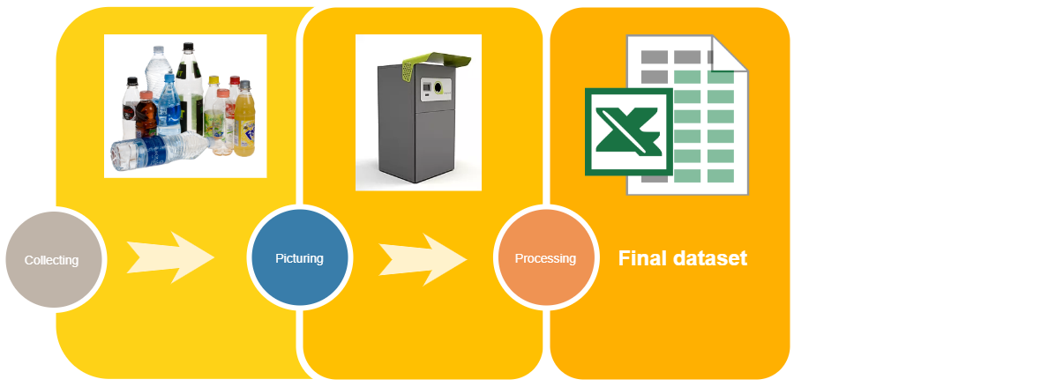

# Aims and objectives

This project aim is to develop a prototype of Reverse Vending Machine (Smart Recycle and Reward Bin). This prototype enables the user to recycle, plastic and metal beverage containers and gets reward points. Through camera and sensor system, the container material is recognized and it is then dropped into respective bins through the aperture. In return, tickets are given or reward points are credited into stored value card according to items recycled.

## Business objectives:

* To provide strategic profiling of key players in the market, comprehensively analysing their core competencies, and drawing a competitive landscape for the market.
* To provide insights about factors affecting the market growth. To analyse the Reverse Vending Machine market based on various factors- price analysis, supply chain analysis, porter five force analysis etc.
* To track and analyse competitive developments such as joint ventures, strategic alliances, new product developments, and research and developments in the Global Reverse Vending Machine market.
* To Identify the ecological profiles and class them as green citizens
* To provide processing companies with sorted containers for further disposal.

## Data science objectives

* Collecting data (pictures) of various containers to build an appropriate labeled dataset.
* Implementation and training of the model on the prepared dataset to reach accurate results.
* Recognition and classification of inputs using Deep Learning algorithms
* Implementation of facial recognition algorithm.
* Extraction and processing of the data collected from the machine

# Internal data preparation

## Data collection:

## Our target data are the images of recyclable products consumed by Tunisian citizens, so for the first phase we tried to collect the maximum possible number of cans ( soda and juice) and plastic bottles ( water, soda and juice ), taking into account all available sizes.

## Résultat de recherche d'images pour "safia" Résultat de recherche d'images pour "Eau Safia 0,5L png"

## Data capture:

## For this phase, we first prepared a prototype for our machine with a camera attached to capture photos from the same angle and with the same distance.

## To be done, we used:

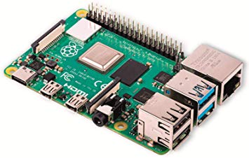 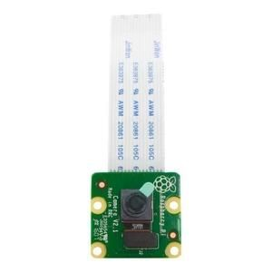

## **Raspberry Pi 4 Module camera 8MP**

## Résultat de recherche d'images pour "led white light rasbery"

## **White LED** **Cardboard box**

## Second, we took pictures of all the collected products, trying to change the position and the format each time to reach a number of 304 photos.

Examples :

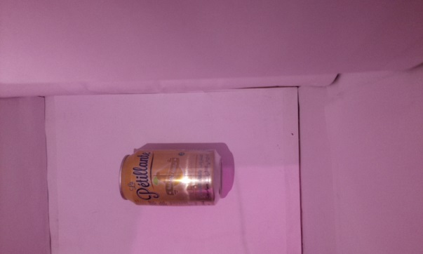 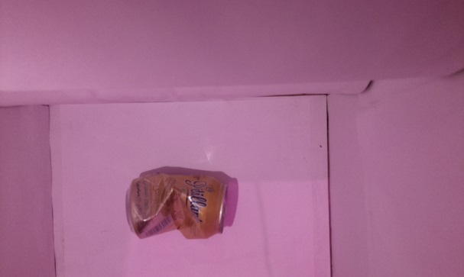

**Normal shaped can Deformed can**

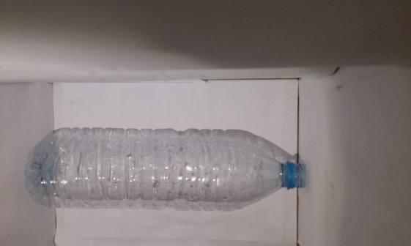 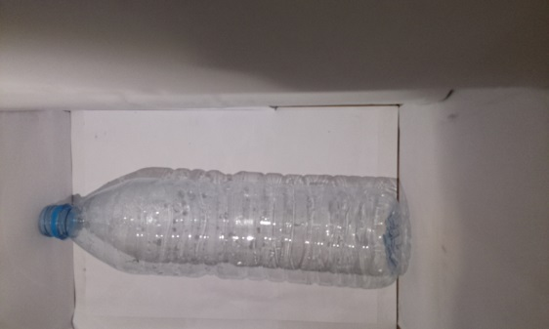

**Bottle oriented to the right Bottle oriented to the left**

## Data labeling:

## To be useful, our data need to be labeled, and to complete this task we used **LabelImg** which is a graphical image annotation tool and label object bounding boxes in images.

## C:\Users\Amin\Desktop\PIDS 25-02-2020\Screen\4.PNG

**Labelling a 0.25L plastic bottle using LabelImg**

## LabelImg’s output annotations are saved as XML files in PASCAL VOC format which contains the image file name, its width, height and depth and the bounding box coordinates:

## 

## Dataset generation:

## The final phase of the preparation of internal data consists in splitting our data into random train and test (80% 20%) subsets and generating files in csv format using the python code below:

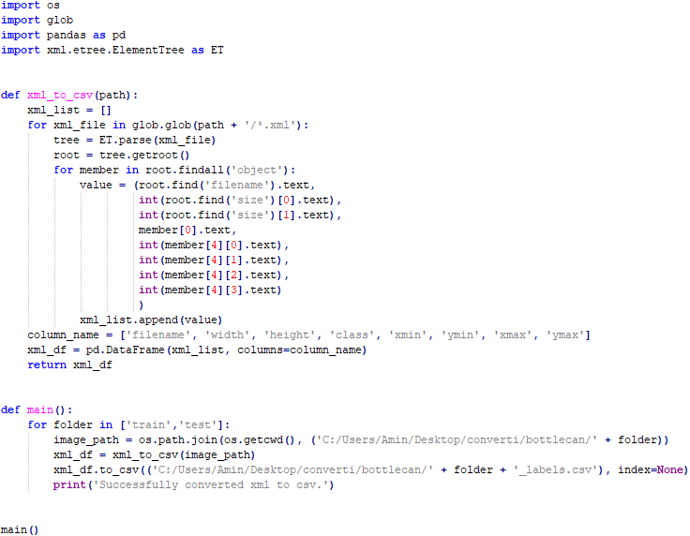

## 

## As results, we got those two dataset which contain all the required information for the rest of our project:

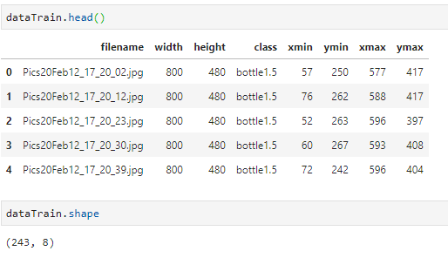

**Train set: 80% (243 out of 304)**

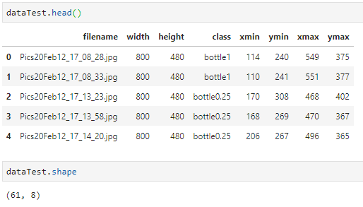

**Train set: 20% (61 out of 304)**

## We can finally display the distribution of classes in each set:

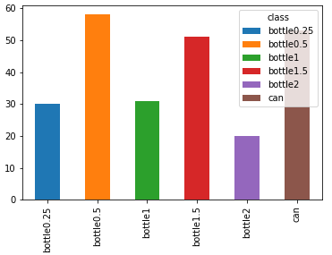

**Train set classes distribution**

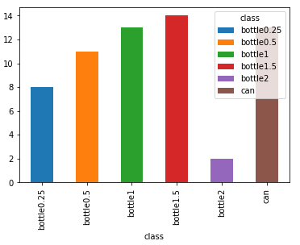

**Test set classes distribution**

# External data

## The online form:

## Concerning the external data, we have created an online form. We have got 500 people from different ages and gender who answered this form.

## Our form contains:

## Environmental questions:

## Are you with the principle of green citizens,

## Are you with the idea of Reverse Vending Machine?

## Questions that are related to our business objectives:

## Where would you like to find these Reverse Vending Machine?

## Which types of bottle materials do you mostly use?

## What would you like to get as a gift in return?

## Personal questions: We asked about the age and gender.

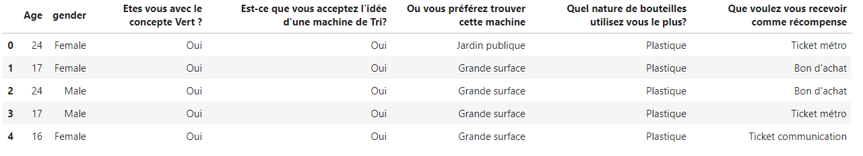

## Graphs and statistics:

After collecting the data, we have done many statistics in order to use these information:

* The number of persons who are with and against the idea of:

- Green citizens

- Reverse Vending Machine.

Then we classified these people by age group then by gender.

* The number of people who chose each modality of these questions:

- Where would you like to find these RVM.

- Which types of bottle materials do you mostly use.

- What would you like to get as a gift in return.

And then we also classified these people by age group then by gender.

## Example:

Let’s see these bar plots as an example:

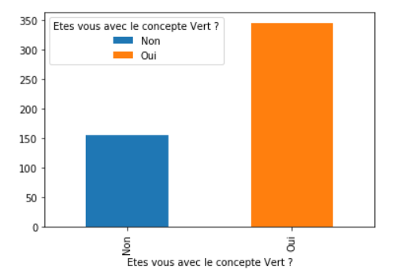

* As you can see we have 350 persons who are with the principle of the green citizens and 150 persons who are against.

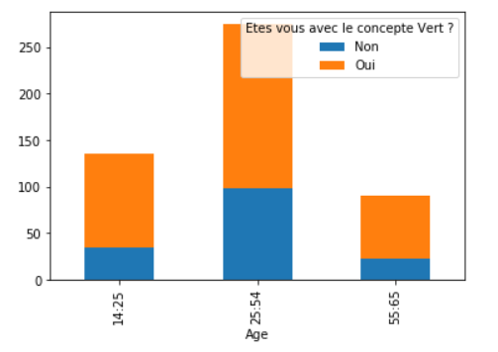

* From these people we can see that the majority of people who answered our form are between 25 years old and 54 years old.
* We can also see that 20% of people who are between 14 and 25 years old and between 55 and 65 years old are against this idea. But this percentage increases for the people who are between 25 and 54 years old 37%.

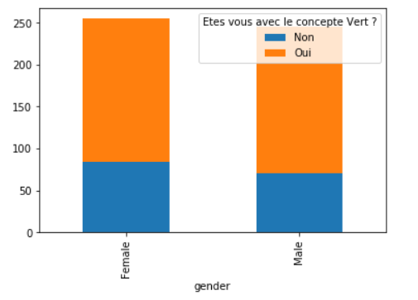

* From the last plot we see that 27 % of males are against the idea of green citizens and 34% of females are against the idea.
* From this graph we can say that the majority of the people are with these types of idea and more precisely females and people between 25 and 54 years old are slightly less interested by this concept.

## The importance of the external data:

These external data will allow us :

* To know if our project can be achieved or not.
* To know if the Tunisian society is interested by these kinds of projects which are in relation with the principle of the green citizens.
* To know where we can put our vending machines and which type of gifts the client would like to get in return.
* To improve the accuracy of our machine and deep learning models.
* To reach our business objectives such as: Identifying the ecological profiles and classes of green citizens, profiling of key players in the market and drawing a competitive landscape for the market.

**=> So as result the external data will help us achieve many of our business and data science objectives.**

# Pre-Trained Models

The main objective of a Reverse Vending Machine is the detection of plastic bottles and tin cans. In order to achieve this objective, we have to use a model that permits the object detection. But if we want to create our proper model we will be facing two major problems which are the difficulty of creating a model from scratch and also our dataset is not quite large which will affect the efficiency of the model.

In order to avoid these problems will be using pre-trained or Transfer Learning Models.

# But first of all what’s a pre-trained model?

## Definition of a pre-trained model:

A pre-trained model is the one that has been trained on a previous problem and that can be used to solve other problems of similar domains. The architecture of these models can be slightly altered so that the model can be fine-tuned as per the requirements of the application it is being used for.

## The importance of a pre-trained model:

These Transfer Learning Models are efficient alternatives to the lengthy process of creation of a deep learning Object Detection Model from Scratch. Transfer learning approaches are primarily used for solving a new problem by using old problem results. Any new dataset can be used for training a pre-trained model after concurrently fine-tuning the pre-trained model. Pre-trained models are also very useful where the data available is not quite large. Generally, it needs to be smaller than the one used to train the original pre-trained model. By using pre-trained models we are able to retain the functionalities, features, and weights of the previous model when utilizing it another one.

## List of pre-trained models:

## So here are some of the very popularly used pre-trained object detection models.

# **R-CNN**

R-CNN uses search selective method to find the regions to detect objects after it passes through convolutional networks. It uses 2k areas that are passed to SVM classifier and then the ground truth-truth boxes are computed. It is highly efficient as it passes the image to the pre-trained CNN only once. The input images are used to predict the detected object. Bounding box localisations are used along with linear regressor to propose the search selective process in R-CNNs.

# **Resnet50**

The Resnet50 is a deep residual neural network that can also be used for object detection. It is faster and efficient. Resnet50 along with ImageAI can be used to develop object detection applications. Resnet50 is deeper and provides better training and testing capabilities. It also has other variants such as Resnet101 etc. Resnet is also used in many other applications like Image Classification, image masking, etc.

# **FPN**

It uses pooling as a method of selection. It contains a single feature map and a pyramid based feature hierarchy, is what makes it useful by carrying out end to end training. They also tend to obtain more accurate results than other methods. It is highly focused on building feature pyramids in the ConvNets. FPN uses pre-trained convnets for multi-scale testing to create feature pyramids. The use of FPN has shown a great improvement in the feature extraction in many recognition systems.

# **Retinanet**

Retinanet is a state of the art Transfer Learning based Neural Network approach used for Object Detection based applications in deep learning. Retinanet improves the prediction accuracy and resolves the class imbalance problem. Thus, inhibiting around 100,000 boxes. Retinanet has a upper hand in achieving higher accuracy in detecting objects. Retinanet was initially created to overcome the shortcomings of the SSD and YOLO based neural networks.

# **Yolo V3/V2**

Yolo or ‘You Only Look Once’ can detect over 9000 object categories. A basic YOLO model has 2 categories. Yolo V3 is the latest version of in the Yolo object detection series. Yolo is simple to understand as it takes an input image and then learns the class probabilities instantly. It only runs the input image once through the CNN. Yolo is one of the most used Transfer Learning approach in Object Detection applications. Yolo also works on unlabelled data also. So, Yolo is super fast and highly accurate than its peers. Yolo uses custom functions that cater to increasing the stability of the overall model.

# **Faster R-CNN**

It is similar to the R-CNN approach but the only difference here is the induction of convolutional feature map that is used to detect the regions in an image to reshape them into a bounding box. It profoundly replaces the Selective Search technique with much efficient Region Proposal Network that generates the detected areas in an image. It is highly used for carrying out real-time performance-based tasks in object detection tasks. It provides a trade-off between accuracy and speed. Faster R-CNN was the first to include the anchor boxes. It also carries out processes like testing and training way faster than R-CNN.

# **SSD**

SSD or Single Shot Detector is a multi-box approach used for real-life object detection. This technique is built on VGG-16 architecture. It takes only a single shot to detect multiple images within a given input image. It is different than other models on this page as a pre-trained model like RNN takes more than 1 shot to detect objects in an image. SSD is easy to train and integrate the detection components into the object detection system. SSD is one of the most popular approaches used today.

**Most of these pre-trained models can be working using Keras or Tensorflow.**

# **Examples of pre-trained models working with Keras**

The table below shows the size of the pre-trained models, their performance and their complexity in terms of parameters of the Convolutional Neural Network Architecture.

| **Model** | **Size** | **Top-1 Accuracy** | **Top-5 Accuracy** | **Parameters** | **Depth** |
| --- | --- | --- | --- | --- | --- |
| [Xception](https://keras.io/applications/#xception) | 88 MB | 0.790 | 0.945 | 22,910,480 | 126 |
| [VGG16](https://keras.io/applications/#vgg16) | 528 MB | 0.713 | 0.901 | 138,357,544 | 23 |
| [VGG19](https://keras.io/applications/#vgg19) | 549 MB | 0.713 | 0.900 | 143,667,240 | 26 |
| [ResNet50](https://keras.io/applications/#resnet) | 98 MB | 0.749 | 0.921 | 25,636,712 | – |
| [ResNet101](https://keras.io/applications/#resnet) | 171 MB | 0.764 | 0.928 | 44,707,176 | – |
| [ResNet152](https://keras.io/applications/#resnet) | 232 MB | 0.766 | 0.931 | 60,419,944 | – |
| [ResNet50V2](https://keras.io/applications/#resnet) | 98 MB | 0.760 | 0.930 | 25,613,800 | – |
| [ResNet101V2](https://keras.io/applications/#resnet) | 171 MB | 0.772 | 0.938 | 44,675,560 | – |
| [ResNet152V2](https://keras.io/applications/#resnet) | 232 MB | 0.780 | 0.942 | 60,380,648 | – |
| [ResNeXt50](https://keras.io/applications/#resnet) | 96 MB | 0.777 | 0.938 | 25,097,128 | – |
| [ResNeXt101](https://keras.io/applications/#resnet) | 170 MB | 0.787 | 0.943 | 44,315,560 | – |
| [InceptionV3](https://keras.io/applications/#inceptionv3) | 92 MB | 0.779 | 0.937 | 23,851,784 | 159 |
| [InceptionResNetV2](https://keras.io/applications/#inceptionresnetv2) | 215 MB | 0.803 | 0.953 | 55,873,736 | 572 |
| [MobileNet](https://keras.io/applications/#mobilenet) | 16 MB | 0.704 | 0.895 | 4,253,864 | 88 |
| [MobileNetV2](https://keras.io/applications/#mobilenetv2) | 14 MB | 0.713 | 0.901 | 3,538,984 | 88 |
| [DenseNet121](https://keras.io/applications/#densenet) | 33 MB | 0.750 | 0.923 | 8,062,504 | 121 |
| [DenseNet169](https://keras.io/applications/#densenet) | 57 MB | 0.762 | 0.932 | 14,307,880 | 169 |
| [DenseNet201](https://keras.io/applications/#densenet) | 80 MB | 0.773 | 0.936 | 20,242,984 | 201 |
| [NASNetMobile](https://keras.io/applications/#nasnet) | 23 MB | 0.744 | 0.919 | 5,326,716 | – |
| [NASNetLarge](https://keras.io/applications/#nasnet) | 343 MB | 0.825 | 0.960 | 88,949,818 | – |

# TOOLS

## TensorFlow:

## TensorFlow is an end-to-end open source platform for machine learning. It has a comprehensive, flexible ecosystem of tools, libraries and community resources that lets researchers push the state-of-the-art in ML and developers easily build and deploy ML powered applications.

## 

## OpenCV:

## OpenCV (Open Source Computer Vision) is a library of programming functions mainly aimed at real time computer vision. In simple language it is library used for Image Processing. It is mainly used to do all the operation related to Images.

## 

## Jupyter Notebook:

## The Jupyter Notebook is an open-source web application that allows you to create and share documents that contain live code, equations, visualizations and narrative text. Uses include: data cleaning and transformation, numerical simulation, statistical modeling, data visualization, machine learning, and much more.

## 

## Python:

## Python is an interpreted, object-oriented, high-level programming language with dynamic semantics, it is simple, easy to learn syntax emphasizes readability and therefore reduces the cost of program maintenance. Python supports modules and packages, which encourages program modularity and code reuse.

## 

# Data Modeling

1. Target models

**R-CNN** and **SSD** are the models that we chose to base our project on, but eventually one of them will be excluded after the evaluation and comparison phases.

1. Models comparison

SSD ( 6000 steps )



R-CNN ( 3000 steps )



Before choosing one of the selected models we should compare them, to do so, we moved to the training and validation phases, as we can see here we 6000 steps for **SSD Mobilnet** and it gave 77% of precision and 81% of recall, for **R-CNN** we stopped the training at 3000 steps and as we can see 75% for the precision and 85% for the recall, so comparing the number of steps and the evaluation metrics we can say that R-CNN is our best model here that we should chain our work with.

1. Model training

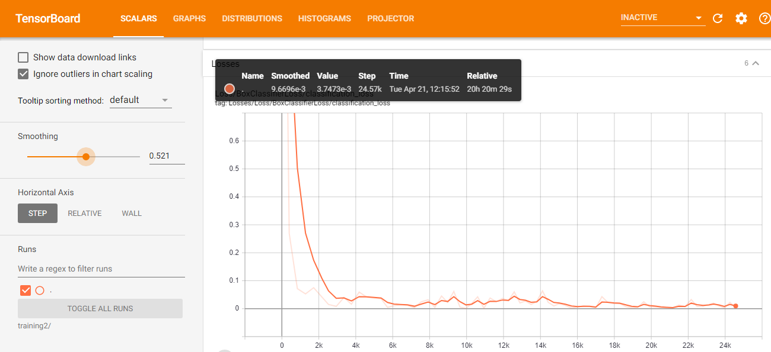

Along the training phase, we displayed the loss function in order to follow the decreasement of the cost according to steps increasement, so we got 0,003 as a final value of the loss.

1. Model evaluation

**Precision (94%)**

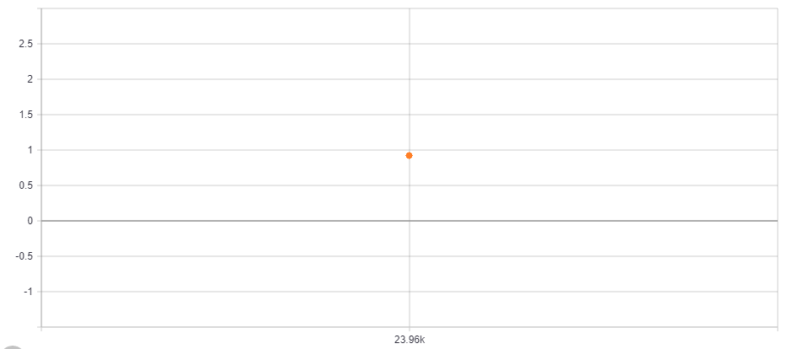

**Recall (88%)**

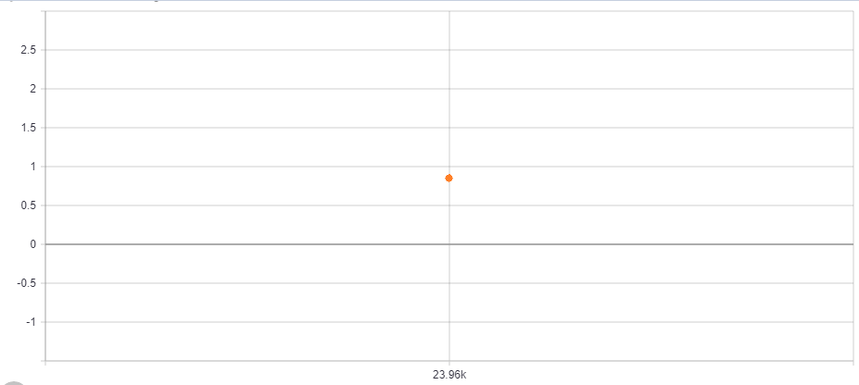

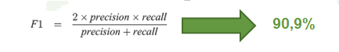

For this final phase, we evaluated our model by calculating its precision and its recall to end up with 0,9 as a F1 score value.

# Data Visualization

Our website provides 2 types of data visualization:

* User profile
* Admin dashboard

**User profile:**

The user can check his profile, see his number of points and all his information, he can also add his gender, his birth date and update his profile picture.

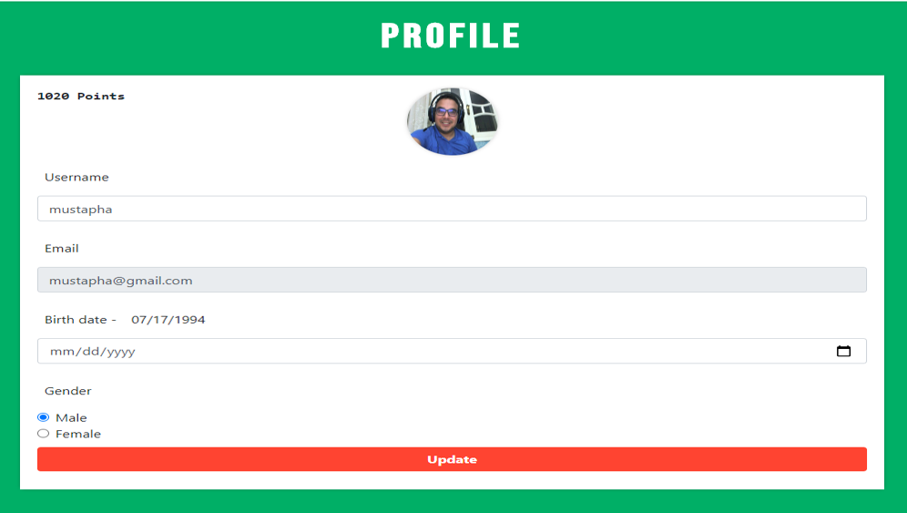

**Admin dashboard:**

The admin dashboard has 3 main sections: General information, issues and analytics.

In the general section we can see the total number of scanned bottles and cans and the total number of points. We can also choose a type of bottle and the number of scans and points of this type will appear.

We can also find the list of all users and all the guests that have used the machine and get the profile of the user by searching his username. When we click the view button of the selected user we will get all the detailed information of that particular user.

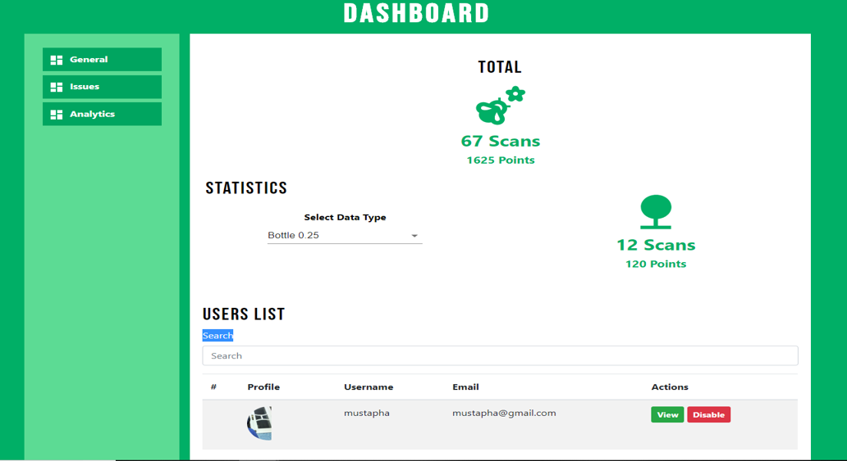

**General Section**

In the issues section we can find all the messages sent by users or guests.

These messages can be related to either technical, customer or commercial issues.

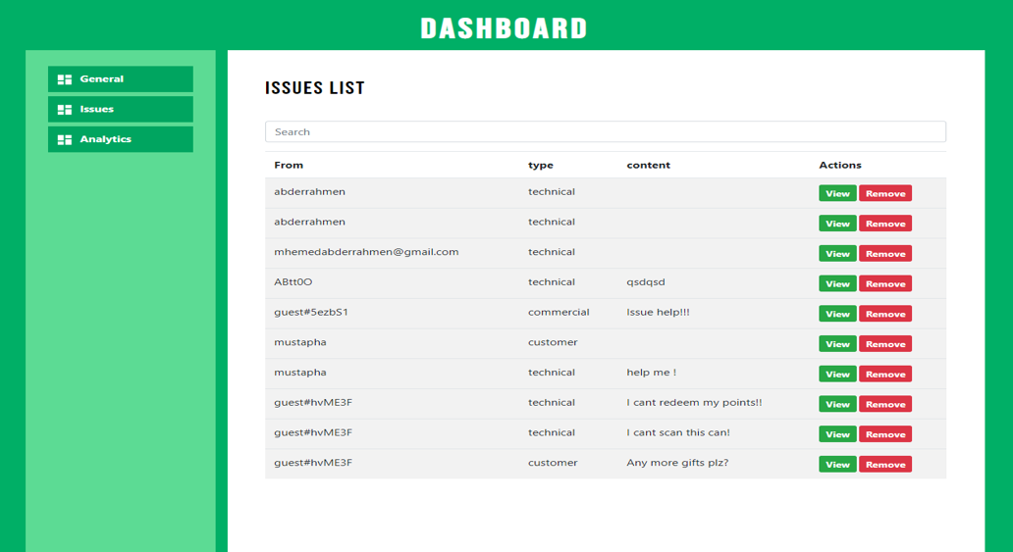

**Issues Section**

In the analytics section we can find 2 pie charts: These 2 charts give us the percentage of users by gender and by age range.

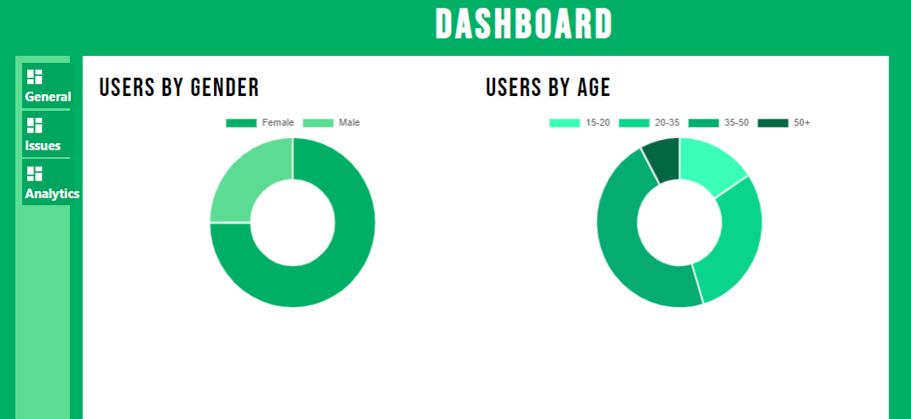

**Analytics Section**

* All these dashboards will allow the admin of the website to achieve the business objectives set at the beginning. It allows the admin to identify the key players and the factors affecting the market and helps him classify end user’s profiles.

# Conclusion

Smart Recycle and Reward Bin is meant to encourage the public to develop the habit for recycling by rewarding them with points. Thus, the machine should be located at public places such as shopping complexes.

The private sectors can play a major role by sponsoring the machines. Take

for instance, the supermarket sponsors the machine and encourages its shoppers to

recycle. In return, the shoppers apply for loyalty cards where they are able to collect

their reward points. The reward points can be used to redeem shopping vouchers or

goodies from the supermarket.