React Router – a gentle Introduction

Installing the Router : npm install – save react-router-dom

The React Router is the core navigation library , consisting of react-router-dom (Navigation for DOM based) , react-router-native (Navigation for React Native apps),
react-router-redux (Provides binding between React and Redux )
//React-Router
React-Router-DOM (This is what we need to install)
React-Router-Native
React-Router-Redux

Router is used for handling different rendering views by controlling the url. Different content for different urls.

A simple example follows as:

import React from "react";

import { BrowserRouter, Route } from "react-router-dom";

const PageOne = () => {
return <div>Page One</div>;
};

const PageTwo = () => {
return <div>Page Two</div>;
};

const App = () => {
return (
<BrowserRouter>
<div>
<Route path='/' exact component={PageOne} />
<Route path='/two' exact component={PageTwo} />
</div>
</BrowserRouter>
);
};

export default App;

Working of Router

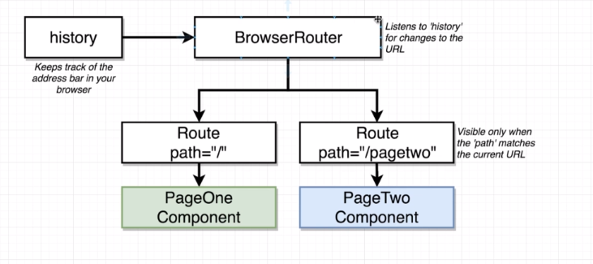

BrowserRouter Component internally creates a history object. History Object communicates the path to BrowserRouter which communicates it to the Route, depending upon the received path , a Route determines wheather to show itself or not.

The exact Keyword

renders the component only if path matches exactly.

<Route path='/' component={PageOne} />
<Route path='/two' component={PageTwo} />

upon assigning the url as /two. Both the components are rendered. To overcome this problem we use exact as a prop.

Not to Navigate using Anchor Tags:

although using anchor tags and setting up relative paths we might be able to navigate around but this approach should not be used.

The problem with this approach is that with each anchor tag click. Browser makes a new request for the index.html file. The browser dumps the old index file including all the React/Redux State.

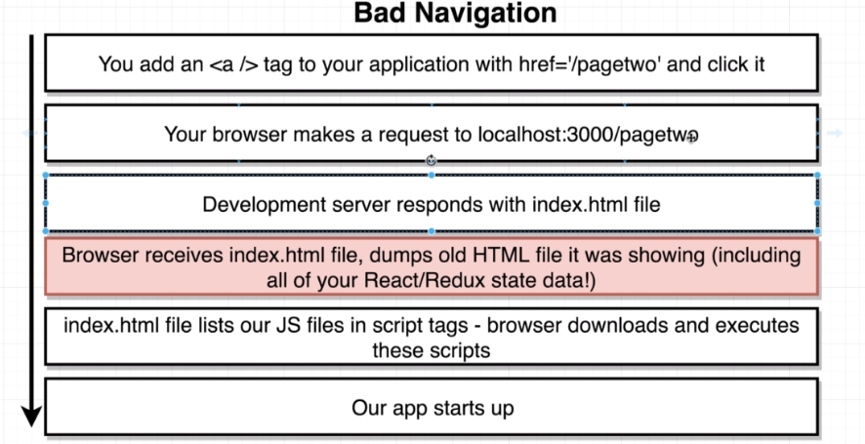

Actually Handling Navigation – Link Component

import React from "react";
import { BrowserRouter, Route, Link } from "react-router-dom";
const PageOne = () => {
return (
<div>
Page One
<Link to='/two'>Page Two</Link>
</div>
);
};

const PageTwo = () => {
return (
<div>
Page Two
<Link to='/'>Page One</Link>
</div>
);
};

const App = () => {
return (
<BrowserRouter>
<div>
<Route path='/' exact component={PageOne} />
<Route path='/two' exact component={PageTwo} />
</div>
</BrowserRouter>
);};

export default App;
Actually this Link Component is rendered as an anchor tag inside the DOM. However it doesnot make any request. Router prevents the anchor tag in navigating away. This is the concept of Single Page Application.

We trick the user in going to different pages, but actually hide and show components based on the url.

Different Types of Routers

There are three Routers in React Router, all differening on the part of url they consider for making routing.

- BrowserRouter
- HashRouter – uses everything after a # as a path.
- MemoryRouter – doesnt use the url to track navigation

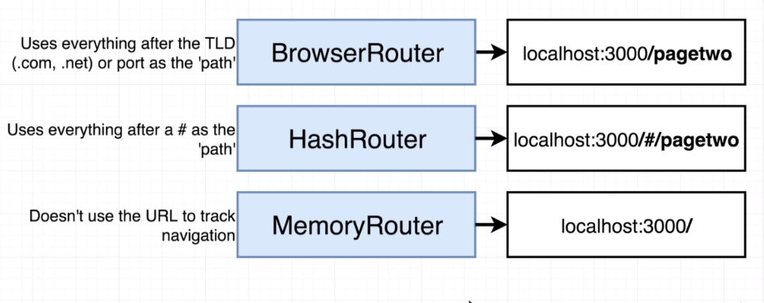
Hash Router:
inserts # sign automatically.

The urls become localhost:3000/#/ , the second one becomes localhost:3000/#/two

Reasons for these different Routers is pure case of deployment.

In particular the BrowserRouter is the most complicated to deploy. Some deployment services makes BrowserRouter deployment very easy.
With Traditional Servers, if a particulat router is not defined, the server responds with error 404 ie Resource not found.

But the React Development Server is different. It checks the dev resoruces, if nothing matches, it checks the public folder. Still if not a hit, finally it will serve up index.html

