PrivateDesk MemoryAgent
Architecture & Design Document
Per-principal private memory · provable isolation · one codebase, two deployments
Qwen Cloud Global AI Hackathon — Track 1 (MemoryAgent)
Version 1.0

Contents

1. System overview
PrivateDesk MemoryAgent is a private memory layer for AI agents. Each principal — an end-user of an application, a tenant, an autonomous agent, or, in the reference build shown here, a member of a household — is given private, isolated, persistent memory. A fact a principal shares accumulates across sessions and is recalled later without being repeated; one principal’s memory is never reachable by another principal’s agent; outdated facts are forgotten; and even when the memory store grows large, only a small, relevant slice enters the model’s context. A human-in-the-loop step gates any action the agent proposes.
The household assistant is the use case demonstrated in this document and submitted for Track 1, but it is one instantiation, not the system. The architecture is domain-agnostic: the same engine serves any application that needs per-user private memory. Throughout this document the isolation unit is called a principal and the grouping boundary a tenant; in the household build a tenant is a household and a principal is a household member.
The design rests on one conviction that also drives the product thesis: privacy is not about where the bytes live — it is isolation, open weights, and never training on user data. To make that concrete, the identical codebase runs two ways, selected by one environment variable. With DASHSCOPE_API_KEY set, every model call routes to Qwen Cloud (DashScope); with it empty, the stack falls back to local, open-weight Qwen3 served by Ollama. Nothing else in the code branches on the choice.

1.1 The four behaviors this design targets
- Accumulation — durable memories captured from conversation and recalled, unprompted, in later sessions.
- Isolation — each principal is a separate memory unit; cross-principal reads are impossible by construction and audited when attempted.
- Forgetting — supersession, expiry, and salience decay keep the active memory set current.
- Bounded recall — retrieval returns a fixed top-k under a token budget, regardless of how many memories are stored.

1.2 Use cases — the household is one of several
Because the contract is simply ‘give principal X private, isolated, forgetting-capable memory,’ the same system applies anywhere that contract is needed:
- Household / family assistant (the reference build and Track 1 demo) — each family member is a principal with a distinct persona.
- Multi-tenant SaaS copilots — each end-user, or each customer organization, is a principal whose memory must never surface in another tenant’s session.
- Regulated enterprise assistants — each employee or client is a principal, and the isolation must be auditable for a security or compliance review.
- Multi-agent systems — each agent is a principal with its own scoped, persistent memory, preventing context bleed between agents.
Everything that follows is described generically. Where the running reference build uses concrete names (the households and members tables), that is noted so the document stays faithful to the code.

2. Architecture at a glance
The system is a small set of cooperating services wired by Docker Compose. A Next.js frontend talks to a FastAPI backend over HTTP and Server-Sent Events. The backend hosts the memory engine and the isolation chokepoint, reaches models through a single LiteLLM seam, and persists state across Qdrant (vectors), PostgreSQL (identity, memories, audit), and Redis (sessions).
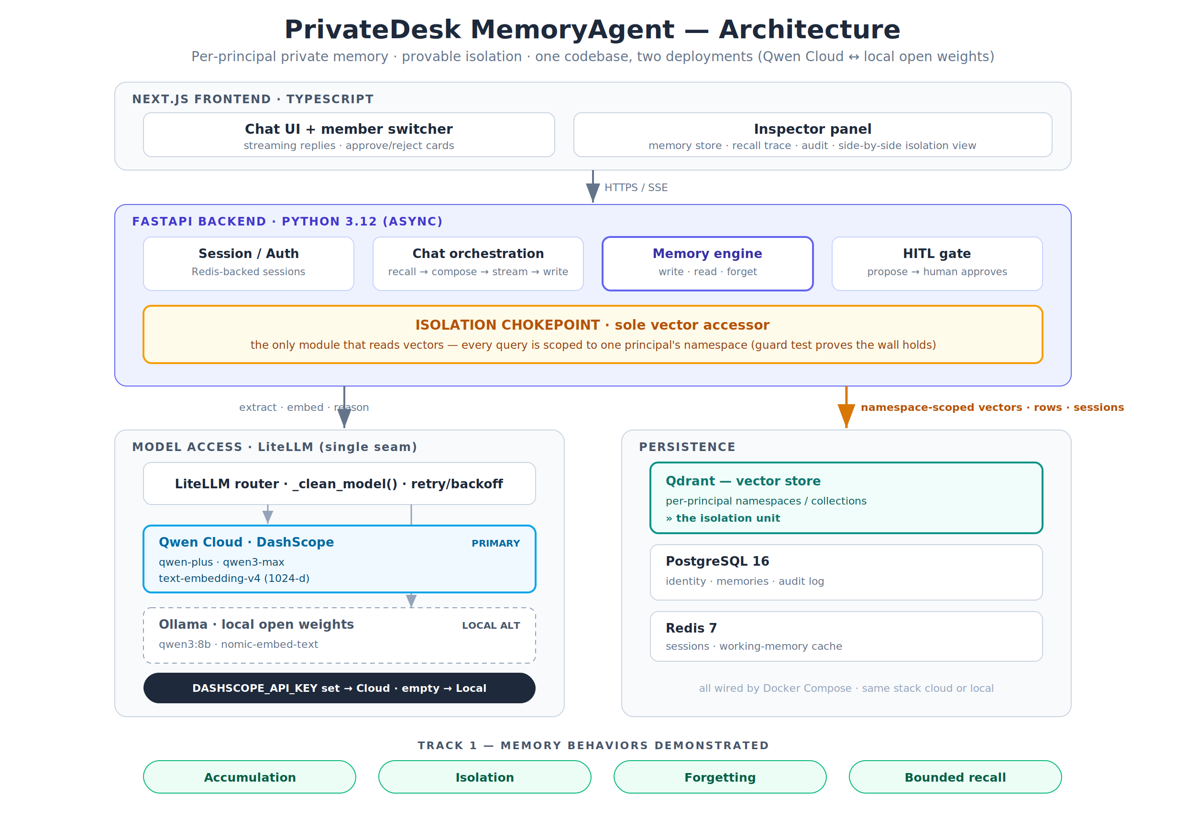
Figure 1 — Component architecture. The amber band is the isolation chokepoint; the dark pill is the cloud/local deployment switch.
The remainder of this document walks each layer top to bottom, then traces the end-to-end flows that cross them.

3. Layers, one by one

3.1 Frontend layer — Next.js
The frontend is intentionally thin: it renders conversation and makes the system’s internals visible. It has two surfaces.
- Chat UI — a switcher between principals, the streaming conversation, and an approval card that appears when the agent proposes an action.
- Inspector panel — the demonstrative heart of the UI. It shows a principal’s memory store with status and salience badges, the live recall trace (query → candidates → selected → token count), the audit log including isolation blocks, and a side-by-side view that makes the separation between two principals’ stores tangible.
Communication uses SSE so the chat streams token-by-token, and so the backend can push structured events — the recall trace first, then tokens, then any proposed action — onto the same channel.

3.2 API / orchestration layer — FastAPI
The FastAPI backend is async throughout and owns four responsibilities: session handling, chat orchestration, the memory engine, and the human-in-the-loop gate. Routers are deliberately small; the logic lives in the engine.
The chat router performs the core loop for every turn: persist the user message, recall bounded memories, compose the persona-scoped system prompt, stream the reply, then asynchronously write new memories and detect any proposed action. Because the write path runs after the reply has streamed, memory extraction never adds latency to what the user sees.

3.3 Memory engine — the core
The engine is where the scored behaviors are implemented. It has three concerns: a write path, a read path, and forgetting.

3.3.1 Write path
After a reply streams, the user’s turn is sent to qwen-plus with an extraction prompt that returns a small JSON array of candidate memories, each typed (fact, preference, event, task, relationship) and scored for salience. Each candidate is embedded with text-embedding-v4 (1024 dimensions) and checked against the principal’s own namespace for near-duplicates. If a near-duplicate exists and the new statement updates it, the old memory is marked superseded; if it is a true duplicate, the candidate is skipped; otherwise it is written as a new active memory to both PostgreSQL and Qdrant, and the write is audited.
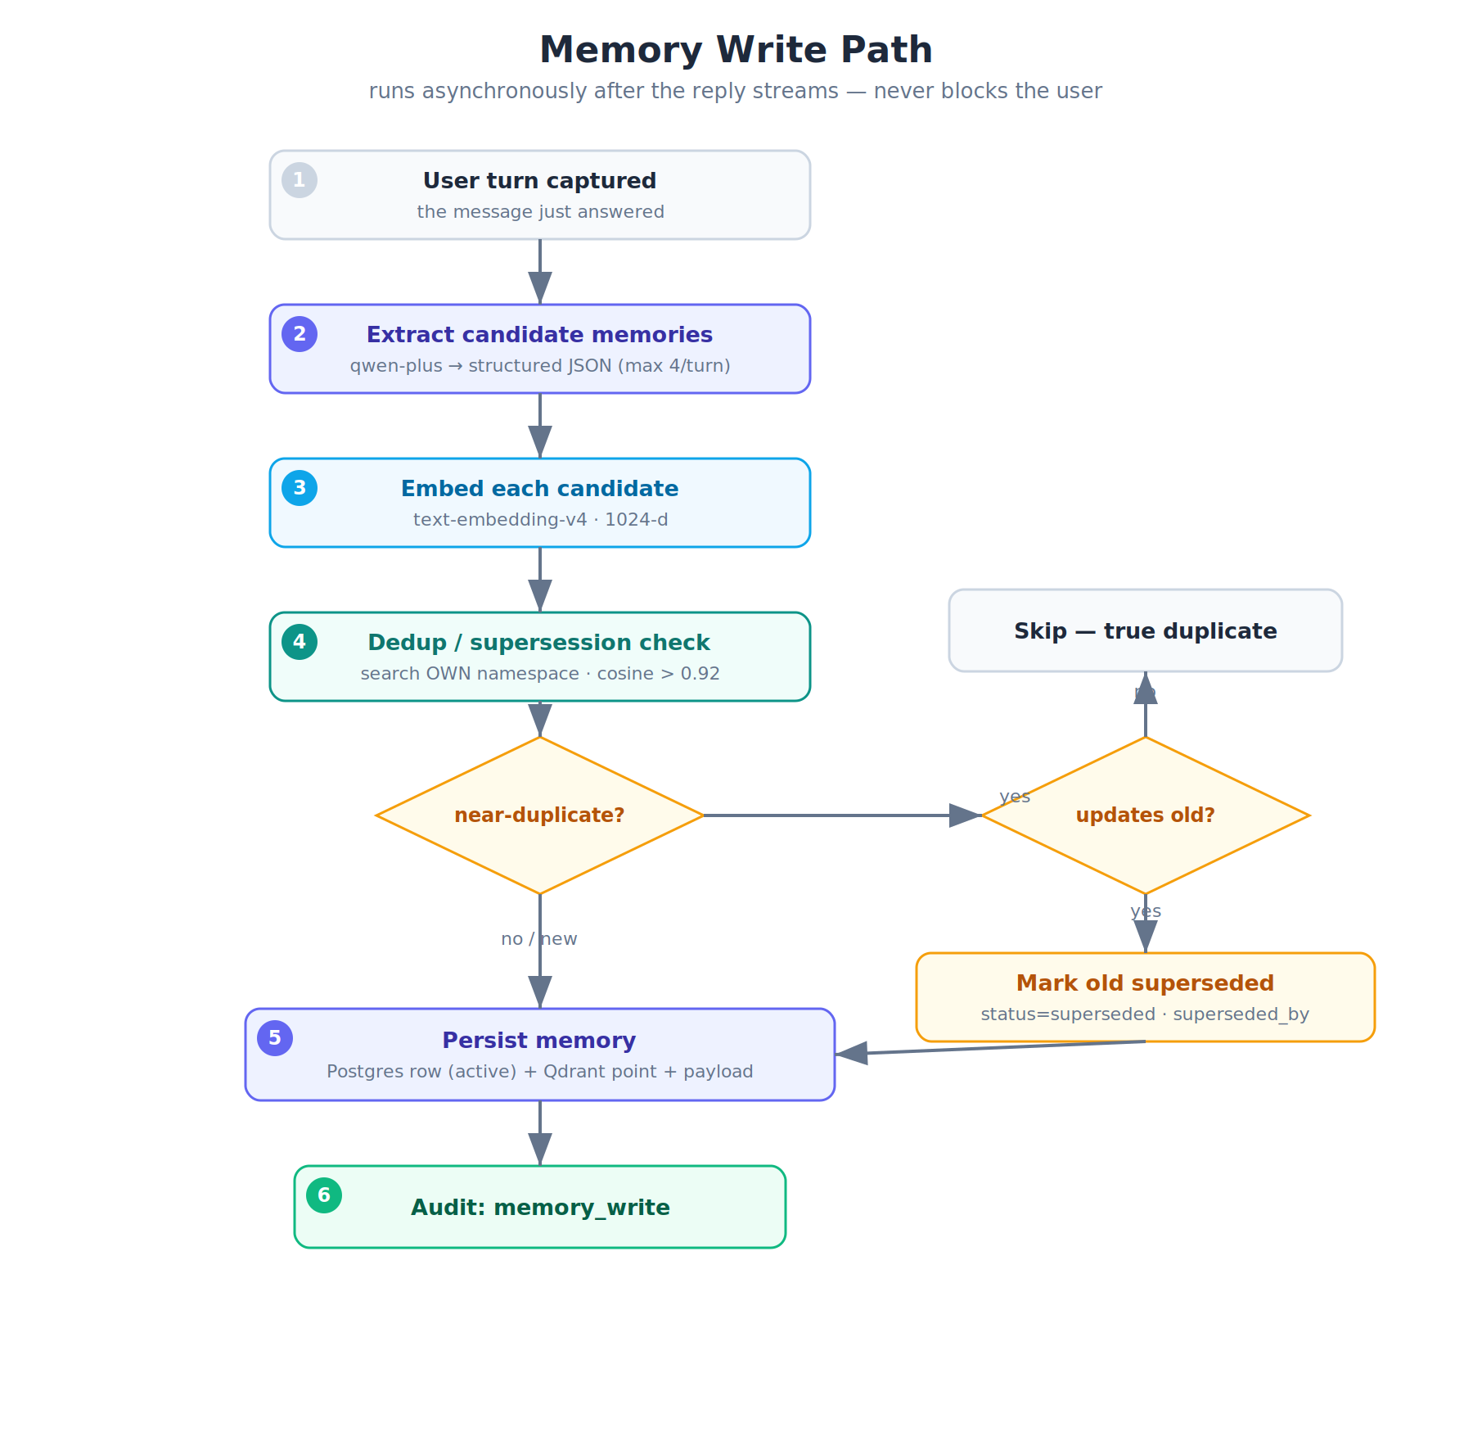
Figure 2 — Memory write path, including dedup and supersession.

3.3.2 Read path — bounded recall
Before generating a reply, the incoming query is embedded and used to search only the principal’s namespace, returning up to K_CANDIDATES (20) active candidates. These are reranked by a blend of similarity, salience, and recency, and the top K_CONTEXT (6) are kept under a token budget and injected into the prompt. This is what makes recall bounded: the store may hold hundreds of memories per principal, but only a handful ever reach the model. The full trace is emitted for the inspector, and the recalled memories’ last-used timestamps are bumped to feed future recency ranking.
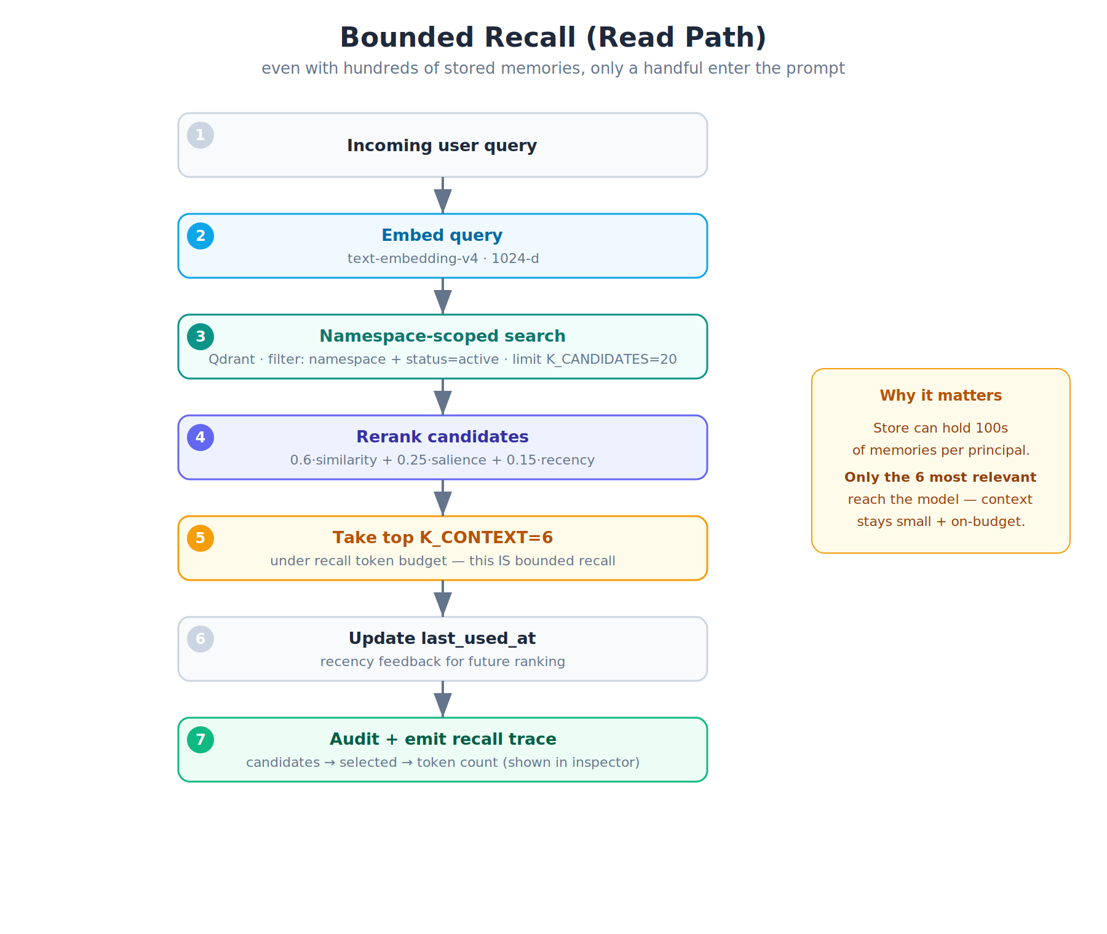
Figure 3 — Bounded recall. Hundreds stored; only the top six enter the context window.

3.3.3 Forgetting
Three mechanisms keep the active set current, and every transition is audited so the inspector can show it happening.
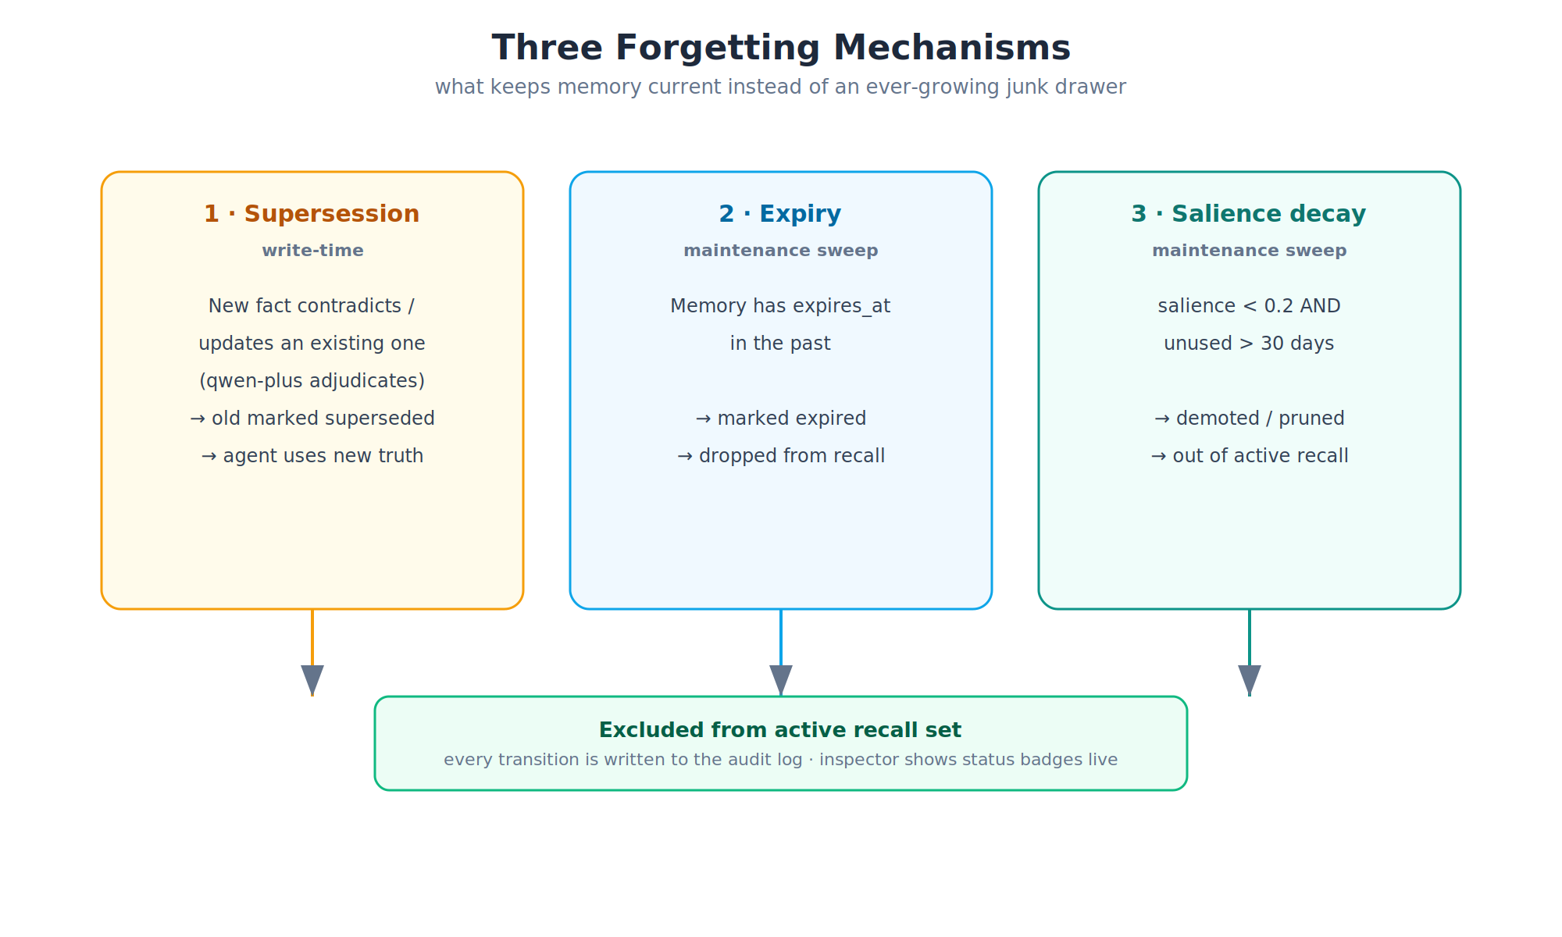
Figure 4 — The three forgetting mechanisms feeding a single ‘excluded from recall’ outcome.

3.4 Isolation layer — the chokepoint
Isolation is enforced at exactly one place. memory/qdrant_client.py is the only module permitted to read vectors, and its search() function always scopes to a single principal’s namespace — there is no code path, and must never be one, that reads vectors without a namespace filter. In the recommended mode each principal gets a physically separate Qdrant collection, so the stores are not merely filtered but literally distinct. A hard assertion fails loudly rather than ever returning a foreign memory, and an automated guard test proves that across 100+ seeded memories one principal’s query never returns another principal’s id.
When an agent is asked for something only another principal knows, the namespace-scoped search returns nothing, the agent truthfully says it does not have that information, and an isolation_block event is written to the audit log.
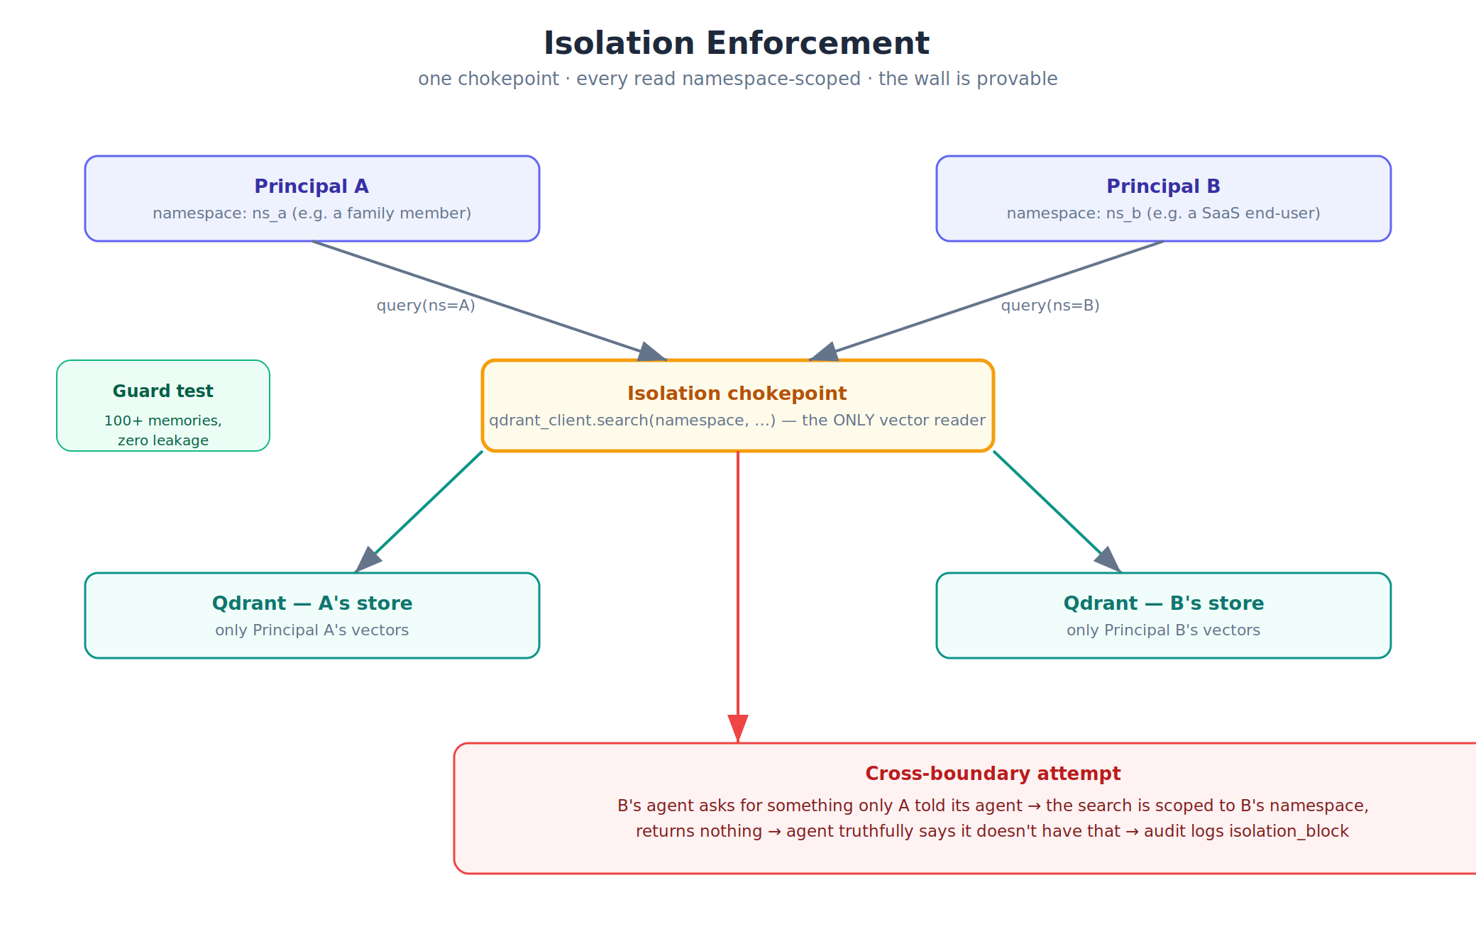
Figure 5 — Isolation enforcement. One chokepoint, separate stores, audited cross-boundary attempts.

3.5 Model access layer — LiteLLM
All model and embedding calls pass through one wrapper. Model names carry a provider prefix (dashscope/ or ollama/) which is stripped by _clean_model() before the OpenAI-compatible HTTP call, so the same code reaches DashScope’s compatible-mode endpoint or a local Ollama server with no change. Calls retry with backoff on rate limits. This single seam is what makes the cloud/local swap a configuration change rather than a code change — the technical spine of the ‘same architecture, two deployments’ story.
Role | Cloud (Qwen Cloud) | Local (Ollama)
Reasoning / extraction | qwen-plus | qwen3:8b
Headline turns | qwen3-max | qwen3:32b
Embeddings | text-embedding-v4 (1024-d) | nomic-embed-text

3.6 Persistence layer
- Qdrant — the vector store, partitioned by per-principal namespace/collection. This partition is the isolation unit.
- PostgreSQL 16 — the system of record for identity, the canonical memory rows (content, kind, salience, status, supersession links, expiry), and the audit log.
- Redis 7 — session tokens and short-term working state.

3.7 Human-in-the-loop
When a reply proposes a concrete action — a reminder, a message draft, a calendar event — it is captured as a proposed_action in the ‘pending’ state and surfaced as an approval card. Nothing is committed until a human approves, and both approval and rejection are audited. The agent drafts and proposes; the person decides.

4. End-to-end chat flow
A single chat turn crosses every layer in a fixed order. Recall happens before generation; the heavy write work happens after the reply has already reached the user.
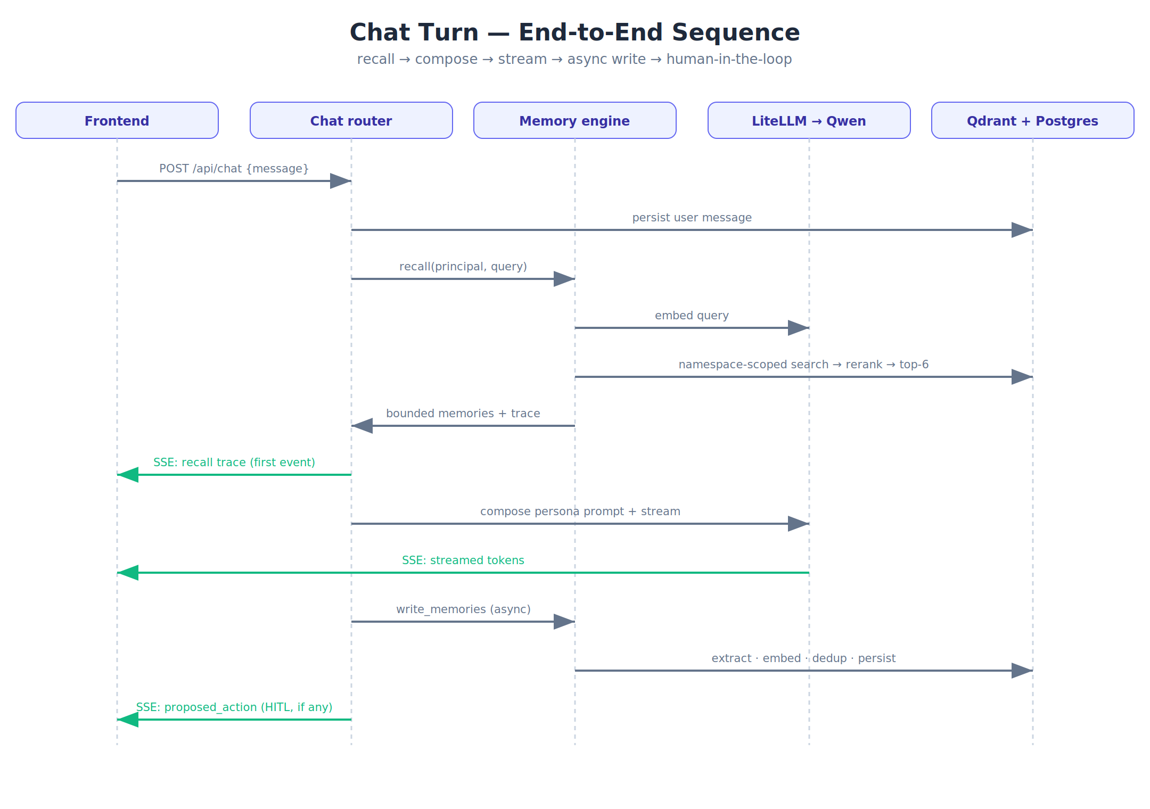
Figure 6 — One chat turn, end to end. Green arrows are SSE events to the browser.

5. Data model
PostgreSQL holds seven tables. The memories table is the heart; the namespace column is denormalized onto it and onto every Qdrant point as the isolation key. The tenant and principal concepts map to the households and members tables in the reference build — renaming them is the main change when adapting the system to a non-household use case.
Table | Purpose
households | A tenant boundary — the grouping for a set of principals (a household in the reference build).
members | A memory-isolated principal (a household member in the reference build): name, role, persona, and the unique memory_namespace — the isolation key.
sessions / messages | Multi-turn conversation history; cross-session recall is the point.
memories | Distilled durable memories: kind, content, salience, status (active/superseded/expired), supersession link, expiry, and the 1:1 Qdrant point id.
audit_log | Every memory write, recall, isolation block, maintenance run, and HITL decision.
proposed_actions | Agent-proposed actions awaiting human approval.

6. API surface
Endpoint | Purpose
POST /api/session/start | Begin a session for a member.
POST /api/chat | SSE chat: recall → compose → stream → async write → HITL detect.
GET /api/members | Member list for the demo switcher.
GET /api/inspector/memories | A member’s memory store with status and salience.
GET /api/inspector/audit | Audit log including isolation_block events.
POST /api/inspector/maintenance | Run the forgetting sweep live.
GET /api/actions/pending | Pending proposed actions.
POST /api/actions/{id}/approve|reject | Resolve a proposed action (audited).
POST /api/demo/seed | Seed 3 personas + 100+ memories for the bounded-recall demo.

7. Deployment
Docker Compose brings up PostgreSQL, Qdrant, Redis, and the API as one stack. The /health endpoint proves the configured provider is reachable by performing one real completion and one real embedding. The cloud path is the hackathon demo (deployed on Alibaba Cloud ECS); the local path runs the identical stack against Ollama. litellm_config.yaml is the declarative record of the Qwen Cloud integration.
 | Cloud path | Local path
Selector | DASHSCOPE_API_KEY set | DASHSCOPE_API_KEY empty
Models | Qwen Cloud (DashScope) | Ollama open-weight Qwen3
Data leaves boundary? | Inference only, never trained on | No — fully local
Code changes | None | None

8. Security & privacy posture
- Isolation by construction — a single vector-read chokepoint, always namespace-scoped, with separate collections per member and a guard test as evidence.
- Auditability — every memory operation, isolation block, and human decision is recorded and exportable.
- Open weights, no training — the local path runs entirely on open-weight models with no data leaving the host; the cloud path uses inference only.
- Human in control — the agent proposes; a person approves before anything is committed.

9. How the design maps to Track 1 scoring
Scored behavior | Where it lives | How it is shown
Accumulation | Write path + cross-session recall | Fact in session A recalled in session B; recall trace in inspector.
Isolation | Chokepoint + per-principal collections | Cross-principal query returns nothing; side-by-side stores; isolation_block audit.
Forgetting | Supersession + expiry + decay | Old memory flips to superseded; ‘run maintenance’ sweeps live.
Bounded recall | Rerank + top-k under budget | 100+ stored, only 6 enter context; token count in the trace.

