IDs : 208220962 , 318451937 , 207500448 , 209545771 -> Team Scorpion.

**BlackBox Tests:**

|  |  |  |  |
| --- | --- | --- | --- |
| **TestID** | **Description** | **Expected Output** | **Actual Output** |
| 1 | Feature: soldier upgrade to queen.  Methods can be used:  MoveBlackSoldier  MoveWhiteSoldier | Queen with number 11 in Tile (0,5) | Queen with number 11 in Tile (0,5) |
| 2 | Feature: grant a player additional move in gameplay. | False (not granting player additional move) | False (not granting player additional move) |
| 3 | generateBlueTile  generating a blue tile during gameplay  and resurrecting a soldier using the method resurrectSoldier. | Soldier revived | Soldier revived |
| 4 | The points calculation for player in turn. | -153 | -153 |

**Test 1:**

**Test 2:**

**Test 3 :**

feature: resurrecting a soldier.

By methods generateBlueTile which

Generates a blue tile(returns the tile)

And then boolean method resurrectSodlier

Which checks sets it

In an input tile

If its legal.

**Test 4:**

**WhiteBox Tests:**

|  |  |  |  |
| --- | --- | --- | --- |
| **TestID** | **Description** | **Expected Output** | **Actual Output** |
| 1 | isGameOver | True | True |
| 2 | getMiddleEnemySoldier | Tile (3,4) | Tile (3,4) |
| 3 | Feature : once a player missed a kill, a soldier burns.  Feature in the methods :  moveBlackSoldier  moveWhiteSoldier  moveQueen | Soldier burned(removed from the board) | Soldier burned (removed from the board) |
| 4 | Winner | blackPlayer | blackPlayer |

**Test 1:**

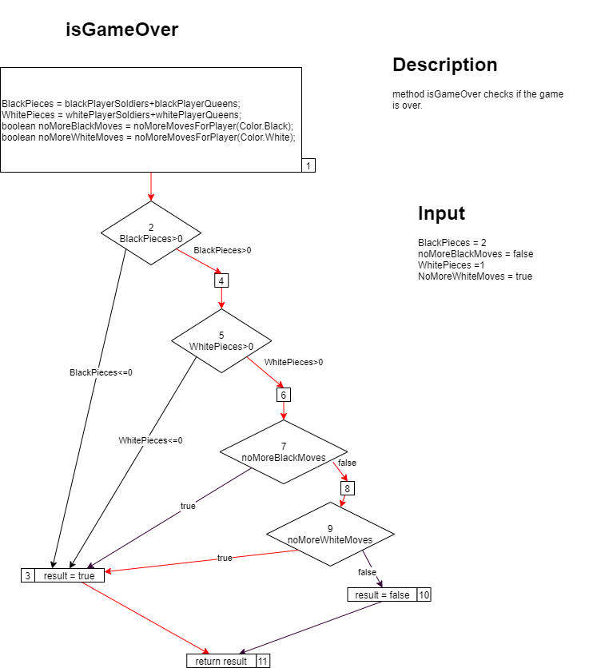

**Test 2:**

**Test 3:**

**Test 4:**

**Unit Tests**

|  |  |  |  |  |
| --- | --- | --- | --- | --- |
| **@TestID** | **Description** | **Input** | **Expected Output** | **Actual Output** |
| 1-*@Test*  void testGameGetContent() | Testing the Ability of the Method to return the Correct Tile Content ! (White/Black – Soldier/Queen ) | Case : Start Board , Tile (1,2). | Case : 2-Black Soldier . | 2-Black Soldier |
| 2- *@Test*  void testGetPossibleMovesForBlackSoldier() | In A Given Situation , Test the Possible moves for A Black Soldier . | Case : opponent Soldier | Null | Null |
| 3- *@Test*  void testMoveBlackSoldier() | Testing if the Black Soldier moves through out the Board Correctly | Case : Black Soldier at Tile(2,1) | Black Soldier At Tile(3,2) , An Empty Tile at (2,1) | Black Soldier At Tile(3,2) , An Empty Tile at (2,1) |
| 4-*@Test*  void testGetSoldierWithKill() | Testing the Possible Kill Moves A Soldier Can Execute ! , Returning the Soldier with the Kills !(given a player Color ) | ** Board | Tiles –  (4,5),(4,3),(4,1) | Tiles –  (4,5),(4,3),(4,1) |
| 5- *@Test*  void testgetMiddleEnemySoldier() | Testing the Method returning the Killed Soldier ! | ** Board | Tile(3,2) | Tile(3,2) |

*\*\*- {-1,2,-1,2,-1,2,-1,2*

*{2,-1,2,-1,2,-1,2,-1},*

*{-1,2,-1,2,-1,2,-1,2},*

*{0,-1,11,-1,1,-1,0,-1},*

*{-1,0,-1,0,-1,0,-1,0},*

*{1,-1,0,-1,1,-1,1,-1},*

*{-1,2,-1,1,-1,1,-1,1},*

*{1,-1,0,-1,1,-1,1,-1} };*