MLB - R Markdown Example
Michael Hahsler
2/12/2020
This is an R Markdown document. Markdown is a simple formatting syntax for authoring HTML, PDF, and MS Word documents. For more details on using R Markdown see http://rmarkdown.rstudio.com.
When you click the Knit button a document will be generated that includes both content as well as the output of any embedded R code chunks within the document.

Loading the MLB Dataset
Reading the data from the Web.
mlb <- read.csv("https://michael.hahsler.net/SMU/DS_Workshop_Intro_R/examples/MLB_cleaned.csv")

Inspect the first few data rows.
Raw R output:
head(mlb)
## First.Name Last.Name Team Position Height.inches. Weight.pounds. Age
## 1 Jeff Mathis ANA Catcher 72 180 23.92
## 2 Mike Napoli ANA Catcher 72 205 25.33
## 3 Jose Molina ANA Catcher 74 220 31.74
## 4 Howie Kendrick ANA First Baseman 70 180 23.64
## 5 Kendry Morales ANA First Baseman 73 220 23.70
## 6 Casey Kotchman ANA First Baseman 75 210 24.02
A fancy option:
knitr::kable(head(mlb))
First.Name | Last.Name | Team | Position | Height.inches. | Weight.pounds. | Age
Jeff | Mathis | ANA | Catcher | 72 | 180 | 23.92
Mike | Napoli | ANA | Catcher | 72 | 205 | 25.33
Jose | Molina | ANA | Catcher | 74 | 220 | 31.74
Howie | Kendrick | ANA | First Baseman | 70 | 180 | 23.64
Kendry | Morales | ANA | First Baseman | 73 | 220 | 23.70
Casey | Kotchman | ANA | First Baseman | 75 | 210 | 24.02
An interactive option:
DT::datatable(mlb)
## PhantomJS not found. You can install it with webshot::install_phantomjs(). If it is installed, please make sure the phantomjs executable can be found via the PATH variable.

Data summary
The dataset contains 1034 players. Here is a summary:
knitr::kable(summary(mlb))
 | First.Name | Last.Name | Team | Position | Height.inches. | Weight.pounds. | Age
 | Jason : 27 | Johnson : 9 | NYM : 38 | Relief Pitcher :315 | Min. :67.0 | Min. :150.0 | Min. :20.90
 | Chris : 26 | Perez : 7 | ATL : 37 | Starting Pitcher:221 | 1st Qu.:72.0 | 1st Qu.:187.0 | 1st Qu.:25.44
 | Mike : 26 | Gonzalez : 6 | DET : 37 | Outfielder :194 | Median :74.0 | Median :200.0 | Median :27.93
 | Scott : 24 | Hernandez: 6 | OAK : 37 | Catcher : 76 | Mean :73.7 | Mean :201.7 | Mean :28.74
 | Ryan : 23 | Jones : 6 | BOS : 36 | Second Baseman : 58 | 3rd Qu.:75.0 | 3rd Qu.:215.0 | 3rd Qu.:31.23
 | Matt : 19 | Ramirez : 6 | CHC : 36 | First Baseman : 55 | Max. :83.0 | Max. :290.0 | Max. :48.52
 | (Other):889 | (Other) :994 | (Other):813 | (Other) :115 | NA | NA | NA

The height distribution
Base R:
hist(mlb$Height.inches.)
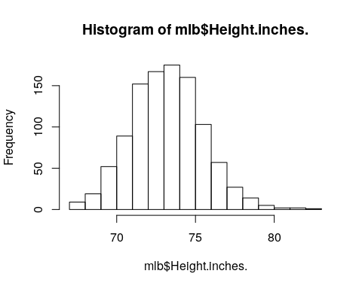
Use plotly:
plotly::plot_ly(mlb, x = ~Height.inches., type = "histogram")

Exercises - Analyse an MLB Team
The goal of this exercise is to create a report that analyzes an MLB Team of your choice including basic information, tables and graphs.
- Change the title and author.
- Clean up the document and only keep the tables/figures you like.
- Write what team you are analyzing.
- Do a in-dept analysis of one team of your choice including tables and charts. Answer questions like:
  - How many players has the team in total?
  - Who is the youngest player?
  - How many players does the team have for each position?
  - What is the age range of the players?
  - Is there a difference in height and weight between positions?

