Variable

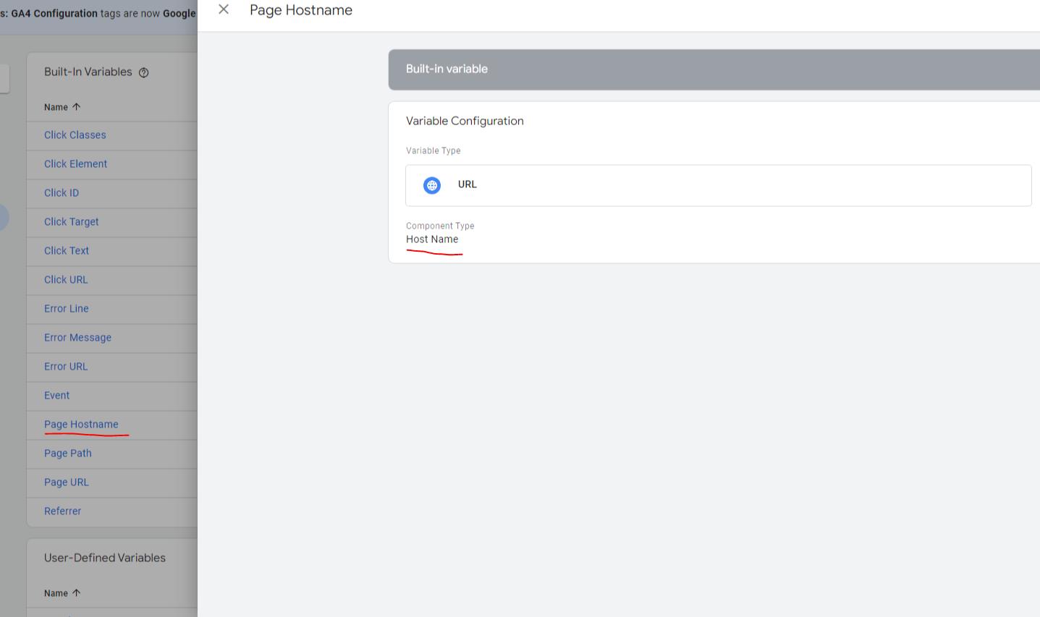

Variable: Lookup table aggregated

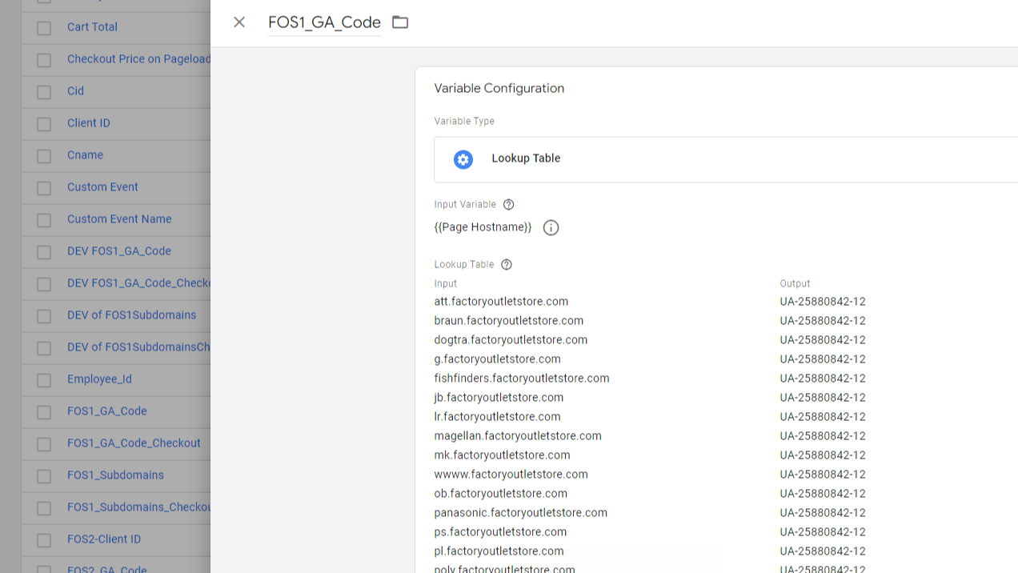

Main property

Vriable: Lookup table induvial subdomains : FOS_1 Subdomains GA

Subdomain level propery

Sub domain level property

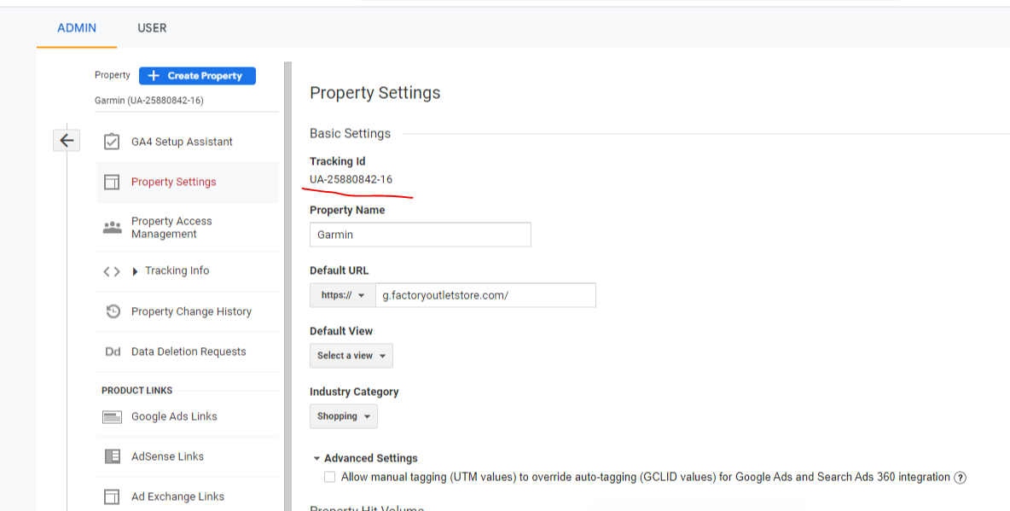

Tag

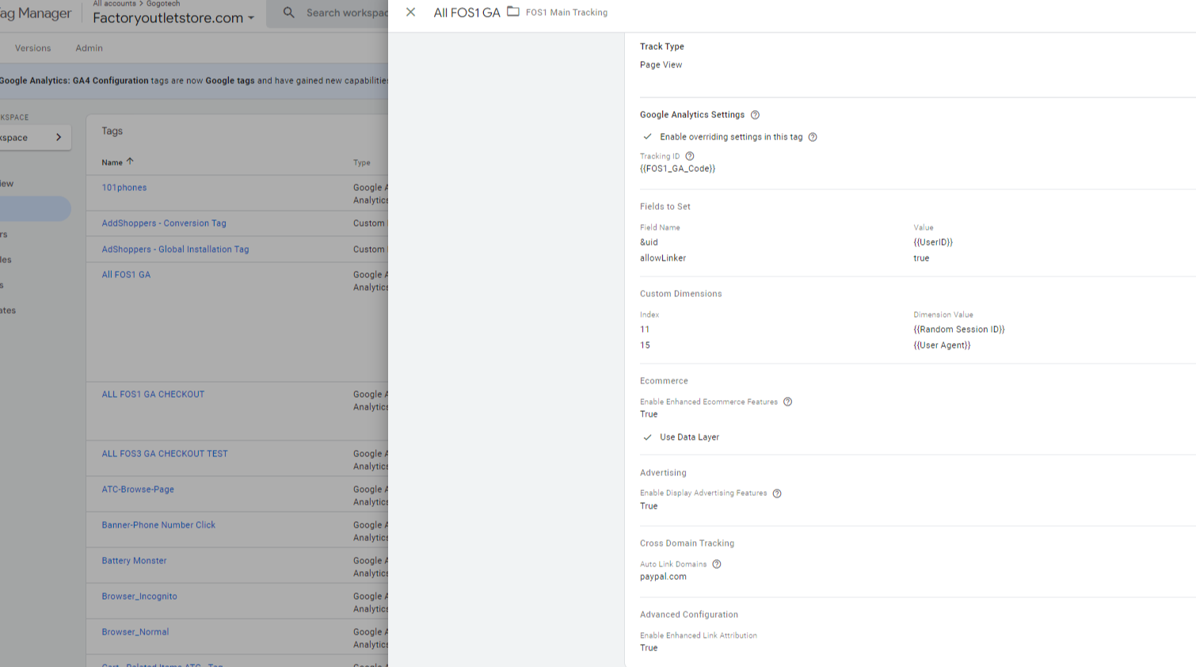

Trigger

Tag

Trigger

<https://flintanalytics.com/track-multiple-websites-with-one-google-tag-manager-container/>

<https://samuelschmitt.com/google-tag-manager-analytics-tutorial/ga-gtm-mutliple-domains/>