**Nama : Rafif Yusuf Avandy  
NIM : 6701180060  
Kelas : D3SI-42-04**

**Assesment 2**

1. DROP FUNCTION IF EXISTS fpotongan;

DELIMITER //

CREATE FUNCTION fpotongan(jbayar INT) RETURNS VARCHAR(20)

DETERMINISTIC

BEGIN

DECLARE hasil VARCHAR(20);

IF jbayar >= 1000 THEN

SET hasil = '25%';

ELSEIF jbayar >= 700 THEN

SET hasil = '15%';

ELSEIF jbayar < 700 THEN

SET hasil = '0%';

END IF;

RETURN hasil;

END//

DELIMITER ;

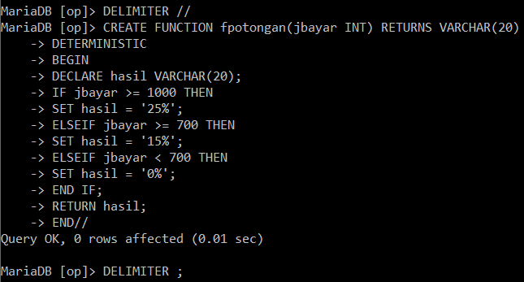

1. DROP PROCEDURE IF EXISTS phadiah;

DELIMITER //

CREATE PROCEDURE phadiah(IN jbelanja INT, OUT jhadiah INT)

BEGIN

IF jbelanja >= 5000 && jbelanja < 10000 THEN

SET jhadiah = 1;

ELSEIF jbelanja >= 10000 && jbelanja < 15000 THEN

SET jhadiah = 2;

ELSEIF jbelanja < 5000 THEN

SET jhadiah = 0;

END IF;

END//

DELIMITER ;

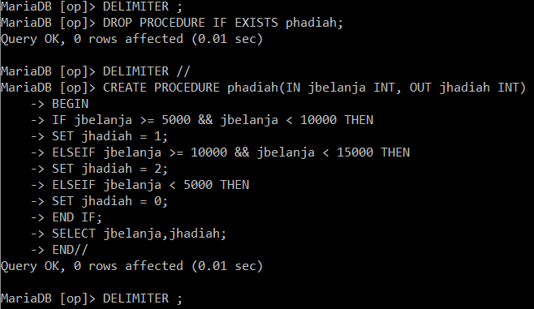

1. DROP PROCEDURE IF EXISTS pakumulasi;

DELIMITER //

CREATE PROCEDURE pakumulasi()

BEGIN

DECLARE kode_pembeli,nama_pembeli,negara,kode_order,tgl_order,jml_belanja,total TEXT DEFAULT '';

DECLARE hasil TEXT DEFAULT '';

DECLARE selesai INT DEFAULT '';

DECLARE ass2 CURSOR FOR

SELECT o.customerid,companyname,country,orderdate,sum(quantity * unitprice) from customers

join orders o USING(customerid) JOIN orderdetails USING(orderid) JOIN products USING(productid) WHERE o.customerid = 'QUICK';

DECLARE CONTINUE HANDLER FOR NOT FOUND

SET selesai = 1;

SET hasil = CONCAT(hasil, '\n', RPAD('Kode Order', 15, ' '),'|', RPAD('tgl_order', 15, ' '),'|' ,

RPAD('jml-belanja', 15, ' '),'\n');

OPEN ass2;

WHILE

selesai < 1 DO

FETCH ass2 INTO kode_order,nama_pembeli,negara,tgl_order,jml_belanja;

SET hasil = CONCAT(hasil, '\n', RPAD(kode_order, 15, ' '),'|', RPAD(tgl_order, 15, ' '),'|' ,

RPAD(jml_belanja, 15, ' '),'\n');

END WHILE;

CLOSE ass2;

SELECT hasil;

END//

DELIMITER ;

CALL pakumulasi();

