**Introduction**

This project addresses copyright infringement concerns in the music industry, focusing on preventing unauthorized copying of user recordings. The application employs robust authentication mechanisms, role-based access control, and encryption techniques to safeguard recordings. User authentication ensures that only registered users and admins can access the system, with admins having broader management capabilities. Role-based access control restricts regular users from viewing or managing other users' recordings, while admins can oversee all recordings. Encryption of filenames and passwords provides an additional layer of security, ensuring data remains protected even if the database is compromised. These measures collectively prevent unauthorized access and copying, effectively mitigating copyright infringement risks. By securing user data and controlling access, the application ensures that recordings remain accessible only to their rightful owners and authorized personnel.

1. **Secure database**

The application employs encryption to protect the filenames of recordings stored in the database, ensuring that only authorized users can access and understand the data. Here’s a detailed breakdown of how this encryption helps in preventing copyright infringement:

**Storage of Encrypted Filenames:** When a recording is saved, its filename is encrypted before being stored in the database. This means that even if someone gains unauthorized access to the database, they would not be able to determine the names of the files, let alone access the recordings themselves.

**Retrieval of Encrypted Filenames:** When a user views their recordings, the application decrypts the filenames before displaying them. This ensures that the data remains secure during storage and transit but is accessible in a readable format to the rightful owner.

**Generation and Storage of Encryption Keys:** A secure encryption key is generated and stored in a file when the application is first run. This key is essential for both encrypting and decrypting the filenames. The key management process ensures that the encryption is strong and that the key is not easily accessible.

**Loading the Encryption Key:** Every time the application runs, it checks for the existence of the key file. If the file exists, the key is loaded for use in encryption and decryption operations. This ensures consistency and security across sessions.

**Encrypting Messages:** The encrypt_message function uses the encryption key to securely encrypt the filenames. This makes the filenames unreadable to anyone who does not have access to the key.

**Decrypting Messages:** Conversely, the decrypt_message function decrypts the filenames when they need to be accessed by authorized users. This ensures that only legitimate users can view and manage the recordings.

1. **Controlled access**

The application prevents copyright infringement through controlled access by implementing several security measures, including user authentication, role-based access control, and encryption. Here’s how these mechanisms work together to ensure that only authorized users can access or manage recordings:

**User Registration:** During registration, users create a unique username and password. The password is encrypted before being stored in the database, ensuring it remains secure.

**User and Admin Roles:** The application distinguishes between regular users and the admin. Regular users can only see and manage their own recordings, while the admin has broader access for oversight. This role-based access control, combined with encrypted filenames, ensures that data is not exposed inappropriately.

**User Login:** Users must provide their username and password to log in. The application decrypts the stored password and compares it with the entered password to authenticate the user.

**Admin and User Roles:** The application differentiates between regular users and the admin. The admin has broader access and control over the system, while regular users can only access their own recordings.

**Admin Access:** The admin can view all recordings, delete recordings, and perform other administrative tasks.

**User Access:** Regular users can view and manage only their recordings. This access is restricted to ensure that users cannot view or modify other users' recordings.

**Viewing Recordings:** Users can view only their recordings, ensuring that they do not have access to recordings made by other users.

**Admin Management:** The admin can view and delete any recordings, providing oversight and control over the entire database.

**Usage**

1. **Run the Program**:

**\*** Execute the script by running python Digital_Music.py from your command line or terminal.

1. **Main Menu**:

**\*** User is presented with the options 1 to register as a new user or 2 to log in if you already have an account

1. **Register a New User**:

**\***If you choose to register, enter a new username and password when prompted

**\*** After successful registration, you will have options to record audio or log out

1. **Login**:

**\*** If you choose to login, enter username and password to login

**\*** If you choose to login as an admin, enter admin username and password to login

1. **User/admin Options**:

**\***After successful login, you will have options to record audio, view recording or log out.

**\*** If logged in as admin, you will have options to record audio, view all recordings, delete specific or log out.

1. **Recording Audio**:

**\*** When you choose to record audio, enter a filename for your song

**\*** The program will record audio.

**\*** The recording will be saved, encrypted, and stored in the database with song rating.

1. **Viewing Recordings**:

**\***Regular users can view their own recordings, displaying the filename, timestamp, and rating.

**\*** Admins can view all recordings from all users, along with associated usernames.

1. **Logout**:

**\***Select the logout option to exit the user or admin session.

**Code Decom**

Imports

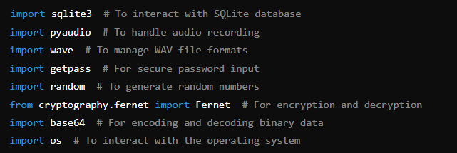

These imports include necessary libraries for database management, audio recording, encryption, and general operations.

Encryption Functions

Generate Encryption Key

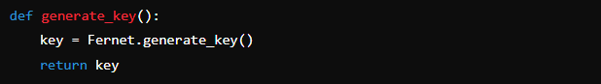

This function generates a new encryption key using Fernet.

Save Encryption Key

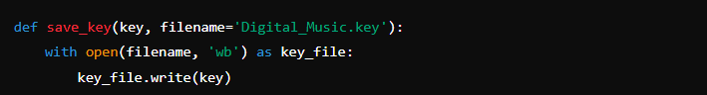

This function saves the generated key to a file.

Load Encryption Key

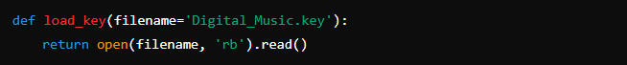

This function loads the encryption key from a file.

Encrypt Message

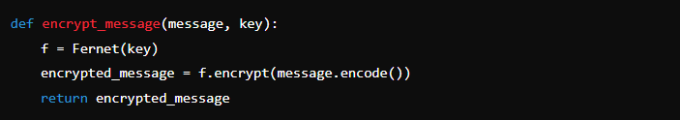

This function encrypts a message using the given key.

Decrypt Message

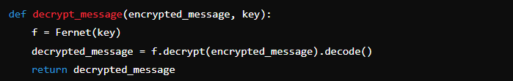

This function decrypts an encrypted message using the given key.

Key Management

Check if Key Exists

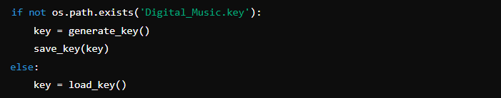

This part checks if the encryption key file exists. If not, it generates a new key and saves it; otherwise, it loads the existing key.

Database Setup

Setup Database

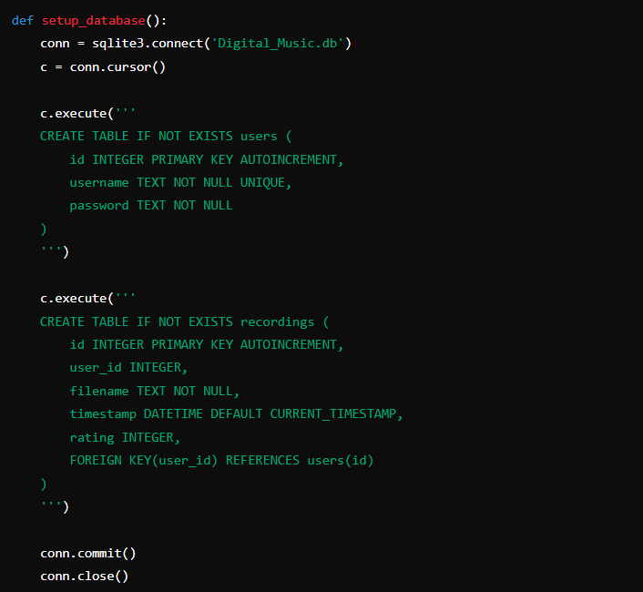

This function sets up the SQLite database with users and recordings tables.

User Registration

Register User

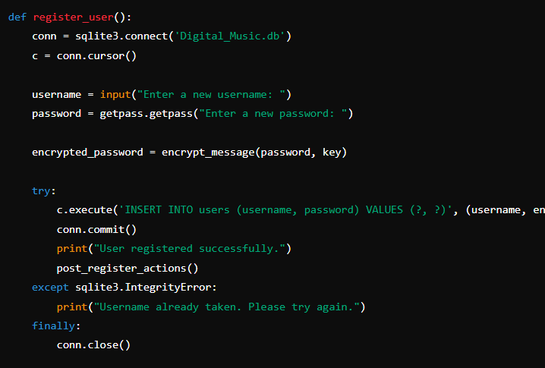

This function registers a new user by prompting for a username and password, encrypting the password, and saving the details to the database.

Post Register Actions

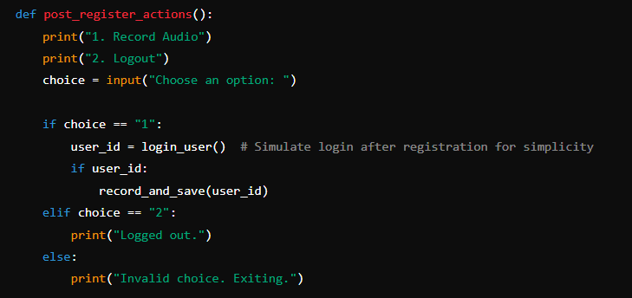

This function handles actions immediately after user registration, such as recording audio or logging out.

User Login

Login User

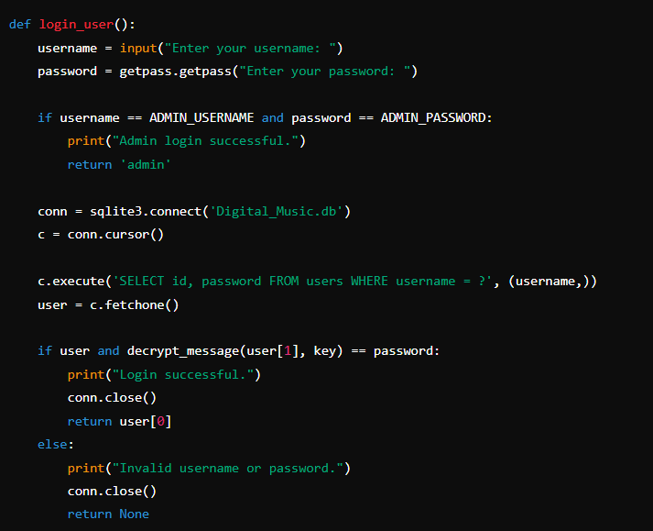

This function handles user login by verifying the username and password. If the admin credentials are used, it returns 'admin'.

Viewing Recordings

View User's Recordings

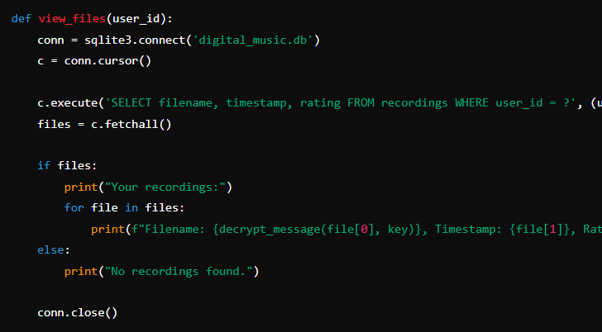

This function retrieves and displays a user's recordings from the database

View All Recordings (Admin)

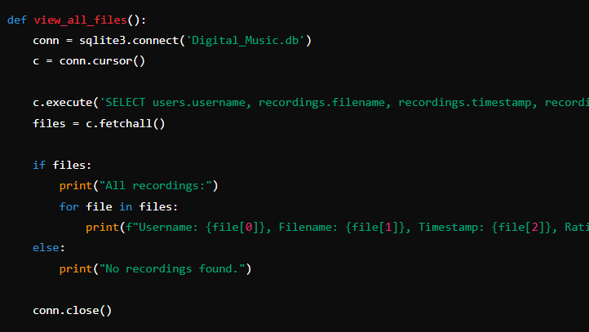

This function allows the admin to view all recordings from all users.

Managing Recordings

Delete Recording (Admin)

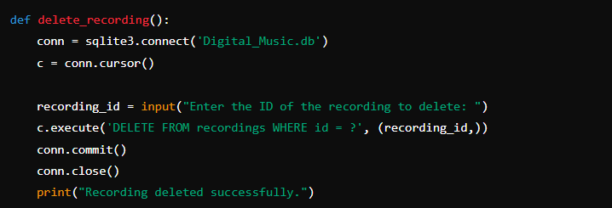

This function allows the admin to delete a recording by its ID.

Record Audio

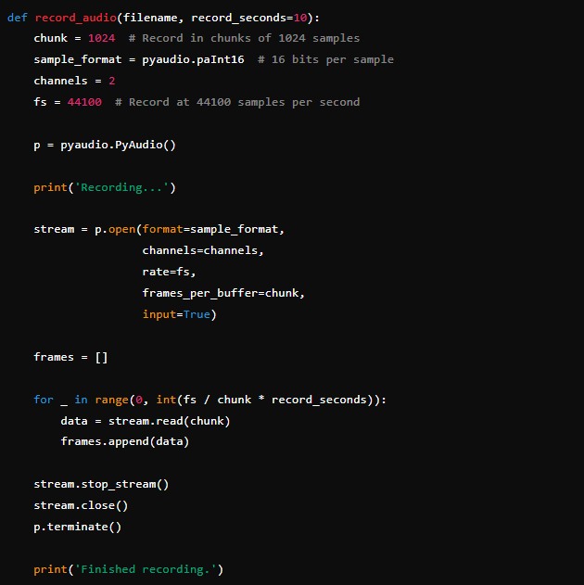

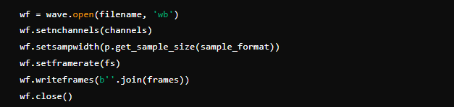

This function handles audio recording and saves the recorded audio to a file.

Save Recording Metadata

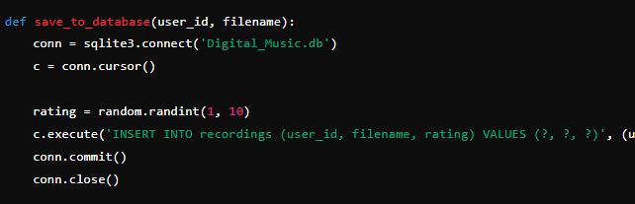

This function saves recording metadata (user ID, filename, and rating) to the database.

Record and Save

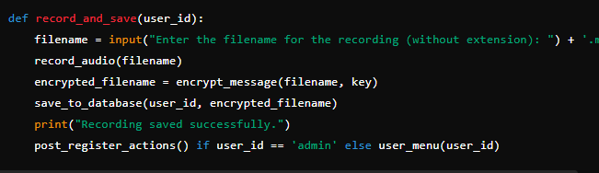

This function handles the entire process of recording audio, encrypting the filename, and saving it to the database.

User and Admin Menus

User Menu

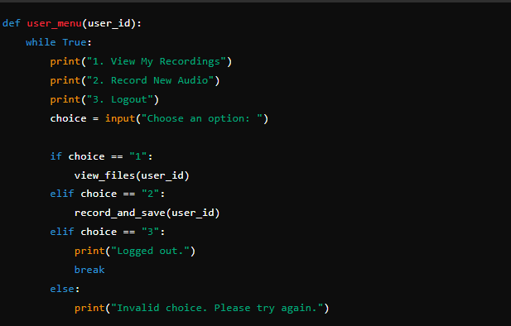

This function displays the user menu with options to view recordings, record new audio, or log out.

Main Function

Main Function

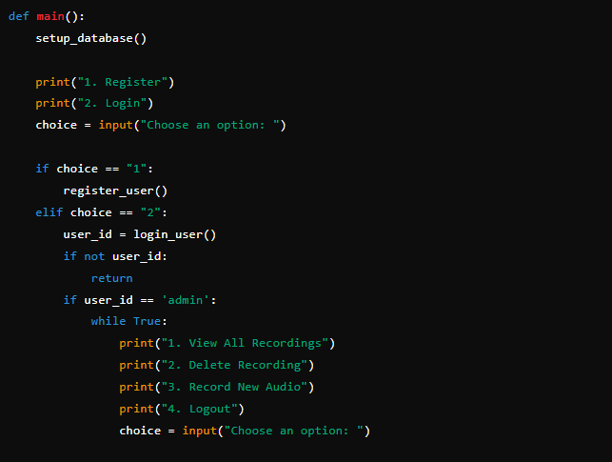

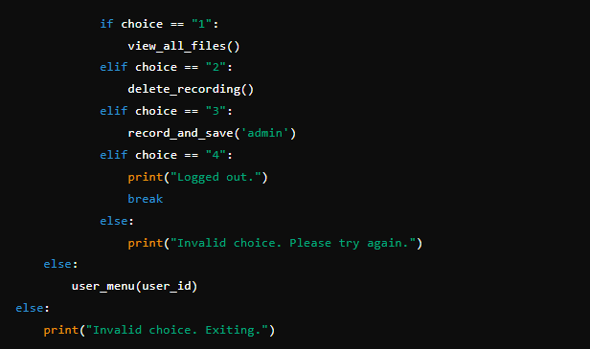

This is the main function that starts the application. It sets up the database and provides initial options to register or log in.

Run Main Function



This ensures that the main() function is called when the script is run directly.