MathBlocks: native Word equations vs. precision rendering
For each equation: first the native Word equation (Latin Modern Math, tuned spacing), then the same equation typeset by MathBlocks' precision engine (LaTeX-quality layout, New Computer Modern), inserted as a vector picture (SVG). Zoom in to 400% to compare. Pictures stay sharp at any zoom and in print.

Newton's second law
Native Word equation
$$\vec{F}=m\vec{a}$$
Precision rendering
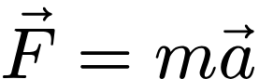

Quadratic formula
Native Word equation
$$x=\frac{−b±\sqrt{b^{2}−4ac}}{2a}$$
Precision rendering
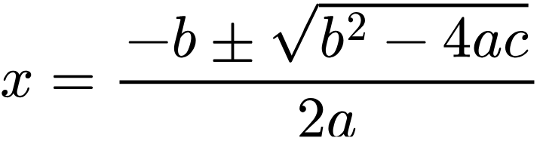

Gaussian integral
Native Word equation
$$\int_{−∞}^{∞}{e^{−x^{2}} dx}=\sqrt{π}$$
Precision rendering
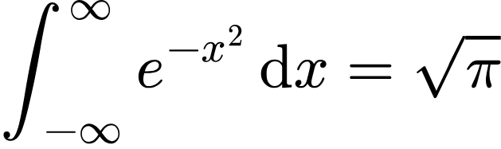

Taylor series
Native Word equation
$$f(x)=\sum_{n=0}^{∞}{\frac{f^{(n)}(a)}{n!}(x}−a)^{n}$$
Precision rendering
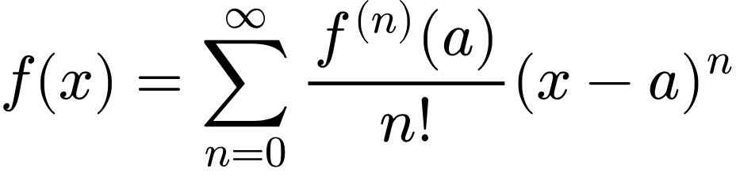

Fundamental limit
Native Word equation
$$\lim_{x→0}{\frac{\sin{x}}{x}}=1$$
Precision rendering
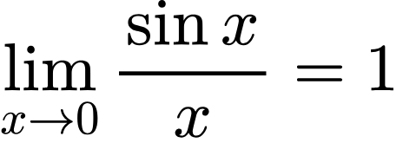

Double integral
Native Word equation
$$\iint_{D}{\left(\frac{∂Q}{∂x}−\frac{∂P}{∂y}\right)dA}=\oint_{∂D}{P dx}+Q dy$$
Precision rendering
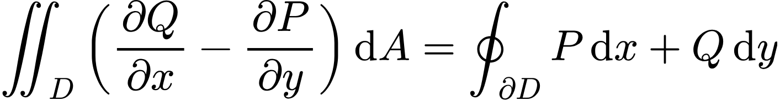

Heat equation
Native Word equation
$$\frac{∂u}{∂t}=α∇^{2}u$$
Precision rendering
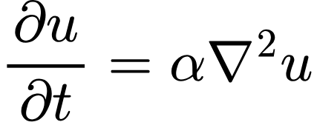

Damped oscillator
Native Word equation
$$m\ddot{x}+c\dot{x}+kx=F_{0}\cos{(ωt)}$$
Precision rendering

Rotation matrix
Native Word equation
Rz(θ)=cosθ−sinθ0sinθcosθ0001||cosθ−sinθ0sinθcosθ0001
Precision rendering
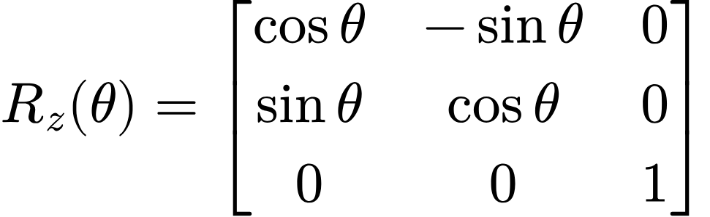

2×2 determinant
Native Word equation
detA=abcd||abcd=ad−bc
Precision rendering
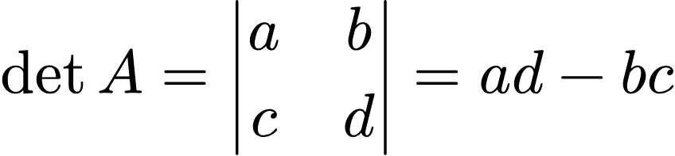

Eigenvalue problem
Native Word equation
$$Av=λv$$
Precision rendering


Cross product
Native Word equation
a×b=ijkaxayazbxbybz||ijkaxayazbxbybz
Precision rendering
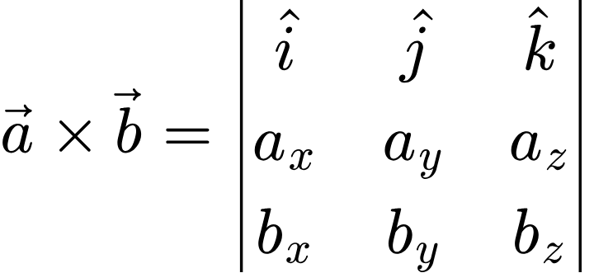

Divergence theorem
Native Word equation
$$\iiint_{V}{∇⋅\vec{F} dV}=∯_{S}{\vec{F}⋅\hat{n} dS}$$
Precision rendering
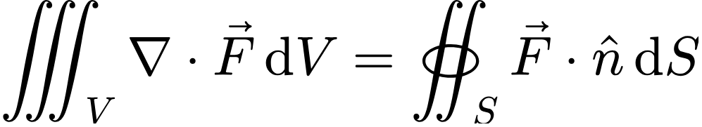

Absolute value (piecewise)
Native Word equation
$$|x|=\left\{\begin{aligned}x x≥0 \\ −x x<0\end{aligned}\right.$$
Precision rendering
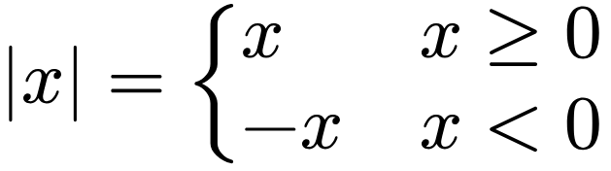

Linear system
Native Word equation
$$\left\{\begin{aligned}2x+y=5 \\ x−3y=−1\end{aligned}\right.$$
Precision rendering
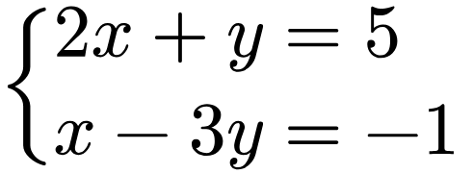

Aligned derivation
Native Word equation
$$\begin{aligned}(a+b)^{2}=(a+b)(a+b) \\ =a^{2}+ab+ba+b^{2} \\ =a^{2}+2ab+b^{2}\end{aligned}$$
Precision rendering
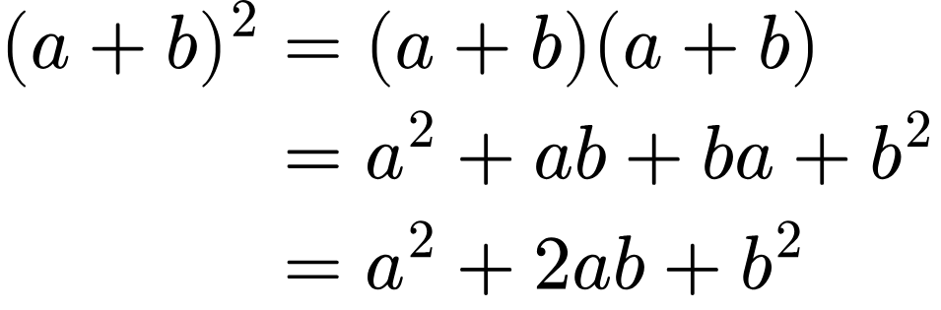

Euler–Lagrange equation
Native Word equation
$$\frac{d}{dt}\left(\frac{∂L}{∂{\dot{q}}_{i}}\right)−\frac{∂L}{∂q_{i}}=0$$
Precision rendering
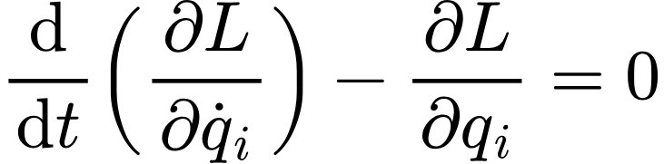

Euler's rigid-body equations
Native Word equation
$$I_{1}{\dot{ω}}_{1}+(I_{3}−I_{2}) ω_{2}ω_{3}=M_{1}$$
Precision rendering

Angular momentum
Native Word equation
$$\vec{L}=\vec{r}×m\vec{v}=I\vec{ω}$$
Precision rendering
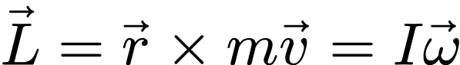

Vis-viva equation
Native Word equation
$$v^{2}=μ\left(\frac{2}{r}−\frac{1}{a}\right)$$
Precision rendering
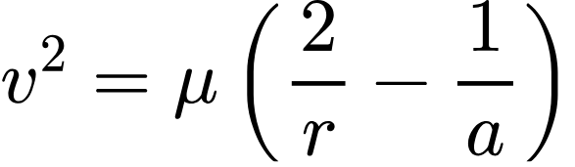

Kepler's equation
Native Word equation
$$M=E−e\sin{E}$$
Precision rendering


Two-body equation of motion
Native Word equation
$$\ddot{\vec{r}}=−\frac{μ}{r^{3}}\vec{r}$$
Precision rendering
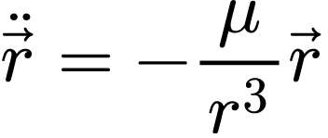

Orbital period
Native Word equation
$$T=2π\sqrt{\frac{a^{3}}{μ}}$$
Precision rendering
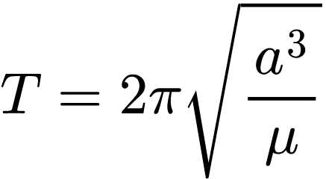

Transfer function
Native Word equation
$$G(s)=\frac{ω_{n}^{2}}{s^{2}+2ζω_{n}s+ω_{n}^{2}}$$
Precision rendering
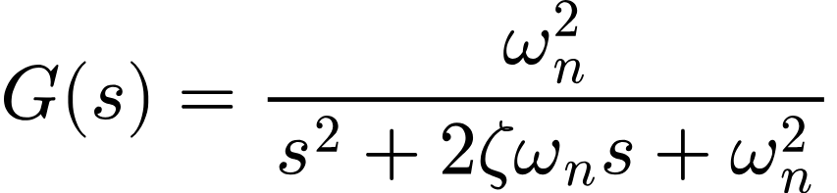

State-space model
Native Word equation
$$\begin{aligned}\dot{x}=Ax+Bu \\ y=Cx+Du\end{aligned}$$
Precision rendering
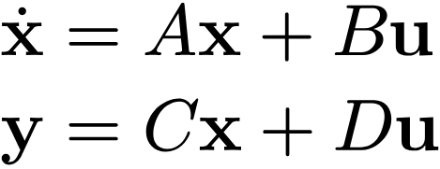

Faraday's law
Native Word equation
$$∇×\vec{E}=−\frac{∂\vec{B}}{∂t}$$
Precision rendering
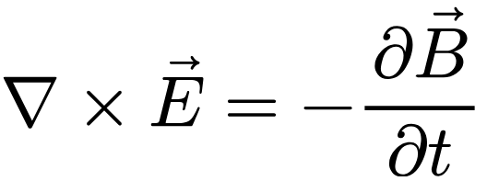

Tensor with prescripts
Native Word equation
$${}_{j}^{i}{T_{m}^{kl}}=g^{ka}R_{aj}$$
Precision rendering
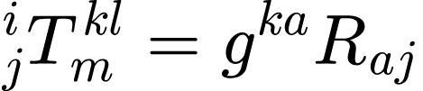

Nth root and product
Native Word equation
$$\sqrt[n]{\prod_{i=1}^{n}{x_{i}}}≤\frac{1}{n}\sum_{i=1}^{n}{x_{i}}$$
Precision rendering
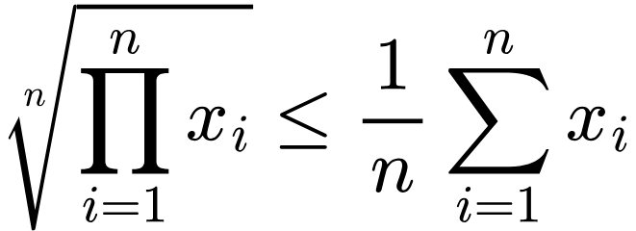

Binomial theorem
Native Word equation
$$(x+y)^{n}=\sum_{k=0}^{n}{\left({n \atop k}\right)x^{n−k}y^{k}}$$
Precision rendering
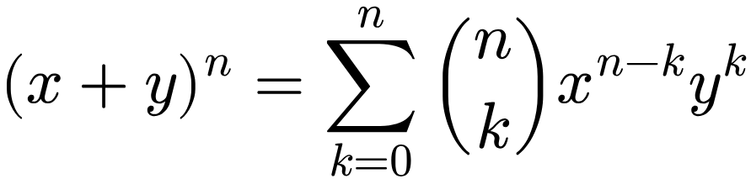

Underbrace annotation
Native Word equation
$$\underset{n\text{ times}}{\underbrace{1+1+⋯+1}}=n$$
Precision rendering
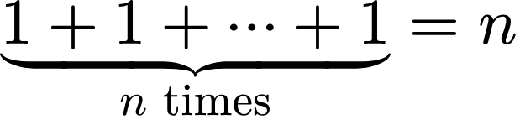

Norm and inner product
Native Word equation
$$\left\|x\right\|=\sqrt{\left\langle x,x\right\rangle }$$
Precision rendering
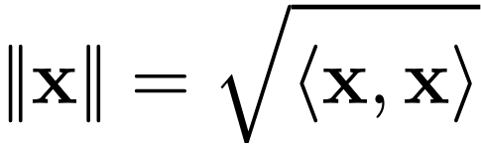

Centre of mass integral
Native Word equation
$${\vec{p}}_{k}=\int_{V_{k}}{\vec{x} dm}$$
Precision rendering
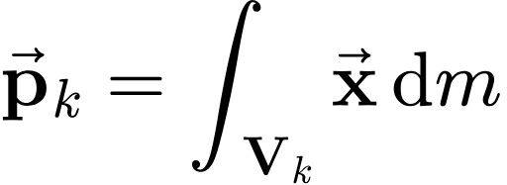

Vectrix form
Native Word equation
$${\vec{p}}_{2}={\vec{F}}^{T}p_{2}={\vec{F}}^{T}\int_{V_{2}}{x dm}$$
Precision rendering
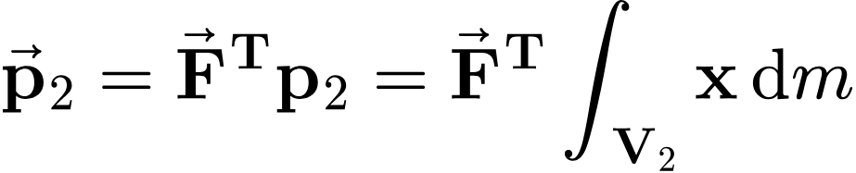

Area element and position
Native Word equation
dA=du dv, x=uv0||uv0T
Precision rendering

Split double integral
Native Word equation
$$q=\int_{−a}^{0}{\int_{−u−a}^{u+a}{μ x dv du}}+\int_{0}^{a}{\int_{u−a}^{a−u}{μ x dv du}}$$
Precision rendering
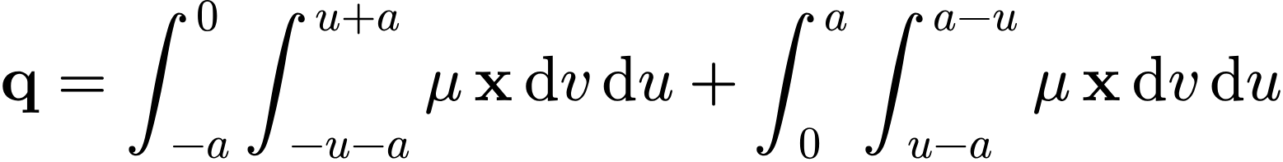

Aligned definitions
Native Word equation
$$\begin{aligned}dm=μ dA, \\ dA=R dθ du \text{(cylinder surface)}\end{aligned}$$
Precision rendering
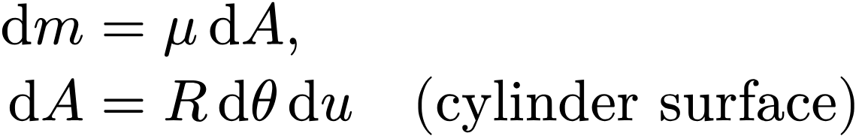

Column with fraction
Native Word equation
qr=ML200||ML200T
Precision rendering
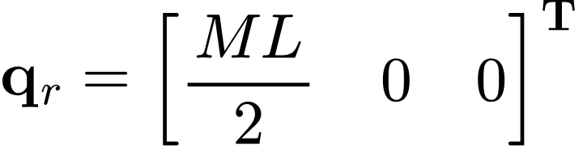

Ranges
Native Word equation
$$a≤u≤a+b, −\frac{c}{2}≤v≤\frac{c}{2}$$
Precision rendering
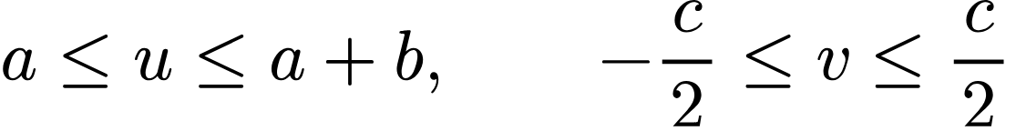

Triple integral, cylindrical
Native Word equation
$$q=\int_{−H/2}^{H/2}{\int_{0}^{2π}{\int_{0}^{R}{ρ r x dr dθ du}}}$$
Precision rendering
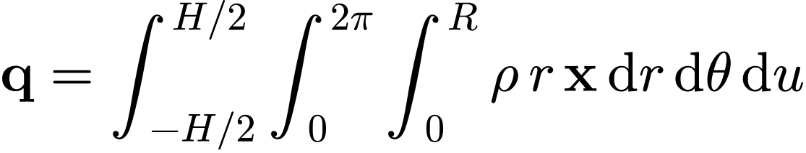

Sum of moments
Native Word equation
$$\vec{p}={\vec{p}}_{1}+{\vec{p}}_{2}={\vec{F}}^{T}\left(p_{1}+p_{2}\right)$$
Precision rendering
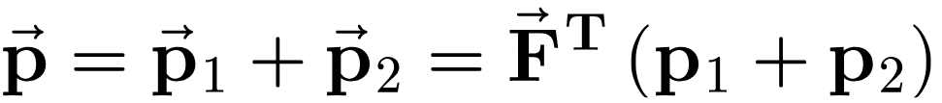

Inline equations
Native: the kinetic energy $E_{k}=\frac{1}{2}mv^{2}$ of a body moving at speed $v$ on an orbit with $v^{2}=μ\left(\frac{2}{r}−\frac{1}{a}\right)$.
Precision: the kinetic energy 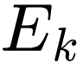 of a body moving at speed 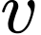 on an orbit with 

