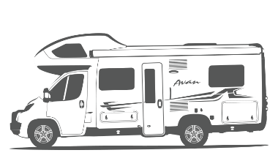

LILLEN CHECKLISTS

# Pre-Departure

Ensure that the rooftop tv antenna is retracted and secured

Ensure awning is retracted and secured properly

Ensure sunroof hatch is closed. Including in the bathroom

Ensure bike rack is secure

Ensure that Button 1-4 on the ***Error! Reference source not found.*** are off

Ensure that the hot water heater is off

*Buttons are located on the left-hand side back lounge area*

Ensure that the diesel heater is off *if applicable*

*Dial is located on the left-hand side back lounge area*

Disconnect 240V electricity *if applicable*

Disconnect city water *if applicable*

Disconnect greywater *if applicable*

Ensure LPG gas bottles are turned off

Ensure that the windows are securely closed and locked

Ensure that the TV is locked away and secured

Ensure that the bunk bed safety net is connected

Ensure everything in the kitchen has been put away and is rattle-proof

Secure all drawers and doors

Secure all loose objects for travel

Ensure the table is in travel position

Start the engine for warm up

Ensure that the refrigerator (in auto mode) has shifted back 12V

# On Arrival

Select as flat and level a parking site as possible. Use leveling blocks if required.

Ensure the solar panels are not covered by shade as then they

will not charge the 12V battery properly.

Connect 240V electricity *if applicable*

*Check if* *15A to 10A Power Adaptor* *is required.*

Connect city water *if applicable*

Connect greywater *if applicable*

Ensure LPG gas bottle is open

Turn on button 1-3 on the ***Error! Reference source not found.***

Turn the water pump on, if not connected to city water  
*Button 4 on the* ***Error! Reference source not found.***

Turn the hot water heater on using either 240V or LPG gas.

Ensure the refrigerator (in auto mode) switch to either 240V or LPG gas.

If using LPG gas, turn the refrigerator fan on.

Ensure that the rooftop solar panels are not covered by shade.

**Please note!** If using LPG gas, it can take up **20 minutes** before the fridge turns on.

The refrigerator must be level and will not operate if not parked on a flat surface.

# Bad Weather

Before bad weather arises, please ensure the following:

Ensure awning is packed away

Ensure sunroof hatch is closed. Including in the bathroom

Ensure external storage hatches are closed

**Important!** Do not leave awning out overnight or unattended.

# Pre-Return

Full Tank of Diesel

Empty Toilet Cassette

Empty Greywater Tank

Interior Neat and Tidy