**ECE3300L Lab10 Group H Report (Sherwin Sathish & Mohamed Hamida)**

**SCHEMATIC:**

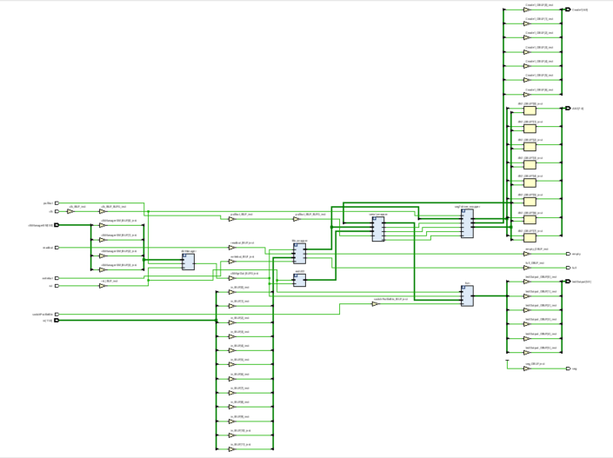

***Xdc for top.v:***

## This file is a general .xdc for the Nexys A7-100T

## To use it in a project:

## - uncomment the lines corresponding to used pins

## - rename the used ports (in each line, after get_ports) according to the top level signal names in the project

## Clock signal

set_property -dict { PACKAGE_PIN E3 IOSTANDARD LVCMOS33 } [get_ports { clk }]; #IO_L12P_T1_MRCC_35 Sch=clk100mhz

create_clock -add -name sys_clk_pin -period 10.00 -waveform {0 5} [get_ports {clk}];

##Switches

set_property -dict { PACKAGE_PIN J15 IOSTANDARD LVCMOS33 } [get_ports { redSW[0] }]; #IO_L24N_T3_RS0_15 Sch=sw[0]

set_property -dict { PACKAGE_PIN L16 IOSTANDARD LVCMOS33 } [get_ports { redSW[1] }]; #IO_L3N_T0_DQS_EMCCLK_14 Sch=sw[1]

set_property -dict { PACKAGE_PIN M13 IOSTANDARD LVCMOS33 } [get_ports { redSW[2] }]; #IO_L6N_T0_D08_VREF_14 Sch=sw[2]

set_property -dict { PACKAGE_PIN R15 IOSTANDARD LVCMOS33 } [get_ports { redSW[3] }]; #IO_L13N_T2_MRCC_14 Sch=sw[3]

set_property -dict { PACKAGE_PIN R17 IOSTANDARD LVCMOS33 } [get_ports { greenSW[0] }]; #IO_L12N_T1_MRCC_14 Sch=sw[4]

set_property -dict { PACKAGE_PIN T18 IOSTANDARD LVCMOS33 } [get_ports { greenSW[1] }]; #IO_L7N_T1_D10_14 Sch=sw[5]

set_property -dict { PACKAGE_PIN U18 IOSTANDARD LVCMOS33 } [get_ports { greenSW[2] }]; #IO_L17N_T2_A13_D29_14 Sch=sw[6]

set_property -dict { PACKAGE_PIN R13 IOSTANDARD LVCMOS33 } [get_ports { greenSW[3] }]; #IO_L5N_T0_D07_14 Sch=sw[7]

set_property -dict { PACKAGE_PIN T8 IOSTANDARD LVCMOS18 } [get_ports { blueSW[0]}]; #IO_L24N_T3_34 Sch=sw[8]

set_property -dict { PACKAGE_PIN U8 IOSTANDARD LVCMOS18 } [get_ports { blueSW[1]}]; #IO_25_34 Sch=sw[9]

set_property -dict { PACKAGE_PIN R16 IOSTANDARD LVCMOS33 } [get_ports { blueSW[2] }]; #IO_L15P_T2_DQS_RDWR_B_14 Sch=sw[10]

set_property -dict { PACKAGE_PIN T13 IOSTANDARD LVCMOS33 } [get_ports { blueSW[3] }]; #IO_L23P_T3_A03_D19_14 Sch=sw[11]

set_property -dict { PACKAGE_PIN H6 IOSTANDARD LVCMOS33 } [get_ports { clkManagerSW[0] }]; #IO_L24P_T3_35 Sch=sw[12]

set_property -dict { PACKAGE_PIN U12 IOSTANDARD LVCMOS33 } [get_ports { clkManagerSW[1] }]; #IO_L20P_T3_A08_D24_14 Sch=sw[13]

set_property -dict { PACKAGE_PIN U11 IOSTANDARD LVCMOS33 } [get_ports { clkManagerSW[2] }]; #IO_L19N_T3_A09_D25_VREF_14 Sch=sw[14]

set_property -dict { PACKAGE_PIN V10 IOSTANDARD LVCMOS33 } [get_ports { clkManagerSW[3] }]; #IO_L21P_T3_DQS_14 Sch=sw[15]

## RGB LEDs

set_property -dict { PACKAGE_PIN R12 IOSTANDARD LVCMOS33 } [get_ports { ledOutput[2] }]; #IO_L5P_T0_D06_14 Sch=led16_b

set_property -dict { PACKAGE_PIN M16 IOSTANDARD LVCMOS33 } [get_ports { ledOutput[1] }]; #IO_L10P_T1_D14_14 Sch=led16_g

set_property -dict { PACKAGE_PIN N15 IOSTANDARD LVCMOS33 } [get_ports { ledOutput[0] }]; #IO_L11P_T1_SRCC_14 Sch=led16_r

set_property -dict { PACKAGE_PIN G14 IOSTANDARD LVCMOS33 } [get_ports { ledOutput[5]}]; #IO_L15N_T2_DQS_ADV_B_15 Sch=led17_b

set_property -dict { PACKAGE_PIN R11 IOSTANDARD LVCMOS33 } [get_ports { ledOutput[4]}]; #IO_0_14 Sch=led17_g

set_property -dict { PACKAGE_PIN N16 IOSTANDARD LVCMOS33 } [get_ports { ledOutput[3]}]; #IO_L11N_T1_SRCC_14 Sch=led17_r

##Buttons

#set_property -dict { PACKAGE_PIN C12 IOSTANDARD LVCMOS33 } [get_ports { CPU_RESETN }]; #IO_L3P_T0_DQS_AD1P_15 Sch=cpu_resetn

set_property -dict { PACKAGE_PIN N17 IOSTANDARD LVCMOS33 } [get_ports { rst }]; #IO_L9P_T1_DQS_14 Sch=btnc

set_property -dict { PACKAGE_PIN M18 IOSTANDARD LVCMOS33 } [get_ports { switchProfileBtn }]; #IO_L4N_T0_D05_14 Sch=btnu

#set_property -dict { PACKAGE_PIN P17 IOSTANDARD LVCMOS33 } [get_ports { rstTop }]; #IO_L12P_T1_MRCC_14 Sch=btnl

#set_property -dict { PACKAGE_PIN M17 IOSTANDARD LVCMOS33 } [get_ports { ld }]; #IO_L10N_T1_D15_14 Sch=btnr

#set_property -dict { PACKAGE_PIN P18 IOSTANDARD LVCMOS33 } [get_ports { btn }]; #IO_L9N_T1_DQS_D13_14 Sch=btnd

**Fifo.v**

`timescale 1ns / 1ps

//`default_nettype none

module fifo #(

parameter WIDTH = 12,

parameter DEPTH = 16

)(

input [WIDTH-1:0] data_in,

input wire clk,

input wire write,

input wire read,

output reg [WIDTH-1:0] data_out,

output wire fifo_full,

output wire fifo_empty,

output wire fifo_not_empty,

output wire fifo_not_full

);

integer count;

// memory will contain the FIFO data.

reg [WIDTH-1:0] memory [0:DEPTH-1];

// $clog2(DEPTH+1)-2 to count from 0 to DEPTH

reg [$clog2(DEPTH)-1:0] write_ptr;

reg [$clog2(DEPTH)-1:0] read_ptr;

assign fifo_empty = ( write_ptr == read_ptr ) ? 1'b1 : 1'b0;

assign fifo_full = ( write_ptr == (DEPTH-1) ) ? 1'b1 : 1'b0;

assign fifo_not_empty = ~fifo_empty;

assign fifo_not_full = ~fifo_full;

always @ (posedge clk) begin

if ( write ) begin

memory[write_ptr] <= data_in;

end

if ( read ) begin

data_out <= memory[read_ptr];

end

end

always @ ( posedge clk ) begin

if ( write ) begin

write_ptr <= write_ptr + 1;

end

if ( read && fifo_not_empty ) begin

read_ptr <= read_ptr + 1;

end

end

endmodule

The fifo basically stores memory across a particular width at a certain depth. Write and read pointers are used to save the data into the memory array, and there is a counter for these pointers to store memory at different indexes. Flags of full and empty are used to prevent pushing data that doesn’t exist and prevent loading in too much data.

**SERIALIZER.v**

`timescale 1ns / 1ps

module SERIALIZER(

input [11:0] pull_in,

input pull_but,

output reg [3:0] out_red,

output reg [3:0] out_green,

output reg [3:0] out_blue

);

reg state=0;

always@(pull_but or pull_in)

begin

if (pull_but)

state = ~state;

else

state = state;

end

always@(pull_but or state)

begin

case(state)

1'b0:

begin end

1'b1:

begin

out_red <= pull_in[3:0];

out_green <= pull_in[7:4];

out_blue <= pull_in[11:8];

end

endcase

end

endmodule

`timescale 1ns / 1ps

module SERIALIZER_TB(

);

reg [11:0] pull_in_tb;

reg pull_but_tb;

wire [3:0] out_red_tb;

wire [3:0] out_green_tb;

wire [3:0] out_blue_tb;

SERIALIZER COMP(

.pull_in(pull_in_tb),

.pull_but(pull_but_tb),

.out_red(out_red_tb),

.out_green(out_green_tb),

.out_blue(out_blue_tb)

);

initial

begin

pull_in_tb = 56;

pull_but_tb = 1;

#10

pull_in_tb = 56;

pull_but_tb = 0;

#100

$finish;

end

endmodule

The serializer pulls an 12-bit number from the fifo using a pull button, and splits it into 3 4-bit numbers that go into the red, green, and blue PWM respectively.

**Top.v**

`timescale 1ns / 1ps

module top

(

input[3:0] clkManagerSW,

input[11:0] in,

input clk,

input rst,

input writebut,

input readbut,

input pullbut,

input switchProfileBtn,

output full,

output empty,

output [6:0] Cnode1,

output [7:0] AN1,

output seg,

output[5:0] ledOutput

);

wire clkMgrOut;

CLKMANAGER clkManager(

.clk(clk),

.rst(rst),

.SW(clkManagerSW),

.clkout(clkMgrOut)

);

fifo fifo_wrapper(

.data_in(in),

.clk(clkMgrOut),

.write(writebut),

.read(readbut),

.data_out(seg7Digit[23:12]),

.fifo_full(full),

.fifo_empty(empty)

);

wire [31:0] seg7Digit;

SERIALIZER serial_wrapper (

.pull_in(seg7Digit[23:12]),

.pull_but(pullbut),

.out_red(seg7Digit[3:0]),

.out_green(seg7Digit[7:4]),

.out_blue(seg7Digit[11:8])

);

wire tmpEn = 1'b1;

wire [2:0] tmpLEDOUT;

PWM redLED(

.inputSW(seg7Digit[3:0]),

.clk(clkMgrOut),

.rst(rst),

.en(tmpEn),

.result(tmpLEDOUT[0])

);

PWM greenLED(

.inputSW(seg7Digit[7:4]),

.clk(clkMgrOut),

.rst(rst),

.en(tmpEn),

.result(tmpLEDOUT[1])

);

PWM blueLED(

.inputSW(seg7Digit[11:8]),

.clk(clkMgrOut),

.rst(rst),

.en(tmpEn),

.result(tmpLEDOUT[2])

);

FSM fsm(

.sel(tmpLEDOUT),

.fsmBTN(switchProfileBtn),

.rst(rst),

.clk(clkMgrOut),

.led1(ledOutput[2:0]),

.led2(ledOutput[5:3])

);

SEGDRIVE seg7driver_wrapper(

.nexysCLK(clk),

.inDigit(seg7Digit),

.Cnode(Cnode1),

.dp(seg),

.AN(AN1)

);

endmodule

Our top file instantiated the PWM redLed, PWM blueLed, and PWM greenLed, the fifo, serializer, and the segdriver. These three PWM modules output to the FSM module which then outputs to our XDC output. We also have a clock manager which is creating an artificial clock to input into each module. The fifo stores user input into a 2-D array then sends it off to a serializer which splits the data into 3 parts that each go into the input of a PWM.

**CLKMANAGER.v**

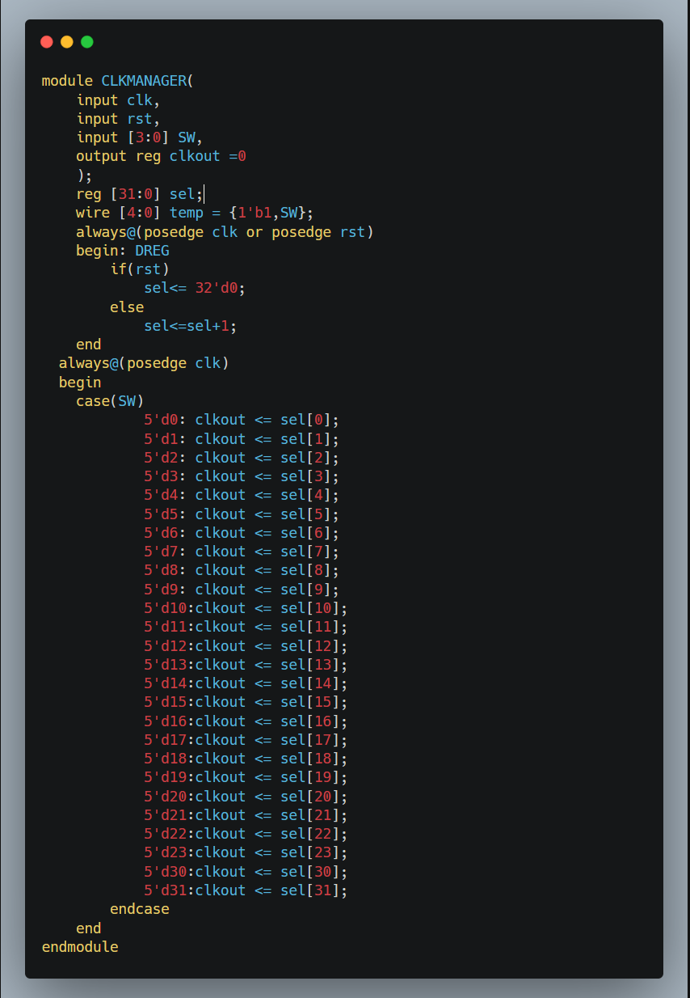

We used a 32 bit clock manager to feed variable frequencies into our PWM LED modules, and our FSM module.

**PWM.v**

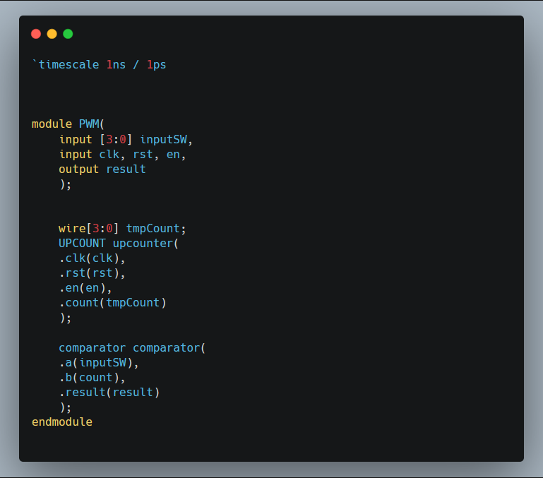

This is the generic PWM file which instantiates into the redLed, blueLed, and greenLed to send off those values to the FSM and eventually to the dedicated output led on our Nexys A7 board. It uses the UPCOUNT and comparator modules to compare the values from the switches to the counter and based off those values it will send the appropriate signals to the FSM for outputting.

**FSM.v**

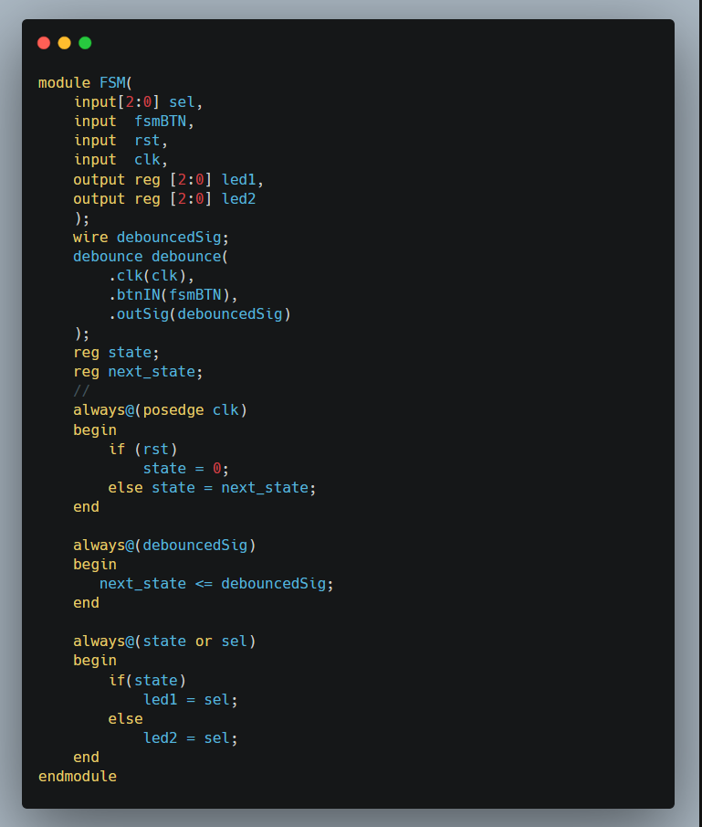

This simple FSM (finite state machine) module will iterate between two states depending on the input button. Depending on the button output (which is debounced using the button debouncer) it will either fill the led1 values or led2 values.

**IMPLEMENTED DESIGN/ TIMING SUMMARY:**

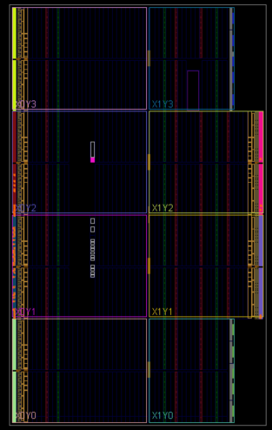

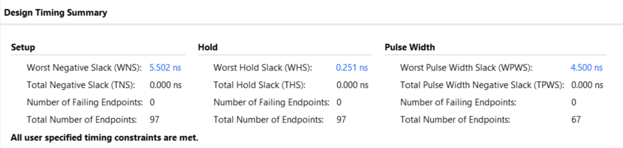

**POWER SUMMARY:**

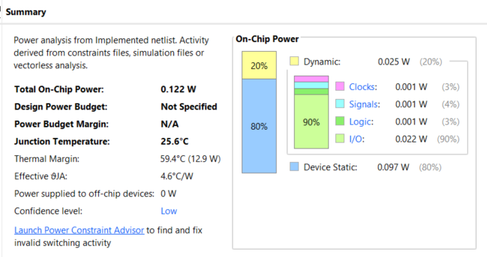

**UTILIZATION:**

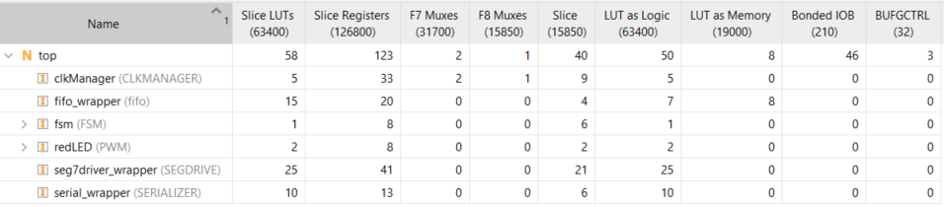

**RESOURCE USAGE:**

