**ECE3300L Lab5 Group H Report (Sherwin Sathish & Mohamed Hamida)**

**SCHEMATIC():**

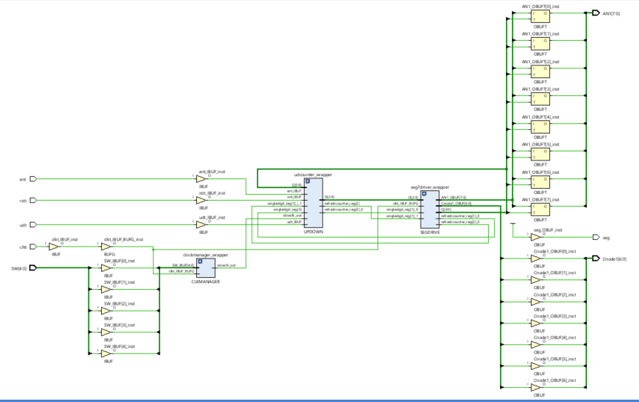

***Xdc for top.v:***

## This file is a general .xdc for the Nexys A7-100T

## To use it in a project:

## - uncomment the lines corresponding to used pins

## - rename the used ports (in each line, after get_ports) according to the top level signal names in the project

## Clock signal

set_property -dict { PACKAGE_PIN E3 IOSTANDARD LVCMOS33 } [get_ports { clkt}];# IO_L12P_T1_MRCC_35 Sch=clk100mhz

create_clock -add -name sys_clk_pin -period 10.00 -waveform {0 5} [get_ports {clkt}];

##Switches

set_property -dict { PACKAGE_PIN J15 IOSTANDARD LVCMOS33 } [get_ports { SW[0] }]; #IO_L24N_T3_RS0_15 Sch=sw[0]

set_property -dict { PACKAGE_PIN L16 IOSTANDARD LVCMOS33 } [get_ports { SW[1] }]; #IO_L3N_T0_DQS_EMCCLK_14 Sch=sw[1]

set_property -dict { PACKAGE_PIN M13 IOSTANDARD LVCMOS33 } [get_ports { SW[2] }]; #IO_L6N_T0_D08_VREF_14 Sch=sw[2]

set_property -dict { PACKAGE_PIN R15 IOSTANDARD LVCMOS33 } [get_ports { SW[3] }]; #IO_L13N_T2_MRCC_14 Sch=sw[3]

set_property -dict { PACKAGE_PIN R17 IOSTANDARD LVCMOS33 } [get_ports { SW[4] }]; #IO_L12N_T1_MRCC_14 Sch=sw[4]

set_property -dict { PACKAGE_PIN T18 IOSTANDARD LVCMOS33 } [get_ports { udt }]; #IO_L7N_T1_D10_14 Sch=sw[5]

set_property -dict { PACKAGE_PIN U18 IOSTANDARD LVCMOS33 } [get_ports { rstt }]; #IO_L17N_T2_A13_D29_14 Sch=sw[6]

set_property -dict { PACKAGE_PIN R13 IOSTANDARD LVCMOS33 } [get_ports { ent}]; #IO_L5N_T0_D07_14 Sch=sw[7]

#set_property -dict { PACKAGE_PIN T8 IOSTANDARD LVCMOS18 } [get_ports { cinbit }]; #IO_L24N_T3_34 Sch=sw[8]

#set_property -dict { PACKAGE_PIN U8 IOSTANDARD LVCMOS18 } [get_ports { SW[9] }]; #IO_25_34 Sch=sw[9]

#set_property -dict { PACKAGE_PIN R16 IOSTANDARD LVCMOS33 } [get_ports { SW[10] }]; #IO_L15P_T2_DQS_RDWR_B_14 Sch=sw[10]

#set_property -dict { PACKAGE_PIN T13 IOSTANDARD LVCMOS33 } [get_ports { SW[11] }]; #IO_L23P_T3_A03_D19_14 Sch=sw[11]

#set_property -dict { PACKAGE_PIN H6 IOSTANDARD LVCMOS33 } [get_ports { SW[12] }]; #IO_L24P_T3_35 Sch=sw[12]

#set_property -dict { PACKAGE_PIN U12 IOSTANDARD LVCMOS33 } [get_ports { SW[13] }]; #IO_L20P_T3_A08_D24_14 Sch=sw[13]

#set_property -dict { PACKAGE_PIN U11 IOSTANDARD LVCMOS33 } [get_ports { SW[14] }]; #IO_L19N_T3_A09_D25_VREF_14 Sch=sw[14]

#set_property -dict { PACKAGE_PIN V10 IOSTANDARD LVCMOS33 } [get_ports { SW[15] }]; #IO_L21P_T3_DQS_14 Sch=sw[15]

## LEDs

#set_property -dict { PACKAGE_PIN H17 IOSTANDARD LVCMOS33 } [get_ports { sumbit[0] }]; #IO_L18P_T2_A24_15 Sch=led[0]

#set_property -dict { PACKAGE_PIN K15 IOSTANDARD LVCMOS33 } [get_ports { sumbit[1] }]; #IO_L24P_T3_RS1_15 Sch=led[1]

#set_property -dict { PACKAGE_PIN J13 IOSTANDARD LVCMOS33 } [get_ports { sumbit[2] }]; #IO_L17N_T2_A25_15 Sch=led[2]

#set_property -dict { PACKAGE_PIN N14 IOSTANDARD LVCMOS33 } [get_ports { sumbit[3] }]; #IO_L8P_T1_D11_14 Sch=led[3]

#set_property -dict { PACKAGE_PIN R18 IOSTANDARD LVCMOS33 } [get_ports { coutbit }]; #IO_L7P_T1_D09_14 Sch=led[4]

#set_property -dict { PACKAGE_PIN V17 IOSTANDARD LVCMOS33 } [get_ports { LED[5] }]; #IO_L18N_T2_A11_D27_14 Sch=led[5]

#set_property -dict { PACKAGE_PIN U17 IOSTANDARD LVCMOS33 } [get_ports { LED[6] }]; #IO_L17P_T2_A14_D30_14 Sch=led[6]

#set_property -dict { PACKAGE_PIN U16 IOSTANDARD LVCMOS33 } [get_ports { LED[7] }]; #IO_L18P_T2_A12_D28_14 Sch=led[7]

#set_property -dict { PACKAGE_PIN V16 IOSTANDARD LVCMOS33 } [get_ports { LED[8] }]; #IO_L16N_T2_A15_D31_14 Sch=led[8]

#set_property -dict { PACKAGE_PIN T15 IOSTANDARD LVCMOS33 } [get_ports { LED[9] }]; #IO_L14N_T2_SRCC_14 Sch=led[9]

#set_property -dict { PACKAGE_PIN U14 IOSTANDARD LVCMOS33 } [get_ports { LED[10] }]; #IO_L22P_T3_A05_D21_14 Sch=led[10]

#set_property -dict { PACKAGE_PIN T16 IOSTANDARD LVCMOS33 } [get_ports { LED[11] }]; #IO_L15N_T2_DQS_DOUT_CSO_B_14 Sch=led[11]

#set_property -dict { PACKAGE_PIN V15 IOSTANDARD LVCMOS33 } [get_ports { LED[12] }]; #IO_L16P_T2_CSI_B_14 Sch=led[12]

#set_property -dict { PACKAGE_PIN V14 IOSTANDARD LVCMOS33 } [get_ports { LED[13] }]; #IO_L22N_T3_A04_D20_14 Sch=led[13]

#set_property -dict { PACKAGE_PIN V12 IOSTANDARD LVCMOS33 } [get_ports { LED[14] }]; #IO_L20N_T3_A07_D23_14 Sch=led[14]

#set_property -dict { PACKAGE_PIN V11 IOSTANDARD LVCMOS33 } [get_ports { LED[15] }]; #IO_L21N_T3_DQS_A06_D22_14 Sch=led[15]

## RGB LEDs

#set_property -dict { PACKAGE_PIN R12 IOSTANDARD LVCMOS33 } [get_ports { LED16_B }]; #IO_L5P_T0_D06_14 Sch=led16_b

#set_property -dict { PACKAGE_PIN M16 IOSTANDARD LVCMOS33 } [get_ports { LED16_G }]; #IO_L10P_T1_D14_14 Sch=led16_g

#set_property -dict { PACKAGE_PIN N15 IOSTANDARD LVCMOS33 } [get_ports { LED16_R }]; #IO_L11P_T1_SRCC_14 Sch=led16_r

#set_property -dict { PACKAGE_PIN G14 IOSTANDARD LVCMOS33 } [get_ports { LED17_B }]; #IO_L15N_T2_DQS_ADV_B_15 Sch=led17_b

#set_property -dict { PACKAGE_PIN R11 IOSTANDARD LVCMOS33 } [get_ports { LED17_G }]; #IO_0_14 Sch=led17_g

#set_property -dict { PACKAGE_PIN N16 IOSTANDARD LVCMOS33 } [get_ports { LED17_R }]; #IO_L11N_T1_SRCC_14 Sch=led17_r

##7 segment display

set_property -dict { PACKAGE_PIN T10 IOSTANDARD LVCMOS33 } [get_ports { Cnode1[6] }]; #IO_L24N_T3_A00_D16_14 Sch=ca

set_property -dict { PACKAGE_PIN R10 IOSTANDARD LVCMOS33 } [get_ports { Cnode1[5] }]; #IO_25_14 Sch=cb

set_property -dict { PACKAGE_PIN K16 IOSTANDARD LVCMOS33 } [get_ports { Cnode1[4] }]; #IO_25_15 Sch=cc

set_property -dict { PACKAGE_PIN K13 IOSTANDARD LVCMOS33 } [get_ports { Cnode1[3] }]; #IO_L17P_T2_A26_15 Sch=cd

set_property -dict { PACKAGE_PIN P15 IOSTANDARD LVCMOS33 } [get_ports { Cnode1[2] }]; #IO_L13P_T2_MRCC_14 Sch=ce

set_property -dict { PACKAGE_PIN T11 IOSTANDARD LVCMOS33 } [get_ports { Cnode1[1] }]; #IO_L19P_T3_A10_D26_14 Sch=cf

set_property -dict { PACKAGE_PIN L18 IOSTANDARD LVCMOS33 } [get_ports { Cnode1[0] }]; #IO_L4P_T0_D04_14 Sch=cg

set_property -dict { PACKAGE_PIN H15 IOSTANDARD LVCMOS33 } [get_ports { seg }]; #IO_L19N_T3_A21_VREF_15 Sch=dp

set_property -dict { PACKAGE_PIN J17 IOSTANDARD LVCMOS33 } [get_ports { AN1[0] }]; #IO_L23P_T3_FOE_B_15 Sch=an[0]

set_property -dict { PACKAGE_PIN J18 IOSTANDARD LVCMOS33 } [get_ports { AN1[1] }]; #IO_L23N_T3_FWE_B_15 Sch=an[1]

set_property -dict { PACKAGE_PIN T9 IOSTANDARD LVCMOS33 } [get_ports { AN1[2] }]; #IO_L24P_T3_A01_D17_14 Sch=an[2]

set_property -dict { PACKAGE_PIN J14 IOSTANDARD LVCMOS33 } [get_ports { AN1[3] }]; #IO_L19P_T3_A22_15 Sch=an[3]

set_property -dict { PACKAGE_PIN P14 IOSTANDARD LVCMOS33 } [get_ports { AN1[4] }]; #IO_L8N_T1_D12_14 Sch=an[4]

set_property -dict { PACKAGE_PIN T14 IOSTANDARD LVCMOS33 } [get_ports { AN1[5] }]; #IO_L14P_T2_SRCC_14 Sch=an[5]

set_property -dict { PACKAGE_PIN K2 IOSTANDARD LVCMOS33 } [get_ports { AN1[6] }]; #IO_L23P_T3_35 Sch=an[6]

set_property -dict { PACKAGE_PIN U13 IOSTANDARD LVCMOS33 } [get_ports { AN1[7] }]; #IO_L23N_T3_A02_D18_14 Sch=an[7]

##Buttons

#set_property -dict { PACKAGE_PIN C12 IOSTANDARD LVCMOS33 } [get_ports { rst }]; #IO_L3P_T0_DQS_AD1P_15 Sch=cpu_resetn

#set_property -dict { PACKAGE_PIN N17 IOSTANDARD LVCMOS33 } [get_ports { rstt }]; #IO_L9P_T1_DQS_14 Sch=btnc

#set_property -dict { PACKAGE_PIN M18 IOSTANDARD LVCMOS33 } [get_ports { dir }]; #IO_L4N_T0_D05_14 Sch=btnu

#set_property -dict { PACKAGE_PIN P17 IOSTANDARD LVCMOS33 } [get_ports { BTNL }]; #IO_L12P_T1_MRCC_14 Sch=btnl

#set_property -dict { PACKAGE_PIN M17 IOSTANDARD LVCMOS33 } [get_ports { BTNR }]; #IO_L10N_T1_D15_14 Sch=btnr

#set_property -dict { PACKAGE_PIN P18 IOSTANDARD LVCMOS33 } [get_ports { BTND }]; #IO_L9N_T1_DQS_D13_14 Sch=btnd

**Code Detail:**

`timescale 1ns / 1ps

`timescale 1ns / 1ps

module CLKMANAGER

(

input clk,

input rst,

input [4:0] SW,

output reg clkout =0

);

reg [31:0] sel;

always@(posedge clk or posedge rst)

begin: DREG

if(rst)

sel<= 32'd0;

else

sel<=sel+1;

end

always@(SW)

begin

case(SW)

5'd0: clkout <= sel[0];

5'd1: clkout <= sel[1];

5'd2: clkout <= sel[2];

5'd3: clkout <= sel[3];

5'd4: clkout <= sel[4];

5'd5: clkout <= sel[5];

5'd6: clkout <= sel[6];

5'd7: clkout <= sel[7];

5'd8: clkout <= sel[8];

5'd9: clkout <= sel[9];

5'd10:clkout <= sel[10];

5'd11:clkout <= sel[11];

5'd12:clkout <= sel[12];

5'd13:clkout <= sel[13];

5'd14:clkout <= sel[14];

5'd15:clkout <= sel[15];

5'd16:clkout <= sel[16];

5'd17:clkout <= sel[17];

5'd18:clkout <= sel[18];

5'd19:clkout <= sel[19];

5'd20:clkout <= sel[20];

5'd21:clkout <= sel[21];

5'd22:clkout <= sel[22];

5'd23:clkout <= sel[23];

5'd24:clkout <= sel[24];

5'd25:clkout <= sel[25];

5'd26:clkout <= sel[26];

5'd27:clkout <= sel[27];

5'd28:clkout <= sel[28];

5'd29:clkout <= sel[29];

5'd30:clkout <= sel[30];

5'd31:clkout <= sel[31];

endcase

end

endmodule

The purpose of the clock manager is to have a counter and a 5-bit mux to output a clk with various levels of frequency depending on the integer div in this case. First we set up the counter by using an always loop that accounts for the reset, and sets up the different frequencies for all 32 values. Then we created an always loop that takes effect when the switches are changed, and we used a case statement for all 32 values of the 5-bit switches. Depending on the clkout that is selected by the switches, the frequency could vary for each clkout. We used the non-blocking assignment <= so that the code doesn’t have to be done in order from top to bottom.

`timescale 1ns / 1ps

module CLKMANAGER_TB (

);

reg clk_tb,rst_tb;

reg [4:0] SW_tb;

wire clkout_tb;

CLKMANAGER COMP(

.clk(clk_tb),

.rst(rst_tb),

.SW(SW_tb),

.clkout(clkout_tb)

);

initial

begin

clk_tb = 1;

end

always

begin

#5 clk_tb = ~clk_tb;

//#20 SW_tb = SW_tb+1;

end

initial

begin

rst_tb = 1;

SW_tb <= 0;

#10

rst_tb = 0;

#100

SW_tb = 4;

#100

$finish;

end

endmodule

The purpose of this testbench is to test the code in the design source. We instantiate the variables of the design source code by calling that class,so that we can test them in this simulation source. We set the initial values for the inputs, and we use an always loop to make sure that the clock is toggling. We set a value for the switch to analyze the change in frequency.

EXAMPLE FOR CLKMANAGER:

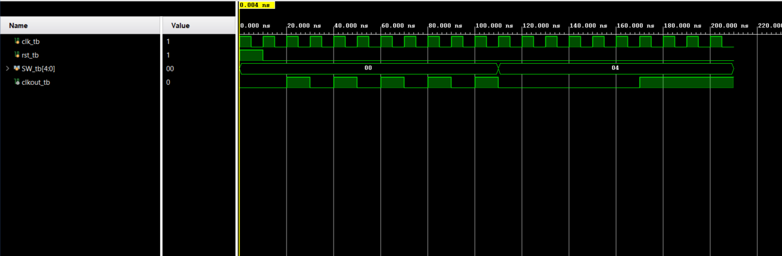

`timescale 1ns / 1ps

module udcounter(

input clk1,

input rst1,

input en,

input ud,

output reg [26:0] tmp

);

always@(posedge clk1 or posedge rst1)

begin

if(en)

begin

if(rst1)

begin

if(ud)// 0 is up, 1 is down

tmp<= 27'd99999999;

else

tmp<= 27'd0;

end

else

begin

if(ud)

if(tmp==27'd0)

tmp <= 27'd99999999;

else

tmp <= tmp-1;

else

if(tmp==27'd99999999)

tmp <= 27'd0;

else

tmp <= tmp+1;

end

//tmp = tmp;

end

else

tmp=tmp;

end

endmodule

The purpose of this code is to count up or down in BCD. The always@(posedge or rst) was used because this is a sequential circuit , and the non-blocking assignment <= is used as well because this code runs in parallel. The if statement with en is used first because without the en the updown counter wouldn’t run. Next there is a if statement to see if the reset value is 1, if it is then we need to see whether the updown counter is 0 for up or 1 for down. This is because if we are counting from 9 to 0 then the value should reset to 9, whereas if we count from 0 to 9 it should reset to 0.

begin

always@(posedge clk1 or posedge rst1)

begin

if(en)

begin

if(rst1)

begin

if(ud)// 0 is up, 1 is down

tmp<= 4'd9;

else

tmp<= 4'd0;

end

else

begin

if(ud)

if(tmp==4'd0)

tmp <= 4'd9;

else

tmp <= tmp-1;

else

if(tmp==4'd9)

tmp <= 4'd0;

else

tmp <= tmp+1;

end

//tmp = tmp;

end

else

tmp=0;

end

The code above verifies the bcd because it checks whether the updown is 1 or 0, and based on what the maximum value for counting up and the minimum value for counting down is the tmp wire is reset to the beginning of the number counting scale. For example, the number counting scale is 0 to 9 for ud =0, so when it reaches 9 it will set back to 0 so that it doesn’t go to 10 and so on. The tmp is the wire that connects the updown counter results to the 32-bit output that goes to the 7seg.

`timescale 1ns / 1ps

module UPDOWN_TB(

);

reg clk_tb,rst_tb;

reg en_tb;

reg ud_tb;

wire [26:0] cnt_tb;

UPDOWN COMP (

.clk1(clk_tb),

.rst1(rst_tb),

.en(en_tb),

.ud(ud_tb),

.tmp(cnt_tb)

);

initial

begin

clk_tb = 0;

rst_tb = 0;

ud_tb = 0;

en_tb = 1;

end

always

begin

#5 clk_tb = ~clk_tb;

end

always

begin

#20 rst_tb = ~rst_tb;

end

endmodule

The purpose of this testbench is to test the code in the design source. We instantiate the variables of the design source code by calling that class,so that we can test them in this simulation source. We set the initial values for the inputs, then we use an always loop to make sure that the clock is toggling, and I had an always loop for reset just to test it out.

EXAMPLE FOR UPDOWN, same applies for [26:0]:

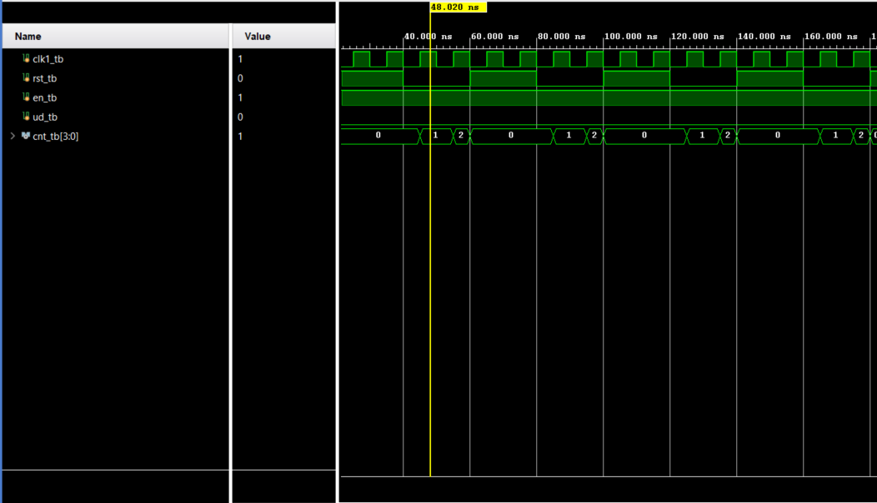

module bin2bcd(

input [26:0] bin,

output reg [31:0] bcd

);

integer i;

always @(bin) begin

bcd=0;

for (i=0;i<27;i=i+1) begin //Iterate once for each bit in input number

if (bcd[3:0] >= 5) bcd[3:0] = bcd[3:0] + 3; //If any BCD digit is >= 5, add three

if (bcd[7:4] >= 5) bcd[7:4] = bcd[7:4] + 3;

if (bcd[11:8] >= 5) bcd[11:8] = bcd[11:8] + 3;

if (bcd[15:12] >= 5) bcd[15:12] = bcd[15:12] + 3;

if (bcd[19:16] >= 5) bcd[19:16] = bcd[19:16] + 3;

if (bcd[23:20] >= 5) bcd[23:20] = bcd[23:20] + 3;

if (bcd[27:23] >= 5) bcd[27:23] = bcd[27:23] + 3;

if (bcd[31:27] >= 5) bcd[31:27] = bcd[31:27] + 3;

bcd = {bcd[27:0],bin[15-i]}; //Shift one bit, and shift in proper bit from input

end

end

endmodule

`timescale 1ns / 1ps

module bin2bcd_tb(

);

reg [31:0]bin_tb;

wire [31:0] bcd_tb;

bin2bcd COMP (

.bin(bin_tb),

.bcd(bcd_tb)

);

initial

begin

bin_tb = 45;

//$finish

end

endmodule

The purpose of this code is to implement the double dabble algorithm. The “double dabble” algorithm is commonly used to convert a binary number to BCD. The binary number is left-shifted once for each of its bits, with bits shifted out of the MSB of the binary number and into the LSB of the accumulating BCD number. After every shift, all BCD digits are examined, and 3 is added to any BCD digit that is currently 5 or greater. This works because every left shift multiplies all BCD digits by two. Since BCD digits cannot exceed nine, a pre-shift number of five or more would result in a post-shift number of ten or more, which cannot be represented. Adding three to any BCD digit greater than five does two things: first, at the next shift, the 3 that was added becomes 6, and that accounts for the difference in binary and BCD codes

`timescale 1ns / 1ps

module segdisplaydriver(

input [31:0] inDigit,

output reg [6:0] Cnode,

output dp,

output reg [7:0] AN,

input nexysCLK, // 100MHz

output reg divided_clk = 0 // 10kHz => 10ms period, 0.5ms ON, 0.5ms OFF

);

reg [3:0] singledigit = 0;

reg [3:0] refreshcounter = 0;

// Calculate division value = 100MHz / (2 * desired frequency) - 1 => 10kHz => 4999

localparam div_value = 25000;

integer counter_value = 0;

always @(posedge nexysCLK)

begin

if (counter_value == div_value) // For every (div_value) clock cycles, reset counter back to 0

counter_value <= 0; // Use <= for parallel & same time, = for sequential - one after the other

else

counter_value <= counter_value + 1;

end

// divide clock

always @(posedge nexysCLK)

begin

if (counter_value == div_value)

divided_clk <= ~divided_clk; // Flip signal

else

divided_clk <= divided_clk; // Keep signal the same

end

/*CLOCK DIVIDER CODE*/

always @(posedge divided_clk)

begin

refreshcounter <= refreshcounter + 1;

end

always @(refreshcounter)

begin

case(refreshcounter)

4'b0000: singledigit = inDigit[3:0]; // digit 1 value (right digit)

4'b0001: singledigit = inDigit[7:4]; // digit 2 value

4'b0010: singledigit = inDigit[11:8]; // digit 3 value

4'b0011: singledigit = inDigit[15:12]; // digit 4 value

4'b0101: singledigit = inDigit[19:16]; // digit 5 value

4'b0110: singledigit = inDigit[23:20]; // digit 6 value

4'b0111: singledigit = inDigit[27:24]; // digit 7 value

4'b1000: singledigit = inDigit[31:28]; // digit 8 value (left digit)

endcase

end

always @(refreshcounter)

begin

case(refreshcounter)

4'b0000: AN = 8'b11111110; // digit 1 ON (right digit)

4'b0001: AN = 8'b11111101; // digit 2 ON

4'b0010: AN = 8'b11111011; // digit 3 ON

4'b0011: AN = 8'b11110111; // digit 4 ON

4'b0100: AN = 8'b11101111; // digit 5 ON

4'b0101: AN = 8'b11011111; // digit 6 ON

4'b0110: AN = 8'b10111111; // digit 7 ON

4'b0111: AN = 8'b01111111; // digit 8 ON (left digit)

default: AN = 8'bZZZZZZZZ;

endcase

end

assign dp = 1'b1;

always@(singledigit)

begin

case (singledigit)

4'd0: Cnode<= 7'b0000001; //0

4'd1: Cnode<= 7'b1001111; //1

4'd2: Cnode<= 7'b0010010; //2

4'd3: Cnode<= 7'b0000110; //3

4'd4: Cnode<= 7'b1001100; //4

4'd5: Cnode<= 7'b0100100; //5

4'd6: Cnode<= 7'b0100000; //6

4'd7: Cnode<= 7'b0001111; //7

4'd8: Cnode<= 7'b0000000; //8

4'd9: Cnode<= 7'b0000100; //9

4'd10:Cnode<= 7'b0001000; //A

4'd11:Cnode<= 7'b1100000; //B

4'd12:Cnode<= 7'b0110001; //C

4'd13:Cnode<= 7'b1000010; //D

4'd14:Cnode<= 7'b0110000; //E

4'd15:Cnode<= 7'b0111000; //F

default: Cnode = 7'b0000000; //DEFAULT CASE EVERYTHING ON

endcase

end

endmodule

`timescale 1ns / 1ps

module SEGDRIVE_TB(

);

reg [31:0] tmp_SW_tb;

wire [6:0] Cnode_tb;

wire dp_tb;

wire [7:0] AN_tb;

SEGDRIVE COMP (

.tmp_SW(tmp_SW_tb),

.Cnode(Cnode_tb),

.dp(dp_tb),

.AN(AN_tb)

);

initial

begin

//dp_tb = 1;

tmp_SW_tb=0;

#10

tmp_SW_tb=4;

#1000

$finish;

end

endmodule

This code takes an input of 32 switches and depending on when the switches change value, one of the many possible outputs will be selected to display on the 7 segment display. AN and dp are assigned in the beginning to make sure it is only one digit without the decimal place being shown. The different cases range from 0 to 9, and the 32-bit switch value selects the specific digit that needs to be modified. In this particular code 0 represents on, while 1 represents off. There is also a clock divider to make sure that the digits can change asynchronously so that the official updown 32-bit counter will work.

`timescale 1ns / 1ps

module top(

input clkt,

input rstt,

input ent,

input udt,

input [4:0] SW,

output seg,

output [6:0] Cnode1,

output [7:0] AN1

);

wire slowclk_out;

wire [31:0] inDigit;

clockmanager clockmanager_wrapper(

.clk(clkt),

.SW(SW),

.clkout(slowclk_out)

);

wire [26:0] tmp_cnt;

udcounter udcounter_wrapper(

.rst1(rstt),

.en(ent),

.clk1(slowclk_out),

.tmp(tmp_cnt),

.ud(udt)

);

bin2bcd bin2bcd_wrapper(

.bin(tmp_cnt),

.bcd(inDigit)

);

segdisplaydriver seg7driver_wrapper(

.nexysCLK(clkt),

.inDigit(inDigit),

.Cnode(Cnode1),

.dp(seg),

.AN(AN1)

);

endmodule

The top file basically instantiates the clock, switches, and clock out of the CLKMANAGER. It instantiates the reset, enable, clock, updown, and 32-bit output of the BCD converter from the UPDOWN, and the SEGDRIVE switches, Cnode, dp, and Anode. Two wires are created to connect everything together. The slowclk_out wire connects the output clk of the clk manager to the input of the updown counter clk. The wire tmp_cnt connects the 4-bit output of the updown to the input of the switches, so the values of 0 to 9 can be displayed on the FPGA board.

This code represents the following schematic of a clkmanager that generates 32 random frequencies and then sends it out as the clock of the updown which counts 0 to 9 or 9 to 0 at different frequencies. The 32-bit output represents the BCD value, which will be connected to the switches of the 7-segment display, so that it could display the BCD on the 7-segment display.

**Corner Cases/Error :**

***One corner case can be the CLKMANAGER Testbench. At first the testbench wasn’t working because of :***

always@(SW)

begin

***The problem is that the loop can only run if the SW changes, so we had to change SW to posedge clk or posedge rst, so that the code could effectively work in the testbench.***

**IMPLEMENTED DESIGN/ TIMING SUMMARY:**

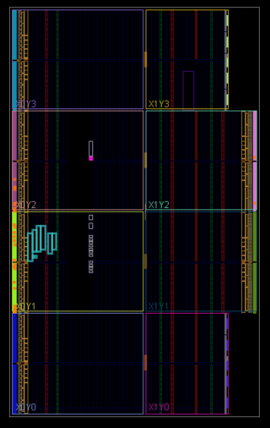

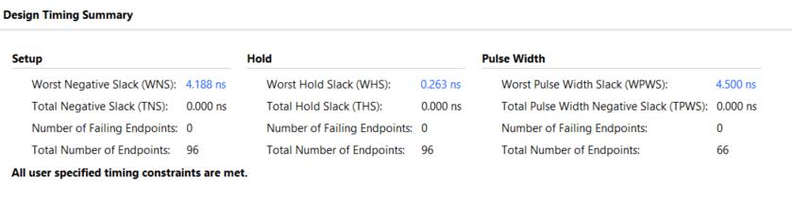

**POWER SUMMARY:**

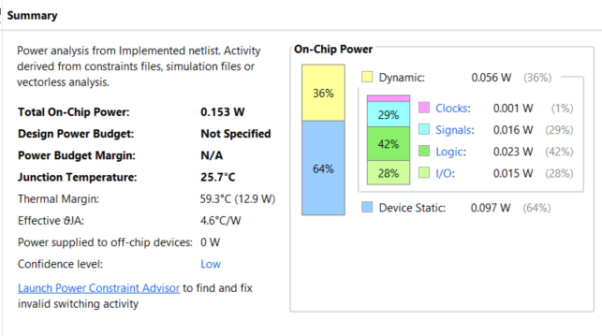

**UTILIZATION:**

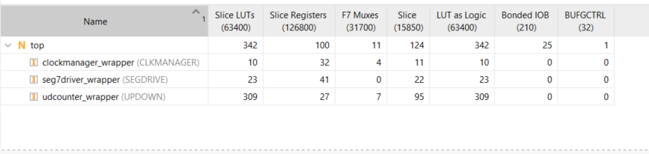

**RESOURCE USAGE:**

