**ECE3300L Lab7 Group H Report (Sherwin Sathish & Mohamed Hamida)**

**SCHEMATIC():**

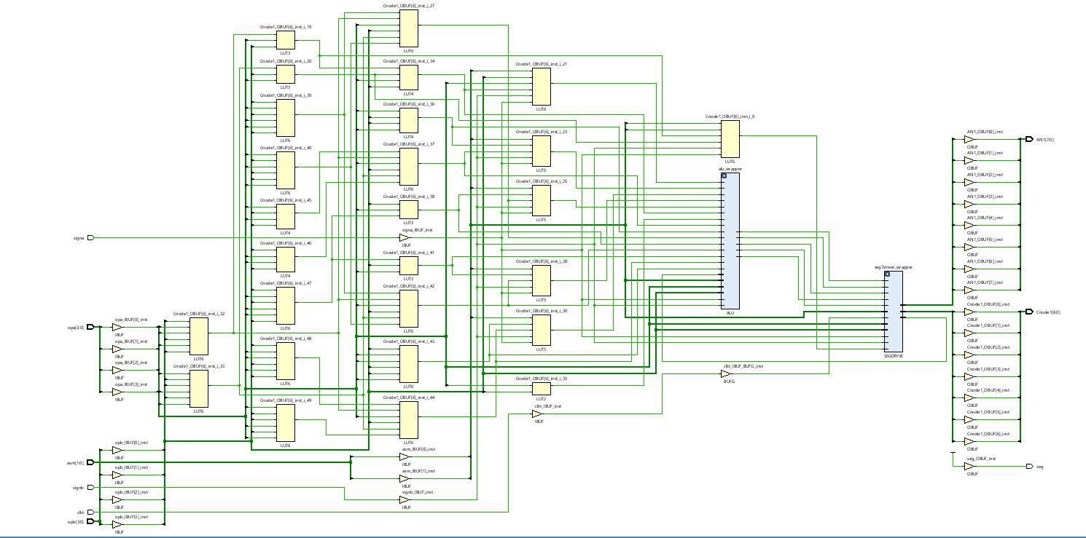

***Xdc for top.v:***

## This file is a general .xdc for the Nexys A7-100T

## To use it in a project:

## - uncomment the lines corresponding to used pins

## - rename the used ports (in each line, after get_ports) according to the top level signal names in the project

## Clock signal

set_property -dict { PACKAGE_PIN E3 IOSTANDARD LVCMOS33 } [get_ports { clkt}];# IO_L12P_T1_MRCC_35 Sch=clk100mhz

create_clock -add -name sys_clk_pin -period 10.00 -waveform {0 5} [get_ports {clkt}];

##Switches

set_property -dict { PACKAGE_PIN J15 IOSTANDARD LVCMOS33 } [get_ports { opb[0] }]; #IO_L24N_T3_RS0_15 Sch=sw[0]

set_property -dict { PACKAGE_PIN L16 IOSTANDARD LVCMOS33 } [get_ports { opb[1] }]; #IO_L3N_T0_DQS_EMCCLK_14 Sch=sw[1]

set_property -dict { PACKAGE_PIN M13 IOSTANDARD LVCMOS33 } [get_ports { opb[2] }]; #IO_L6N_T0_D08_VREF_14 Sch=sw[2]

set_property -dict { PACKAGE_PIN R15 IOSTANDARD LVCMOS33 } [get_ports { opb[3] }]; #IO_L13N_T2_MRCC_14 Sch=sw[3]

set_property -dict { PACKAGE_PIN R17 IOSTANDARD LVCMOS33 } [get_ports { signb }]; #IO_L12N_T1_MRCC_14 Sch=sw[4]

set_property -dict { PACKAGE_PIN T18 IOSTANDARD LVCMOS33 } [get_ports { opa[0] }]; #IO_L7N_T1_D10_14 Sch=sw[5]

set_property -dict { PACKAGE_PIN U18 IOSTANDARD LVCMOS33 } [get_ports { opa[1] }]; #IO_L17N_T2_A13_D29_14 Sch=sw[6]

set_property -dict { PACKAGE_PIN R13 IOSTANDARD LVCMOS33 } [get_ports { opa[2] }]; #IO_L5N_T0_D07_14 Sch=sw[7]

set_property -dict { PACKAGE_PIN T8 IOSTANDARD LVCMOS18 } [get_ports { opa[3] }]; #IO_L24N_T3_34 Sch=sw[8]

set_property -dict { PACKAGE_PIN U8 IOSTANDARD LVCMOS18 } [get_ports { signa }]; #IO_25_34 Sch=sw[9]

set_property -dict { PACKAGE_PIN R16 IOSTANDARD LVCMOS33 } [get_ports { asm[0] }]; #IO_L15P_T2_DQS_RDWR_B_14 Sch=sw[10]

set_property -dict { PACKAGE_PIN T13 IOSTANDARD LVCMOS33 } [get_ports { asm[1] }]; #IO_L23P_T3_A03_D19_14 Sch=sw[11]

#set_property -dict { PACKAGE_PIN H6 IOSTANDARD LVCMOS33 } [get_ports { SW[12] }]; #IO_L24P_T3_35 Sch=sw[12]

#set_property -dict { PACKAGE_PIN U12 IOSTANDARD LVCMOS33 } [get_ports { SW[13] }]; #IO_L20P_T3_A08_D24_14 Sch=sw[13]

#set_property -dict { PACKAGE_PIN U11 IOSTANDARD LVCMOS33 } [get_ports { SW[14] }]; #IO_L19N_T3_A09_D25_VREF_14 Sch=sw[14]

#set_property -dict { PACKAGE_PIN V10 IOSTANDARD LVCMOS33 } [get_ports { SW[15] }]; #IO_L21P_T3_DQS_14 Sch=sw[15]

## LEDs

#set_property -dict { PACKAGE_PIN H17 IOSTANDARD LVCMOS33 } [get_ports { sumbit[0] }]; #IO_L18P_T2_A24_15 Sch=led[0]

#set_property -dict { PACKAGE_PIN K15 IOSTANDARD LVCMOS33 } [get_ports { sumbit[1] }]; #IO_L24P_T3_RS1_15 Sch=led[1]

#set_property -dict { PACKAGE_PIN J13 IOSTANDARD LVCMOS33 } [get_ports { sumbit[2] }]; #IO_L17N_T2_A25_15 Sch=led[2]

#set_property -dict { PACKAGE_PIN N14 IOSTANDARD LVCMOS33 } [get_ports { sumbit[3] }]; #IO_L8P_T1_D11_14 Sch=led[3]

#set_property -dict { PACKAGE_PIN R18 IOSTANDARD LVCMOS33 } [get_ports { coutbit }]; #IO_L7P_T1_D09_14 Sch=led[4]

#set_property -dict { PACKAGE_PIN V17 IOSTANDARD LVCMOS33 } [get_ports { opc[0] }]; #IO_L18N_T2_A11_D27_14 Sch=led[5]

#set_property -dict { PACKAGE_PIN U17 IOSTANDARD LVCMOS33 } [get_ports { opc[1] }]; #IO_L17P_T2_A14_D30_14 Sch=led[6]

#set_property -dict { PACKAGE_PIN U16 IOSTANDARD LVCMOS33 } [get_ports { opc[2] }]; #IO_L18P_T2_A12_D28_14 Sch=led[7]

#set_property -dict { PACKAGE_PIN V16 IOSTANDARD LVCMOS33 } [get_ports { opc[3] }]; #IO_L16N_T2_A15_D31_14 Sch=led[8]

#set_property -dict { PACKAGE_PIN T15 IOSTANDARD LVCMOS33 } [get_ports { opc[4] }]; #IO_L14N_T2_SRCC_14 Sch=led[9]

#set_property -dict { PACKAGE_PIN U14 IOSTANDARD LVCMOS33 } [get_ports { opc[5] }]; #IO_L22P_T3_A05_D21_14 Sch=led[10]

#set_property -dict { PACKAGE_PIN T16 IOSTANDARD LVCMOS33 } [get_ports { opc[6] }]; #IO_L15N_T2_DQS_DOUT_CSO_B_14 Sch=led[11]

#set_property -dict { PACKAGE_PIN V15 IOSTANDARD LVCMOS33 } [get_ports { opc[7] }]; #IO_L16P_T2_CSI_B_14 Sch=led[12]

#set_property -dict { PACKAGE_PIN V14 IOSTANDARD LVCMOS33 } [get_ports { signc1 }]; #IO_L22N_T3_A04_D20_14 Sch=led[13]

#set_property -dict { PACKAGE_PIN V12 IOSTANDARD LVCMOS33 } [get_ports { LED[14] }]; #IO_L20N_T3_A07_D23_14 Sch=led[14]

#set_property -dict { PACKAGE_PIN V11 IOSTANDARD LVCMOS33 } [get_ports { LED[15] }]; #IO_L21N_T3_DQS_A06_D22_14 Sch=led[15]

## RGB LEDs

#set_property -dict { PACKAGE_PIN R12 IOSTANDARD LVCMOS33 } [get_ports { LED16_B }]; #IO_L5P_T0_D06_14 Sch=led16_b

#set_property -dict { PACKAGE_PIN M16 IOSTANDARD LVCMOS33 } [get_ports { LED16_G }]; #IO_L10P_T1_D14_14 Sch=led16_g

#set_property -dict { PACKAGE_PIN N15 IOSTANDARD LVCMOS33 } [get_ports { LED16_R }]; #IO_L11P_T1_SRCC_14 Sch=led16_r

#set_property -dict { PACKAGE_PIN G14 IOSTANDARD LVCMOS33 } [get_ports { LED17_B }]; #IO_L15N_T2_DQS_ADV_B_15 Sch=led17_b

#set_property -dict { PACKAGE_PIN R11 IOSTANDARD LVCMOS33 } [get_ports { LED17_G }]; #IO_0_14 Sch=led17_g

#set_property -dict { PACKAGE_PIN N16 IOSTANDARD LVCMOS33 } [get_ports { LED17_R }]; #IO_L11N_T1_SRCC_14 Sch=led17_r

##7 segment display

set_property -dict { PACKAGE_PIN T10 IOSTANDARD LVCMOS33 } [get_ports { Cnode1[6] }]; #IO_L24N_T3_A00_D16_14 Sch=ca

set_property -dict { PACKAGE_PIN R10 IOSTANDARD LVCMOS33 } [get_ports { Cnode1[5] }]; #IO_25_14 Sch=cb

set_property -dict { PACKAGE_PIN K16 IOSTANDARD LVCMOS33 } [get_ports { Cnode1[4] }]; #IO_25_15 Sch=cc

set_property -dict { PACKAGE_PIN K13 IOSTANDARD LVCMOS33 } [get_ports { Cnode1[3] }]; #IO_L17P_T2_A26_15 Sch=cd

set_property -dict { PACKAGE_PIN P15 IOSTANDARD LVCMOS33 } [get_ports { Cnode1[2] }]; #IO_L13P_T2_MRCC_14 Sch=ce

set_property -dict { PACKAGE_PIN T11 IOSTANDARD LVCMOS33 } [get_ports { Cnode1[1] }]; #IO_L19P_T3_A10_D26_14 Sch=cf

set_property -dict { PACKAGE_PIN L18 IOSTANDARD LVCMOS33 } [get_ports { Cnode1[0] }]; #IO_L4P_T0_D04_14 Sch=cg

set_property -dict { PACKAGE_PIN H15 IOSTANDARD LVCMOS33 } [get_ports { seg }]; #IO_L19N_T3_A21_VREF_15 Sch=dp

set_property -dict { PACKAGE_PIN J17 IOSTANDARD LVCMOS33 } [get_ports { AN1[0] }]; #IO_L23P_T3_FOE_B_15 Sch=an[0]

set_property -dict { PACKAGE_PIN J18 IOSTANDARD LVCMOS33 } [get_ports { AN1[1] }]; #IO_L23N_T3_FWE_B_15 Sch=an[1]

set_property -dict { PACKAGE_PIN T9 IOSTANDARD LVCMOS33 } [get_ports { AN1[2] }]; #IO_L24P_T3_A01_D17_14 Sch=an[2]

set_property -dict { PACKAGE_PIN J14 IOSTANDARD LVCMOS33 } [get_ports { AN1[3] }]; #IO_L19P_T3_A22_15 Sch=an[3]

set_property -dict { PACKAGE_PIN P14 IOSTANDARD LVCMOS33 } [get_ports { AN1[4] }]; #IO_L8N_T1_D12_14 Sch=an[4]

set_property -dict { PACKAGE_PIN T14 IOSTANDARD LVCMOS33 } [get_ports { AN1[5] }]; #IO_L14P_T2_SRCC_14 Sch=an[5]

set_property -dict { PACKAGE_PIN K2 IOSTANDARD LVCMOS33 } [get_ports { AN1[6] }]; #IO_L23P_T3_35 Sch=an[6]

set_property -dict { PACKAGE_PIN U13 IOSTANDARD LVCMOS33 } [get_ports { AN1[7] }]; #IO_L23N_T3_A02_D18_14 Sch=an[7]

**Code Detail:**

`timescale 1ns / 1ps

module ALU(

input [3:0] opa,

input [3:0] opb,

input signa,

input signb,

input [1:0] asm,

output [7:0] opc,

output signc1

);

reg [7:0] ropc=0;

reg signc=0;

always@(*)

begin

case(asm)

2'b00:

begin

ropc <= 0;

signc <=0;

end

2'b01://ADD

begin

if(opa==0 && opb==0)

begin

ropc=0;

signc=0;

end

else if(signa==0 && signb==1)

begin

if(opa<opb)

begin

ropc <= opb-opa;

signc <=1;

end

else if(opa>opb)

begin

ropc <= opa-opb;

signc <=0;

end

else

begin

ropc <=0;

signc <=0;

end

end

else if(signa==1 && signb==0)

begin

if(opa<opb)

begin

ropc <= opb-opa;

signc <=0;

end

else if(opa>opb)

begin

ropc <= opa-opb;

signc <=1;

end

else

begin

ropc <=0;

signc <=0;

end

end

else if(signa==1 && signb==1)

begin

ropc <=opa+opb;

signc <=1;

end

else

begin

ropc <=opa+opb;

signc <=0;

end

end

2'b10://SUBTRACT

begin

if(opa==0 && opb==0)

begin

ropc=0;

signc=0;

end

else if(signa==0 && signb==0)

begin

if(opa<opb)

begin

ropc <= opb-opa;

signc <=1;

end

else if(opa>opb)

begin

ropc <= opa-opb;

signc <=0;

end

else

begin

ropc <=0;

signc <=0;

end

end

else if(signa==1 && signb==1)

begin

if(opa<opb)

begin

ropc <= opb-opa;

signc <=0;

end

else if(opa>opb)

begin

ropc <= opa-opb;

signc <=1;

end

else

begin

ropc <=0;

signc <=0;

end

end

else if(signa==1 && signb==0)

begin

ropc <=opa+opb;

signc <=1;

end

else

begin

ropc <=opa+opb;

signc <=0;

end

end

2'b11: //MULTIPICATION

begin

ropc = opa * opb;

if(opa==0 && opb==0)

begin

ropc=0;

signc=0;

end

else if(signa==1 && signb==1)

signc <= 0;

else if(signa==0 && signb==0)

signc <= 0;

else

signc <= 1;

end

endcase

end

assign opc = ropc;

assign signc1 = signc;

endmodule

`timescale 1ns / 1ps

module alu_tb();

reg [3:0] opatb;

reg [3:0] opbtb;

reg signatb;

reg signbtb;

reg [1:0] asmtb;

wire [7:0] opctb;

wire signctb;

ALU alu_tb(

.opa(opatb),

.opb(opbtb),

.signa(signatb),

.signb(signbtb),

.asm(asmtb),

//output to 7seg

.opc(opctb),

.signc1(signctb)

);

initial

begin: TEST

asmtb = 3;

opatb = 4;

opbtb = 2;

signatb = 0;

signbtb = 0;

#100

asmtb = 2;

opatb = 4;

opbtb = 4;

signatb = 0;

signbtb = 1;

#100

asmtb = 1;

opatb = 9;

opbtb = 1;

signatb = 0;

signbtb = 0;

#100

asmtb = 3;

opatb = 1;

opbtb = 9;

signatb = 1;

signbtb = 0;

#1000

$finish;

end

endmodule

The alu code takes 2 single digit numbers and either adds, subtracts, or multiplies them to yield a 2 digit answer. To solve this we created truth tables to simplify the algorithm. We compared the signs first, then we set opa as the main digit, and created many cases based on opa compared to opb. At the end of the code we yield the opc and the signc values based on the different cases. The truth tables were used for addition and subtraction, but multiplication was simple because a size comparison between opa and opb wasn’t necessary. The truth tables and testbench are shown below:

**ADDITION:**

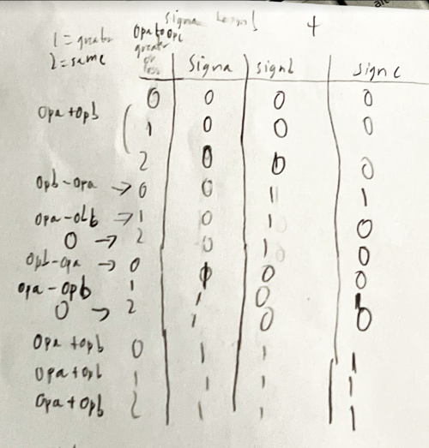

**SUBTRACT AND MULTIPLY:**

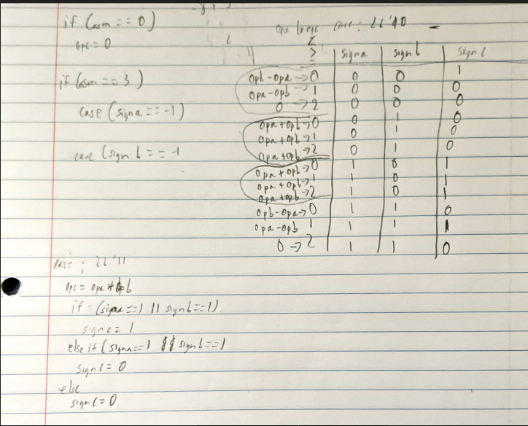

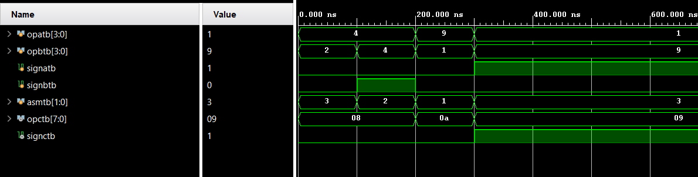

module bin2bcd(

input [7:0] bin,

output reg [7:0] bcd

);

integer i;

always @(bin) begin

bcd=0;

for (i=0;i<6;i=i+1) begin

// else

// begin

//Iterate once for each bit in input number

if (bcd[3:0] >= 5) bcd[3:0] = bcd[3:0] + 3; //If any BCD digit is >= 5, add three

if (bcd[7:4] >= 5) bcd[7:4] = bcd[7:4] + 3;

bcd = {bcd[7:0],bin[5-i]};

//end

end //Shift one bit, and shift in proper bit from input

end

endmodule

`timescale 1ns / 1ps

module bin2bcd_tb(

);

reg [31:0]bin_tb;

wire [31:0] bcd_tb;

bin2bcd COMP (

.bin(bin_tb),

.bcd(bcd_tb)

);

initial

begin

bin_tb = 12;

//$finish

end

endmodule

The purpose of this code is to implement the double dabble algorithm. The “double dabble” algorithm is commonly used to convert a binary number to BCD. The binary number is left-shifted once for each of its bits, with bits shifted out of the MSB of the binary number and into the LSB of the accumulating BCD number. After every shift, all BCD digits are examined, and 3 is added to any BCD digit that is currently 5 or greater. This works because every left shift multiplies all BCD digits by two. Since BCD digits cannot exceed nine, a pre-shift number of five or more would result in a post-shift number of ten or more, which cannot be represented. Adding three to any BCD digit greater than five does two things: first, at the next shift, the 3 that was added becomes 6, and that accounts for the difference in binary and BCD codes. This code takes the opc output of the alu and converts it into BCD.

`timescale 1ns / 1ps

module segdisplaydriver(

input [31:0] inDigit,

output reg [6:0] Cnode,

output dp,

output reg [7:0] AN,

input nexysCLK, // 100MHz

output reg divided_clk = 0 // 10kHz => 10ms period, 0.5ms ON, 0.5ms OFF

);

reg [3:0] singledigit = 0;

reg [3:0] refreshcounter = 0;

// Calculate division value = 100MHz / (2 * desired frequency) - 1 => 10kHz => 4999

localparam div_value = 25000;

integer counter_value = 0;

always @(posedge nexysCLK)

begin

if (counter_value == div_value) // For every (div_value) clock cycles, reset counter back to 0

counter_value <= 0; // Use <= for parallel & same time, = for sequential - one after the other

else

counter_value <= counter_value + 1;

end

// divide clock

always @(posedge nexysCLK)

begin

if (counter_value == div_value)

divided_clk <= ~divided_clk; // Flip signal

else

divided_clk <= divided_clk; // Keep signal the same

end

/*CLOCK DIVIDER CODE*/

always @(posedge divided_clk)

begin

refreshcounter <= refreshcounter + 1;

end

always @(refreshcounter)

begin

case(refreshcounter)

4'b0000: singledigit = inDigit[3:0]; // digit 1 value (right digit)

4'b0001: singledigit = inDigit[7:4]; // digit 2 value

4'b0010: singledigit = inDigit[11:8]; // digit 3 value

4'b0011: singledigit = inDigit[15:12]; // digit 4 value

4'b0101: singledigit = inDigit[19:16]; // digit 5 value missing 4’b0010

4'b0110: singledigit = inDigit[23:20]; // digit 6 value

4'b0111: singledigit = inDigit[27:24]; // digit 7 value

4'b1000: singledigit = inDigit[31:28]; // digit 8 value (left digit)

endcase

end

always @(refreshcounter)

begin

case(refreshcounter)

4'b0000: AN = 8'b11111110; // digit 1 ON (right digit)

4'b0001: AN = 8'b11111101; // digit 2 ON

4'b0010: AN = 8'b11111011; // digit 3 ON

4'b0011: AN = 8'b11110111; // digit 4 ON

4'b0100: AN = 8'b11101111; // digit 5 ON

4'b0101: AN = 8'b11011111; // digit 6 ON

4'b0110: AN = 8'b10111111; // digit 7 ON

4'b0111: AN = 8'b01111111; // digit 8 ON (left digit)

default: AN = 8'bZZZZZZZZ;

endcase

end

assign dp = 1'b1;

always@(singledigit)

begin

case (singledigit)

4'd0: Cnode<= 7'b0000001; //0

4'd1: Cnode<= 7'b1001111; //1

4'd2: Cnode<= 7'b0010010; //2

4'd3: Cnode<= 7'b0000110; //3

4'd4: Cnode<= 7'b1001100; //4

4'd5: Cnode<= 7'b0100100; //5

4'd6: Cnode<= 7'b0100000; //6

4'd7: Cnode<= 7'b0001111; //7

4'd8: Cnode<= 7'b0000000; //8

4'd9: Cnode<= 7'b0000100; //9

4'd10:Cnode<= 7'b0001000; //A

4'd11:Cnode<= 7'b1100000; //B

4'd12:Cnode<= 7'b0110001; //C

4'd13:Cnode<= 7'b1000010; //D

4'd14:Cnode<= 7'b1011000; //POSITIVE AKA 1110

4'd15:Cnode<= 7'b0010100; //NEGATIVE AKA 1111

default: Cnode = 7'b0000000; //DEFAULT CASE EVERYTHING ON

endcase

end

endmodule

`timescale 1ns / 1ps

module SEGDRIVE_TB(

);

reg [31:0] tmp_SW_tb;

wire [6:0] Cnode_tb;

wire dp_tb;

wire [7:0] AN_tb;

SEGDRIVE COMP (

.tmp_SW(tmp_SW_tb),

.Cnode(Cnode_tb),

.dp(dp_tb),

.AN(AN_tb)

);

initial

begin

//dp_tb = 1;

tmp_SW_tb=0;

#10

tmp_SW_tb=4;

#1000

$finish;

end

endmodule

This code takes an input of 32 switches and depending on when the switches change value, one of the many possible outputs will be selected to display on the 7 segment display. AN and dp are assigned in the beginning to make sure it is only one digit without the decimal place being shown. The different cases range from 0 to 9, and the 32-bit switch value selects the specific digit that needs to be modified. In this particular code 0 represents on, while 1 represents off. The values of E and F are set to display the positive and negative “sign” that is desired from the alu.

`timescale 1ns / 1ps

module top(

//INPUTS FROM FPGA

input [3:0] opa,

input [3:0] opb,

input signa,

input signb,

input [1:0] asm,

//OUTPUT TO 7SEG DISPLAY

// output [7:0] opc,

//output signc1,

//7SEG DISPLAY INPUTS

input clkt,

output [6:0] Cnode1,

output [7:0] AN1,

output seg

);

wire [31:0] seg7Digit;

//Send input changes to 7seg display

assign seg7Digit[3:0] = opb;

assign seg7Digit[7:4] = signb + 14;

assign seg7Digit[11:8] = opa;

assign seg7Digit[15:12] = signa + 14;

assign seg7Digit[27:24] = signc1 + 14;

assign seg7Digit[31:28] = asm;

wire [7:0] opc;

ALU alu_wrapper(

.opa(opa),

.opb(opb),

.signa(signa),

.signb(signb),

.asm(asm),

.opc(opc),

.signc1(signc1)

);

bin2bcd b2bwrap(

.bin(opc),

.bcd(seg7Digit[23:16])

);

SEGDRIVE seg7driver_wrapper(

.nexysCLK(clkt),

.inDigit(seg7Digit),

.Cnode(Cnode1),

.dp(seg),

.AN(AN1)

);

endmodule

`timescale 1ns / 1ps

module top_tb();

reg [3:0] opatb;

reg [3:0] opbtb;

reg signatb;

reg signbtb;

reg [1:0] asmtb;

wire [6:0] Cnode_tb;

wire dp_tb;

wire [7:0] AN_tb;

top top_t(

.opa(opatb),

.opb(opbtb),

.signa(signatb),

.signb(signbtb),

.asm(asmtb),

//output to 7seg

.Cnode1(Cnode_tb),

.seg(dp_tb),

.AN1(AN_tb)

);

initial

begin: TEST

asmtb = 3;

opatb = 4;

opbtb = 2;

signatb = 0;

signbtb = 0;

#100

asmtb = 2;

opatb = 4;

opbtb = 4;

signatb = 0;

signbtb = 1;

#100

asmtb = 1;

opatb = 9;

opbtb = 1;

signatb = 0;

signbtb = 0;

#100

asmtb = 3;

opatb = 1;

opbtb = 9;

signatb = 1;

signbtb = 0;

#1000

$finish;

end

endmodule

The top file instantiates the ALU input, 8-bit output of the BCD converter from the ALU output, and the SEGDRIVE input, Cnode, dp, and Anode. The wires are used to establish connections between the ALU output to the binary to bcd converter, and also establish the input and output connections to the SEGDRIVE. The assign is used to give specific digits on the FPGA the desired values, whether it’s an actual number or sign.

**Corner Cases/Error :**

***One corner case can be A-D can be displayed, to cope this either the default case in the case statements should be 9, or the user simply just shouldn’t input those values.***

**IMPLEMENTED DESIGN/ TIMING SUMMARY:**

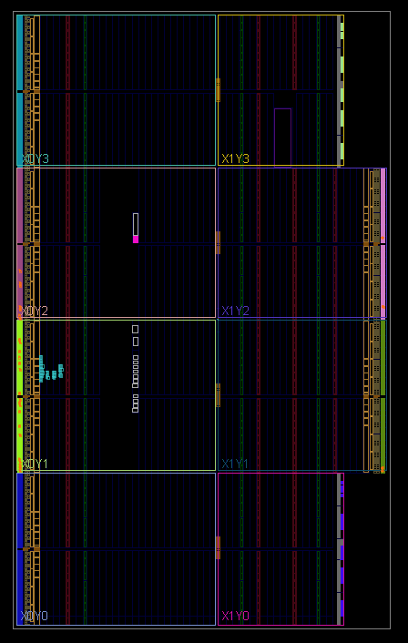

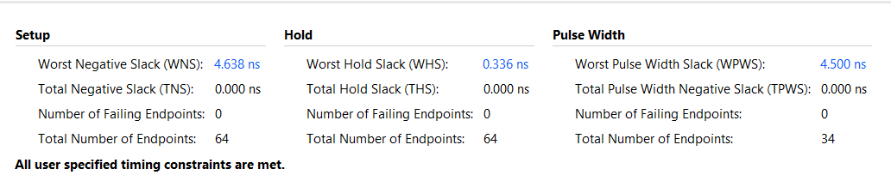

**POWER SUMMARY:**

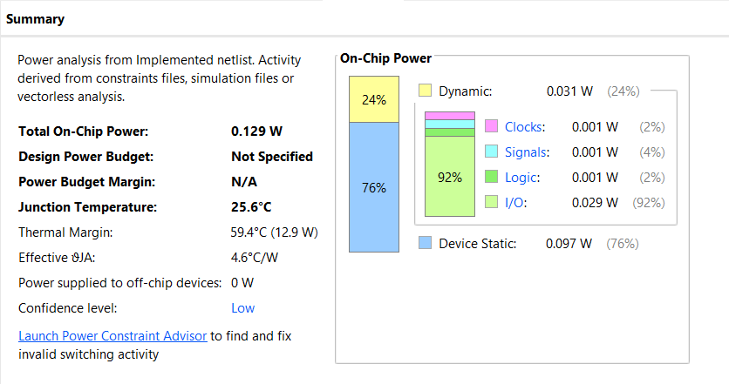

**UTILIZATION:**

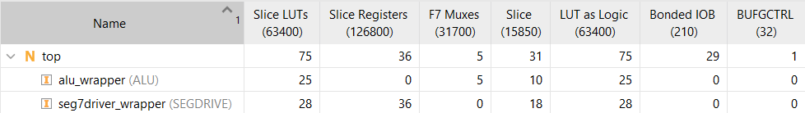

**RESOURCE USAGE:**

