**ECE3300L Lab8 Group H Report (Sherwin Sathish & Mohamed Hamida)**

**SCHEMATIC:**

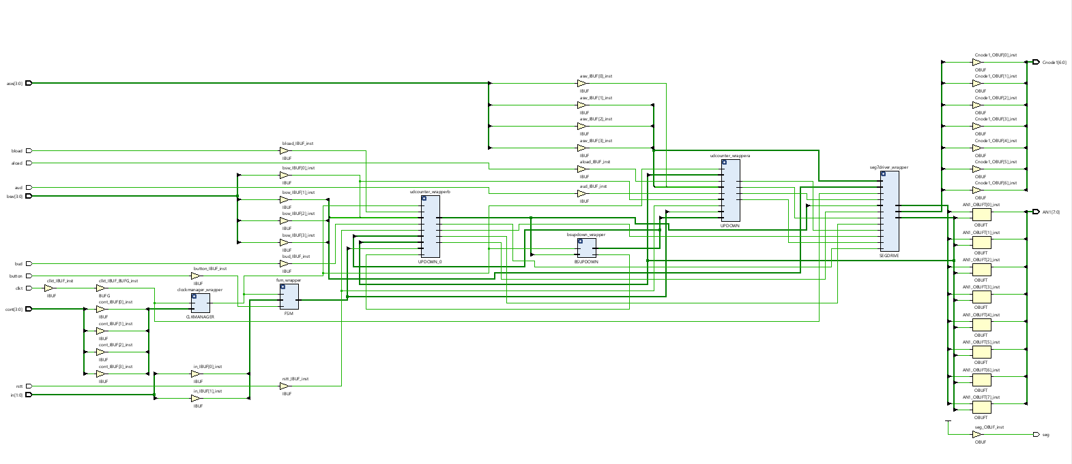

***Xdc for top.v:***

## This file is a general .xdc for the Nexys A7-100T

## To use it in a project:

## - uncomment the lines corresponding to used pins

## - rename the used ports (in each line, after get_ports) according to the top level signal names in the project

## Clock signal

set_property -dict { PACKAGE_PIN E3 IOSTANDARD LVCMOS33 } [get_ports { clkt}];# IO_L12P_T1_MRCC_35 Sch=clk100mhz

create_clock -add -name sys_clk_pin -period 10.00 -waveform {0 5} [get_ports {clkt}];

##Switches

set_property -dict { PACKAGE_PIN J15 IOSTANDARD LVCMOS33 } [get_ports { asw[0] }]; #IO_L24N_T3_RS0_15 Sch=sw[0]

set_property -dict { PACKAGE_PIN L16 IOSTANDARD LVCMOS33 } [get_ports { asw[1] }]; #IO_L3N_T0_DQS_EMCCLK_14 Sch=sw[1]

set_property -dict { PACKAGE_PIN M13 IOSTANDARD LVCMOS33 } [get_ports { asw[2] }]; #IO_L6N_T0_D08_VREF_14 Sch=sw[2]

set_property -dict { PACKAGE_PIN R15 IOSTANDARD LVCMOS33 } [get_ports { asw[3] }]; #IO_L13N_T2_MRCC_14 Sch=sw[3]

set_property -dict { PACKAGE_PIN R17 IOSTANDARD LVCMOS33 } [get_ports { bsw[0] }]; #IO_L12N_T1_MRCC_14 Sch=sw[4]

set_property -dict { PACKAGE_PIN T18 IOSTANDARD LVCMOS33 } [get_ports { bsw[1] }]; #IO_L7N_T1_D10_14 Sch=sw[5]

set_property -dict { PACKAGE_PIN U18 IOSTANDARD LVCMOS33 } [get_ports { bsw[2] }]; #IO_L17N_T2_A13_D29_14 Sch=sw[6]

set_property -dict { PACKAGE_PIN R13 IOSTANDARD LVCMOS33 } [get_ports { bsw[3] }]; #IO_L5N_T0_D07_14 Sch=sw[7]

set_property -dict { PACKAGE_PIN T8 IOSTANDARD LVCMOS18 } [get_ports { cont[0] }]; #IO_L24N_T3_34 Sch=sw[8]

set_property -dict { PACKAGE_PIN U8 IOSTANDARD LVCMOS18 } [get_ports { cont[1] }]; #IO_25_34 Sch=sw[9]

set_property -dict { PACKAGE_PIN R16 IOSTANDARD LVCMOS33 } [get_ports { cont[2] }]; #IO_L15P_T2_DQS_RDWR_B_14 Sch=sw[10]

set_property -dict { PACKAGE_PIN T13 IOSTANDARD LVCMOS33 } [get_ports { cont[3] }]; #IO_L23P_T3_A03_D19_14 Sch=sw[11]

set_property -dict { PACKAGE_PIN H6 IOSTANDARD LVCMOS33 } [get_ports { aud }]; #IO_L24P_T3_35 Sch=sw[12]

set_property -dict { PACKAGE_PIN U12 IOSTANDARD LVCMOS33 } [get_ports { bud }]; #IO_L20P_T3_A08_D24_14 Sch=sw[13]

set_property -dict { PACKAGE_PIN U11 IOSTANDARD LVCMOS33 } [get_ports { in[0] }]; #IO_L19N_T3_A09_D25_VREF_14 Sch=sw[14]

set_property -dict { PACKAGE_PIN V10 IOSTANDARD LVCMOS33 } [get_ports { in[1] }]; #IO_L21P_T3_DQS_14 Sch=sw[15]

## LEDs

#set_property -dict { PACKAGE_PIN H17 IOSTANDARD LVCMOS33 } [get_ports { sumbit[0] }]; #IO_L18P_T2_A24_15 Sch=led[0]

#set_property -dict { PACKAGE_PIN K15 IOSTANDARD LVCMOS33 } [get_ports { sumbit[1] }]; #IO_L24P_T3_RS1_15 Sch=led[1]

#set_property -dict { PACKAGE_PIN J13 IOSTANDARD LVCMOS33 } [get_ports { sumbit[2] }]; #IO_L17N_T2_A25_15 Sch=led[2]

#set_property -dict { PACKAGE_PIN N14 IOSTANDARD LVCMOS33 } [get_ports { sumbit[3] }]; #IO_L8P_T1_D11_14 Sch=led[3]

#set_property -dict { PACKAGE_PIN R18 IOSTANDARD LVCMOS33 } [get_ports { coutbit }]; #IO_L7P_T1_D09_14 Sch=led[4]

#set_property -dict { PACKAGE_PIN V17 IOSTANDARD LVCMOS33 } [get_ports { LED[5] }]; #IO_L18N_T2_A11_D27_14 Sch=led[5]

#set_property -dict { PACKAGE_PIN U17 IOSTANDARD LVCMOS33 } [get_ports { LED[6] }]; #IO_L17P_T2_A14_D30_14 Sch=led[6]

#set_property -dict { PACKAGE_PIN U16 IOSTANDARD LVCMOS33 } [get_ports { LED[7] }]; #IO_L18P_T2_A12_D28_14 Sch=led[7]

#set_property -dict { PACKAGE_PIN V16 IOSTANDARD LVCMOS33 } [get_ports { LED[8] }]; #IO_L16N_T2_A15_D31_14 Sch=led[8]

#set_property -dict { PACKAGE_PIN T15 IOSTANDARD LVCMOS33 } [get_ports { LED[9] }]; #IO_L14N_T2_SRCC_14 Sch=led[9]

#set_property -dict { PACKAGE_PIN U14 IOSTANDARD LVCMOS33 } [get_ports { LED[10] }]; #IO_L22P_T3_A05_D21_14 Sch=led[10]

#set_property -dict { PACKAGE_PIN T16 IOSTANDARD LVCMOS33 } [get_ports { LED[11] }]; #IO_L15N_T2_DQS_DOUT_CSO_B_14 Sch=led[11]

#set_property -dict { PACKAGE_PIN V15 IOSTANDARD LVCMOS33 } [get_ports { LED[12] }]; #IO_L16P_T2_CSI_B_14 Sch=led[12]

#set_property -dict { PACKAGE_PIN V14 IOSTANDARD LVCMOS33 } [get_ports { LED[13] }]; #IO_L22N_T3_A04_D20_14 Sch=led[13]

#set_property -dict { PACKAGE_PIN V12 IOSTANDARD LVCMOS33 } [get_ports { LED[14] }]; #IO_L20N_T3_A07_D23_14 Sch=led[14]

#set_property -dict { PACKAGE_PIN V11 IOSTANDARD LVCMOS33 } [get_ports { LED[15] }]; #IO_L21N_T3_DQS_A06_D22_14 Sch=led[15]

## RGB LEDs

#set_property -dict { PACKAGE_PIN R12 IOSTANDARD LVCMOS33 } [get_ports { LED16_B }]; #IO_L5P_T0_D06_14 Sch=led16_b

#set_property -dict { PACKAGE_PIN M16 IOSTANDARD LVCMOS33 } [get_ports { LED16_G }]; #IO_L10P_T1_D14_14 Sch=led16_g

#set_property -dict { PACKAGE_PIN N15 IOSTANDARD LVCMOS33 } [get_ports { LED16_R }]; #IO_L11P_T1_SRCC_14 Sch=led16_r

#set_property -dict { PACKAGE_PIN G14 IOSTANDARD LVCMOS33 } [get_ports { LED17_B }]; #IO_L15N_T2_DQS_ADV_B_15 Sch=led17_b

#set_property -dict { PACKAGE_PIN R11 IOSTANDARD LVCMOS33 } [get_ports { LED17_G }]; #IO_0_14 Sch=led17_g

#set_property -dict { PACKAGE_PIN N16 IOSTANDARD LVCMOS33 } [get_ports { LED17_R }]; #IO_L11N_T1_SRCC_14 Sch=led17_r

##7 segment display

set_property -dict { PACKAGE_PIN T10 IOSTANDARD LVCMOS33 } [get_ports { Cnode1[6] }]; #IO_L24N_T3_A00_D16_14 Sch=ca

set_property -dict { PACKAGE_PIN R10 IOSTANDARD LVCMOS33 } [get_ports { Cnode1[5] }]; #IO_25_14 Sch=cb

set_property -dict { PACKAGE_PIN K16 IOSTANDARD LVCMOS33 } [get_ports { Cnode1[4] }]; #IO_25_15 Sch=cc

set_property -dict { PACKAGE_PIN K13 IOSTANDARD LVCMOS33 } [get_ports { Cnode1[3] }]; #IO_L17P_T2_A26_15 Sch=cd

set_property -dict { PACKAGE_PIN P15 IOSTANDARD LVCMOS33 } [get_ports { Cnode1[2] }]; #IO_L13P_T2_MRCC_14 Sch=ce

set_property -dict { PACKAGE_PIN T11 IOSTANDARD LVCMOS33 } [get_ports { Cnode1[1] }]; #IO_L19P_T3_A10_D26_14 Sch=cf

set_property -dict { PACKAGE_PIN L18 IOSTANDARD LVCMOS33 } [get_ports { Cnode1[0] }]; #IO_L4P_T0_D04_14 Sch=cg

set_property -dict { PACKAGE_PIN H15 IOSTANDARD LVCMOS33 } [get_ports { seg }]; #IO_L19N_T3_A21_VREF_15 Sch=dp

set_property -dict { PACKAGE_PIN J17 IOSTANDARD LVCMOS33 } [get_ports { AN1[0] }]; #IO_L23P_T3_FOE_B_15 Sch=an[0]

set_property -dict { PACKAGE_PIN J18 IOSTANDARD LVCMOS33 } [get_ports { AN1[1] }]; #IO_L23N_T3_FWE_B_15 Sch=an[1]

set_property -dict { PACKAGE_PIN T9 IOSTANDARD LVCMOS33 } [get_ports { AN1[2] }]; #IO_L24P_T3_A01_D17_14 Sch=an[2]

set_property -dict { PACKAGE_PIN J14 IOSTANDARD LVCMOS33 } [get_ports { AN1[3] }]; #IO_L19P_T3_A22_15 Sch=an[3]

set_property -dict { PACKAGE_PIN P14 IOSTANDARD LVCMOS33 } [get_ports { AN1[4] }]; #IO_L8N_T1_D12_14 Sch=an[4]

set_property -dict { PACKAGE_PIN T14 IOSTANDARD LVCMOS33 } [get_ports { AN1[5] }]; #IO_L14P_T2_SRCC_14 Sch=an[5]

set_property -dict { PACKAGE_PIN K2 IOSTANDARD LVCMOS33 } [get_ports { AN1[6] }]; #IO_L23P_T3_35 Sch=an[6]

set_property -dict { PACKAGE_PIN U13 IOSTANDARD LVCMOS33 } [get_ports { AN1[7] }]; #IO_L23N_T3_A02_D18_14 Sch=an[7]

##Buttons

set_property -dict { PACKAGE_PIN C12 IOSTANDARD LVCMOS33 } [get_ports { rstt }]; #IO_L3P_T0_DQS_AD1P_15 Sch=cpu_resetn

set_property -dict { PACKAGE_PIN N17 IOSTANDARD LVCMOS33 } [get_ports { aload }]; #IO_L9P_T1_DQS_14 Sch=btnc

set_property -dict { PACKAGE_PIN M18 IOSTANDARD LVCMOS33 } [get_ports { bload }]; #IO_L4N_T0_D05_14 Sch=btnu

set_property -dict { PACKAGE_PIN P17 IOSTANDARD LVCMOS33 } [get_ports { button }]; #IO_L12P_T1_MRCC_14 Sch=btnl

#set_property -dict { PACKAGE_PIN M17 IOSTANDARD LVCMOS33 } [get_ports { BTNR }]; #IO_L10N_T1_D15_14 Sch=btnr

#set_property -dict { PACKAGE_PIN P18 IOSTANDARD LVCMOS33 } [get_ports { BTND }]; #IO_L9N_T1_DQS_D13_14 Sch=btnd

**Code Detail:**

`timescale 1ns / 1ps

module CLKMANAGER

(

input clk,

input rst,

input [3:0] SW,

output reg clkout =0

);

reg [31:0] sel;

wire [4:0] temp = {1'b1,SW};

always@(posedge clk or posedge rst)

begin: DREG

if(rst)

sel<= 32'd0;

else

sel<=sel+1;

end

always@(posedge clk)

begin

case(SW)

5'd0: clkout <= sel[0];

5'd1: clkout <= sel[1];

5'd2: clkout <= sel[2];

5'd3: clkout <= sel[3];

5'd4: clkout <= sel[4];

5'd5: clkout <= sel[5];

5'd6: clkout <= sel[6];

5'd7: clkout <= sel[7];

5'd8: clkout <= sel[8];

5'd9: clkout <= sel[9];

5'd10:clkout <= sel[10];

5'd11:clkout <= sel[11];

5'd12:clkout <= sel[12];

5'd13:clkout <= sel[13];

5'd14:clkout <= sel[14];

5'd15:clkout <= sel[15];

5'd16:clkout <= sel[16];

5'd17:clkout <= sel[17];

5'd18:clkout <= sel[18];

5'd19:clkout <= sel[19];

5'd20:clkout <= sel[20];

5'd21:clkout <= sel[21];

5'd22:clkout <= sel[22];

5'd23:clkout <= sel[23];

5'd24:clkout <= sel[24];

5'd25:clkout <= sel[25];

5'd26:clkout <= sel[26];

5'd27:clkout <= sel[27];

5'd28:clkout <= sel[28];

5'd29:clkout <= sel[29];

5'd30:clkout <= sel[30];

5'd31:clkout <= sel[31];

endcase

end

endmodule

The purpose of the clock manager is to have a counter and a 4-bit mux to output a clk with various levels of frequency depending on the integer div in this case. First we set up the counter by using an always loop that accounts for the reset, and sets up the different frequencies for all 16 values. Then we created an always loop that takes effect when the switches are changed, and we used a case statement for all 16 values of the 4-bit switches. Depending on the clkout that is selected by the switches, the frequency could vary for each clkout. We used the non-blocking assignment <= so that the code doesn’t have to be done in order from top to bottom.

`timescale 1ns / 1ps

module UPDOWN(

input clk1,

input rst1,

input load,

input ud,

input [3:0] a,

output reg [3:0] tmp=0

);

always@(posedge clk1 or posedge rst1)

begin

if(load)

begin

tmp=a;

end

else

begin

if(rst1)

begin

if(ud)// 0 is up, 1 is down

tmp<= 4'd9;

else

tmp<= 4'd0;

end

else

begin

if(ud)

if(tmp==4'd0)

tmp <= 4'd9;

else

tmp <= tmp-1;

else

if(tmp==4'd9)

tmp <= 4'd0;

else

tmp <= tmp+1;

end

end

end

endmodule

`timescale 1ns / 1ps

module UPDOWN_TB(

);

reg clk_tb,rst_tb;

reg l_tb;

reg ud_tb;

reg [3:0] atb;

wire [3:0] cnt_tb;

UPDOWN COMP (

.clk1(clk_tb),

.rst1(rst_tb),

.load(l_tb),

.ud(ud_tb),

.a(atb),

.tmp(cnt_tb)

);

initial

begin

clk_tb = 0;

rst_tb = 0;

ud_tb = 0;

l_tb= 1;

atb= 3;

end

always

begin

#5 clk_tb = ~clk_tb;

end

always

begin

#20 l_tb = ~l_tb;

end

endmodule

The purpose of this code is to count up or down in BCD. The always@(posedge or rst) was used because this is a sequential circuit , and the non-blocking assignment <= is used as well because this code runs in parallel. The if statement with en is used first because without the en the updown counter wouldn’t run. Next there is a if statement to see if the reset value is 1, if it is then we need to see whether the updown counter is 0 for up or 1 for down. This is because if we are counting from 9 to 0 then the value should reset to 9, whereas if we count from 0 to 9 it should reset to 0.

`timescale 1ns / 1ps

module FSM(

input [1:0] in,

input but,

input clk,

output [1:0] outasm,

output outsra,

output outsrb

);

reg state;

reg [1:0] next_state;

reg [1:0] next_state2;

always@(posedge clk)

if (but)

state = ~state;

else

state = state;

always@(state)

case (state)

1'b0://asm

begin

next_state = in;

end

1'b1://rot or shift for bar shift

begin

next_state2[0] = in[0];

next_state2[1] = in[1];

end

endcase

assign outasm = next_state;

assign outsra = next_state2[0];

assign outsrb = next_state2[1];

Endmodule

`timescale 1ns / 1ps

module FSM(

input [1:0] in,

input but,

//input clk,

output [1:0] outasm,

output outsra,

output outsrb

);

reg state;

reg [1:0] next_state;

reg [1:0] next_state2;

/* always@(posedge clk)

begin

if (but)

state = ~state;

else

state = state;

end*/

always@(but)

begin

case (but)

1'b0://asm

begin

next_state = in;

end

1'b1://rot or shift for bar shift

begin

next_state2[0] = in[0];

next_state2[1] = in[1];

end

endcase

end

assign outasm = next_state;

assign outsra = next_state2[0];

assign outsrb = next_state2[1];

endmodule

The fsm in this circuit passes either the add, subtract, multiply switches or the rotate and shift option for the barrel shifter will occur. The code is created so that when a button is pressed either one of these options will come to pass. This is to account for not enough I/O ports being available.

`timescale 1ns / 1ps

module BSUPDOWN(

input clk1,

output [1:0] s0,

output [1:0] s1

);

reg [3:0] tmp;

always@(posedge clk1)

begin

tmp <= tmp+1;

end

assign s0[0] = tmp[0];

assign s0[1] = tmp[2];

assign s1[0] = tmp[1];

assign s1[1] = tmp[3];

endmodule

The barrel shifter updown counter continuously counts up for a 4-bit number tmp and the digits are separated to equal different parts of s0 and s1 in the actual barrel shifter code to ensure randomization. The first and third digit of tmp go into the first barrel shifter as s0 and s1, the second and last digit go to the other barrel shifter for the same purpose.

`timescale 1ns / 1ps

module BARSHI(

input [3:0] B,

input [1:0] SW,

input sel,

output reg [3:0] P

);

reg [3:0] sr;

always@(*)

begin

if(sel)

begin

case(SW) // rotate

2'b00:

begin

sr[3]=B[3];

sr[2]=B[2];

sr[1]=B[1];

sr[0]=B[0];

end

2'b01:

begin

sr[3]=B[0];

sr[2]=B[3];

sr[1]=B[2];

sr[0]=B[1];

end

2'b10:

begin

sr[3]=B[1];

sr[2]=B[0];

sr[1]=B[3];

sr[0]=B[2];

end

2'b11:

begin

sr[3]=B[2];

sr[2]=B[1];

sr[1]=B[0];

sr[0]=B[3];

end

endcase

end

else

begin//shift

case(SW)

2'b00:

begin

sr[3]=B[3];

sr[2]=B[2];

sr[1]=B[1];

sr[0]=B[0];

end

2'b01:

begin

sr[3]=0;

sr[2]=B[3];

sr[1]=B[2];

sr[0]=B[1];

end

2'b10:

begin

sr[3]=0;

sr[2]=0;

sr[1]=B[3];

sr[0]=B[2];

end

2'b11:

begin

sr[3]=0;

sr[2]=0;

sr[1]=0;

sr[0]=B[3];

end

endcase

end

P = sr;

end

endmodule

`timescale 1ns / 1ps

module BARSHI_TB(

);

reg [3:0] Btb;

reg [1:0] SWtb;

reg seltb;

wire [3:0] Ptb;

BARSHI COMP(

.B(Btb),

.SW(SWtb),

.sel(seltb),

.P(Ptb)

);

initial

begin

Btb = 7;

SWtb = 2;

seltb = 1;

end

endmodule

For the barrel shifting code I created two separate cases to account for the option of shifting or rotating and the output is based on a two level 4 mux rows truth table. The 0 case represents rotation, while the 1 case represents shifting. The option to select is coming from the finite state machine in this case.

`timescale 1ns / 1ps

module ALU(

input [3:0] opa,

input [3:0] opb,

input [1:0] asm,

output [7:0] opc

);

reg [7:0] ropc=0;

always@(*)

begin

case(asm)

2'b00:

begin

ropc <= 0;

end

2'b01://ADD

begin

ropc <=opa+opb;

end

2'b10://SUBTRACT

begin

ropc= opa-opb;

end

2'b11: //MULTIPICATION

begin

ropc = opa * opb;

end

endcase

end

assign opc = ropc;

endmodule

`timescale 1ns / 1ps

module alu_tb();

reg [3:0] opatb;

reg [3:0] opbtb;

reg [1:0] asmtb;

wire [7:0] opctb;

ALU alu_tb(

.opa(opatb),

.opb(opbtb),

.asm(asmtb),

//output to 7seg

.opc(opctb)

);

initial

begin: TEST

asmtb = 3;

opatb = 4;

opbtb = 2;

#100

asmtb = 2;

opatb = 4;

opbtb = 4;

#100

asmtb = 1;

opatb = 9;

opbtb = 1;

#100

asmtb = 3;

opatb = 1;

opbtb = 9;

#1000

$finish;

end

endmodule

The alu code takes 2 single digit numbers and either adds, subtracts, or multiplies them to yield a 2 digit answer. This is a much simplified version because signs weren’t necessary here, but there are 4 cases which depended on the asm chooser from the finite state machine. In addition to the add, subtract, and multiply options, there is also a null option if 00 is chosen from the two switches that control the operations.

`timescale 1ns / 1ps

module segdisplaydriver(

input [31:0] inDigit,

output reg [6:0] Cnode,

output dp,

output reg [7:0] AN,

input nexysCLK, // 100MHz

output reg divided_clk = 0 // 10kHz => 10ms period, 0.5ms ON, 0.5ms OFF

);

reg [3:0] singledigit = 0;

reg [3:0] refreshcounter = 0;

// Calculate division value = 100MHz / (2 * desired frequency) - 1 => 10kHz => 4999

localparam div_value = 25000;

integer counter_value = 0;

always @(posedge nexysCLK)

begin

if (counter_value == div_value) // For every (div_value) clock cycles, reset counter back to 0

counter_value <= 0; // Use <= for parallel & same time, = for sequential - one after the other

else

counter_value <= counter_value + 1;

end

// divide clock

always @(posedge nexysCLK)

begin

if (counter_value == div_value)

divided_clk <= ~divided_clk; // Flip signal

else

divided_clk <= divided_clk; // Keep signal the same

end

/*CLOCK DIVIDER CODE*/

always @(posedge divided_clk)

begin

refreshcounter <= refreshcounter + 1;

end

always @(refreshcounter)

begin

case(refreshcounter)

4'b0000: singledigit = inDigit[3:0]; // digit 1 value (right digit)

4'b0001: singledigit = inDigit[7:4]; // digit 2 value

4'b0010: singledigit = inDigit[11:8]; // digit 3 value

4'b0011: singledigit = inDigit[15:12]; // digit 4 value

4'b0101: singledigit = inDigit[19:16]; // digit 5 value missing 4’b0010

4'b0110: singledigit = inDigit[23:20]; // digit 6 value

4'b0111: singledigit = inDigit[27:24]; // digit 7 value

4'b1000: singledigit = inDigit[31:28]; // digit 8 value (left digit)

endcase

end

always @(refreshcounter)

begin

case(refreshcounter)

4'b0000: AN = 8'b11111110; // digit 1 ON (right digit)

4'b0001: AN = 8'b11111101; // digit 2 ON

4'b0010: AN = 8'b11111011; // digit 3 ON

4'b0011: AN = 8'b11110111; // digit 4 ON

4'b0100: AN = 8'b11101111; // digit 5 ON

4'b0101: AN = 8'b11011111; // digit 6 ON

4'b0110: AN = 8'b10111111; // digit 7 ON

4'b0111: AN = 8'b01111111; // digit 8 ON (left digit)

default: AN = 8'bZZZZZZZZ;

endcase

end

assign dp = 1'b1;

always@(singledigit)

begin

case (singledigit)

4'd0: Cnode<= 7'b0000001; //0

4'd1: Cnode<= 7'b1001111; //1

4'd2: Cnode<= 7'b0010010; //2

4'd3: Cnode<= 7'b0000110; //3

4'd4: Cnode<= 7'b1001100; //4

4'd5: Cnode<= 7'b0100100; //5

4'd6: Cnode<= 7'b0100000; //6

4'd7: Cnode<= 7'b0001111; //7

4'd8: Cnode<= 7'b0000000; //8

4'd9: Cnode<= 7'b0000100; //9

4'd10:Cnode<= 7'b0001000; //A

4'd11:Cnode<= 7'b1100000; //B

4'd12:Cnode<= 7'b0110001; //C

4'd13:Cnode<= 7'b1000010; //D

4'd14:Cnode<= 7'b0110000; //E

4'd15:Cnode<= 7'b0111000; //F

default: Cnode = 7'b0000000; //DEFAULT CASE EVERYTHING ON

endcase

end

endmodule

`timescale 1ns / 1ps

module SEGDRIVE_TB(

);

reg [31:0] tmp_SW_tb;

wire [6:0] Cnode_tb;

wire dp_tb;

wire [7:0] AN_tb;

SEGDRIVE COMP (

.tmp_SW(tmp_SW_tb),

.Cnode(Cnode_tb),

.dp(dp_tb),

.AN(AN_tb)

);

initial

begin

//dp_tb = 1;

tmp_SW_tb=0;

#10

tmp_SW_tb=4;

#1000

$finish;

end

endmodule

This code takes an input of 32 switches and depending on when the switches change value, one of the many possible outputs will be selected to display on the 7 segment display. AN and dp are assigned in the beginning to make sure it is only one digit without the decimal place being shown. The different cases range from 0 to 9, and the 32-bit switch value selects the specific digit that needs to be modified. In this particular code 0 represents on, while 1 represents off.

`timescale 1ns / 1ps

module top(

//INPUTS FROM FPGA

input clkt,

input rstt,

input [3:0] asw,

input [3:0] bsw,

input [3:0] cont,

input aud,

input aload,

input bud,

input bload,

input [1:0] in,

input button,

//OUTPUT TO 7SEG DISPLAY

// output [7:0] opc,

//output signc1,

//7SEG DISPLAY INPUTS

output [6:0] Cnode1,

output [7:0] AN1,

output seg

);

wire [31:0] seg7Digit;

//Send input changes to 7seg display

assign seg7Digit[3:0] = asw;

assign seg7Digit[7:4] = bsw;

// assign seg7Digit[11:8] = tmp_cnta;

//assign seg7Digit[19:16] = tmp_cntb;

wire [7:0] opc;

wire slowclk_out;

CLKMANAGER clockmanager_wrapper(

.clk(clkt),

.SW(cont),

.clkout(slowclk_out)

);

//wire [3:0] tmp_cnta;

UPDOWN udcounter_wrappera(

.rst1(rstt),

.load(aload),

.clk1(slowclk_out),

.tmp(seg7Digit[11:8]),

.a(asw),

.ud(aud)

);

//wire [3:0] tmp_cntb;

UPDOWN udcounter_wrapperb(

.rst1(rstt),

.load(bload),

.clk1(slowclk_out),

.tmp(seg7Digit[19:16]),

.a(bsw),

.ud(bud)

);

wire [1:0] sel1;

wire [1:0] sel2;

BSUPDOWN bsupdown_wrapper(

.clk1(slowclk_out),

.s0(sel1),

.s1(sel2)

);

wire [1:0] amscon;

FSM fsm_wrapper(

.in(in),

.but(button),

.clk(slowclk_out),

.outasm(amscon),

.outsra(sra),

.outsrb(srb)

);

wire sra;

wire srb;

BARSHI barshi_wrappera(

.B(seg7Digit[11:8]),

.SW(sel1),

.sel(sra),

.P(seg7Digit[15:12])

);

BARSHI barshi_wrapperb(

.B(seg7Digit[19:16]),

.SW(sel2),

.sel(srb),

.P(seg7Digit[23:20])

);

ALU alu_wrapper(

.opa(seg7Digit[15:12]),

.opb(seg7Digit[23:20]),

.asm(asmcon),

.opc(seg7Digit[31:24])

);

SEGDRIVE seg7driver_wrapper(

.nexysCLK(clkt),

.inDigit(seg7Digit),

.Cnode(Cnode1),

.dp(seg),

.AN(AN1)

);

endmodule

`timescale 1ns / 1ps

module top_tb();

reg [3:0] opatb;

reg [3:0] opbtb;

reg audtb;

reg budtb;

reg altb;

reg bltb;

reg [1:0] asmtb;

reg but1;

reg clk_tb;

wire [6:0] Cnode_tb;

wire dp_tb;

wire [7:0] AN_tb;

top top_t(

.clkt(clk_tb),

.asw(opatb),

.bsw(opbtb),

.aud(audtb),

.bud(budtb),

.aload(altb),

.bload(bltb),

.in(asmtb),

.button(but1),

//output to 7seg

.Cnode1(Cnode_tb),

.seg(dp_tb),

.AN1(AN_tb)

);

initial

begin: TEST

asmtb = 2;

opatb = 4;

opbtb = 2;

audtb = 1;

budtb = 1;

but1 = 1;

clk_tb=0;

#100

asmtb = 1;

opatb = 3;

opbtb = 6;

audtb = 0;

budtb = 1;

but1 = 0;

altb=1;

bltb=0;

#100

asmtb = 2;

opatb = 5;

opbtb = 2;

audtb = 1;

budtb = 0;

but1 = 1;

#100

asmtb = 3;

opatb = 8;

opbtb = 9;

audtb = 1;

budtb = 1;

but1 = 0;

#1000

$finish;

end

always

begin

#5 clk_tb = ~clk_tb;

end

endmodule

The top file basically instantiates all the previous files and establishes connections to make the circuit display the desired results. So initially the output of the clock manager goes to the two updown counters that were instantiated, the finite state machine that was created, and the upcounter that connects to the s0 and s1 of the two barrel shifters that were created. This is to ensure a synchronous clock for the entire circuit. The output of the updowns connect to the barrel shifters as well as the 7-seg display, and the output of the barrel shifters connect to the two input digits of the alu as well as the 7-seg display. To take care of this a 32-bit wire is created and specific indexes can be addressed like seg7digit[23:20]. This allows one output to go two places through wiring. From the barrel shifter updown counter, the first and third digit of tmp go into the first barrel shifter as s0 and s1, the second and last digit go to the other barrel shifter for the same purpose. The fsm in this circuit passes either the add, subtract, multiply switches or the rotate and shift option for the barrel shifter will occur. The seg7Digit wire establishes most of the connections described, while also displaying the interconnections on the 7-seg display.

**Corner Cases/Error :**

***One corner case can be A-D can be displayed, to cope this either the default case in the case statements should be 9, or the user simply just shouldn’t input those values.***

***Another corner case can be the CLKMANAGER Testbench. At first the testbench wasn’t working because of :***

always@(SW)

begin

***The problem is that the loop can only run if the SW changes, so we had to change SW to posedge clk or posedge rst, so that the code could effectively work in the testbench.***

**IMPLEMENTED DESIGN/ TIMING SUMMARY:**

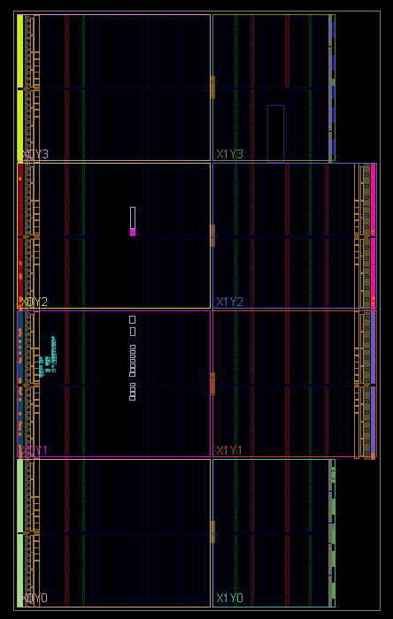

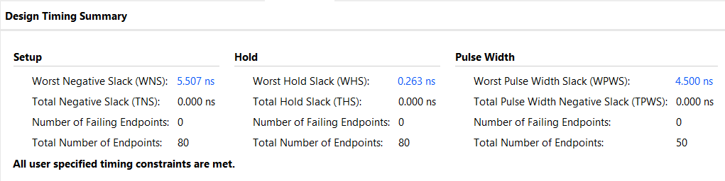

**POWER SUMMARY:**

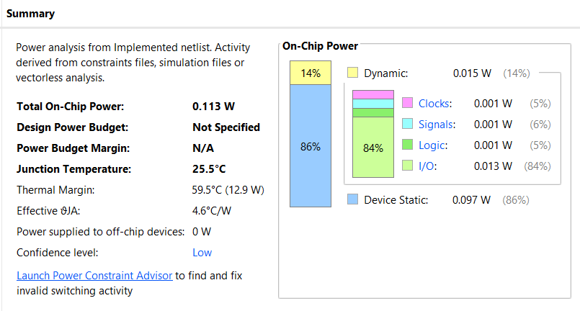

**UTILIZATION:**

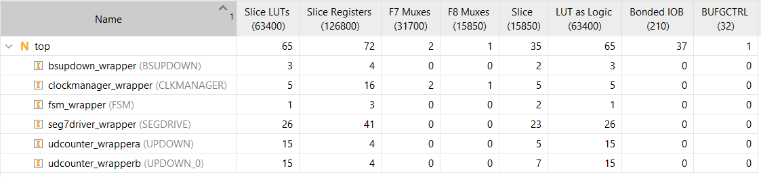

**RESOURCE USAGE:**

