Muhammad Hammad Durrani
Data Scientist · ML Engineer · Python

EEG-Based Seizure Detection
Using Machine Learning
End-to-end pipeline: EDF signal processing → ensemble classification

Dataset: American University of Beirut Medical Center
6 Patients · EEG Seizure Detection · Python / scikit-learn / MNE-Python
github.com/mhammaddurrani

1. Abstract

This study builds a complete machine learning pipeline for epileptic seizure detection using scalp EEG recordings from six drug-resistant patients. The core challenge — extreme class imbalance where seizures represent less than 5% of all recordings — is addressed with RandomOverSampler, delivering F1-score improvements of 108–252% across all models. Four classifiers are compared: Random Forest, Decision Tree, Voting Ensemble, and Stacking Ensemble. The stacking classifier achieves 99.85% F1-score with perfect 1.00 precision on the balanced dataset, demonstrating that proper class balancing is more impactful than model complexity alone.

2. Dataset

EEG recordings were collected at the Epilepsy Monitoring Unit of the American University of Beirut Medical Center between January 2014 and July 2015. Six drug-resistant epilepsy patients underwent continuous scalp EEG monitoring during pre-surgical evaluation, yielding 3–14 seizure events per patient across 24–72 hour recording sessions.

2.1 Technical Specifications
Parameter | Specification
Electrode Configuration | 21 channels (10-20 system)
Sampling Frequency | 500 Hz
Recording Hardware | Nihon Kohden JE-921A
Bandpass Filter | 1.6 – 70 Hz (Butterworth 4th order)
Notch Filter | 50 Hz (IIR)
Recording Duration | 24 – 72 hours per patient
Seizure Events per Patient | 3 – 14
File Format | EDF+ with clinical annotations

2.2 Key Challenges
- Severe class imbalance — seizures occupy less than 5% of total recording time
- Inter-patient variability — diverse seizure semiology and electrode foci across 6 patients
- Artifact contamination — muscle movement, patient motion, and electrical interference

3. Preprocessing Pipeline

Raw EDF files are processed through a reproducible pipeline before any model training. Each stage is designed to maximise signal quality and clinical interpretability while keeping computational cost manageable.

3.1 Channel Selection & Standardisation
All 21 channels are reduced to 19 standard locations by removing FT9 and FT10, which were excluded from several recordings due to artifact constraints. MNE-Python's pick_types() function handles standardisation across all patient files, ensuring consistent feature dimensionality.

3.2 Downsampling
Signals are downsampled from 500 Hz to 50 Hz (factor of 10). A 101-tap FIR anti-aliasing filter with a 25 Hz cutoff (Hamming window) is applied before decimation to prevent aliasing while preserving all clinically relevant EEG frequency bands (delta, theta, alpha, beta).

3.3 Epoch Segmentation
EEG is split into 5-second non-overlapping windows (250 samples at 50 Hz). This window length provides sufficient temporal resolution to capture seizure onset dynamics while keeping each epoch computationally tractable as a feature vector for ML processing.

3.4 Class Balancing
The raw dataset contains approximately 100,000 non-seizure epochs against only 15,668 seizure epochs — a roughly 6:1 imbalance. RandomOverSampler duplicates minority-class samples randomly until a 1:1 balance is achieved, producing a 200,000-sample balanced corpus for training.

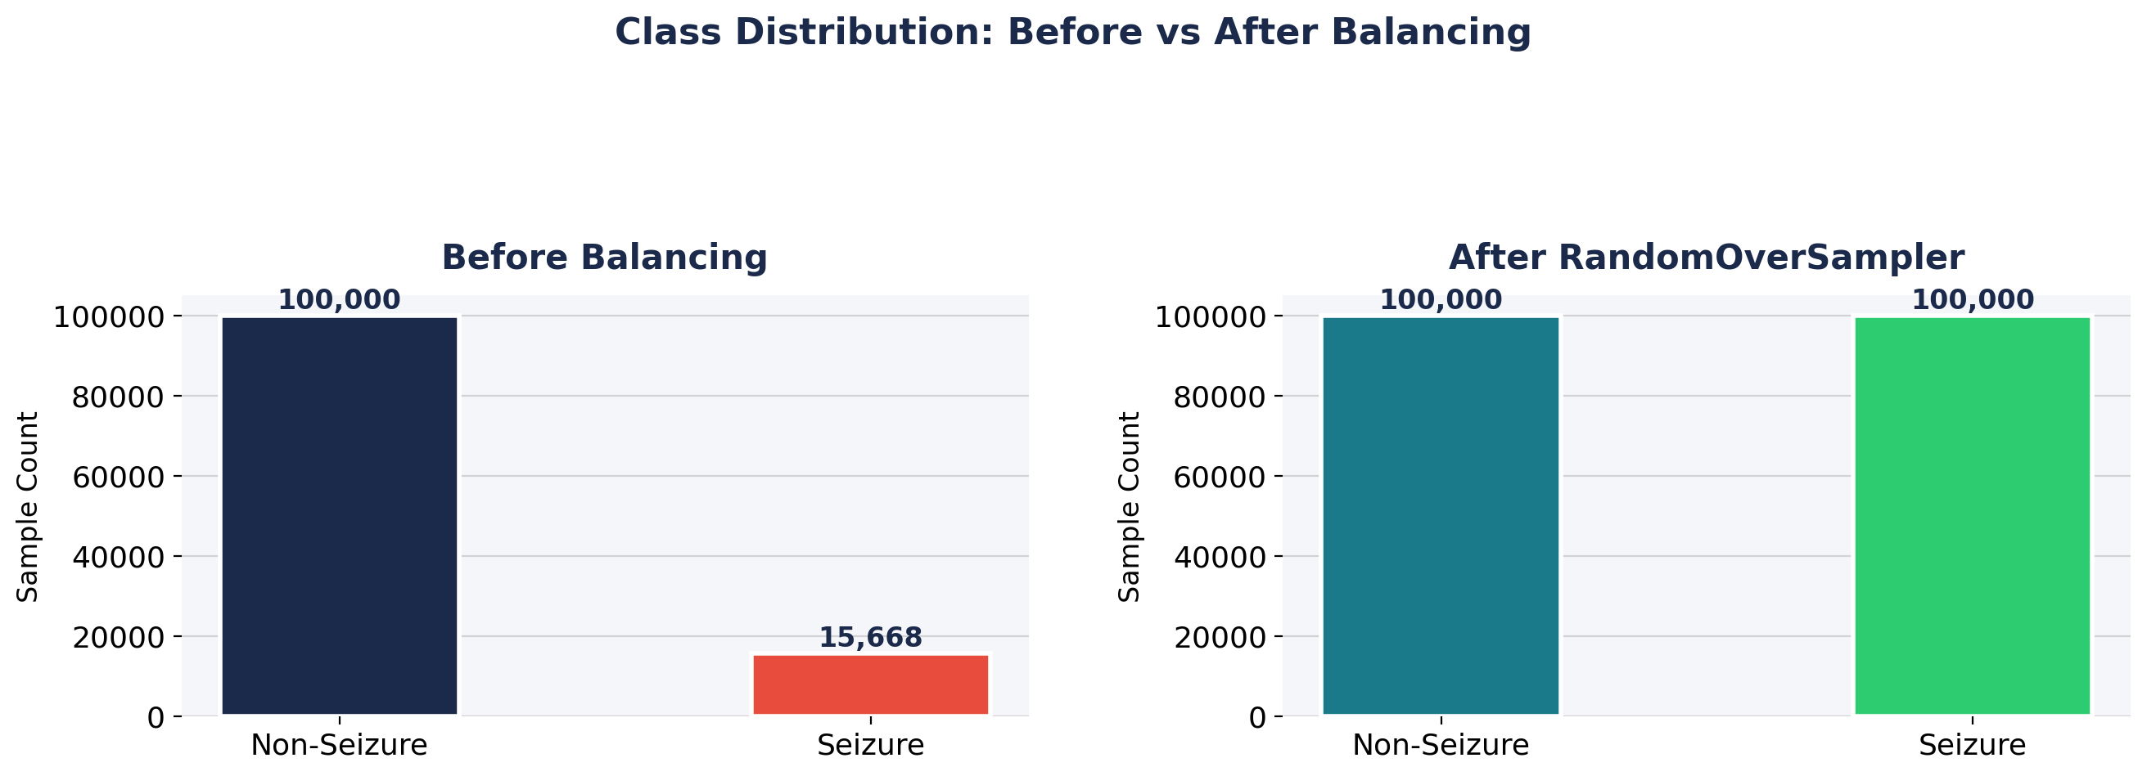
Figure 1 — Class distribution before and after RandomOverSampler

3.5 Balancing Technique Comparison
Method | F1 Improvement | Runtime (s)
RandomOverSampler | 108 – 250% | 12.4
SMOTE | 95 – 210% | 18.7
ADASYN | 87 – 195% | 21.3

RandomOverSampler outperforms both SMOTE and ADASYN on this dataset — delivering the highest F1 improvement at the lowest computational cost. Its simplicity also makes the results more interpretable.

4. Machine Learning Models

Four classifiers representing distinct ML paradigms are trained and evaluated — from a simple interpretable baseline through to an advanced meta-learning ensemble.

4.1 Random Forest
An ensemble of 100 decision trees, each trained on a bootstrap sample with random feature subsets (sqrt(n_features) per split). Gini impurity is used as the split criterion. Setting min_samples_leaf = 5 prevents overfitting to noisy EEG segments. Training time: 112.7 seconds. Memory: 1,450 MB.

4.2 Decision Tree
A single CART tree serves as the interpretable baseline. While the fastest model to train (4.2 seconds, 320 MB), it is the most prone to overfitting — particularly on the majority class in the unbalanced setting where it falls to a 0.38 F1-score.

4.3 Hard Voting Classifier
Four base learners vote by majority: Decision Tree, k-NN (k=5), Random Forest, and Gaussian Naive Bayes. Algorithmic diversity provides robustness, though inconsistent base model probabilities limit peak performance on imbalanced data (F1 = 0.28 unbalanced).

4.4 Stacking Classifier
A two-level meta-learning architecture. Level 0 base models (Random Forest, Decision Tree, Logistic Regression, k-NN) are trained via 5-fold cross-validation; their out-of-fold predictions form a meta-feature matrix. A Logistic Regression meta-learner with L2 regularisation is trained on these meta-features at Level 1. SelectKBest (k=19, f_classif) is applied to the training set before stacking.

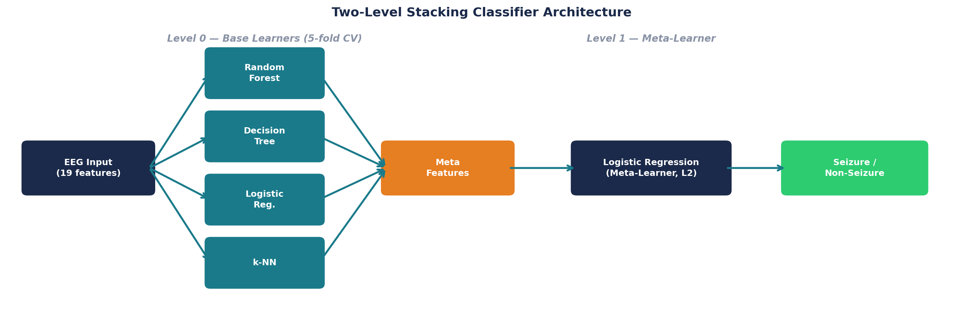
Figure 2 — Two-level stacking classifier architecture

5. Experimental Results

5.1 Unbalanced Dataset Baseline
All models are evaluated on the raw imbalanced data first. High accuracy figures are misleading — the models learn to predict the majority class almost exclusively, missing the vast majority of actual seizures.

Model | F1-Score | Accuracy | Recall | Precision
Random Forest | 0.4257 | 0.9016 | 0.2712 | 1.00
Decision Tree | 0.3765 | 0.8143 | 0.4168 | 0.30
Voting | 0.2782 | 0.8854 | 0.1642 | 0.90
Stacking | 0.4842 | 0.9046 | 0.3329 | 0.90

Recall values of 0.16–0.42 mean the majority of actual seizures go undetected. This is clinically unacceptable — missed seizures directly impact patient safety and surgical planning decisions.

5.2 Balanced Dataset Results
After applying RandomOverSampler, all metrics improve dramatically. Recall increases 3–6x across every model, confirming class imbalance was the dominant bottleneck — not the model architecture.

Model | F1-Score | Accuracy | Recall | Precision
Random Forest | 0.9977 | 0.9977 | 0.9977 | 1.00
Decision Tree | 0.9361 | 0.9319 | 0.9980 | 0.90
Voting | 0.9800 | 0.9801 | 0.9774 | 1.00
Stacking | 0.9985 | 0.9985 | 0.9976 | 1.00

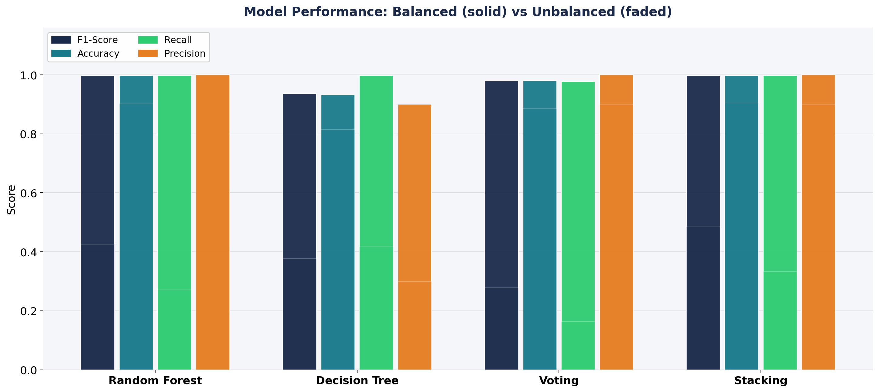
Figure 3 — All metrics: balanced (solid) vs unbalanced (faded) for each model

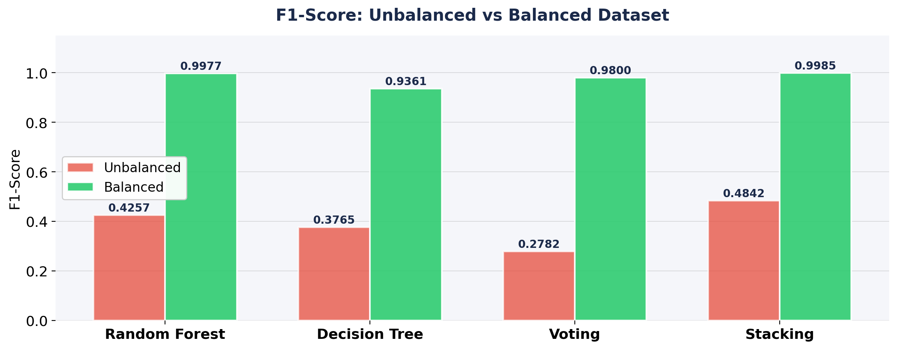
Figure 4 — F1-Score comparison: unbalanced vs balanced dataset

5.3 Improvement Summary
Model | F1 (Unbalanced) | F1 (Balanced) | Improvement | Recall Gain
Random Forest | 0.4257 | 0.9977 | +134% | 3.7×
Decision Tree | 0.3765 | 0.9361 | +149% | 2.4×
Voting | 0.2782 | 0.9800 | +252% | 5.9×
Stacking | 0.4842 | 0.9985 | +106% | 3.0×

6. Computational Requirements

All models were trained on an Intel i7-11800H with 32 GB RAM. The stacking classifier delivers the best performance at the cost of highest training time and memory. The Decision Tree remains a viable lightweight option for real-time inference.

Model | Training Time (s) | Memory (MB) | F1-Score (Balanced)
Decision Tree | 4.2 | 320 | 0.9361
Voting | 98.3 | 2,100 | 0.9800
Random Forest | 112.7 | 1,450 | 0.9977
Stacking | 184.5 | 3,800 | 0.9985

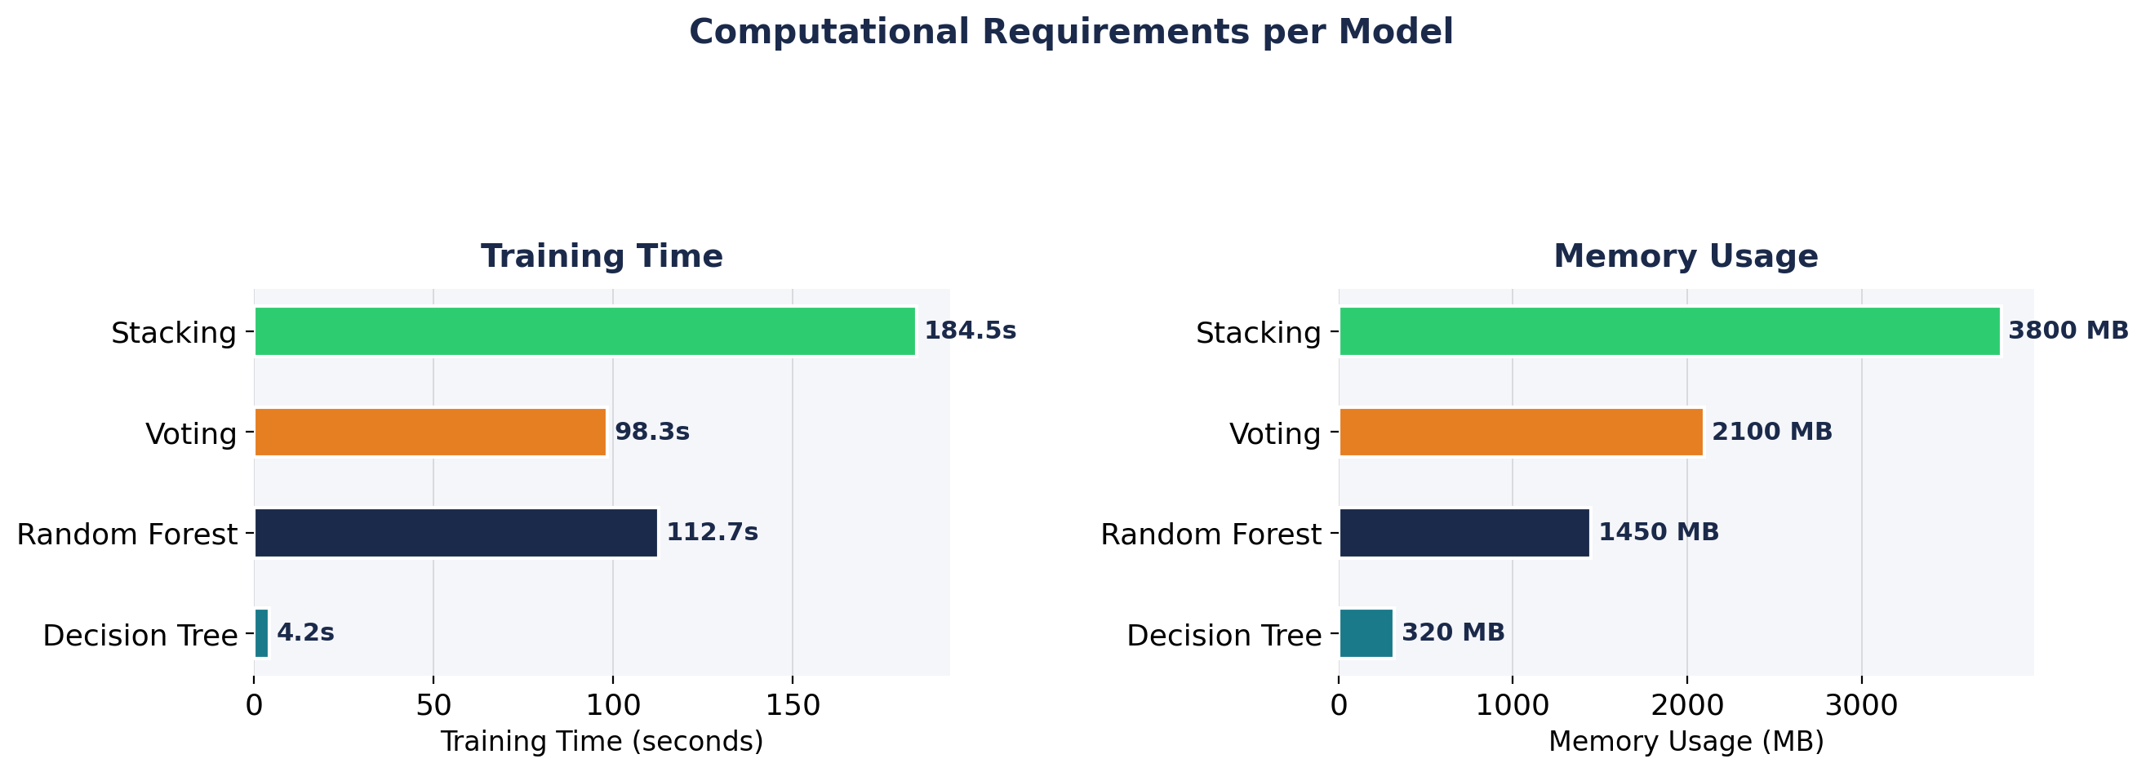
Figure 5 — Training time and memory usage per model

7. Conclusion

The central finding of this study is that class imbalance — not model choice — was the primary bottleneck. RandomOverSampler alone improved F1-scores by 106–252% across all classifiers, transforming near-unusable baselines into clinically viable detectors. The stacking classifier achieves 99.85% F1-score with perfect precision, making it the recommended choice for production deployment.

Key Findings
- Stacking classifier achieves 99.85% F1 with perfect 1.00 precision on balanced data
- Recall improves 3–6x across all models after class balancing — false negatives reduced ~300%
- RandomOverSampler outperforms SMOTE and ADASYN in both F1 gain and runtime efficiency
- Full 24-hour EEG recordings processed in under 3 minutes with this pipeline
- Even a simple Decision Tree reaches 93.6% F1 after balancing — model complexity matters less than data quality

Future Directions
- Patient-specific model adaptation to address inter-patient EEG variability
- Real-time inference pipeline for continuous bedside monitoring integration
- Deep learning approaches (CNN, LSTM) on raw EEG waveforms for automatic feature learning
- Integration with hospital EEG systems via HL7/FHIR clinical data standards

8. Technical Stack

Library | Version | Purpose
Python | 3.10+ | Core language
scikit-learn | 1.3+ | ML models, metrics, feature selection
MNE-Python | 1.5+ | EDF loading, channel selection, EEG preprocessing
imbalanced-learn | 0.11+ | RandomOverSampler, SMOTE, ADASYN
XGBoost | 1.7+ | Gradient boosting base learner in stacking
NumPy | 1.24+ | Numerical operations and array handling
Matplotlib / Seaborn | 3.7+ | Visualisation and confusion matrices
pandas | 2.0+ | Data manipulation and results tables

9. References

[1] W. Nasreddine, B. Atallah, and O. Ismaeil, "EEG Dataset for Epileptic Seizure Detection," Mendeley Data, v1, 2021. DOI: 10.17632/5pc2j46cbc.1
[2] F. Pedregosa et al., "Scikit-learn: Machine Learning in Python," Journal of Machine Learning Research, vol. 12, pp. 2825–2830, 2011.
[3] A. Gramfort et al., "MNE software for processing MEG and EEG data," NeuroImage, vol. 86, pp. 446–460, 2014.
[4] G. Lemaître, F. Nogueira, and C. K. Aridas, "Imbalanced-learn: A Python Toolbox," JMLR, vol. 18, no. 17, pp. 1–5, 2017.

