IFRC Global Humanitarian Dashboard
An Interactive R Shiny Dashboard for Global Disaster Response Data

 | 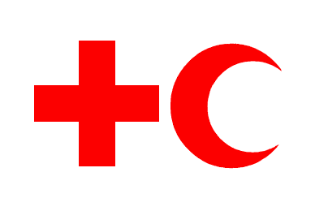

PROJECT REPORT
Mhamad Shhab Aldeen Hasan | P166175
MSc Data Science & Analytics, Universiti Kebangsaan Malaysia
STQD6124 Data Visualization & Communication

1. Overview
The IFRC Global Humanitarian Dashboard is an interactive R Shiny application built to explore humanitarian emergency data published on the IFRC GO Platform. It brings together three real, unedited datasets — Emergency Events, Appeals, and Countries — spanning 2023–2026, covering 1,000 logged disaster events, 1,000 funding appeals, and 151 countries.
Unlike a static report, the dashboard lets a user filter, click, and drill into individual events and appeals in real time — by region, country, disaster type, severity, appeal status, and year. The goal was to give the same evidence-based storytelling as the project's companion R Markdown storyboard, but in a format built for hands-on exploration rather than a fixed narrative.

Key headline figures shown on every tab
1,000 | 151 | $4.34B | $1.99B | $2.35B | 6
Events | Countries | Aid Requested | Aid Funded | Funding Gap | Red Alerts

2. Technical Architecture
The dashboard is built entirely in R using the Shiny reactive framework, with the following supporting packages:
Package | Role in the dashboard
shiny | Core reactive web application framework
leaflet | Interactive choropleth world map (Events Map tab)
sf / rnaturalearth | Real country boundary polygons for the choropleth
plotly | Interactive charts (bar, line, donut) across all tabs
dplyr | Data filtering, joins, and aggregation
DT | Sortable, searchable data table (Appeals tab)
lubridate / stringr / scales | Date handling, text cleaning, number formatting

All filters across the three tabs are reactive: selecting a region, country, disaster type, severity level, or year range immediately recalculates the map, charts, and data table without reloading the page.

3. Dashboard Walkthrough
The dashboard is organised into three tabs, each covering a different angle on the same underlying data: where disasters are happening, how well they are funded, and what patterns emerge over time.

TAB 1 — Events Map

The Events Map tab is the dashboard's entry point. On the left, five filters (region, country, disaster type, severity, and a year-range slider) narrow the dataset in real time, with a live-updating list of matching events below. On the right, an interactive choropleth map colours every country by how many matching events it has logged darker red means more events, and countries with zero matching events still render in light grey rather than being left blank, so the map always shows the complete picture rather than only a partial one.
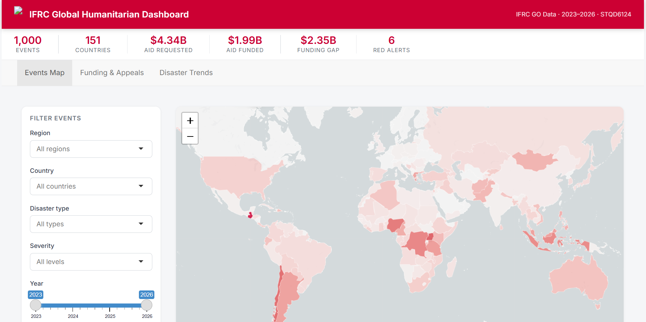
Figure 1. Events Map tab — filter panel and country choropleth.
Clicking any country on the map, or any event in the list, opens a detail panel with the disaster's name, country, date, type, IFRC severity rating, the responding National Society (with a live link to its website), and a cleaned summary of the situational report.

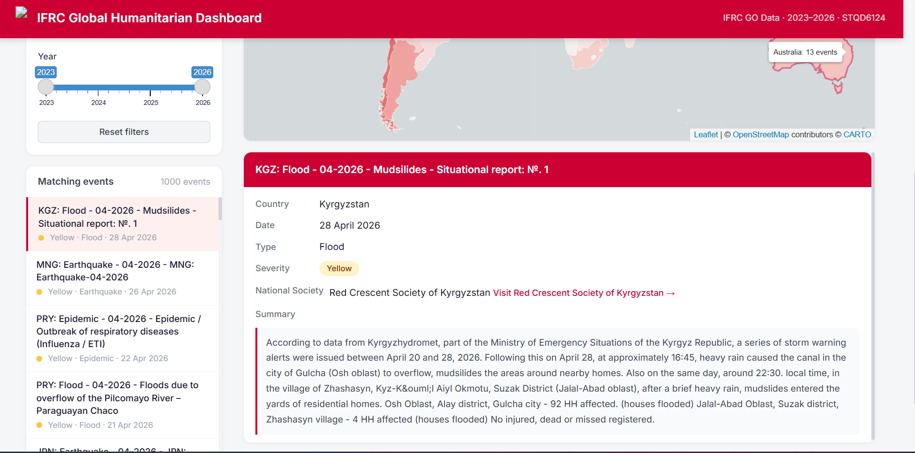
Figure 2. Clicking an event (here, a flood in Kyrgyzstan) opens its full detail panel, including the National Society link and situational report summary.

TAB 2 — Funding & Appeals

The Funding & Appeals tab answers the dashboard's most important question: is IFRC receiving the money it asks for? Four summary cards at the top give the headline numbers — total requested, total funded, the resulting gap, and the average percentage funded across all appeals — recalculated live as filters change.
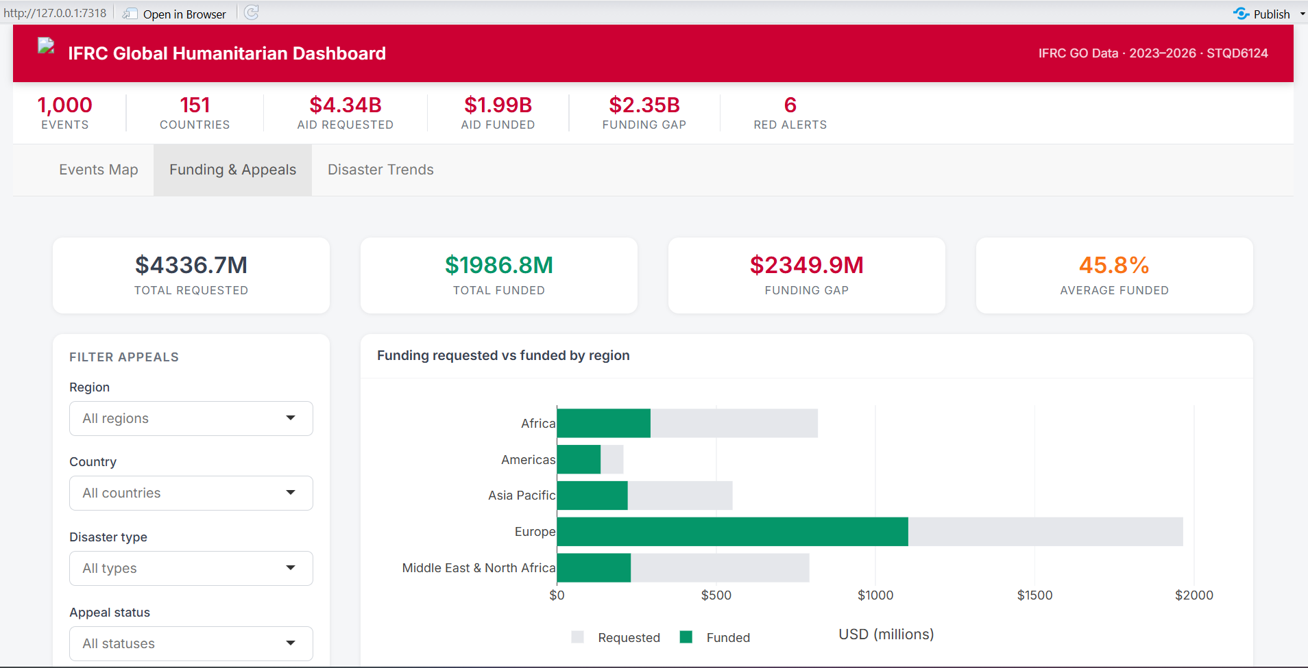
Figure 3. Funding & Appeals tab — summary cards and the requested-vs-funded chart by region.
Below the summary cards, a horizontal bar chart compares requested versus funded amounts by region, making it immediately visible that funding shortfalls are not evenly distributed — some regions consistently receive a larger share of what they ask for than others. A full, searchable appeal-level table sits beneath the chart, with colour-coded status badges (Active, Closed, Frozen) and a direct link to each National Society's website.
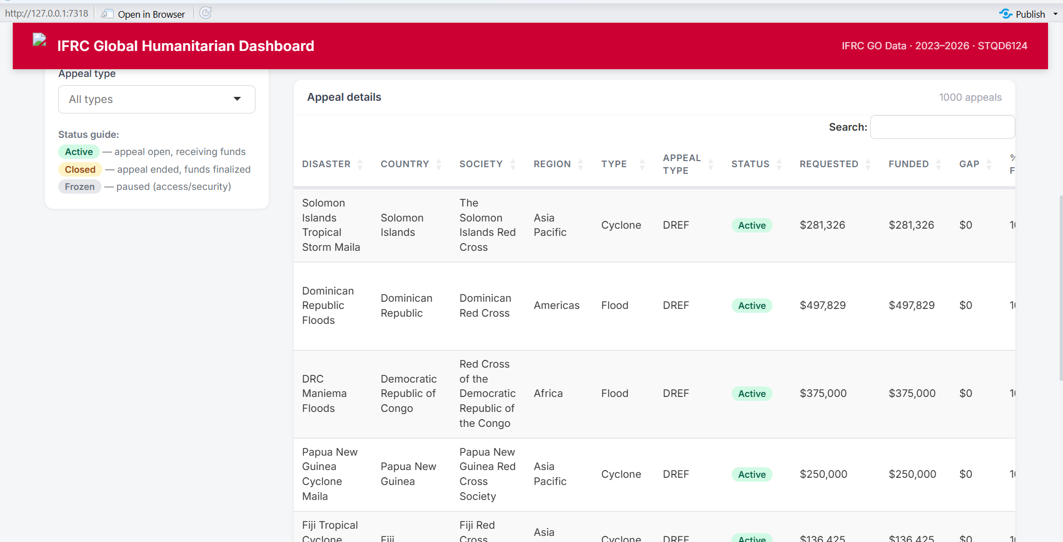
Figure 4. The appeal-level data table, with status badges and a live status guide explaining what each badge means.

TAB 3 — Disaster Trends

The Disaster Trends tab steps back from individual events to show patterns across the whole dataset. A horizontal bar chart ranks disaster types by frequency floods dominate, consistent with their global reach and seasonal recurrence while a multi-line chart alongside it tracks how each disaster type's event count has moved year by year from 2023 to 2026.
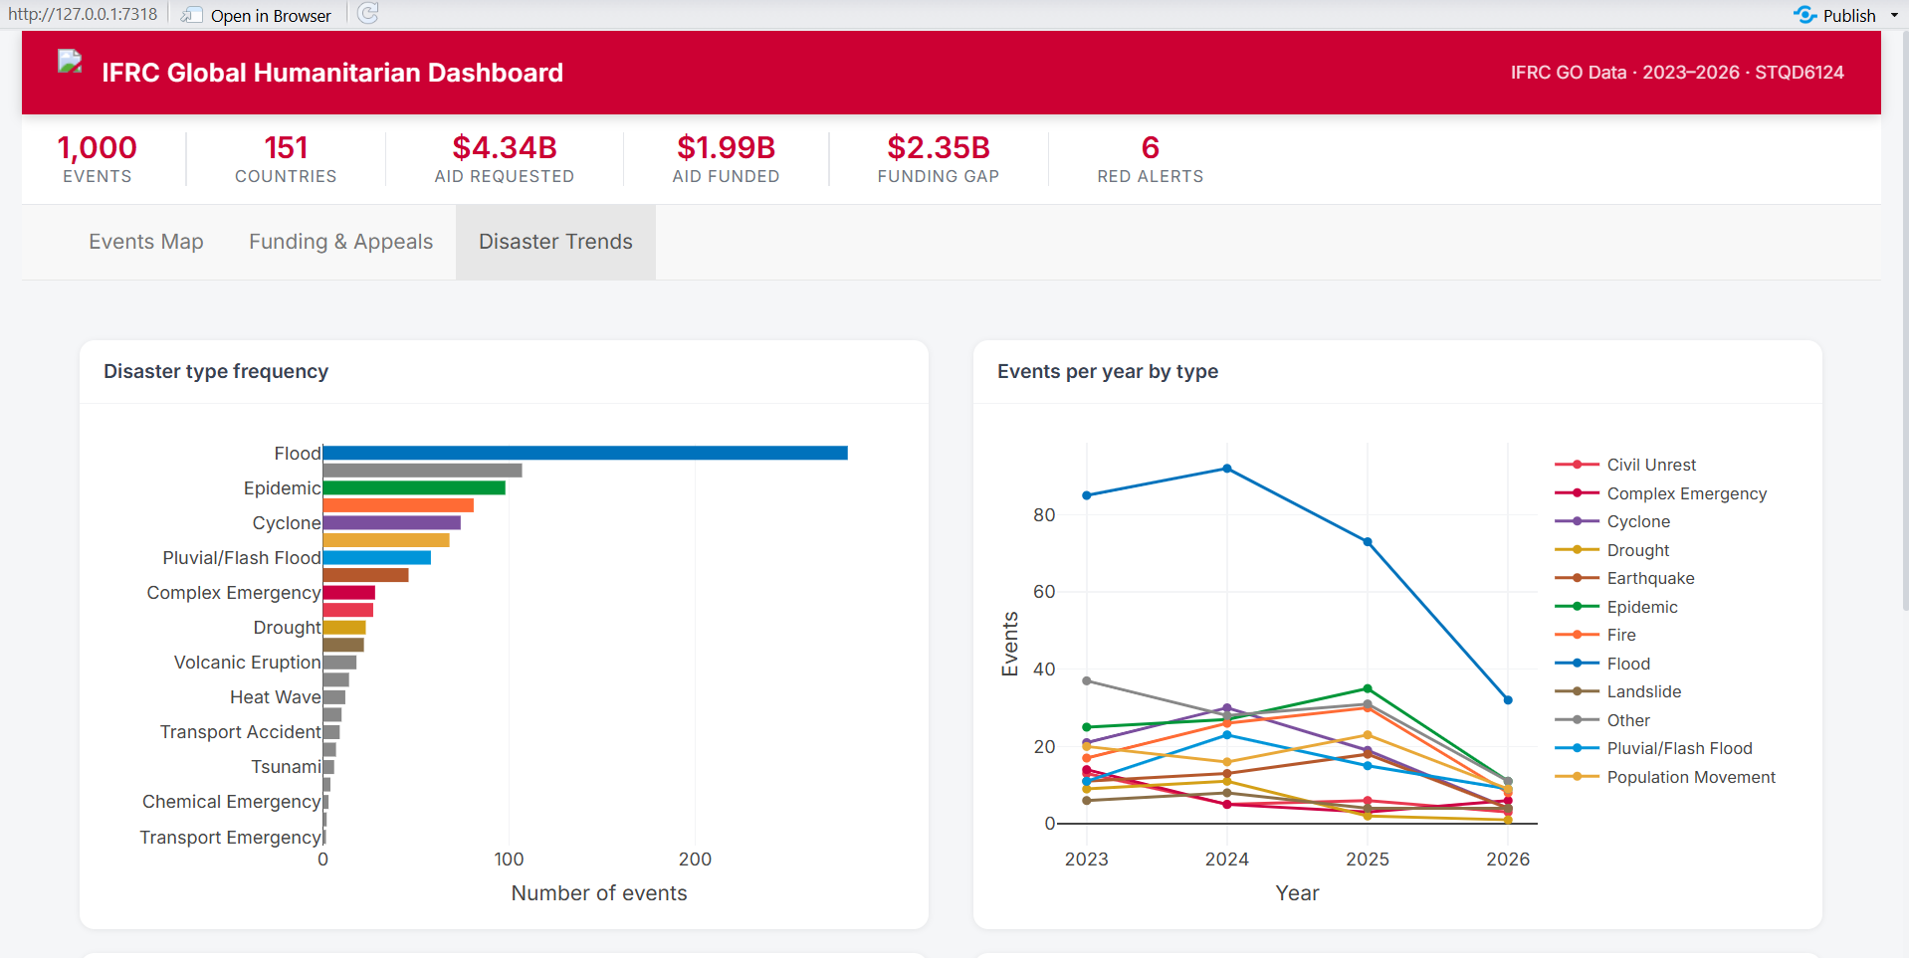
Figure 5. Disaster type frequency (left) and year-by-year trend per disaster type (right).
Underneath, a donut chart breaks down IFRC's own severity classification (Yellow, Orange, Red) across all logged events, and a second bar chart ranks the 15 most affected countries by raw event count giving a quick answer to “where is this happening most?” without needing to touch a filter.
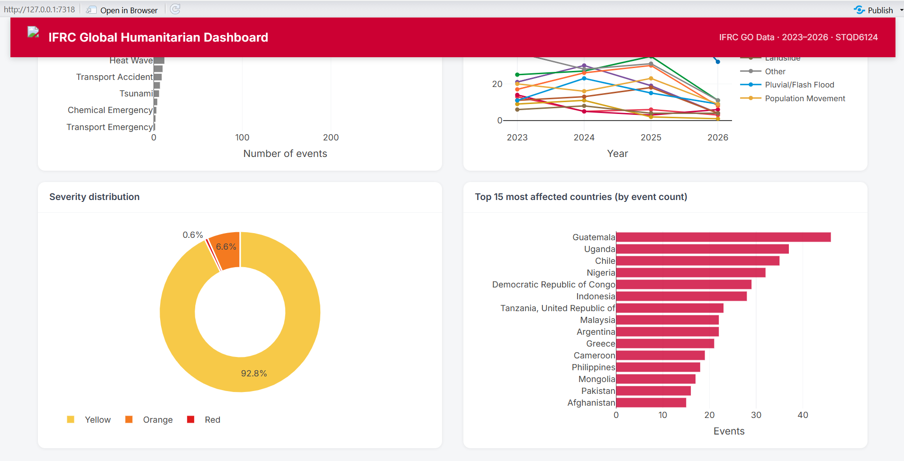
Figure 6. Severity distribution (left) and the 15 most affected countries by event count (right).

4. Design & Branding
The dashboard's visual identity was built to match IFRC's own brand rather than use Shiny's default styling. All UI elements were custom-styled with CSS layered on top of the standard Shiny/Bootstrap components:
- Primary red (#CC0033) used for the top bar, active tab underline, key statistics, and chart accents.
- Neutral grays (6B7280 / #E5E7EB) for secondary text, borders, and card backgrounds, keeping the red reserved for what matters most.
- Card-based layout every chart, table, and panel sits in its own white rounded card with a subtle shadow, consistent across all three tabs.
- Inter typeface (loaded from Google Fonts) for a clean, modern sans-serif look throughout.
- Status colour coding green for funded amounts, red for gaps, orange for percentages, and a traffic-light badge system (green/yellow/gray) for appeal status.

5. Data Integrity Notes
In keeping with the same principle applied throughout this project's companion storyboard, the dashboard is built exclusively from real, unedited fields in the source datasets. Two limitations are worth stating explicitly:
- The map colours and event counts reflect the Emergency Events extract as logged by IFRC field reports; they are a record of what was reported, not an independent verification of ground conditions.
- Funding figures (requested, funded, gap) come directly from the Appeals extract's own amount_requested and amount_funded fields, aggregated with no adjustment or estimation.
No value in this dashboard is simulated, interpolated, or estimated beyond straightforward aggregation (counts, sums, and percentages) of the source data.

6. Summary
Together, the three tabs let a user move from a global overview (Disaster Trends), to a specific country or event (Events Map), to the financial reality behind the response (Funding & Appeals) — all from the same underlying, honestly-documented dataset. The dashboard is intended as a companion tool to the project's R Markdown storyboard: where the storyboard tells one fixed story, this dashboard lets the reader explore the data on their own terms.

