**Topic**

Title: Surficial Geologic Map of the Union Qaudrangle, Kentucky

This map will show the surficial geology deposits of the Union Quadrangle in Northern Kentucky. The map will show various deposits such as alluvium, glacial drift, and residuum.

**Objective**

The objective of this map is to show people the surficial geology of the Union Quadrangle. I want to be able to display this and other surficial geology maps on the web so I can understand the process better of displaying my maps online. It may be a way for us to host our maps at some point. I want to learn the different user interactivity that can be used. This map can be used by the general population for a variety of reasons, such as: building construction, road construction, and other land use purposes. The user could look at this map and determine which areas are suitable to build on, such a land developer looking for suitable areas to build new subdivisions, that are geologically stable. I would like for a user to be able to turn on and off certain sediment layers on the map.

**Data Source**

The data will come from the KGS. I created the data for this quad 2 years ago. Here is a pic of the finished map in pdf form. I will include a shape file to go along with this.

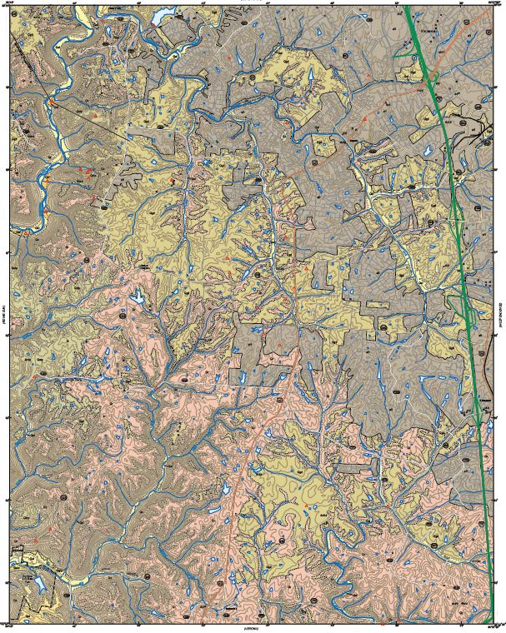

**Technology Stack**

I would imagine I would use ArcMap, but may try to open the file in QGIS. I’m not sure on how to approach this. I need some guidance from you. I think I would use a GeoJSON file. I do not think we have covered this entirely, as far as bringing a shapefile in. I’ll probably use GitHub Pages to host it.