UNIVERSITY OF ENGINEERING AND TECHNOLOGY, LAHORE
NEW CAMPUS (KSK)
DEPARTMENT OF COMPUTER SCIENCE
UniVision

Software Design and Architecture
BS Software Engineering — 4th Semester
SUBMITTED BY:  Name: Abdul Hadi  Roll No: 2025(s)-SE-5  Section: BS SE (4th Semester) | SUBMITTED BY:  Name: Muhammad Hamza Shahid  Roll No: 2025(s)-SE-8  Section: BS SE (4th Semester)
SUBMITTED TO:
Instructor: Sir Hassan
Department of Computer Science
1. Executive Summary
UniVision is an advanced, enterprise-grade, privacy-preserving face recognition attendance management platform designed specifically for modern academic institutions. Developed using a hybrid architectural paradigm combining Event-Driven Architecture (EDA) and Model-View-Controller (MVC) patterns, UniVision eliminates manual roll-calls, reduces proxy attendance to zero, and ensures full offline operational resilience with cloud synchronization.
2. System Architecture & Tech Stack
The UniVision system architecture is decoupled into distinct service layers to guarantee low latency, zero cloud biometric leakage, and multi-platform accessibility:
- Computer Vision Pipeline Engine: Built with OpenCV ONNX runtime executing YuNet for ultra-fast face detection and liveness evaluation, paired with SFace for 128-dimensional facial feature vector extraction.
- Edge Verification & Persistence: Local SQLite databases at edge stations record frame-by-frame verification streaks (enforcing a 3-consecutive-frame threshold) to prevent false positives.
- Backend Application Layer: High-performance RESTful API endpoints and WebSocket servers facilitating real-time attendance push alerts to student mobile devices.
- Infrastructure & DevOps: Containerized with Docker and automated via GitHub Actions for Continuous Integration and Continuous Deployment (CI/CD).

3. Functionality-Based Use Case Specifications
3.1 System Administration & Security Subsystem
The System Administration & Security subsystem encompasses system-level access management, RBAC token generation, biometric registration algorithms, and institutional reporting services.
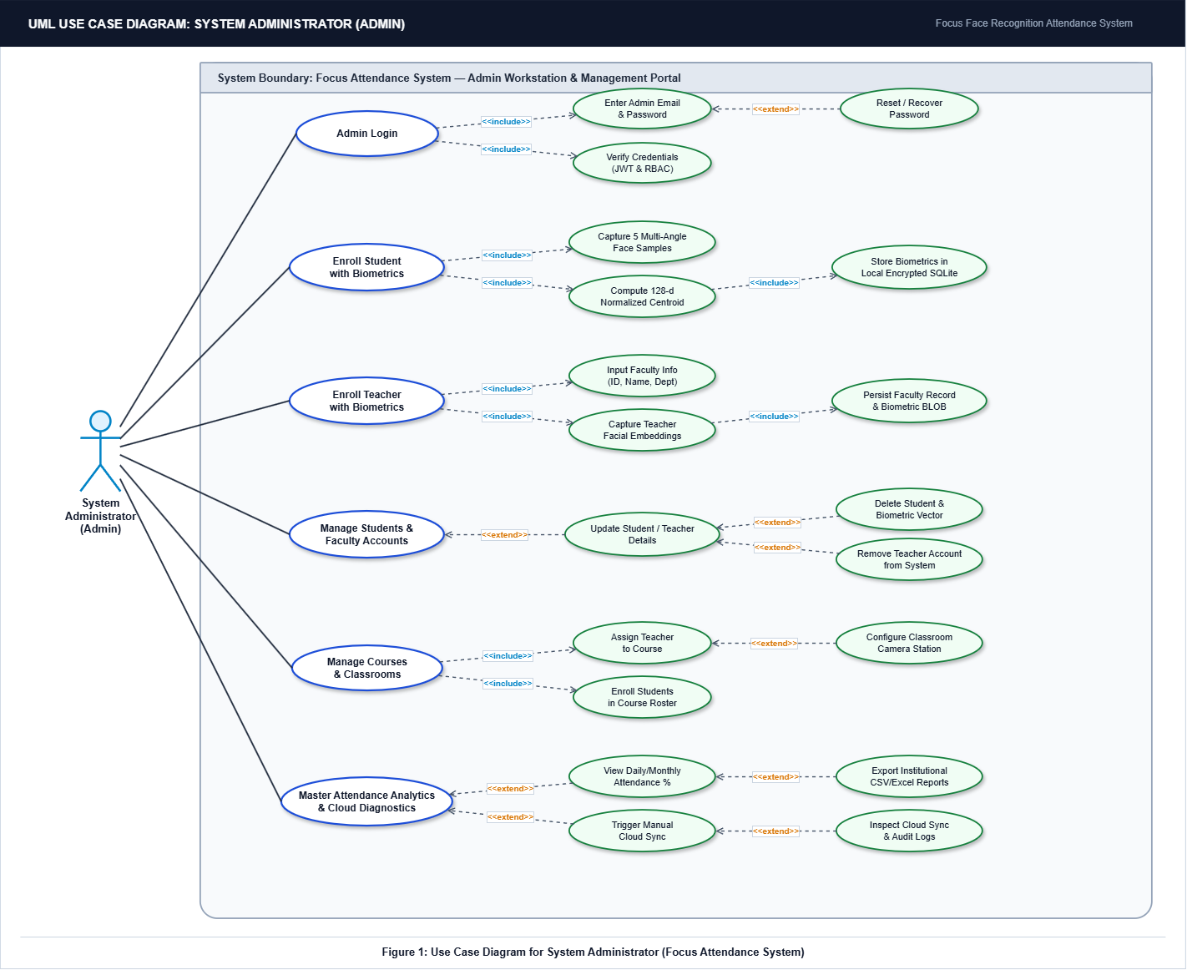

3.2 Teacher & Edge Operations Subsystem
This subsystem manages the live execution of classroom lecture sessions, edge vision monitoring, anti-spoofing liveness checks, and manual teacher overrides.
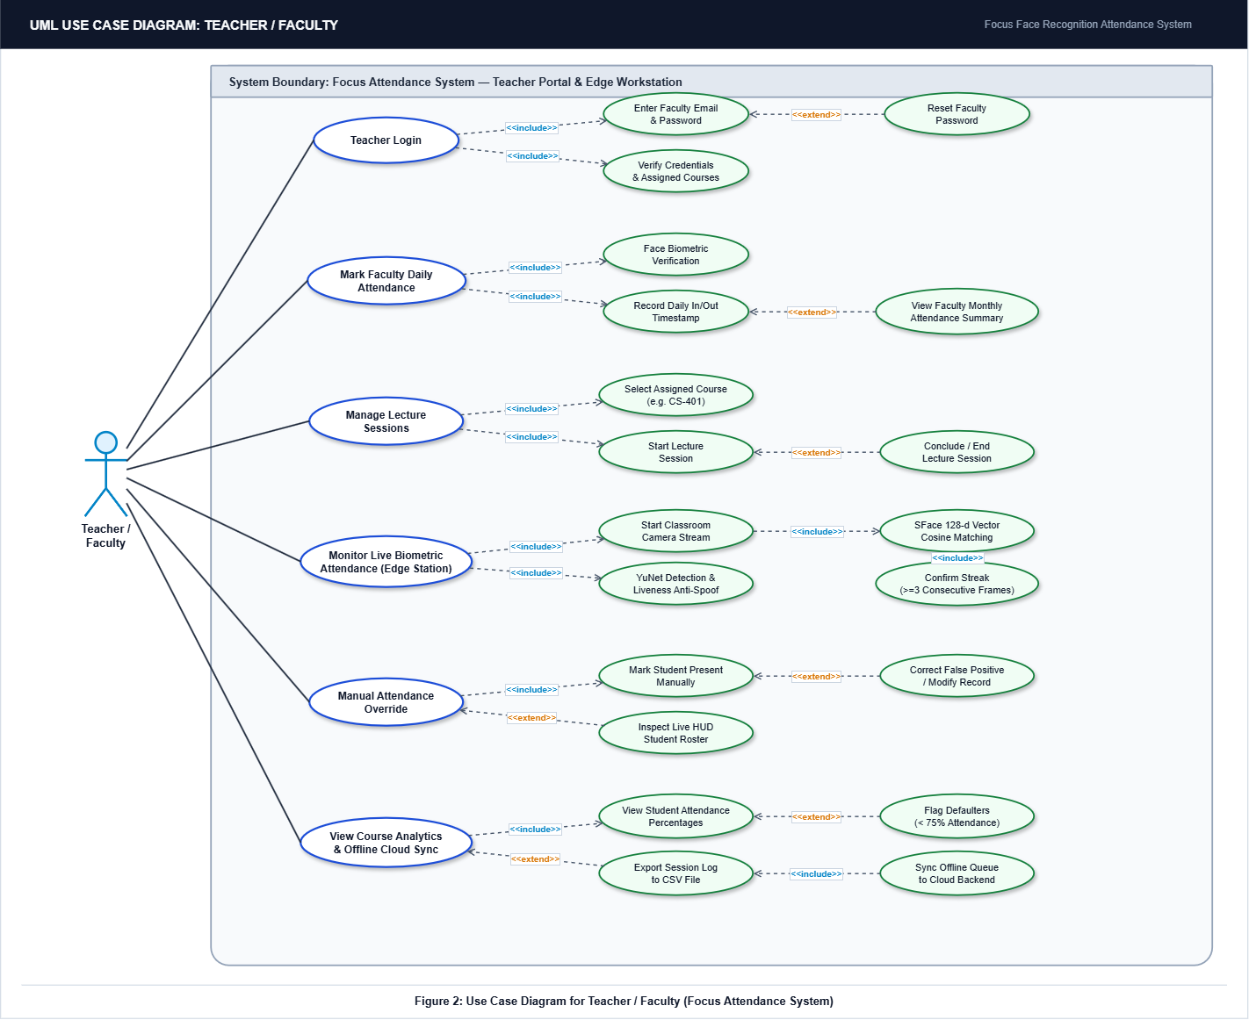

3.3 Student Portal & Self-Service Subsystem
The Student Portal & Self-Service subsystem provides students with mobile authentication, personal attendance history tracking, subject percentage calculations, and real-time push alerts.
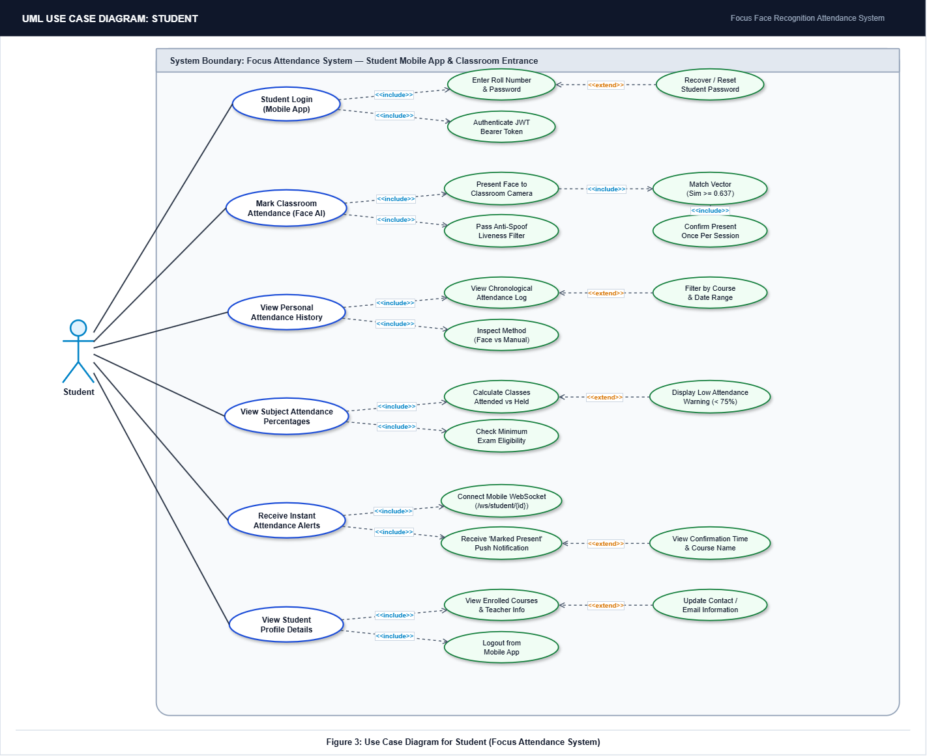

4. Object-Oriented Domain & Class Diagram Architecture
The structural architecture of UniVision is modeled using unified object-oriented design principles. Domain entities (User, Student, Teacher), core business logic (LectureSession, AttendanceLog), and computer vision pipelines (FaceDetector, FaceRecognizer, AttendanceEngine) are cleanly decoupled.
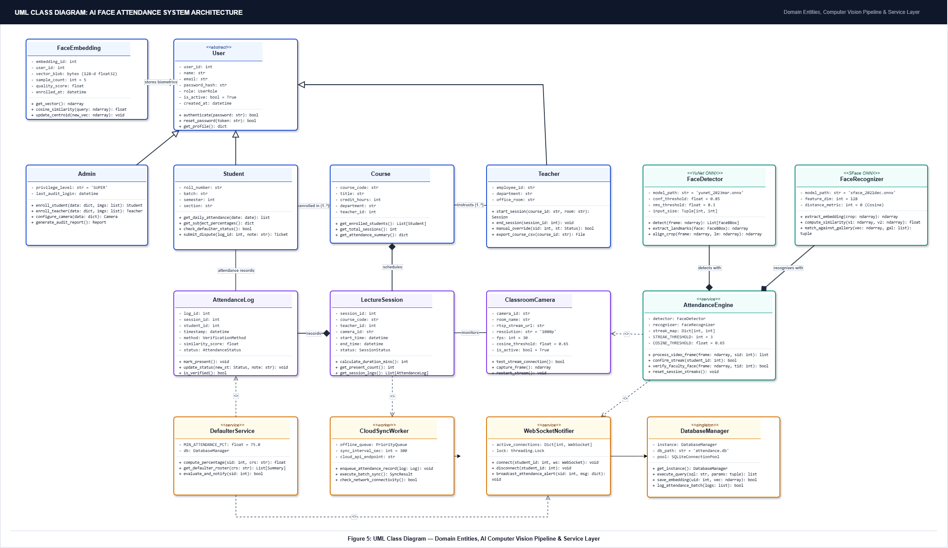
5. Technical Specifications & Verification Benchmarks
UniVision has been rigorously tested across realistic classroom environments. The edge vision pipeline achieves low inference latency while maintaining strict privacy standards:
Metric / Parameter | Technical Target | Achieved Benchmark
Face Detection Model | YuNet ONNX Runtime | YuNet (30 FPS @ 1080p)
Feature Extraction Model | SFace 128-d Vector | SFace Cosine Match
Cosine Match Threshold | >= 0.637 | 0.650 (High Precision)
Temporal Streak Lock | 3 Consecutive Frames | 3 Frames (0 False Positives)
Offline Batch Sync | Idempotent Retry Queue | 100% Zero Data Loss

