**Portfolio #1**

First described by economist William Forester Lloyd in 1833 in a discussion about overgrazing cattle, the Tragedy of the Commons was born. Garrett Hardin, roughly one-hundred years later, revised the concept to describe the phenomena that occur when a limited resource is shared and harvested at different rates. The basic concept is that there is a limited resource that is being harvested and is of popular demand. Being limited, that resources holds a threshold at which it can be harvested without complete and immediate depletion.

Several businesses today struggle in maintaining this threshold and understanding the effect of their harvesting rates on that threshold. More specifically it can be difficult to understand how under harvesting compares to over-harvesting and what can be done to recover from these situations.

Previously, we have worked personally with a fish hatchery that undergoes this phenomenon consistently. From that experience, we were able to develop a differential equation [Figure 1.1] to model what that hatchery’s fish population, P, would look like over a significant amount of time, t, where the population is in thousands and time is in years.

$\frac{dP}{dt}=2P(1 - \frac{P}{25})$ [Figure 1.1]

Recently, the owners of Fish.net purchased this hatchery with the intention of allowing fishing to the public. Being inexperienced with hatcheries and how harvest rates can dramatically affect population, the hatchery’s population was fluctuating fast. Upon seeing our previous success with the hatchery, the owners of Fish.net decided to reach out to us for assistance in repairing the population loss to the hatchery.

$\frac{dP}{dt}=2P(1 - \frac{P}{25}) - k$ [Figure 1.2]

In tackling this problem, we began by altering our model equation to incorporate harvesting, k [Figure 1.2]. In order to analyze and understand properly how the population changed, we investigated their previous harvesting rates and the effect each one had on the population of fish. From that investigation, we were able to come to a solution on how to restore the initial population.

After significant communication with the owners of Fish.net, they agreed on our model equation [Figure 1.2] as it related to their business decisions. Upon agreeing with that model, they informed us that they initially allowed a harvesting rate of 12 (k=12). Upon plugging in the determined value for the harvesting rate, we were left with a quadratic equation.

$\frac{dP}{dt}=2P(1 - \frac{P}{25}) - (12)$

$\frac{dP}{dt}=- \frac{2P^{2}}{25}+2P – 12$

Given that the equation models the rate at which population changes, if we set the quadratic equal to zero and solve for population, P, we are therefore able to see where the population plateaus for different initial conditions. Given that the model is a quadratic, we can simply plug it into the quadratic formula to get our solution.

$\frac{dP}{dt}=- \frac{2P^{2}}{25}+2P – 12=0$

$a=-\frac{2}{25} , b=2 , c=-12$

$P=\frac{-(2)±\sqrt{{(2)}^{2}-4(-\frac{2}{25})(-12)}}{2(-\frac{2}{25})}$

$P=10 and P=15$

Given these values, we know how the population remains unchanged at those values, but we don’t know the behavior around those values. To easily view this behavior, we can graph our model equation with the given harvesting rate [Figure 1.3].

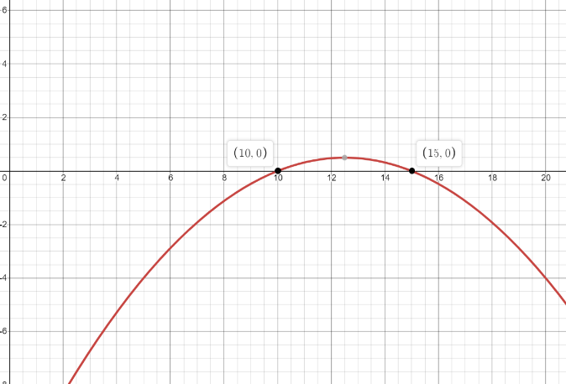

[Figure 1.3] (Desmos.com)

It is clear to see that with this harvesting rate if the initial population was less than 10,000 fish, the population would decrease until the population was completely depleted. In the event that the population lies somewhere between 10,000 and 15,000 fish, the population would grow logistically approaching a plateau of 15,000 fish. Finally, if the population lies anywhere above 15,000 fish, the population will decrease and over a significant amount of time slowly approach a plateau at 15,000 fish. This can be visualized in the following graph [Figure 1.4].

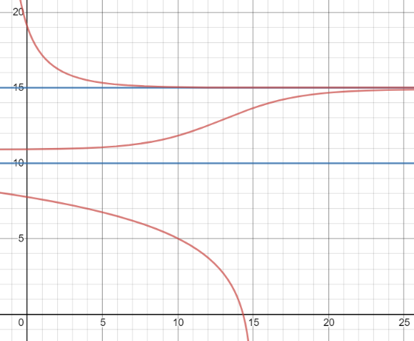

[Figure 1.4] (Desmos.com)

For the first few years, the harvesting rate of 12 was working well and Fish.net was making a good profit and the population was remaining stable. To capitalize on their success, they decided to increase the harvesting rate by a minor amount. To determine the effect that the new harvesting rate would have on the fish population we followed the same process we did previously.

$$\frac{dP}{dt}=2P(1 - \frac{P}{25}) - (13)$$

$\frac{dP}{dt}=- \frac{2P^{2}}{25}+2P – 13$ =0

$a=-\frac{2}{25} , b=2 , c=-13$

$P=\frac{-(2)±\sqrt{{(2)}^{2}-4(-\frac{2}{25})(-13)}}{2(-\frac{2}{25})}$

$$P=nonreal answer$$

Given that when solving for when the population is not growing results in a nonreal answer means that the population is always growing or always decreasing. To tell what is happening in this case, a graph of the modified model will make it clear [Figure 1.5].

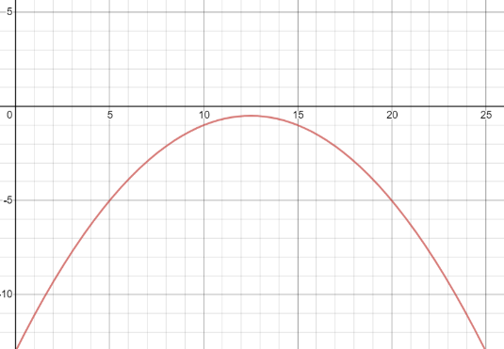

[Figure 1.5] (Desmos.com)

After viewing the graph, it is clear that no matter what the fish population is initially, it will decrease and if allowed to decrease long enough, the population will be depleted.

The owners of Fish.net became aware of the depleting population when it fell to only 5,000 fish. In fear that the population would quickly be gone, but also not wanting to halt business, returned to the harvesting rate of 12. After realizing this did not solve the issue they panicked further as the population fell to 4,000 fishes. It was at this point that Fish.net reached out to us for help in restoring the fish population. We assured them that there was an easy solution although it may damage their business’s income temporarily.

Before we can determine a new harvesting rate that would allow the business to continue without depleting the hatchery, we must first understand why the population continued to decrease. Looking back at the model created with a harvesting rate of 12, recall that there were two points at which the population would not change. Those two values were when the population was equal to 10,000 and when the population was equal to 15,000. We followed up this discovery by determining the behavior around these population sizes. When the initial population was below 10,000, we saw a trend in population decease and when considering that our new initial condition for this harvesting rate is less than 10,000, it makes sense that our population would decrease further.

Now we are in the situation of determining what new harvesting rate can we apply to our initial population of 4,000, which would have a trend in increasing population. In order to answer this question optimally, we can create a bifurcation graph to represent every harvesting rate. In creating a bifurcation graph, we allow the x-axis to be k, our harvesting rate, and our y-axis to be P, the population of fish. Recall in comparing harvesting values to the population we set our rate of change model equal to zero after plugging in our value for k. If we set our model to zero without plugging in any values for k, we are left with an equation, in terms of k and P, what the population will plateau at for different values of k.

$$\frac{dP}{dt}=2P(1 - \frac{P}{25}) - k$$

$\frac{dP}{dt}=- \frac{2P^{2}}{25}+2P – k$ =0

$a=-\frac{2}{25} , b=2 , c=-k$

$P=\frac{-(2)±\sqrt{{(2)}^{2}-4(-\frac{2}{25})(-k)}}{2(-\frac{2}{25})}$ [Figure 1.6]

If we graph the new model equation [Figure 1.6], we can better visualize optimal harvesting rates.

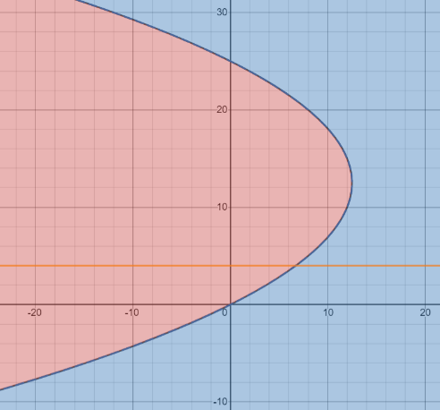

[Figure 1.7] (Desmos.com)

Finally, in getting a new harvesting rate that would allow the population to restore, we graph the line P = 4 in order to find the intersection point with the bifurcation. Since the bifurcation line tells us points in which the population is not changing, the intersection point tells us that for a certain harvesting rate k, the population will remain 4,000 forever. Since we want to eventually restore the population, we will choose any k value less than that intersections k value. Since the k value at that intersection is 6.72, we now know that as long as less than 6,720 fish are harvested each year the population will experience a trend to increase. Additionally, by examining the upper plateau, we can see if they dropped the harvesting value below 6.72, the fish population has the potential raise to upwards of 21,000 or more, depending on the value for k. In returning to the original business model, once the population surpasses 10,000 fishes, they can return to a harvesting value of 12. The size of the population beyond 10,000 is irrelevant in the long run because after a long time the population will plateau at 15,000 fishes anyway. In concluding our work with Fish.net, it becomes clear that just because one harvesting rate may work efficiently for one population, does not mean it will work the same for others.

**Portfolio #2**

Whether we choose to believe it or not, climate change is amongst us. Since the Industrial Revolution began back in 1840, the Earth’s temperature has increased 1.5 degrees. While this change may appear small, to put it in perspective, a 5-degree change engulfed most of North America in an extreme amount of ice. We now, more than ever, need to develop means of controlling this global climate change. As part of understanding this climate change, there is often concern resulting from positive feedback loops. In a positive feedback loop two or more processes amplify each other, creating a vicious cycle of amplification.

Of the positive feedback loops in relation to climate change, interaction of water vapor with global temperature is of the most significant. If there is an increase in global temperature, the capacity of the atmosphere for evaporated water vapor increases proportionally. So, if water is available for evaporation, then the water vapor in the atmosphere will increase. Additionally, water vapor is a greenhouse gas and therefore if more water vapor is evaporated than more insulation will be added to the atmosphere and increase global temperature.

Scientists have predicted that if global temperatures increase two degrees, a positive feedback loop will begin that would result in an additional temperature rise of four degrees. An increase of that severity would be enough to turn rainforests into deserts, melt the ice caps, and may even make some of the currently habitable locations for humans inhabitable.

$$\frac{dC}{dt}=\frac{1}{10}\left(C-20\right)\left(22-C\right)\left(C-26\right)-k [Figure 2.1]$$

Our team, along with the help from several other scientists, are committed to preventing this future crisis. After significant research, we have developed a differential equation to model global climate [Figure 2.1]. Using predictions for rising global temperature, our equation models the behavior of the temperature, C, in Celsius, and uses k as a parameter to that represents government regulation of greenhouse gas emissions. Currently, the equatorial temperature is 20 degrees Celsius and the governmental regulation states no greenhouse gases are to be emitted. With current technologies, greenhouse gas emission is necessary and so some amount of regulation must be permitted. Our teams’ goal is to understand how exactly changing regulation will affect the future climate and ultimately what we can do to prevent the future positive feedback loop.

Our team, in order to push our idea’s forward, wrote a report directed to congress and the president sharing our findings. Our report outlined the effects of different regulation on the current global climate. Our explanation went as follows.

It is to be understood that with our current technologies, greenhouse gas emission is vital for progress. Given that our current regulation does not allow any emission we want to understand what happens to global temperature in three cases. Those three cases include, increased regulation, decreased regulation, and unchanged regulation. In relation to our model, that would follow as k values greater than zero, less than zero, and equal to zero.

Evaluating our model for a k-value of zero leaves us with a cubic function with three zeros. Our model is a rate of change function in terms of temperature, so the zeros would represent temperatures that result in no change over time.

$$\frac{dC}{dt}=\frac{1}{10}\left(C-20\right)\left(22-C\right)\left(C-26\right)-\left(0\right)$$

$$C=20, 22, 26$$

The zeros occur at C-values of 20, 22, and 26. Considering that the current equatorial temperature is 20 degrees, which is one of our zeros, we can determine that the temperature will remain unchanged as long as regulation remains unchanged. If the current temperature were to be a different, the resulting temperature over time may have been completely different. By plugging in values around our zeros, we can understand how the temperature may have changed in time. Plugging in a temperature less than 20 degrees into our model results in an overall positive answer, which would mean a positive increase in temperature. It is important to also note as the temperature would not be able to exceed 20 degrees as it is one of our zeros and does not allow change, therefore the temperature would rather just approach 20 slowly overtime. For a temperature greater than 20 degrees but less than 22 degrees, the model would give out a negative answer, meaning a decreasing temperature. Again, the temperature would not be able to decrease less than 20 degrees and would instead slowly approach it. The same pattern continues for values between 22 and 26 degrees, where the result is a positive growth that approaches a temperature of 26 degrees. Finally, if the temperature had been above 26 degrees, the result would have been a negative answer ergo a decreasing result approaching 26 degrees. The previous behaviors described are easier visualized by graphing our model with a k-value of zero [Figure 2.2].

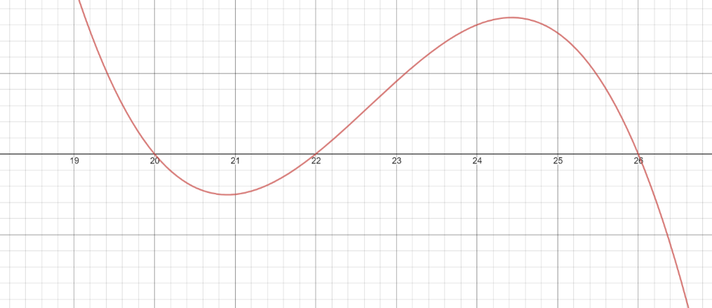

[Figure 2.2] (Desmos.com)

In the graph, values above the x-axis, or t-axis in this case, represent growth where values below the t-axis represent decreasing temperatures. For different amounts of regulation, where regulation in our model is simply a constant, the graph is shifted up or down in the plane. For decreased regulation, the function is shifted up, which results in the 20- and 22-degree equatorial temperatures to approach each other and the 26-degree equatorial temperature to increase slowly. With enough regulation, there would only be one equatorial temperature at some value greater than 26. For increased regulation, the behavior is similar as the function is shifted downward. Instead of the 20- and 22-degree equatorial temperatures approaching one-another, the 22- and 26-degree equatorial temperatures do, and the 20-degree temperature decreases slowly. Eventually, only the one equatorial temperature remains at some temperature less than 20-degrees.

Following the submission of our report, government officials push for decreased regulation equivalent to a new k-value of negative one-half. As discussed in our report, a negative k-value ultimately would result in increased temperatures if allowed to be large enough. To determine the exact result for this case, we need to evaluate our rate of change model for when it is zero, ergo not changing, with the k-value of negative one-half.

$$\frac{dC}{dt}=\frac{1}{10}\left(C-20\right)\left(22-C\right)\left(C-26\right)-\left(-\frac{1}{2}\right)$$

$$\frac{dC}{dt}=\frac{1}{10}\left(C-20\right)\left(22-C\right)\left(C-26\right)+\frac{1}{2}$$

Using the same process as before of plugging in values around the zeros, we can determine the behavior of our model for different initial temperatures. Rather than do that, as it requires a semi-length discussion, we can depict the behavior through the modified graph [Figure 2.3].

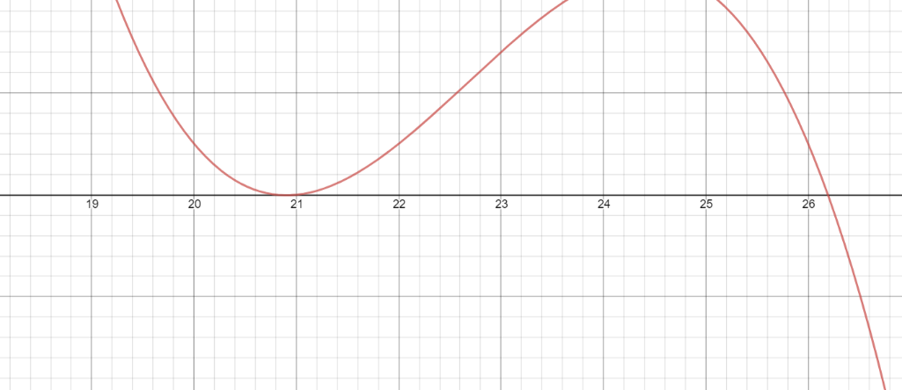

[Figure 2.3] (Desmos.com)

Although it is difficult to see in the image above, there is a slight peak below the t-axis where the temperature holds the trend to decrease.

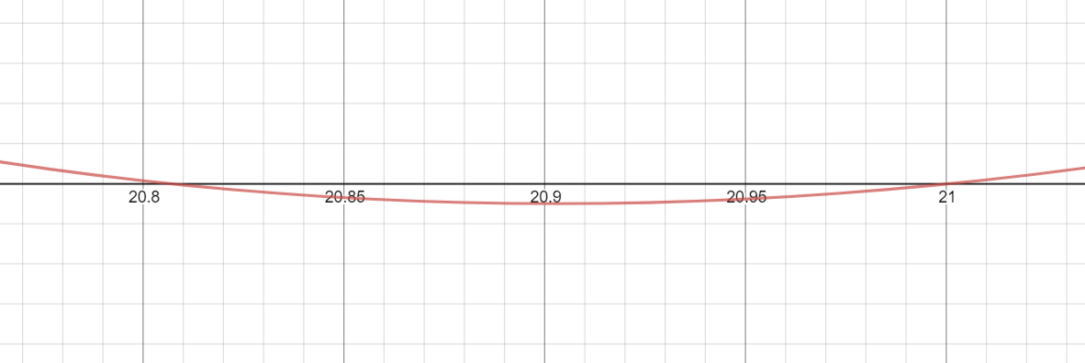

[Figure 2.4] (Desmos.com)

Recalling ideas from our previous discussion, we can see that an initial condition of 20-degrees Celsius lies above the t-axis, meaning that there is a trend for temperature increase approaching a new equatorial temperature of 20.807-degrees, if given enough time.

After some time in the future, allowing the system to reach equilibrium, the Smokestack Association was able to lobby for a 5-percent change in regulation equivalent to a k-value of negative twenty-one fortieths. Still being a negative value, the trend to shifting the graph up remains.

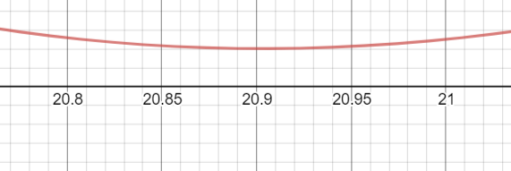

[Figure 2.5] (Desmos.com)

While the change in regulation was very subtle, the result was enough to completely remove two of the equatorial temperatures resulting in as discussed before [Figure 2.5], one remaining equatorial point. Given enough time, a temperature previously limited by these equatorial temperatures would experience a significant change. In the previous model, the temperature increased and was rebounded by an equatorial temperature of 20.807-degrees, which now with the decreased regulation is no longer bounded by that equatorial temperature and is now bounded by the final remaining equatorial temperature of 26.201-degrees.

Government officials eventually decided against deregulating emission and increased regulation back to an equivalent of a k-value of negative one-half. Referring back to the graph of our model with this k-value [Figure 2.3], a new initial condition of 26.201-degrees lies below the t-axis meaning a decrease in temperature would occur until eventually approaching the equatorial temperature of 26.193-degrees.

Following, the major global temperature up rises, government officials decided to completely go back to regulating no emissions, equivalent to a k-value of zero. Again, as previously discussed, both graphically and descriptively, a temperature above 26-degrees for a k-value of zero, results in a negative rate and thus a decrease in temperature approaching 26-degrees. This would mean that after all the changes were implemented, the equatorial temperature increased from 20-degrees Celsius to 26-degrees Celsius.

Changing regulations relationship with equatorial temperatures is majorly affected by initial conditions. Just because a regulation worked to hold a certain temperature before, does not necessarily mean that the same regulation would return any initial temperature back to that equatorial temperature.

In order to return to our initial condition, it is easiest to explain through a bifurcation diagram, which displays how temperature behaves in comparison to different values for regulation. A bifurcation diagram can also be explained as a set amount of phase lines stacked side by side in order of increasing values for k. As we begin to visualize each of these phase lines, we can see that the bifurcation graph being formed is just our model equation reflected across y = x.

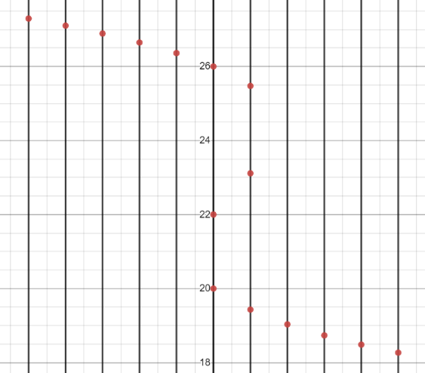 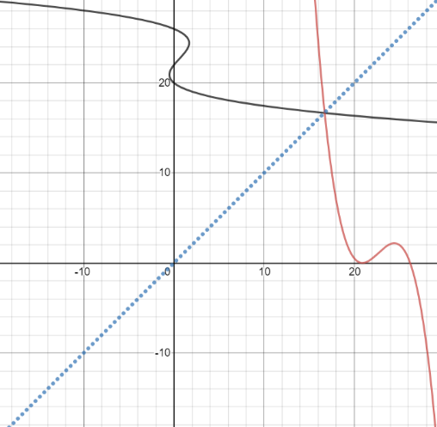

[Figure 2.6] (Desmos.com) [Figure 2.7] (Desmos.com)

<div class=”img” style=”float: left; margin-left: 50px;”><img><img></div>

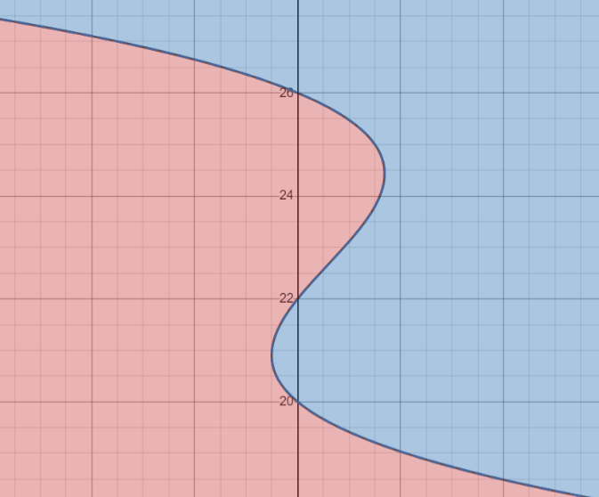

[Figure 2.8] (Desmos.com)

The bifurcation diagram provides an easy visual for how the temperature is affected for different initial conditions and different values of k. The area highlighted in blue, represents initial values that have a trend to decrease approaching the black line. The area highlighted in red, represents initial values that have a trend to increase approaching the black line. We can see in this bifurcation our initial condition after the change in regulation is now at C=26, where C is the vertical axis and the k-value is represented by the horizontal axis. As we increase regulation, moving to the right, there is a trend in decreasing temperatures that allows the temperature to drop down slowly until it passes the hump and is able to decrease more rapidly towards a value below our first initial condition of C=20-degrees. After C is a value below 20, regulation can be reset to zero and the temperature will hold a trend to approach a equatorial temperature of 20-degrees Celsius.