**Portfolio #1**

**[INTRODUCTION]**

First described by economist William Forester Lloyd in 1833 in a discussion about overgrazing cattle, the Tragedy of the Commons was born. Garrett Hardin, roughly one-hundred years later, revised the concept to describe the phenomena that occur when a limited resource is shared and harvested at different rates. The basic concept is that there is a limited resource that is being harvested and is of popular demand. Being limited, that resources holds a threshold at which it can be harvested without complete and immediate depletion.

Several businesses today struggle in maintaining this threshold and understanding the effect of their harvesting rates on that threshold. More specifically it can be difficult to understand how under harvesting compares to over-harvesting and what can be done to recover from these situations.

Previously, we have worked personally with a fish hatchery that undergoes this phenomenon consistently. From that experience, we were able to develop a differential equation to model what that hatchery’s fish population, P, would look like over a significant amount of time, t, where the population is in thousands and time is in years.

$$\frac{dP}{dt}=2P(1 - \frac{P}{25})$$

Recently, the owners of Fish.net purchased this hatchery with the intention of allowing fishing to the public. Being inexperienced with hatcheries and how harvest rates can dramatically affect population, the hatchery’s population was fluctuating fast. Upon seeing our previous success with the hatchery, the owners of Fish.net decided to reach out to us for assistance in repairing the population loss to the hatchery. In our initial report to them, we explained an altered model equation to help us understand how their fish population would be affected by different harvesting rates.

**[INITIAL REPORT]**

In tackling this problem, we began by altering our model equation to incorporate harvesting, k. Subtracting k from the population growth portion of the equation means that it can only be defined with positive values. If k could be negative values, then we would no longer be removing fish from the population but adding fish and that does not make sense in the context of a harvesting variable. That being said, k in this equation is a constant, unaffected by the dependent variable, P. This means that as k grows larger, it shifts the graph down [see below].

$$\frac{dP}{dt}=2P(1 - \frac{P}{25}) - k$$

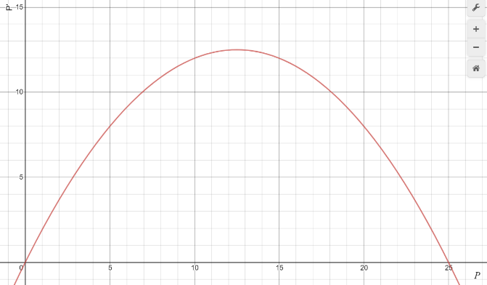 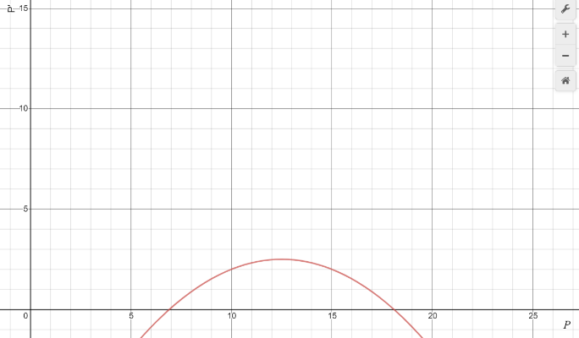

Population Rate of Change v. Population [k-value of 0] Population Rate of Change v. Population [k-value of 10]

Since our model equation is a rate of change function, the points at which P’ ($\frac{dP}{dt}$) is equal to zero are the points at which the population is not changing. In the examples provided, if there is no harvesting occurring, ergo a k-value of 0, the model is equal to zero when P is equal to zero and when P is equal to 25. This means that if the population of fish in the hatchery is zero or twenty-five thousand, then the population will not change until fishes are added or removed.

Continuing with the example of a k-value of 0, if the population were to be somewhere in between zero and twenty-five thousand then the population would increase until it reaches a population of twenty-five thousand. We know this because between P=0 and P=25, the rate of change function lies above the P-axis, meaning its positive and a positive rate of change means growth. Since we know that the population cannot change on its own at P=25, that means that once the population grows to that amount, it will stop.

If the population were to be over twenty-five thousand (P>25), we can see that our model lies below the P-axis, meaning a negative rate of change which would mean that the population would decrease. Again, since we know that the population cannot change on its own when it is equal to twenty-five thousand, once it reaches that value it will stop.

Recall from before, as the harvesting rate grows, our model is shifted down. Additionally, note that our model is just a downward facing parabola. Using this information, we can see that as we increase the harvesting rate, the points at which our population stops growing approach each other and given a high enough harvesting rate, will vanish entirely. This can be visualized using our other example graph for a k-value of 10. Increasing k to 10 resulted in more of the model to lie underneath the P-axis, meaning fewer population sizes that could survive that harvest rate. If you continue to raise k beyond this, there will eventually be a k-value at which the two unchanging populations will be equal. Any k-value higher than that and the model equation will lie entirely under the P-axis meaning a negative rate of change no matter the population size, which would result in eventual depletion of the fish in the hatchery.

**[PROBLEM #1]**

After significant communication with the owners of Fish.net, they agreed on our model equation as it related to their business decisions. Upon agreeing with that model, they informed us that they initially allowed a harvesting rate of 12 (k=12). Upon plugging in the determined value for the harvesting rate, we were left with a quadratic equation.

$\frac{dP}{dt}=2P(1 - \frac{P}{25}) - (12)$

$\frac{dP}{dt}=- \frac{2P^{2}}{25}+2P – 12$

Given that the equation models the rate at which population changes, if we set the quadratic equal to zero and solve for population, P, we are therefore able to see where the population plateaus for different initial conditions. Given that the model is a quadratic, we can simply plug it into the quadratic formula to get our solution.

$\frac{dP}{dt}=- \frac{2P^{2}}{25}+2P – 12=0$

$a=-\frac{2}{25} , b=2 , c=-12$

$P=\frac{-(2)±\sqrt{{(2)}^{2}-4(-\frac{2}{25})(-12)}}{2(-\frac{2}{25})}$

$P=10 and P=15$

Given these values, we know where the population remains unchanged, but we don’t know the behavior around those values. To easily view this behavior, we can graph our model equation with the given harvesting rate.

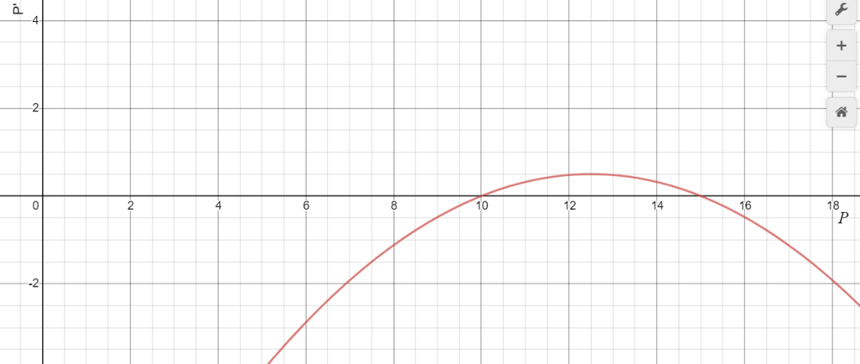

Population Rate of Change v. Population (Desmos.com)

It is clear to see that with this harvesting rate if the initial population was less than 10,000 fish, the population would decrease until the population was completely depleted. If the population lies somewhere between 10,000 and 15,000 fish, the population will grow logistically approaching a plateau at 15,000 fish. Finally, if the population lies anywhere above 15,000 fish, the population will decrease and over a significant amount of time slowly approach a plateau at 15,000 fish. This behavior can be visualized in the following graph where the blue horizontal line represents the value at which the population plateaus and the red lines represent some initial condition within each range.

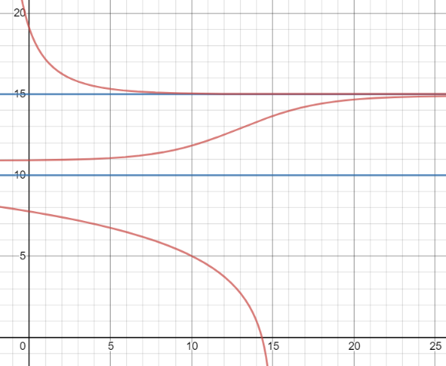

*t*

*P*

Population v. Time (Desmos.com)

**[PROBLEM #2]**

For the first few years, the harvesting rate of 12 was working well and Fish.net was making a good profit and the population was remaining stable. To capitalize on their success, they decided to increase the harvesting rate by a minor amount. To determine the effect that the new harvesting rate would have on the fish population we followed the same process we did previously.

$$\frac{dP}{dt}=2P(1 - \frac{P}{25}) - (13)$$

$\frac{dP}{dt}=- \frac{2P^{2}}{25}+2P – 13$ =0

$a=-\frac{2}{25} , b=2 , c=-13$

$P=\frac{-(2)±\sqrt{{(2)}^{2}-4(-\frac{2}{25})(-13)}}{2(-\frac{2}{25})}$

$$P=nonreal answer$$

Given that when solving for when the population is not growing results in a nonreal answer means that our model lies entirely below the P-axis, which as discussed in our initial report will result in depletion of the fish in the hatchery no matter the population size.

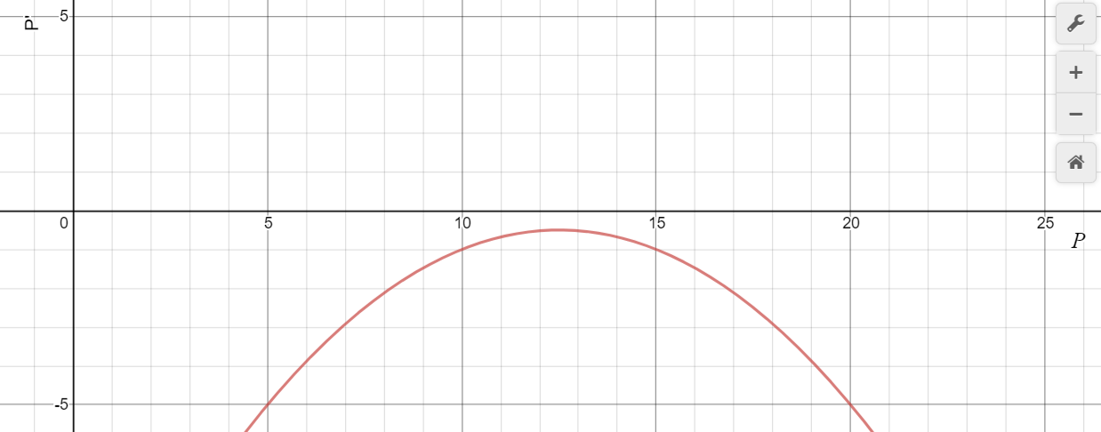

Population Rate of Change v. Population (Desmos.com)

**[PROBLEM #3]**

The owners of Fish.net became aware of the depleting population when it fell to only 5,000 fish. In fear that the population would quickly be gone, but also not wanting to halt business, they decided to return to a harvesting rate of 12. After realizing this did not solve the issue they panicked further as the population fell to 4,000 fishes. It was at this point that Fish.net reached out to us for help in restoring the fish population. We assured them that there was an easy solution although it may damage their business’s income temporarily.

Before we can determine a new harvesting rate that would allow the business to continue without depleting the hatchery, we must first understand why the population continued to decrease. Looking back at the model created with a harvesting rate of 12, recall that there were two points at which the population would not change. Those two values were when the population was equal to 10,000 and when the population was equal to 15,000. We followed up this discovery by determining the behavior around these population sizes. When the initial population was below 10,000, we saw a trend in population decease and when considering that our new initial condition for this harvesting rate is less than 10,000, it makes sense that our population would decrease further.

Now we are in the situation of determining what new harvesting rate can we apply to our initial population of 4,000, which would have a trend in increasing population. In order to answer this question, we can create a bifurcation graph to visualize every harvesting rate in comparison to the population.

In creating a bifurcation graph, we allow the x-axis to be the harvesting rate, k, and our y-axis to be the population, P. Recall in comparing harvesting values to the population we set our rate of change model equal to zero after plugging in our value for k. If we set our model to zero without plugging in any values for k, we are left with an equation, in terms of k and P, what the population will plateau at for different values of k.

$$\frac{dP}{dt}=2P(1 - \frac{P}{25}) - k$$

$\frac{dP}{dt}=- \frac{2P^{2}}{25}+2P – k$ =0

$a=-\frac{2}{25} , b=2 , c=-k$

$P=\frac{-(2)±\sqrt{{(2)}^{2}-4(-\frac{2}{25})(-k)}}{2(-\frac{2}{25})}$

If we graph this solution, we are left with a bifurcation diagram. Using the behaviors we determined previously, we can represent the values in which population will decrease in blue and the values in which population will increase in red.

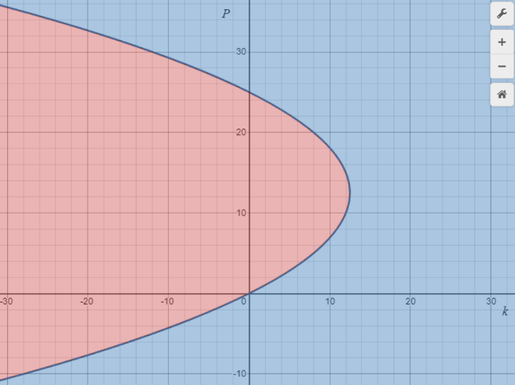

Population v. Harvesting Rate (Desmos.com)

Finally, in getting a new harvesting rate that would allow the population to restore, we graph the line P = 4 to represent the population of fish at the time. The intersection point will give us a coordinating value for k in which the population would remain 4,000 forever. Since we want to eventually restore the population, we will choose any k value less than that intersections k value. Since the k value at that intersection is 6.72, we now know that as long as less than 6,720 fish are harvested each year the population will experience a trend to increase. Additionally, by examining the upper plateau, we can see if they dropped the harvesting value below 6.72, the fish population has the potential raise to upwards of 21,000 or more, depending on the value for k. In returning to the original business model, once the population surpasses 10,000 fishes, they can return to a harvesting value of 12. The size of the population beyond 10,000 is irrelevant in the long run because after a long time the population will plateau at 15,000 fishes anyway. In concluding our work with Fish.net, it becomes clear that just because one harvesting rate may work efficiently for one population, does not mean it will work the same for others.

**Portfolio #2**

**[INTRODUCTION]**

Whether we choose to believe it or not, climate change is amongst us. Since the Industrial Revolution began back in 1840, the Earth’s temperature has increased 1.5 degrees. While this change may appear small, to put it in perspective, a 5˚ change engulfed most of North America in an extreme amount of ice. We now, more than ever, need to develop means of controlling this global climate change. As part of understanding this climate change, there is often concern resulting from positive feedback loops. In a positive feedback loop two or more processes amplify each other, creating a vicious cycle of amplification.

Of the positive feedback loops in relation to climate change, interaction of water vapor with global temperature is of the most significant. If there is an increase in global temperature, the capacity of the atmosphere for evaporated water vapor increases proportionally. So, if water is available for evaporation, then the water vapor in the atmosphere will increase. Additionally, water vapor is a greenhouse gas and therefore if more water vapor is evaporated than more insulation will be added to the atmosphere and increase global temperature.

Scientists have predicted that if global temperatures increase two degrees, a positive feedback loop will begin that would result in an additional temperature rise of four degrees. An increase of that severity would be enough to turn rainforests into deserts, melt the ice caps, and may even make some of the currently habitable locations for humans inhabitable.

$$\frac{dC}{dt}=\frac{1}{10}\left(C-20\right)\left(22-C\right)\left(C-26\right)-k$$

Our team, along with the help from several other scientists, are committed to preventing this future crisis. After significant research, we have developed a differential equation to model global climate. Using predictions for rising global temperature, our equation models the behavior of the temperature, C, in Celsius, and uses k as a parameter to that represents government regulation of greenhouse gas emissions. Currently, the equatorial temperature is 20˚C and the governmental regulation for greenhouse gases is at a baseline. With current technologies, greenhouse gas emission is necessary for progress. Our teams’ goal is to understand how exactly changing regulation will affect the future climate and ultimately what we can do to prevent the future positive feedback loop.

**[PROBLEM #1]**

Our team, in order to push our idea’s forward, wrote a report directed to congress and the president sharing our findings. Our report outlined the effects of different regulation on the current global climate.

**[REPORT]**

It is to be understood that with our current technologies, greenhouse gas emission is vital for progress. Given the push for less regulation to speed production, we want to understand what happens to global temperature in three cases. Those three cases include, increased regulation, decreased regulation, and unchanged regulation. In relation to our model, that would follow as k-values greater than zero, less than zero, and equal to zero.

Evaluating our model for a k-value of zero leaves us with a cubic function with three zeros. Our model is a rate of change function in terms of temperature, so the zeros would represent temperatures that result in no change over time.

$$\frac{dC}{dt}=\frac{1}{10}\left(C-20\right)\left(22-C\right)\left(C-26\right)-\left(0\right)$$

$$C=20, 22, 26$$

The zeros occur at C-values of 20, 22, and 26. Considering that the current equatorial temperature is 20˚C, which is one of our zeros, we can determine that the temperature will remain unchanged as long as regulation remains unchanged. If the current temperature were to be a different, the resulting temperature over time may have been completely different.

By plugging in values around our zeros, we can understand how the temperature may have changed in time. Plugging in a temperature less than 20˚C into our model results in an overall positive answer, which would mean a positive increase in temperature. It is important to also note as the temperature would not be able to exceed 20˚C as it is one of our zeros and does not allow change, therefore the temperature would rather just approach 20˚C slowly overtime. For a temperature greater than 20˚C but less than 22˚C, the model would give out a negative answer, meaning a decreasing temperature. Again, the temperature would not be able to decrease less than 20˚C and would instead slowly approach it. The same pattern continues for values between 22˚C and 26˚C, where the result is a positive growth that approaches a temperature of 26˚C. Finally, if the temperature had been above 26˚C, the result would have been a negative answer ergo a decreasing result approaching 26˚C.

The previous behaviors described are easier visualized by graphing our model with a k-value of zero and comparing it to its phase line.

$$\frac{dP}{dt}$$

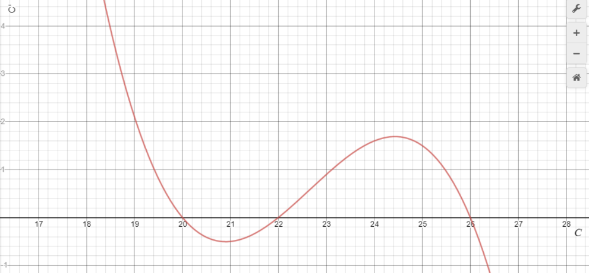

C=26˚

C=20˚

C=22˚

Climate Rate of Change v. Climate (Desmos.com)

In the graph, values above the x-axis, or t-axis in this case, represent growth where values below the t-axis represent decreasing temperatures. For different amounts of regulation, where regulation in our model is simply a constant, the graph is shifted up or down in the plane. For decreased regulation, the function is shifted up, which results in the 20˚C and 22˚C equilibrium temperatures to approach each other and the 26˚C equilibrium temperature to increase slowly. With enough regulation, there would only be one equilibrium temperature at some value greater than 26. For increased regulation, the behavior is similar as the function is shifted downward. Instead of the 20˚C and 22˚C equilibrium temperatures approaching one-another, the 22˚C and 26˚C equilibrium temperatures do, and the 20˚C temperature decreases slowly. Eventually, only the one equilibrium temperature remains at some temperature less than 20˚C.

Repeating this process for all values of k would allow us to visualize what would happen to the climate for any given amount of regulation. Again, since our model equation is a rate of change function, setting it equal to zero allows us to see the points at which the climate will not change. Doing this without subbing any values for our regulation variable, k, generates a function that uses k as a dependent variable. This function combined with the behavior discovered before allows us to create a bifurcation diagram. This diagram shows us the behavior of the climate for any given amount of regulation at any initial condition for climate. To show if a condition around the function tends to decrease, we will color it blue. To show if a condition around the function tends to increase, we will color it red.

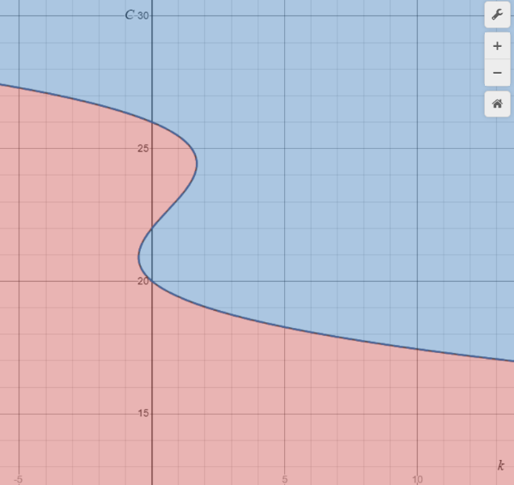

Climate v. Regulation (desmos.com)

**[PROBLEM #2]**

Following the submission of our report, government officials pushed for decreased regulation equivalent to a new k-value of -0.5. As discussed in our report, a negative k-value ultimately would result in increased temperatures if allowed to be large enough. With the use of our bifurcation diagram, we can see a significant shift in behavior from the baseline regulation. The equatorial temperature of 20˚C is no longer an equilibrium temperature and now lies withing a range where it will have a tendency to increase.

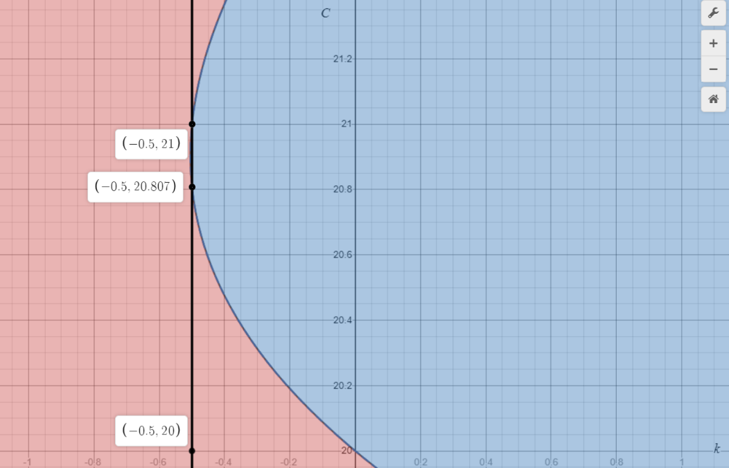

Climate v. Regulation w/ k=-0.5 (Desmos.com)

This regulation stood for a significant enough time that the temperature was able to increase to a newly created equilibrium temperature of 20.807˚C.

Following that increase, the Smokestack Association was able to lobby for a 5-percent change in regulation equivalent to a k-value of -0.525.

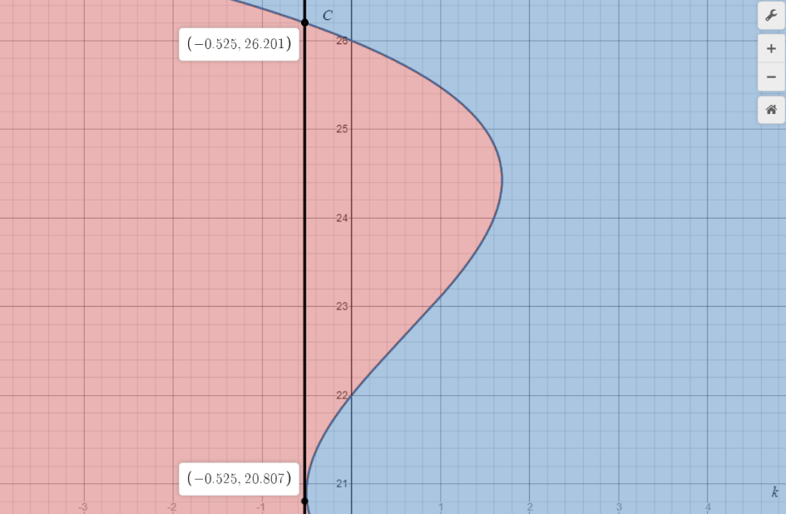

Climate v. Regulation w/ k=-0.525 (Desmos.com)

As we can see in the bifurcation graph, this decrease in regulation caused the previous equilibrium temperature that bounded our equatorial temperature to vanish. This amount of regulation leaves only one equilibrium temperature at a significant increase to 26.201˚C. Government officials allowed this regulation to sit until the equatorial temperature reached this equilibrium. They then decided to revert to a regulation of k=-0.5 in hopes that it would return the equatorial temperature to 20.807˚C.

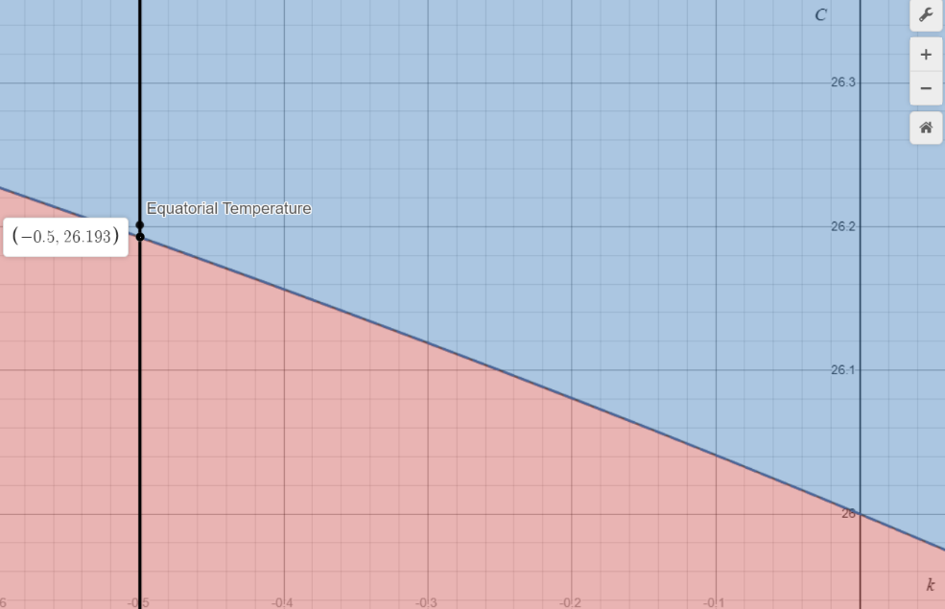

Climate v. Regulation w/ k=-0.5 (Desmos.com)

Instead of the equatorial temperature returning to 20.807˚C, it decreased only slightly to 26.193˚C. Although the lower equilibrium temperatures around 21˚C are now returned, the previous change in regulation held long enough that the equatorial temperature is now bound to the highest equilibrium temperature.

In a second attempt to lower the equatorial temperature, government officials decided to return regulation back to the baseline.

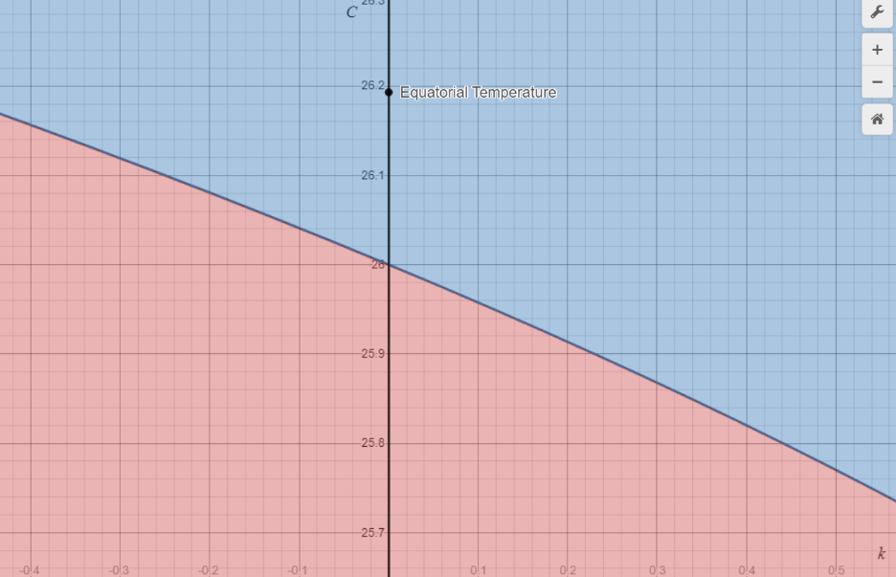

Climate v. Regulation w/ k=0 (Desmos.com)

This decrease in regulation was not significant enough to unbind the equatorial temperature from the highest equilibrium and only allowed for a decrease in temperature from 26.193˚C to 26˚C.

**[PROBLEM #3]**

In order to return to our initial condition, it is easiest to explain through our bifurcation diagram.

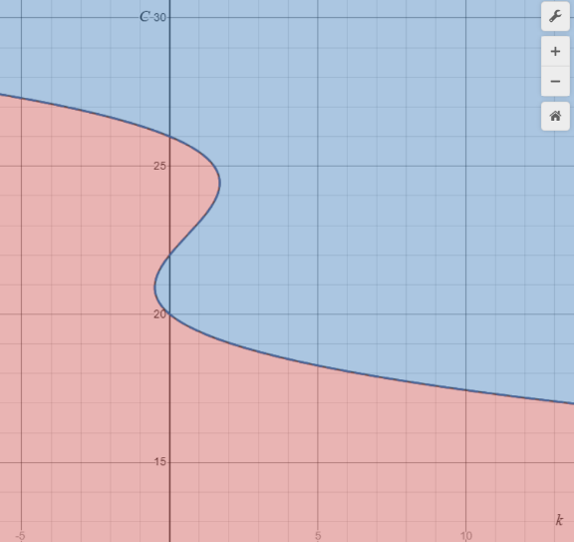

Climate v. Regulation (Desmos.com)

As we increase regulation, moving to the right, there is a trend in decreasing temperatures. Given that our current equatorial temperature lies at 26˚C and is bound the upper equilibrium, we have to increase regulation until the upper limit vanishes. Looking at the bifurcation diagram we can see that the k-value at which the upper bound and middle bound meet is at k=1.69. Any k-value beyond this point would leave only the lower bound which the equatorial temperature was bound to originally. Whatever k-value greater than 1.69 is selected, in order to be able to return to the baseline regulation, the temperature must be allowed to return to just under 22˚C. This is because at the baseline regulation there is a trend for temperatures between 20˚C and 22˚C to decrease until they reach the equilibrium temperature of 20˚C which is the original equatorial temperature.

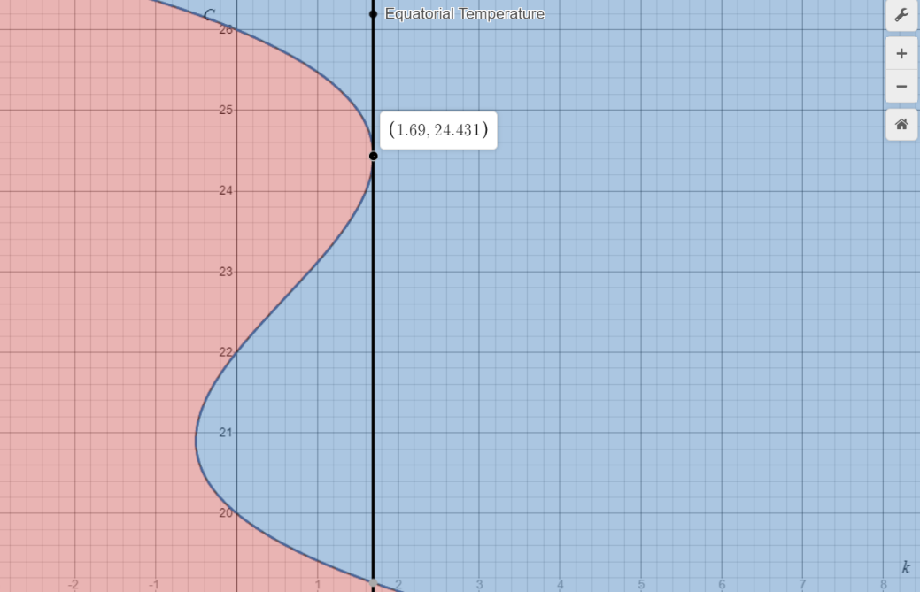

Climate v. Regulation w/ k=1.69 (Desmos.com)

Increasing regulation can be applied in several way. According to the United States Environmental Protection Agency (EPA), the largest sources of greenhouse gases comes from Transportation and Electricity. While it is undesirable, increasing the cost of gas and electricity could be one potential way of increasing regulation. Additionally, advertising initiatives such as the NFLs play 60, which encourages children to decrease electricity use and be active, would help regulation. Along with that, investing into groups such as Ecosia who are committed to planting trees, would assist in removing some of the pollution.