18-348 Spring 2013
Michael Hankowsky and Greg Nazario
Group 3B

1.
Our project is a noise meter that will altert people when they are close to a predefined threshold limit. The threshold us user defined and pased on a potentiometer input. As nose gets closer to a predefined level then the display will become brighter and more leds will light up. If the level crosses the threshold then an alarm amimation will be displayed to ensure useres notice.

2.

- Sysem Inpust
  - Power Switch – unit shall be on when this is powered on
  - Threshold pot – shall set the threshold limit
  - Mic input – will take in the colume of the outside world.
- System Output
  - LCD_Display should display the current threshold level and last sampled input
  - LED_Matrix shall display different animations and interact with sound
- Internal State Variables
  - System enabled – display is on or off
  - Threshold level – the current value of threshold in Db
  - LED rows out – LEDs matrix row that should be turned on
  - LED col out – LED matrix column that should be turned on
  - LEDoutput – The LEDS to output – one led per bit
- Requirements
  - LED matrix shall be sound sensitive
  - The microphone shall be able to detect sound
  - User shall be able to input a noise threshold through a potentiometer
  - Threshold value should dictate what levels are displayed on the LCD
  - A COP timer shall be user to ensure the system is operating properly
  - LCD display should display the current threshold value and last sampled value
  - If the input is beyond the threshold then an alarm shall sound
  - After a predefined time the alarm shall be turned off.

State Chart Design

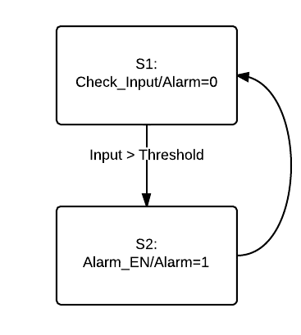

Part 4.

Requirment | S1 | S2 | T1 | T2
R1 | x
R2 | x
R3 | x
R4 | x
R5 | x
R6 | x
R7 |  | x | x
R8 | x |  |  | x

Part5

We will use a priority preemtive scheduler to ensure that our ISRs are run in the needed time.
Below are listed in order of priority

T1 – Check_Noise – Shall check the input noise level – period 100ms
T2 – Calculate_Display – Shall determine which LEDS to turn on at which luminosity
T3 – Alarm_Animation – Sets LEDS in an alarm animation sequence
T4 – Display_LEDS – Shall display the calculated LEDS using PWM
T5 – Display_LCD – Dispalys the current input level and threshold on screen
T6 – Check_Threshold – See if the input has changed

Part 6.

As we have some long calculations, displays and animations we need a watchdog to make sure that everything is timed correctly and does not get out of place.

