Three drug treatments ( 'Capomulin', 'Infubinol', 'Ketapril) and a placebo were tested on mice over 45 days to study the drugs effectiveness on tumor growth and spread.

The first observation of mean tumor growth over the study demonstrated that Capomulin actually decreased tumor volume over time whereas the Infubinol and Ketapril treatments had no significant effect compared to the placebo when standard error was considered.

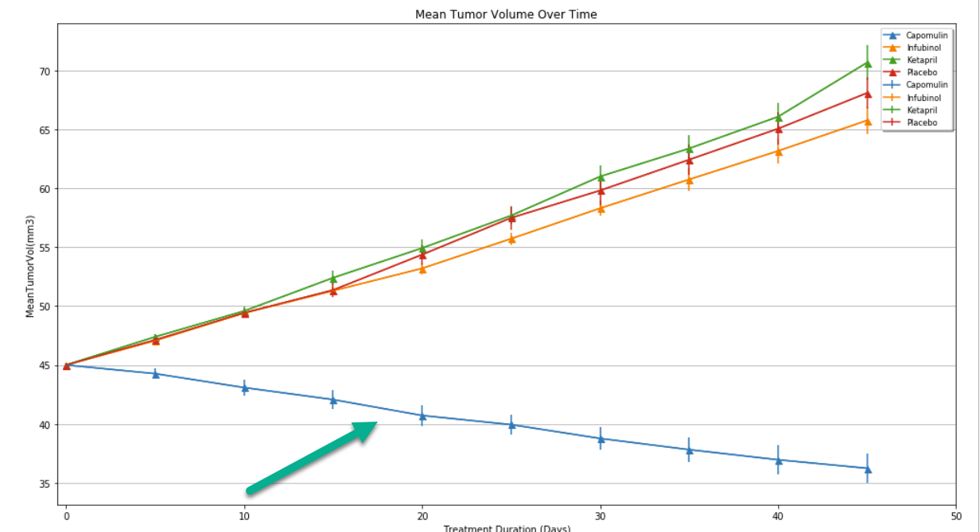

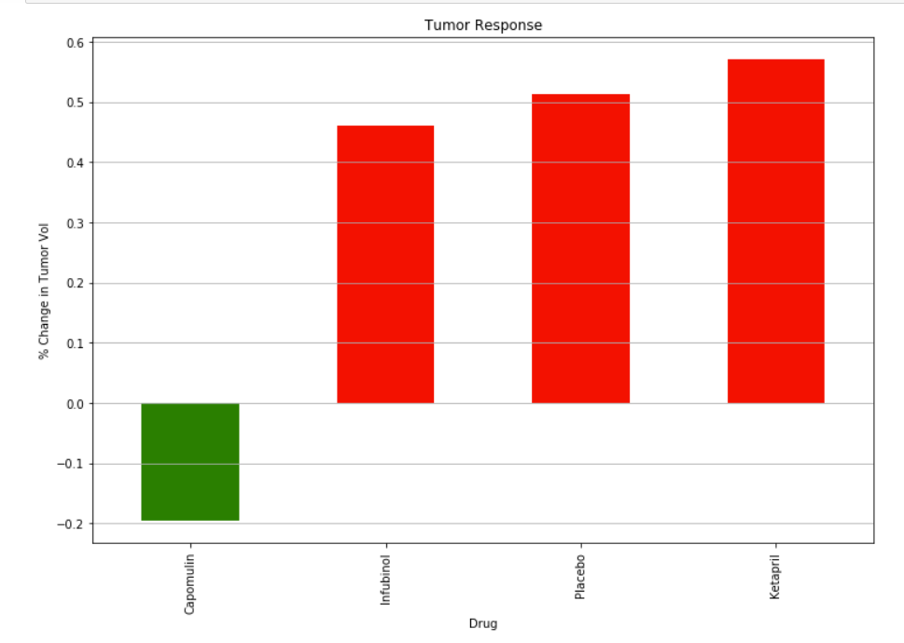

The second series of observations in which the spread of metastatic cancer was measured also showed a significant advantage to mice being treated with Capomulin. Infubinol also demonstrated a substantial effect of slowing cancer growth as compared to mice on the placebo.

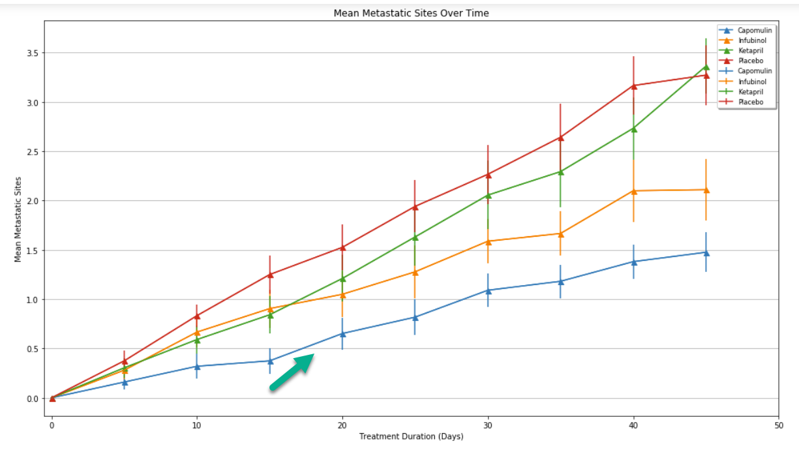

The third observation in which the percentage of mice which survived the study duration again indicates that response to Capomulin was better than the placebo and other drugs in the study.

