**Practical-8**

1. **Simulate Virtual LAN configuration using CISCO Packet Tracer Simulation.**

**Part 1: Build the Network and Configure Basic Device Settings**

**Step 1: Build the network as shown in the topology.**

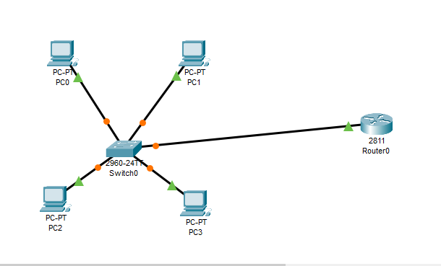

**Step 2: Configure basic settings for each switch.**

**Create VLANs on the switches.**

**Assign VLANs to the correct switch interfaces.**

**Assign a VLAN to multiple interfaces.** 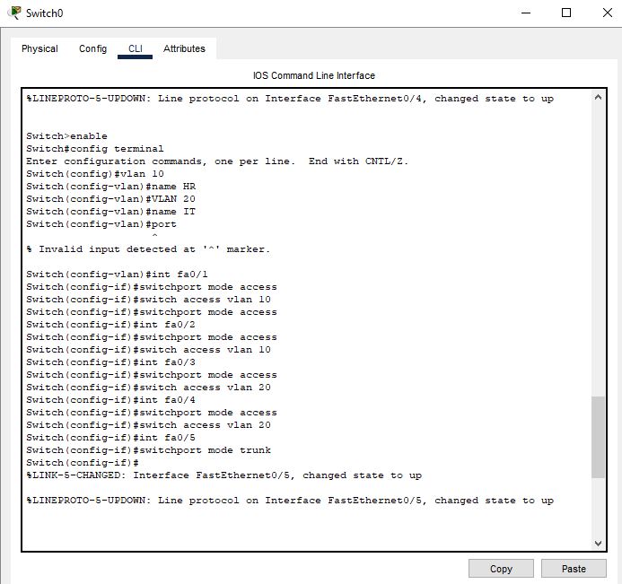

Step 3: Configure PC hosts.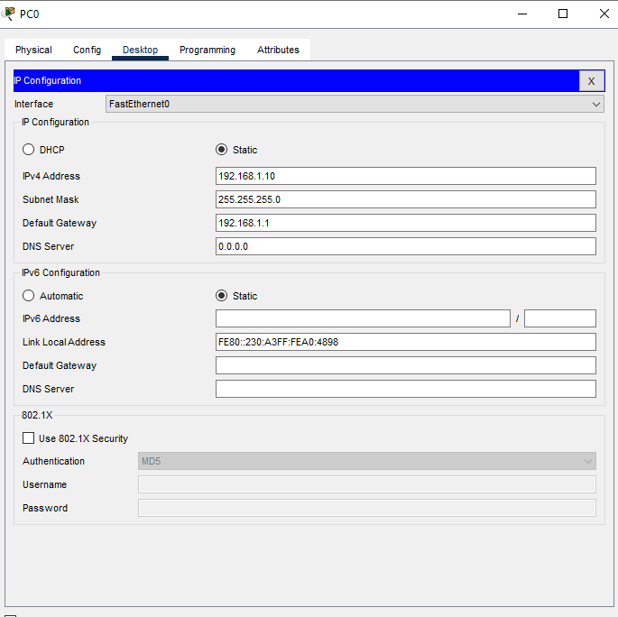

Step 4: Test connectivity. 