PRACTICAL 8:

AIM:-b) Configuration of Wireless LAN using CISCO Packet Tracer.

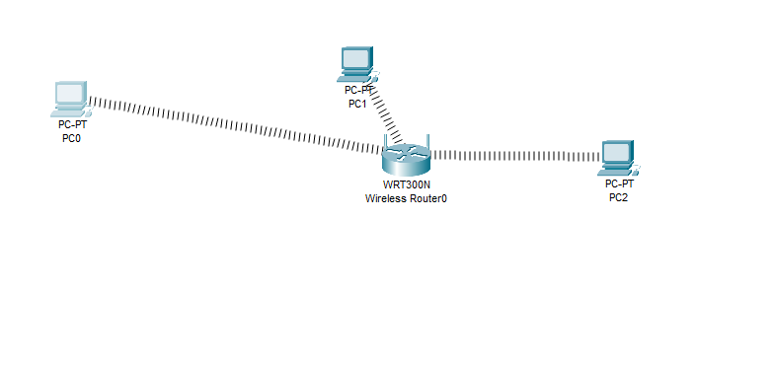

Step1:- Click on wireless router,

Now Select wireless security and change Security Mode to WEP 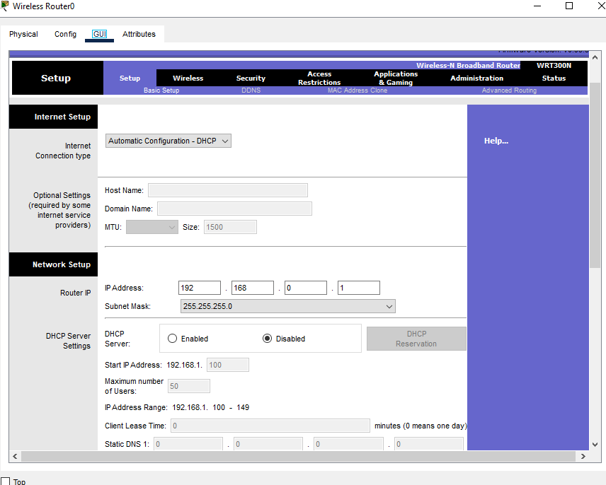

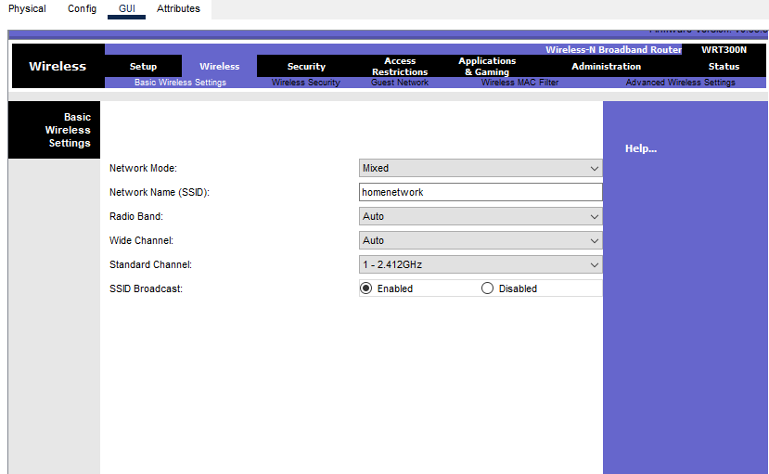 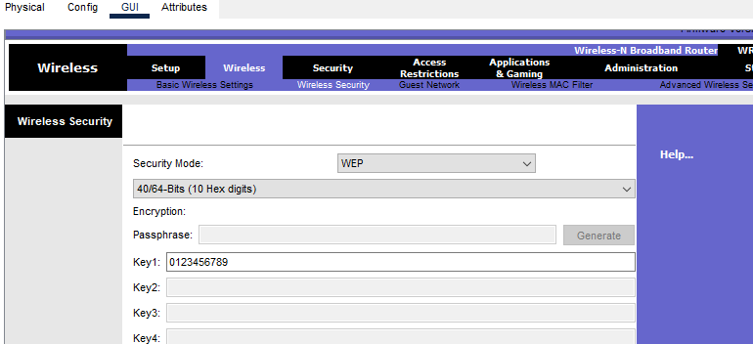

Double click on pc select Desktop tab click on IP configuration select Static IP and

set IP as given below

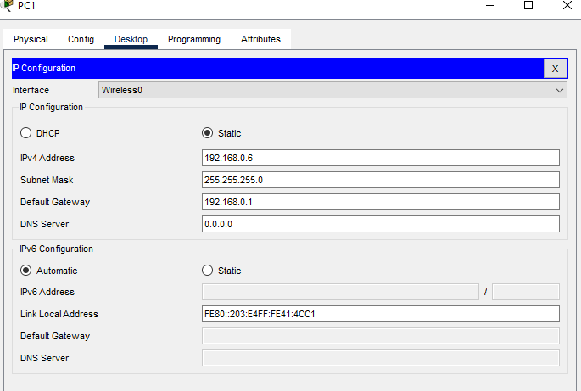 Now it's time to connect PC's from Wireless router. To do so click PC select Desktop

click on PC Wireless

