EDUGENIE
Google Gemini Powered Learning Assistant

A Project Report

Submitted in partial fulfillment of the requirements
for the completion of the project

Submitted By

HARINI M 2522K0596
HEMAPRIYA J 2522K0597
DEEPA P 2522K0593
DEEPADHARSHINI D 2522K0594

DEPARTMENT OF COMPUTER SCIENCE
NAVARASAM ARTS & SCIENCE COLLEGE FOR WOMEN ,ERODE
2026

ABSTRACT
EduGenie is a Generative AI-powered educational learning assistant designed to support students in understanding academic concepts and improving their learning experience. The system uses Google Gemini as the primary Large Language Model to provide intelligent and student-friendly responses.
The application provides multiple learning features including Question and Answer, Concept Explanation, Quiz Generation, Text Summarization, and Personalized Learning Recommendations. Students can enter a question, topic, or educational text through the web interface and receive an AI-generated response.
The system is developed using Python and FastAPI for the backend, with HTML and CSS for the frontend. The application follows a modular architecture in which separate modules handle explanation, question answering, quiz generation, summarization, and learning recommendations.
EduGenie aims to provide an interactive and accessible learning environment where students can obtain explanations, practice questions, summaries, and structured learning guidance through a single application.
1. INTRODUCTION
1.1 Background
Education is increasingly supported by digital technologies and Artificial Intelligence. 3. OBJECTIVES3. Students often need additional explanations, practice questions, summaries, and guidance while learning academic subjects. Traditional learning resources may not always provide immediate and personalized assistance.
Generative Artificial Intelligence provides an opportunity to develop intelligent educational applications that can understand student queries and generate useful learning content. EduGenie is developed as a Generative AI-powered learning assistant to provide such support.
1.2 EduGenie
EduGenie is a web-based educational assistant that uses Google Gemini to generate responses for different learning activities. The system provides a simple interface through which students can interact with the application.
The major functions of EduGenie are:
- Question and Answer
- Concept Explanation
- Quiz Generation
- Text Summarization
- Personalized Learning Recommendations
These functions are implemented as separate modules and connected through a FastAPI backend.
1.3 Need for the System
Students may require quick clarification of concepts, simplified explanations, revision materials, and practice questions. EduGenie combines these requirements into one application and provides AI-assisted learning support through a simple web interface.
1.4 Scope
The scope of EduGenie includes AI-assisted academic question answering, concept explanation, quiz generation, text summarization, and learning-path recommendations. The application can be used as a supplementary learning tool for students.

2. OBJECTIVE
The main objectives of the EduGenie project are:
- To develop a Generative AI-powered educational learning assistant.
- To provide students with quick answers to academic questions.
- To explain difficult concepts using simple and understandable language.
- To generate multiple-choice questions for learning and self-assessment.
- To summarize lengthy educational content into concise information.
- To provide personalized learning recommendations based on the selected topic.
- To develop a simple and user-friendly web interface for student interaction.
- To integrate Google Gemini with a modular FastAPI-based backend.
- To provide different educational functions through a single application.
- To support students as a supplementary digital learning resource.

3. EXISTING SYSTEM
The existing educational system mainly depends on traditional teaching methods and manually available learning resources. Students usually search for study materials from textbooks, websites, videos, and other online platforms. The learning process is not always personalized according to the individual needs of students.

3.1 Limitations of Existing System
- Students need to search manually for suitable learning materials.
- Learning resources are available from different sources and are not organized in one place.
- Personalized learning recommendations are limited.
- Students may not receive immediate answers to their questions.
- Creating quizzes and summaries manually requires additional time.
- The system does not continuously adapt to the student's learning requirements.
- Traditional learning methods may not provide interactive AI-based assistance.
4. PROPOSED SYSTEM
The proposed system, EduGenie AI, is an AI-powered educational learning assistant designed to provide personalized and interactive learning support. The system helps students understand topics, ask questions, generate quizzes, summarize learning materials, and receive suitable learning recommendations.
EduGenie AI integrates artificial intelligence with a simple web-based interface. It provides students with quick responses and learning assistance based on their input.
4.1 Features of Proposed System
- AI-based question answering.
- Topic explanation in a simple and understandable manner.
- Automatic quiz generation.
- Text summarization for quick revision.
- Personalized learning recommendations.
- Interactive web-based learning interface.
- Fast and easy access to educational assistance.
4.2 Advantages of Proposed System
- Reduces the time required to search for learning resources.
- Provides quick responses to student queries.
- Supports personalized learning.
- Makes learning more interactive and convenient.
- Helps students in revision through quizzes and summaries.
- Provides multiple learning features in a single system.
- Improves accessibility to AI-assisted education.

5. SYSTEM REQUIREMENTS
System requirements specify the hardware and software components required to develop and run the EduGenie AI system successfully.
5.1 Hardware Requirements
Component | Requirement
 | Intel Core i3 or above
Storage | Minimum 10 GB free space
Display | 1366 × 768 resolution or above
Keyboard | Standard keyboard
Mouse | Standard mouse
Internet | Required for AI API services
RAM | Minimum 4 GB

5.2 Software Requirements
Component | Requirement
Operating System | Windows 10 / Windows 11
Programming Language | Python
Framework | FastAPI
Frontend | HTML, CSS, JavaScript
Template Engine | Jinja2
AI Service | Google Gemini API
Code Editor | Google Gemini API
Web Browser | Google Chrome / Microsoft Edge
Environment | Python Virtual Environment

5.3 Technologies Used
Python
Python is used as the main programming language for developing the backend and implementing the core functionalities of EduGenie AI.
FastAPI
FastAPI is used to create the web application backend and handle HTTP requests and responses.
HTML, CSS and JavaScript
These technologies are used to design and implement the user interface of the application.
Google Gemini API
The Gemini API provides AI-based capabilities such as answering questions, explaining topics, generating quizzes and summarizing text.
Jinja2
Jinja2 is used as the template engine for rendering dynamic HTML pages.
Visual Studio Code
Visual Studio Code is used as the development environment for writing, editing and running the project.

5.4 Functional Requirements
- The system should accept questions or text from the user.
- The system should provide AI-generated answers.
- The system should explain educational topics.
- The system should generate quizzes.
- The system should summarize provided text.
- The system should provide learning recommendations.
- The system should display the generated results through the web interface.
5.5 Non-Functional Requirements
- Usability – The system should be simple and easy to use.
- Performance – The system should provide responses within a reasonable time.
- Reliability – The application should work consistently during normal usage.
- Scalability – The system should allow additional learning features to be added.
- Security – API credentials and user data should be handled securely.
- Maintainability – The source code should be organized into separate modules.

6. SYSTEM ARCHITECTURE
The system architecture describes the overall structure and working flow of the EduGenie AI application. It shows how the user interacts with the web interface, how requests are processed by the FastAPI backend, and how AI services generate the required response.
6.1 Architecture Flow
User

Web Interface/HTML/CSS/JS

AI MODULES
Q&A/ EXPLANATION / QUIZ / SUMMARY / LEARNING PATH

GEMINI API AI PROCESSING

GENERATED RESULT

USER

6.2 Working Process
The working process of EduGenie AI consists of the following steps:
- The user opens the EduGenie AI web application.
- The user enters a question, topic, or learning content.
- The web interface sends the user request to the FastAPI backend.
- The FastAPI backend receives and processes the request.
- The appropriate AI module is selected based on the user's requirement.
- The AI module sends the required request to the Gemini API.
- The Gemini API processes the input and generates an AI-based response.
- The generated response is returned to the backend and displayed to the user through the web interface.
6.3 Main Components
1. User Interface
The user interface allows students to enter questions, topics, or text and view the generated results.
2. FastAPI Backend
FastAPI manages the communication between the frontend, AI modules, and external AI service.
3. AI Modules
The system contains separate modules for question answering, topic explanation, quiz generation, text summarization, and learning recommendations.
4. Gemini API
Gemini API provides the artificial intelligence functionality required to generate educational responses.
5. Response Display
The generated output is returned to the web interface and displayed to the user in an understandable format.

7. MODULES
The EduGenie AI system is divided into different modules. Each module performs a specific function and together they provide an integrated AI-based learning experience for students.

7.1 Question Answering Module
The Question Answering Module allows students to enter questions related to their studies. The system processes the question using AI and generates a suitable answer. This module helps students get quick explanations without manually searching through multiple resources.
7.2 Explanation Module
The Explanation Module provides simple and understandable explanations for educational topics. It converts complex concepts into easy-to-understand information that can help students improve their learning.
7.3 Quiz Generation Module
The Quiz Generation Module automatically creates questions based on the topic or content provided by the user. It can be used for practice, self-assessment, and examination preparation.
7.4 Summary Module
The Summary Module converts lengthy educational content into a shorter and meaningful summary. This helps students quickly understand the important points and use the summary for revision.
7.5 Learning Recommendation Module
The Learning Recommendation Module provides suitable learning suggestions based on the user's topic or learning requirements. It helps students identify what they can learn next and supports a structured learning process.
7.6 Gemini Client Module
The Gemini Client Module manages communication between the EduGenie AI application and the Google Gemini API. It sends user requests to the AI service and receives the generated responses.
7.7 Main Application Module
The Main Application Module acts as the central component of the system. It manages the FastAPI application, routes user requests to the appropriate modules, and returns the generated results to the web interface.

8. IMPLEMENTATION
The implementation phase describes how the EduGenie AI system is developed using Python, FastAPI, HTML, CSS, JavaScript, and Google Gemini API. The system is implemented as a web-based educational assistant with separate modules for different learning functions.
8.1 Development Environment
The EduGenie AI project is developed using Visual Studio Code. Python is used for backend development and FastAPI is used to create the web application. A Python virtual environment is used to manage the project dependencies.
8.2 Backend Implementation
The backend is implemented using FastAPI. It handles user requests, communicates with the different AI modules, and returns the generated results to the frontend.
The main backend file is:
main.py
It manages the application routes and connects the different modules of the system.

8.3 Frontend Implementation
The frontend provides an interactive interface for students. HTML is used to create the page structure, CSS is used for styling, and JavaScript is used to handle user interactions and communicate with the backend.
The frontend allows users to:
- Enter questions or topics.
- Submit learning requests.
- View AI-generated responses.
- Interact with different learning features.
8.4 AI Integration
The system integrates the Google Gemini API to provide AI-based educational assistance. User input is sent to the AI service through the Gemini client module.
The AI service processes the input and generates the required response, which is then returned to the application.
8.5 Module Implementation
The major modules implemented in the system are:
- Question Answering Module – Provides answers to user questions.
- Explanation Module – Explains educational concepts.
- Quiz Module – Generates practice questions.
- Summary Module – Summarizes lengthy content.
- Learning Path Module – Provides learning recommendations.
8.7 Implementation Steps
- Install Python and required development tools.
- Create the EduGenie AI project folder.
- Create and activate the Python virtual environment.
- Install the required Python packages.
- Configure the Gemini API credentials.
- Develop the FastAPI backend.
- Develop the frontend interface.
- Implement the individual AI modules.
- Connect the modules with the Gemini API.
- Run and test the application using the local server.

8.8 IMPLEMENTATION
8.8.1 Project Structure
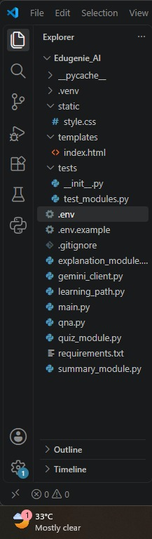
Figure 8.1: EduGenie AI Project Structure

8.8.2 Main Application
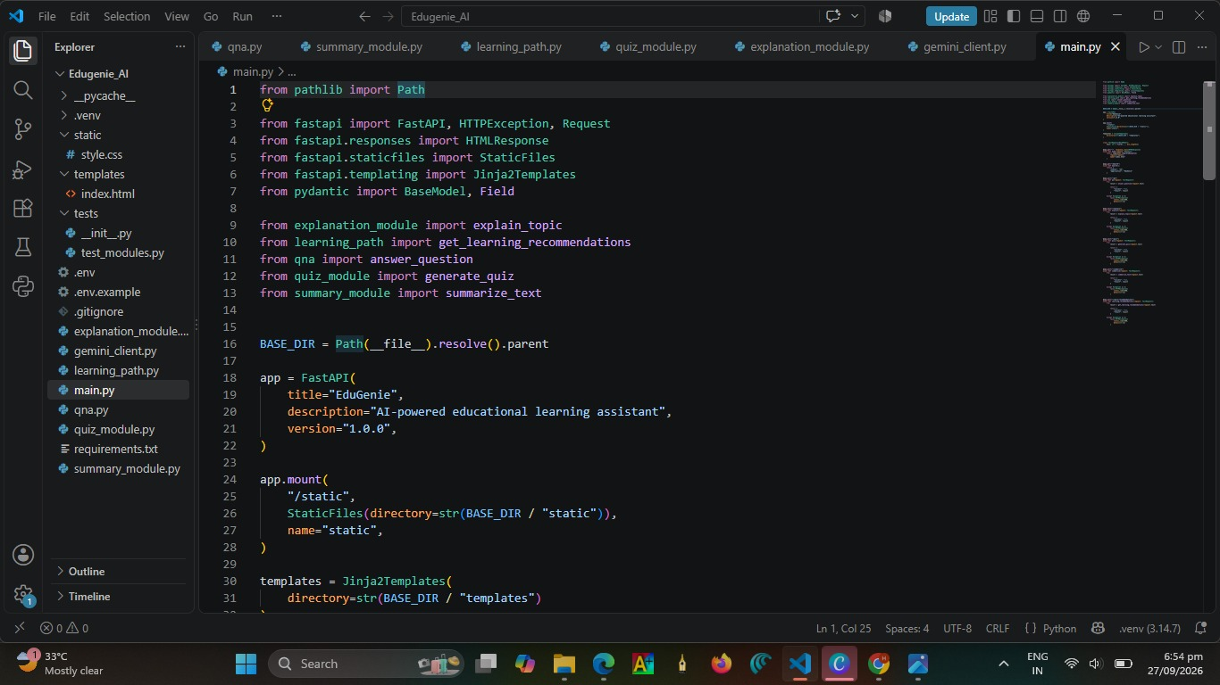
Figure 8.2: Main Application in VS Code
8.8.3 AI Integration
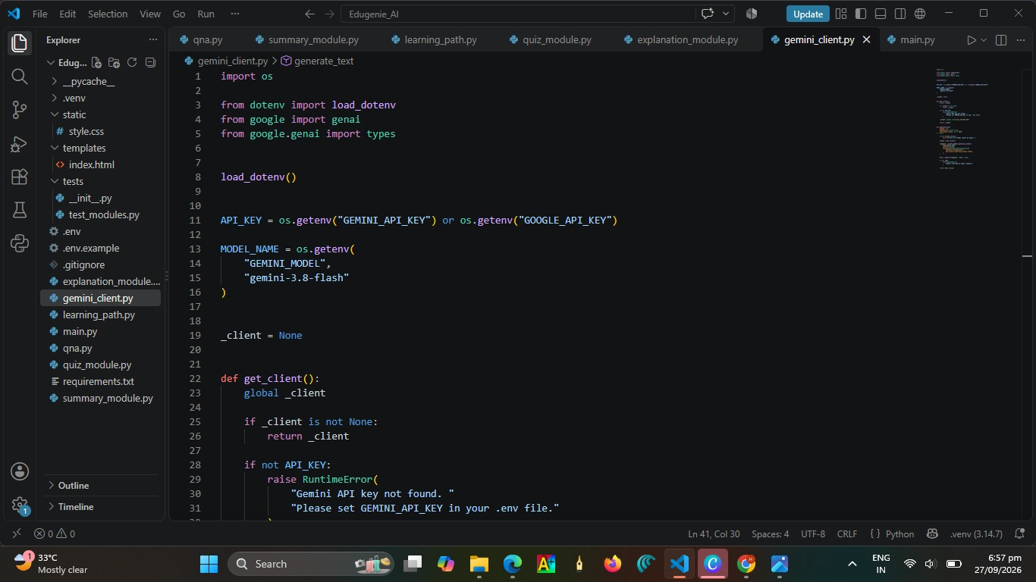
Figure 8.3: Gemini AI Integration

8.8.4 AI Modules
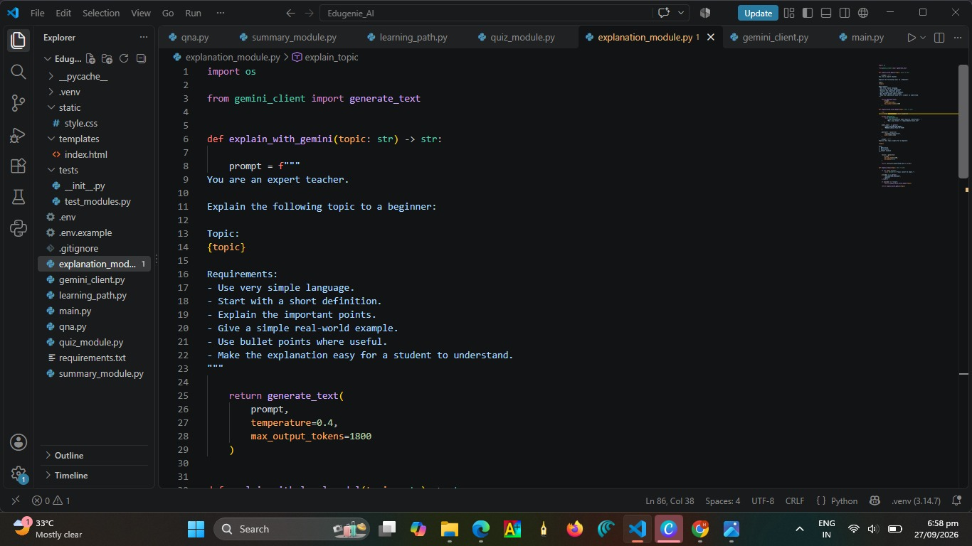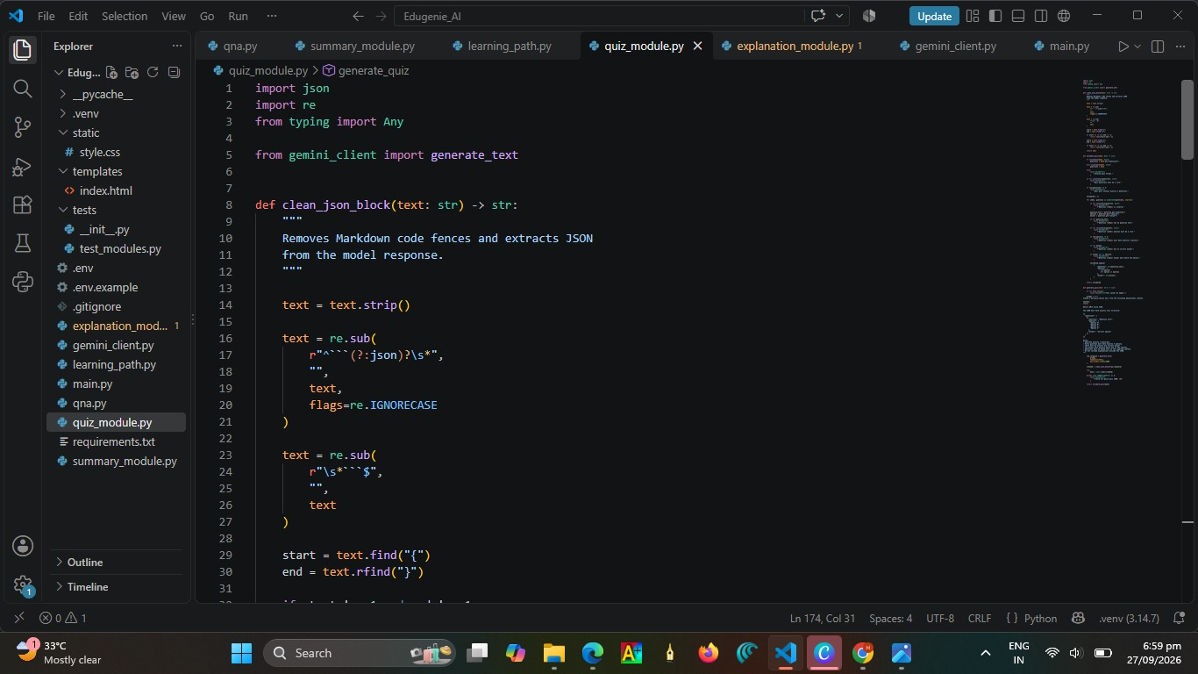
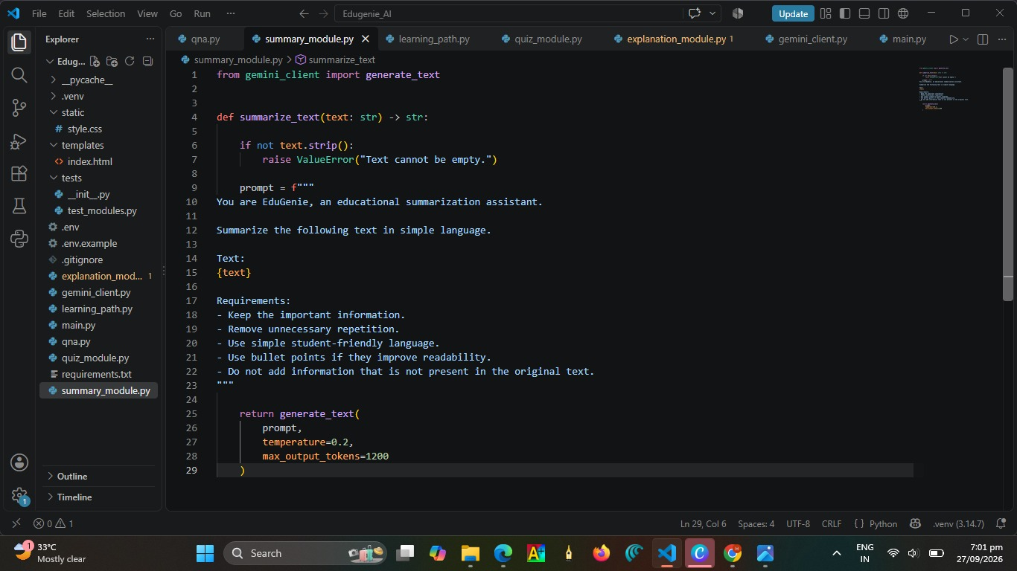

Figure 8.4: EduGenie AI Modules
8.8.5 Server Execution
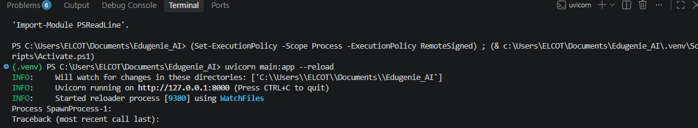
Figure 8.5: FastAPI Server Execution
9. TESTING
Testing is an important phase in the development of the EduGenie AI system. It is performed to identify errors, verify the functionality of different modules, and ensure that the application works as expected.
9.1 Testing Objectives
The main objectives of testing are:
- To verify the functionality of the application.
- To identify and correct errors.
- To verify communication between frontend and backend.
- To verify AI-based responses.
- To ensure that all modules work correctly.
- To check whether the system provides the expected output.

9.2 Types of Testing
9.2.1 Unit Testing
Unit testing is performed on individual modules of the system. Each module is tested separately to verify that it performs its intended function correctly.
9.2.2 Integration Testing
Integration testing verifies the communication between different components such as the frontend, FastAPI backend, AI modules, and Gemini API.
9.2.3 Functional Testing
Functional testing checks whether each feature of EduGenie AI works according to its requirements.
9.2.4 User Interface Testing
User interface testing verifies whether the web application is displayed correctly and whether users can interact with the available features.

9.3 Test Cases
Test Case | Input / Action | Expected Result | Status
TC01 | Open application | Home page should load successfully | Pass
TC02 | Enter a question | AI-generated answer should be displayed | Pass
TC03 | Enter an educational topic | Topic explanation should be generated | Pass
TC04 | Request a quiz | Quiz questions should be generated | Pass
TC05 | Enter lengthy text | Summary should be generated | Pass
TC06 | Request learning recommendation | Suitable recommendation should be displayed | Pass
TC07 | Submit empty input | System should handle invalid input properly | Pass
TC08 | Check backend server | FastAPI server should respond correctly | Pass
9.4 Testing Result
The testing process verifies that the major components of EduGenie AI work together correctly. The application successfully handles user requests, processes them through the appropriate modules, and displays the generated results through the web interface.
Therefore, the system is ready for demonstration and further improvement.
10. OUTPUT
The output of the EduGenie AI system demonstrates the working of the developed web application and its different AI-based learning features. The screenshots provide visual evidence of the system execution and generated results.
10.1 Home Page
The Home Page is the main interface of the EduGenie AI application. It allows the user to access the available learning features and enter the required input.
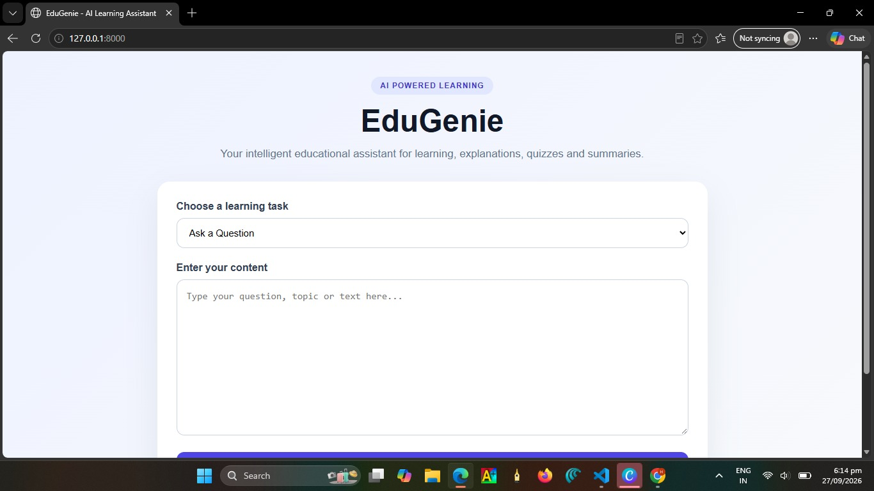
Figure 10.1: EduGenie AI Home Page

10.2 Question Answering Output
The Question Answering feature accepts a question from the user and displays an AI-generated answer.
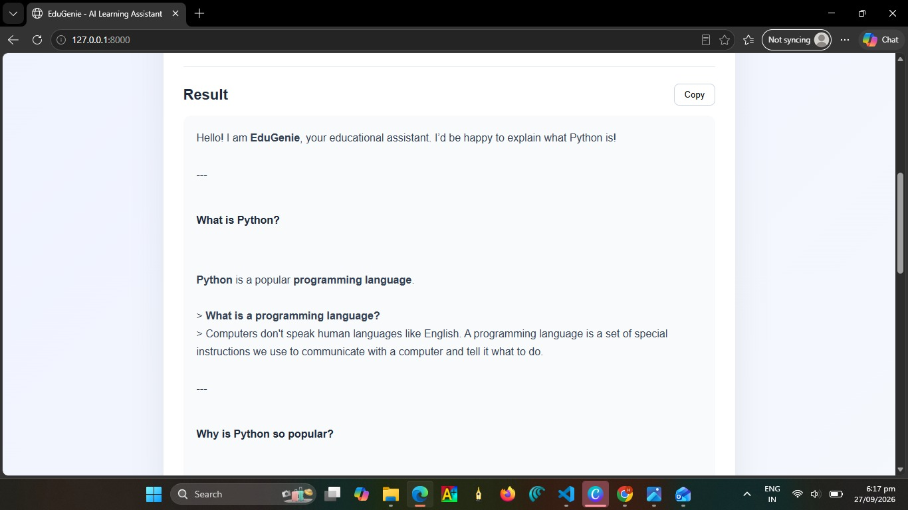
Figure 10.2: Question Answering Output
10.3 Topic Explanation Output
The Explanation feature provides a simple explanation for the topic entered by the user.
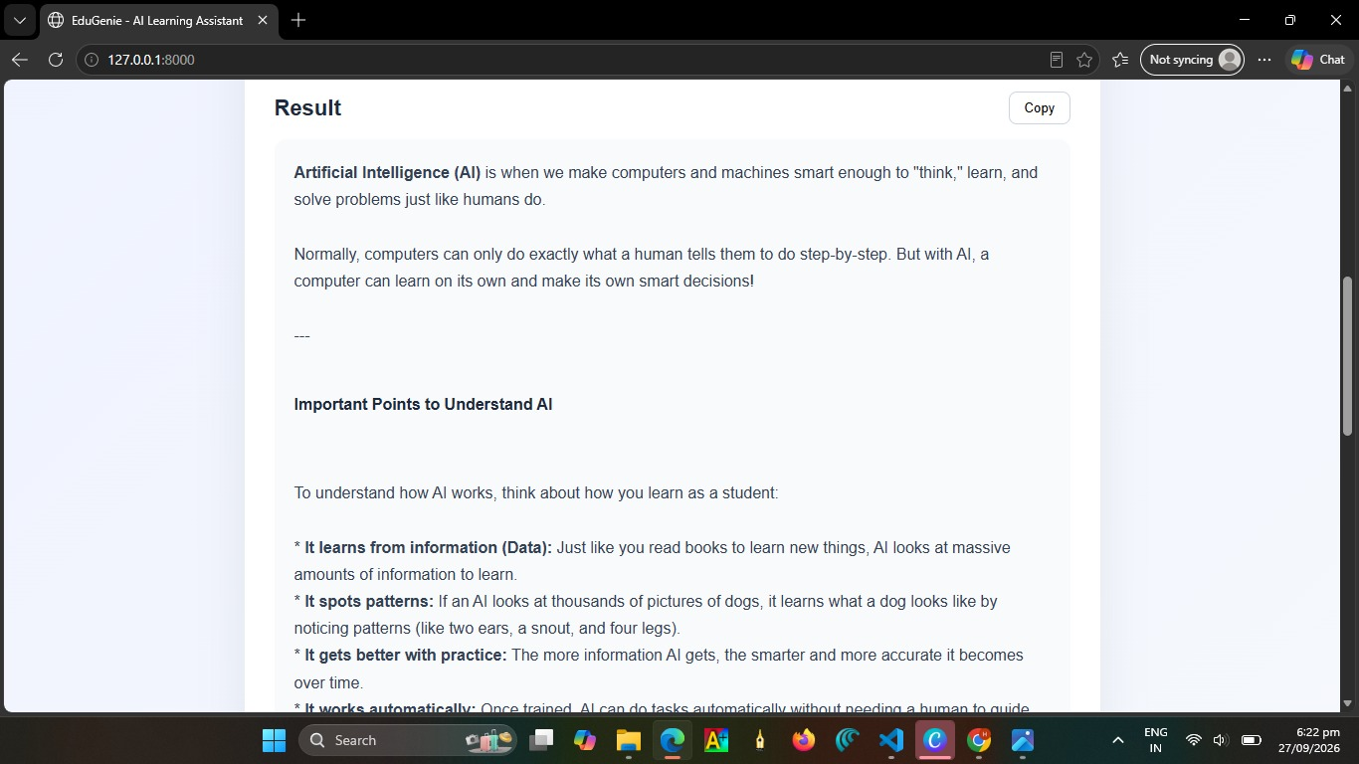
Figure 10.3: Topic Explanation Output
10.4 Quiz Generation Output
The Quiz Generation feature creates questions based on the topic or content provided by the user.
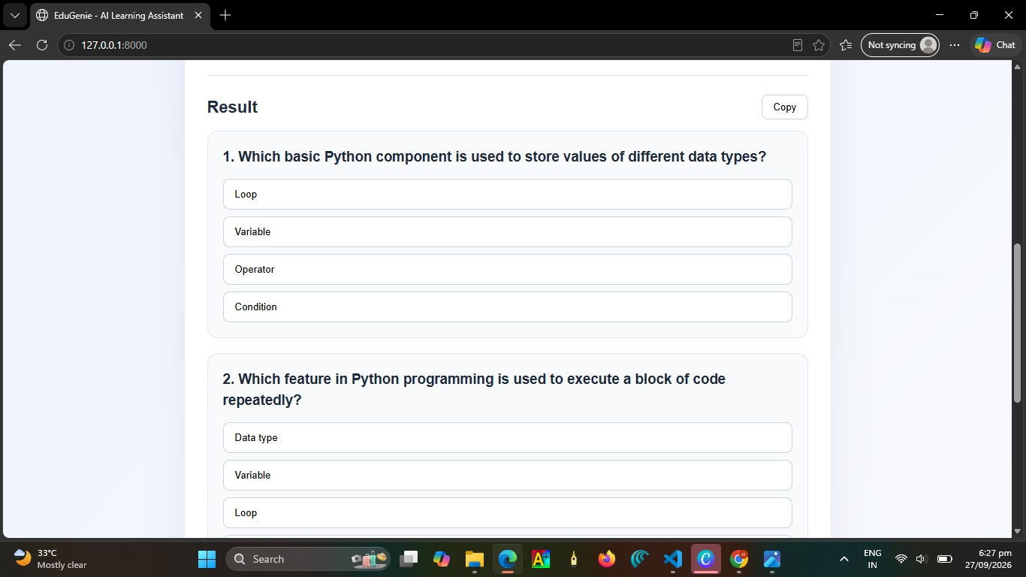
Figure 10.4: Quiz Generation Output
10.5 Text Summarization Output
The Summary feature generates a concise version of the input text and displays the important information.
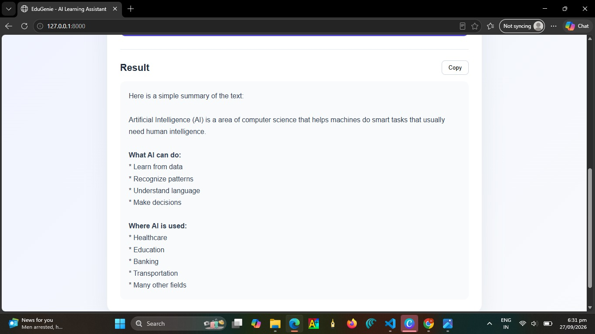
Figure 10.5: Text Summarization Output

10.6 Learning Recommendation Output
The Learning Recommendation feature provides suitable learning suggestions based on the user's requirements.
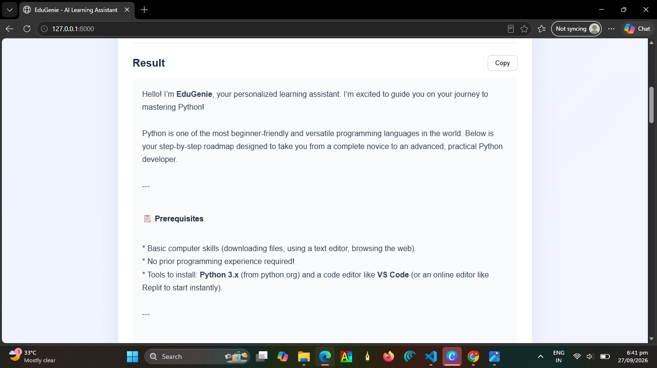
Figure 10.6: Learning Recommendation Output
CONCLUSION
EduGenie AI is an AI-powered educational learning assistant developed to support students in their learning process. The system combines a web-based interface with artificial intelligence to provide useful educational features such as question answering, topic explanation, quiz generation, text summarization, and learning recommendations.
The system uses Python and FastAPI for backend development and integrates the Google Gemini API for AI-based processing. The modular architecture makes the application easier to develop, maintain, test, and extend with additional features.
EduGenie AI reduces the time required to search for learning resources and provides students with quick and interactive learning assistance. The developed system demonstrates how artificial intelligence can be integrated into an educational application to create a convenient and personalized learning environment.
FUTURE ENHANCEMENT
The system can be further enhanced by adding the following features:
- Voice-based question answering.
- User login and personalized profiles.
- Progress tracking and performance analysis.
- More subject-specific learning modules.
- Multilingual learning support.
- Interactive study plans.
- Advanced quiz evaluation and scoring.
- Mobile application support.
Overall, EduGenie AI provides a useful foundation for an intelligent educational assistant and can be further developed into a complete personalized learning platform.

11. REFERENCES
The following resources were referred to during the development of the EduGenie AI project:
- Python Documentation – Python programming language and standard libraries.
- FastAPI Documentation – FastAPI framework and API development.
- Google Gemini API Documentation – AI model integration and API usage.
- Jinja2 Documentation – Template rendering for web applications.
- HTML, CSS and JavaScript Documentation – Frontend development.
- Visual Studio Code Documentation – Development environment and project management.
- Software Engineering concepts and standard academic references.

