**Computer Organization and Architecture**

**Post-Lab Report**

**Lab 03**



|  |  |
| --- | --- |
| Group Members Name & Reg #: | **Muhammad Haris Irfan**  **(FA18-BCE-090)** |
|  |  |
| Class | Computer Organization and Architecture CPE343(**BCE-5B**) |
| Instructor’s Name | Dr. Adeel Israr |

POST LAB

Question:

Write a program that first inputs total no. of student. It then gets student roll no. and marks secured by that student, and stores both in memory. After that it waits in a loop asking to enter roll no. On getting roll no. it displays the marks secured by that roll no. If user enters roll no 9999, it terminates

Solution:

I am attaching my commented code below,

#Title : Lab 4 Task 1. Filename: Lab4Task1.asm

#Author: Muhammad Haris Irfan. Date: 06-10-20

#Roll Number: FA18-BCE-090 Description:

#Registers: $t1, $t2, $t3,$t4, $v0, $a0

################### Data Segment ############################################################

.data

.data

rollNo:.space 200

marks:.space 200

prompt:.asciiz "\nPlease enter number of students:"

rollNoMSg:.asciiz "Please enter roll number: "

markMSg: .asciiz "Please enter marks: "

searchMsg: .asciiz "\nPlease enter roll number to get "

##mark: "

marklsMSg:.asciiz "\nMarks of student is:"

notFound: .asciiz "\nID not found!"

.globl main

############################## Code Segment########################################################

.text

main:

li $v0,4

la $a0,prompt #it will print prompt

syscall

li $v0,5

syscall #ask user input

move $s0,$v0 #save a to t1

la $a3,rollNo

la $a2,marks

li $t0,0 #index

loop:

mul $t1,$t0,4 #get index of i

add $t2,$t1,$a3 #get index of rollNI]

add $t3,$t1,$a2 #get index of marksli]

li $v0,4

la $a0,rollNoMSg #it will print prompt

syscall

li $v0,5

syscall

sw $v0,($t2) #save rolINumber

li $v0,4

la $a0,markMSg #it will print prompt

syscall

li $v0,5

syscall

sw $v0,($t3) #save marks

addi $t0,$t0,1 #i++

blt $t0,$s0 loop

while:

li $v0,4

la $a0,searchMsg #it will print prompt

syscall

li $v0,5

syscall

beq $v0,9999,Exit

li $t0,0 #index

loopSearch:

mul $t1,$t0,4 #get index of i

add $t2,$t1,$a3 #get index of array

Lw $t2,($t2) #get value of arrayll

beq $t2,$v0,found

addi $t0,$t0,1 #i++

blt $t0,$s0 loopSearch

li $v0,4

la $a0,notFound #it will print prompt

syscall

j while

found:

add $t2,$t1,$a2 #get index of array[il

lw $t2,($t2) #get value of array[i]

li $v0,4

la $a0,marklsMSg #it will print prompt

syscall

li $v0,1

move $a0,$t2

syscall

j while

Exit:

li $v0,10

The result for this program is shown below,

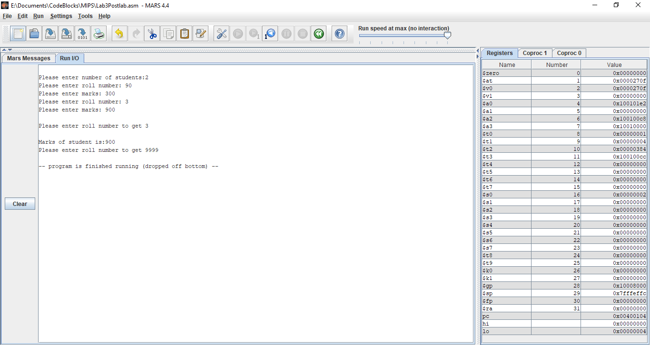

Flow chart of the task:

Critical Analysis/ Conclusion:

In This lab, we learnt about Stacks, through implementation we learnt how to use lw( Load word) and sw(Store word) commands to put and get data from a stack. We also implemented these commands in Different tasks. Moreover, we made handwritten Flowcharts for each task, depicting the working of our code.

______THE END_______

_______________