Lab 5

Verilog Basics

Continuous Assignment

Learning objectives of this lab,

* Continuous Assignment
* Pre-Lab
  1. Code Structure(Continuous Assignment)
     1. Overview

Continuous assignments provide a way of modeling combinational logic at a higher level of abstraction than Gate-Level logic. It allows the use of Boolean logic rather than gate connections. The left-hand side of an assignment is a variable to which the right-side value is to be assigned and must be a net. The right-hand side of an assignment, separated from the left-hand side by the equal (=) character, can be a net, a reg or any expression that evaluates a value including function calls. Continuous assignments are always active and assignments occur whenever the right-hand side operands changes. It drives both vector and scalar.

* + 1. Operators

|  |  |
| --- | --- |
| **Function** | **Operator** |
| NOT | ~ |
| AND | & |
| OR | | |
| XOR | ^ |
| XNOR | ~^ or ^~ |

Table 6.1 (Bitwise operators)

The code example explains these.

|  |  |
| --- | --- |
| **Function** | **Operator** |
| Left Shift | << |
| Right Shift | >> |

Table 6.2 (Bit Shifting)

a>>2 will right shift ‘a’ by 2 bits.

|  |  |
| --- | --- |
| **Function** | **Operator** |
| Concatenation | { } |

Table 6.3 (Concatenation)

Concatenation is used to merge multiple variables. For example if ‘a’ is 8-bit variable ‘b’ is 16-bit variable {a , b[3:0], 4’b1001’} results in 16-bit value.

|  |  |
| --- | --- |
| **Function** | **Operator** |
| Conditional operation | **? :** |

Table 6.4 (Conditional Execution)

Conditional operator is used to implement a circuit using if-else like structure

* + 1. Example

The code for Fig 6.1 using continuous assignment is given below.

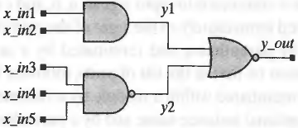

Fig 6.1(five-input and-or-invert (AOI) circuit)

This circuit can be implemented using a single assign statement

module AOI5_CA0 (y_out, x_in);

input [4:0] x_in;

output y_out;

assign y_out = ~((x_in[0] & x_in[1])|(x_in[2]& x_in[3]& x_in[4]));

endmodule

~ means inversion (Not gate), | is Or, and & is And gate.

The module AOI5_CA0 can also be written using multiple continuous assignments

module AOI5_CA3 (y_out, x_in1, x_in2, xin_3, xin_4, xin_5);

input x_in1, x_in2, x_in3, x_in4,x_in5;

output y_out;

wire y1 = x_in[0] & x_in[1] & x_in[4]; // Bitwise and operation

wire y2 = xin_[2] & xin_[3];

assign y_out = ~(y1 | y2); // Complement the result of bitwise OR //operation

endmodule

* + 1. Conditional operator

Conditional operator can be used to implement enables

The five-input AOI circuit can be modified to have an additional input, enable, and to have a three-state output, as described by AOC5_CAI below.

module AOC5_CA1 (y_out, x_in1, x_in2, x_in3, x_in4, x_in5, enable);

input x_in1, x_in2, x_in3, x_in4, x_in5, enable;

output y_out;

assign y_out = enable? ~((x_in1 & x_in2)|(x_in3 & x_in4 & x_in5)): 1'bz;

endmodule

The conditional operator **(? :**) acts like a software if-then-else switch that selects between two expressions. In the above example, the conditional execution stement means,

if enable == 1

y_out=~((x_in1 & x_in2)|(x_in3 & x_in4 & x_in5))

else

y_out= 1’bz;

Example code given below implements a 32-bit 4-1 mux using conditional operator.

Input [31:0] input0, input1, input2, input3;

output [31:0] muxout;  
input [1:0] select;

assign muxout = (select == 2'b00) ? input0:  
  ( (select == 2'b01) ? input1 :  
  ( (select == 2'b10) ? input2 :  
  ( (select == 2'b11) ? input3 : 32’bz )))

* In-Lab

**Task (Use Vectors for declaring variables)**

* Write Verilog HDL description of previous lab tasks using continuous assignment.
* Write the Verilog HDL description of following shift register. Write a module 2-1 mux using continuous assignment, then instantiate D Flip-Flop and 2-1 mux multiple times in a module to describe the given circuit

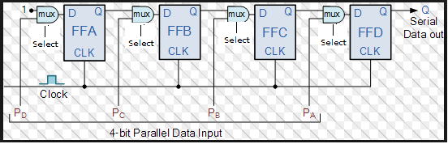

* Post-Lab
* Write Verilog HDL description of Universal shift register. Waveform should display all inputs and contents of register for different select options

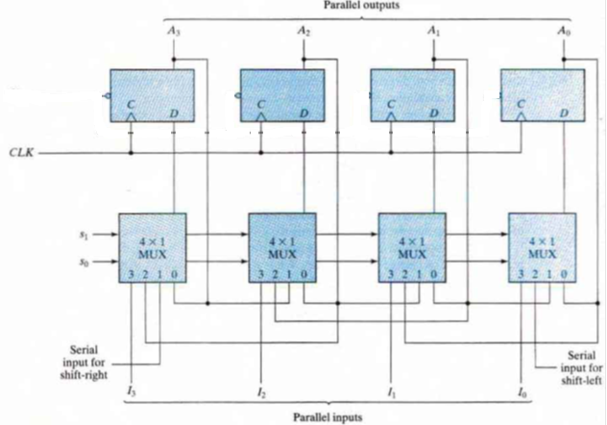

* **Your lab report, a .doc file, should contain properly commented Post-Lab task code, with Screenshots(of print preview) of Schematic and waveforms, and Critical Analysis.**
* **The report must have a title page in the pescribed format.**
* **Name the .doc file RegNo.docx; eg SP14-BCE-99.docx**
* **Send it to** [**khiyamiftikhar@gmail.com**](mailto:khiyamiftikhar@gmail.com)**. With subject Lab No.**