**Task No. 01**

Following figure shows a pattern of squares generated for different input values of N (for N=0 to N=5). Develop a general algorithm to fill in the grid for any input N. Use the 4 step process that was discussed in the class (and is given below for reference)

The four – step algorithm development process:

1. Work an example yourself.

2. Write down what you just did.

3. Generalize your steps.

4. Test your algorithm.

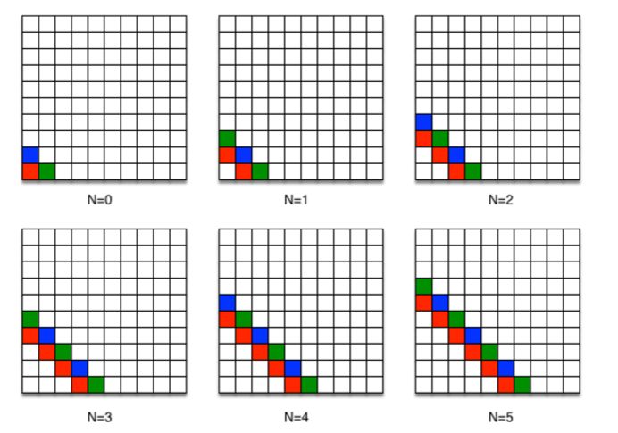

Figure A pattern of squares problem

**Task No. 02**

Write a C program for following piecewise function. Program must take input from user and calculate and print the function result on screen.

$$f[n]=\left\{\begin{aligned}-n-4, & n<3 \\ n^{2}-7, & 3≤n≤10 \\ \frac{120}{n} +n, n>10 \\ \\ where n is an integer variable\end{aligned}\right.$$

**Post Lab**

Write a program that takes integer input from user and tells (displays on the output console screen) whether it is even or odd.