**Technological Institute of the Philippines**

**Manila**

**CIT401 - Systems Administration and Maintenance**

|  |  |
| --- | --- |
| Names | Enriquez, Mhar Vincent M. |
| Section | IT41S3 |

Instructions:

1. Meet as a group and perform the given task.
2. Put your answer on the number (marked as RED) asking for an output.
3. Do not modify the format of this document for easier checking.

Tasks:

1. Installing the LAMP
2. Issue the command for the Apache

* sudo apt install apache2
* sudo ufw app list

1. Issue the command for MySQL

* sudo apt install mysql-server

1. Issue the command for PHP

* sudo apt install php libapache2-mod-php php-mysql

1. Configuring the IP address
2. Follow the link below on how to set static IP address in your Ubuntu server.

<https://technologyrss.com/how-to-configure-static-ip-address-on-ubuntu-21-04-server/>

Note: You can use other references.

**My Server Version**

1. On my copy of VM after setting the static IP I have the following:

Figure .Static IP is set to the Ubuntu VM.

The IP that I set in my Ubuntu is 192.168.254.138 and my desktop is 192.168.254.137. To validate that my desktop pc can communicate with the Ubuntu server, I will issue a ping command and there should be a reply.

Figure . Issuing ping command from PC to Ubuntu server.

This way we can access the website that we will be deploying outside the Ubuntu server.

1. Provide a screenshot of your output like Figure 2.
2. Open a browser on your PC and access the test website by typing on the URL <http://192.167.245.138> or replace it with your own IP address. The output will be like this:

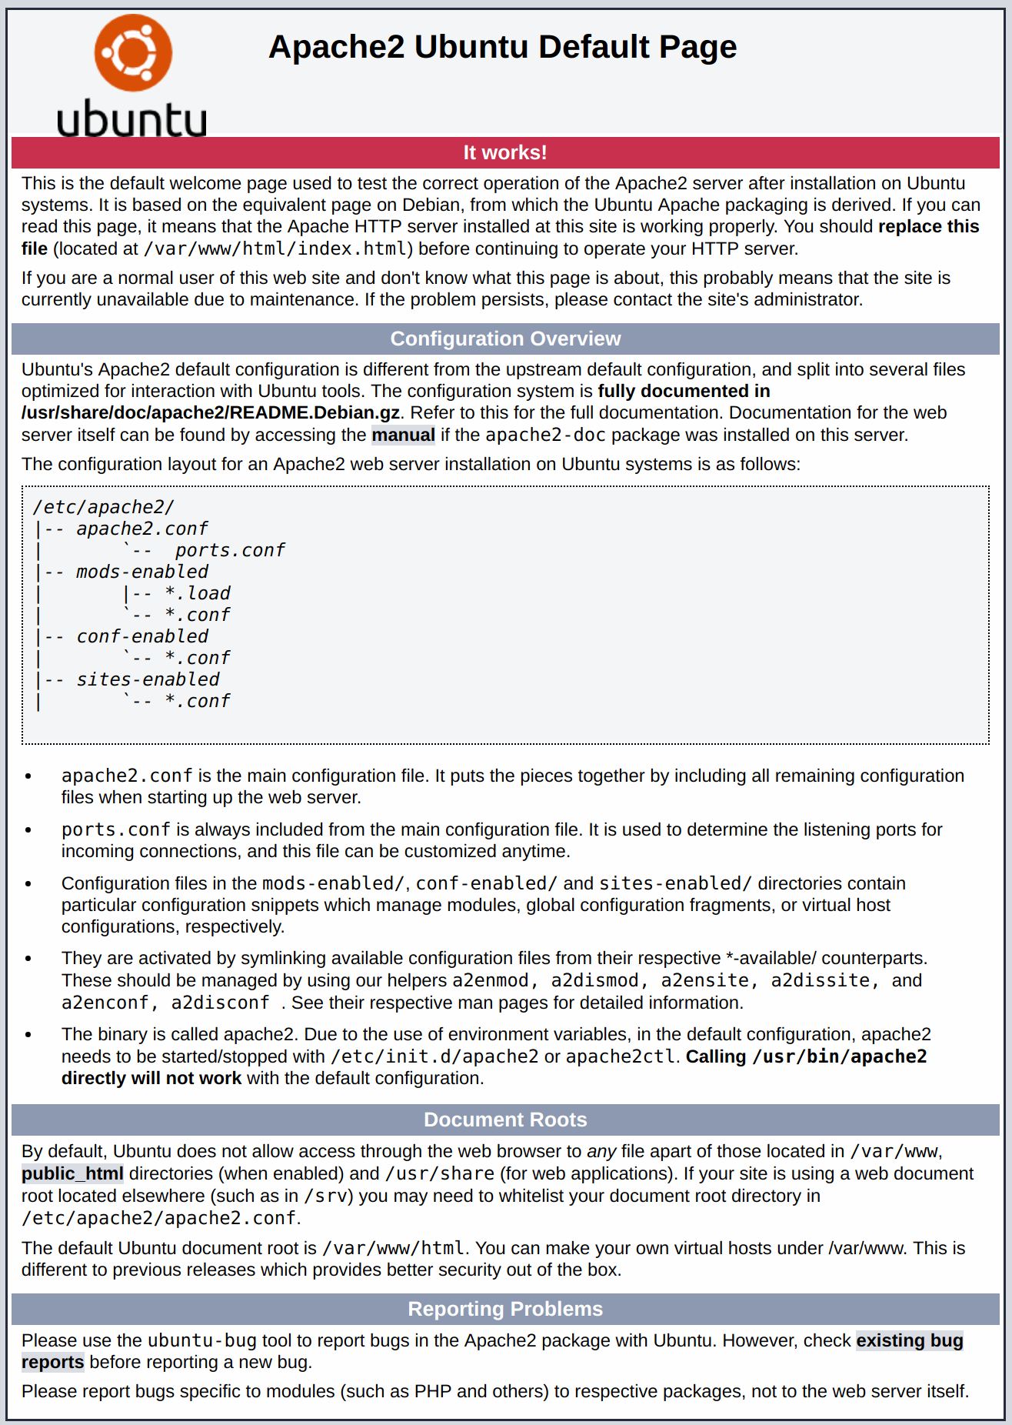

Figure . Default Ubuntu Apache web page.

1. Put your screenshot below including the URL to see that you can access your server on your PC browser.

My Ubuntu static IP is 192.168.1.50

My Desktop IP is 192.168.1.15

To validate that my desktop pc can communicate with the Ubuntu server, I will issue a ping command and there should be a reply.

***http://192.168.1.50/***

**Honor Pledge:**

*“I affirm that I have not given or received any unauthorized help on this assignment, and that this work is my own.”*

*ENRIQUEZ, MHAR VINCENT M.*