Some pictures of the performance of Nano-Gro on pepper in Nigeria-2009. These pictures were taken when Dr Abdoulaye Mando visited Nigeria for a monitoring visit
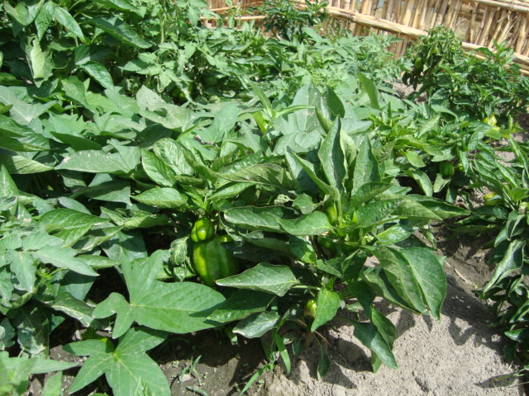  Nano-Gro treated plots | 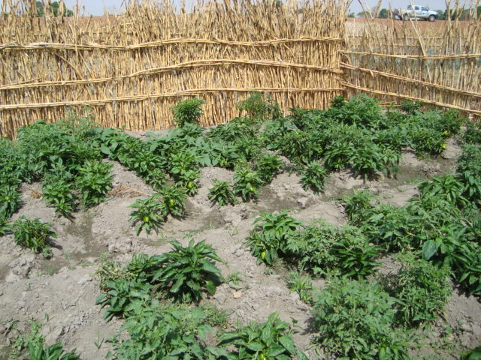  Non treated plots
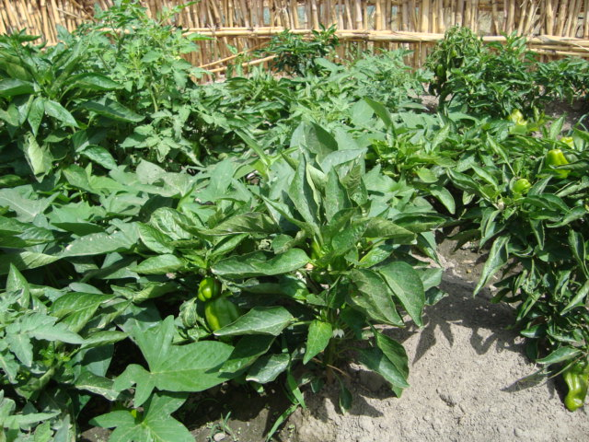  Nano-Gro treated plots | 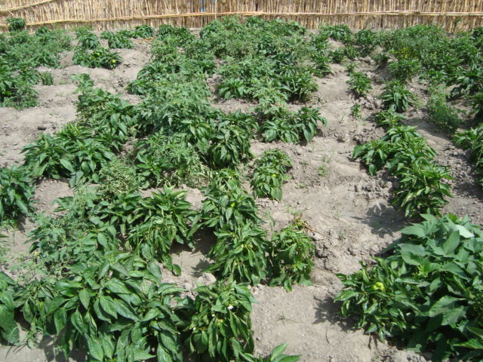  Non treated plots
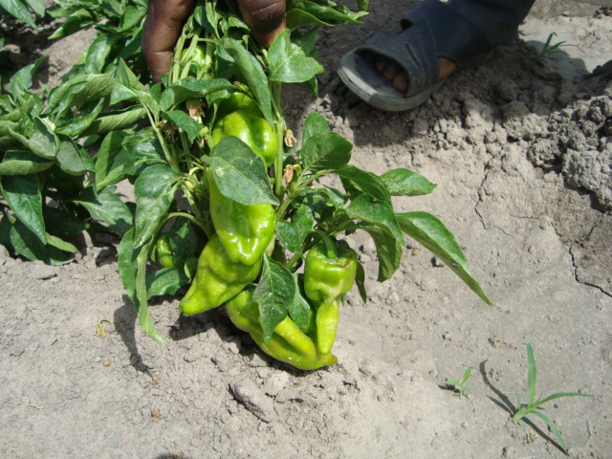  Nano-Gro treated plots | 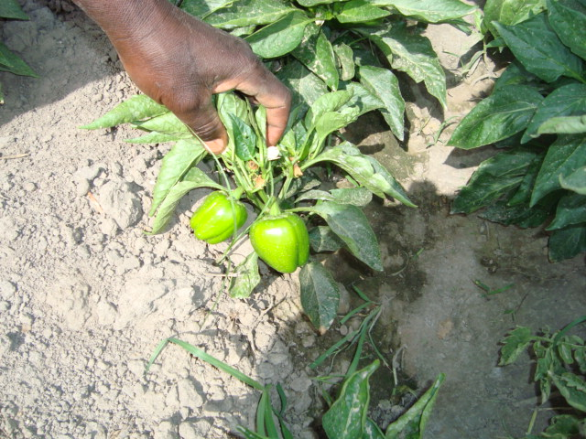  Non treated plots
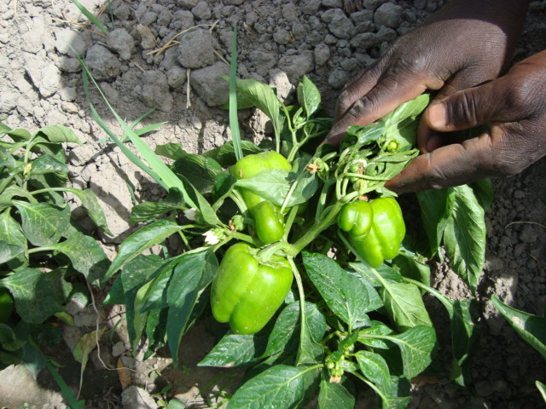  Nano-Gro treated plots | 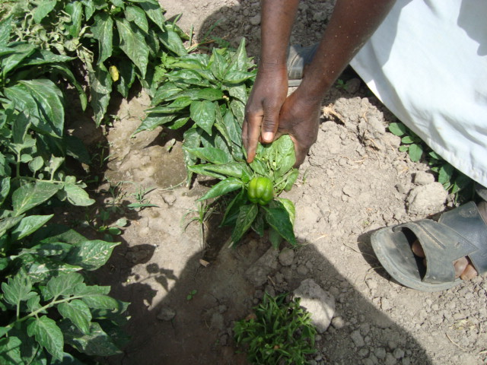  Non treated plots

