AI Deployment Evaluative Framework
Scoring Worksheet
Tool / Activity | Date | Evaluator
Grade level / Subject | Student population context

TEACHER DEMAND
Deployment Judgment
Expertise required to decide whether and how to deploy AI for this task — exercised before use begins.
1  Any teacher could deploy this without specialized preparation. | 2  Requires some familiarity with the tool; basic pedagogical awareness. | 3  Requires meaningful understanding of both the tool and its instructional fit. | 4  Requires deep pedagogical judgment about when and how AI belongs in this context. | 5  Requires expert-level judgment: technical, pedagogical, and contextual — expert teachers only.

○ 1 | ○ 2 | ○ 3 | ○ 4 | ○ 5 | Evidence:

TEACHER DEMAND
Teacher In-Use Judgment
Active professional discernment the teacher must exercise while the tool is running.
1  Teacher can step away entirely; no active oversight needed. | 2  Occasional check-ins sufficient; most of the time the tool runs itself. | 3  Teacher monitors regularly and intervenes when something looks off. | 4  Teacher is actively reading outputs, redirecting, and making real-time calls throughout. | 5  Continuous high-stakes judgment required — every output demands professional interpretation before reaching students.

○ 1 | ○ 2 | ○ 3 | ○ 4 | ○ 5 | Evidence:

STUDENT CAPACITY TRAJECTORY
Tool Fluency
Whether sustained use builds transferable AI literacy in students — understanding how these systems behave, where they fail, and how to work with them critically.
1  Students have no meaningful contact with AI; no fluency builds. | 2  Students interact with a highly constrained or abstracted interface; minimal transferable learning. | 3  Students engage with AI in limited ways; some habits of mind may develop. | 4  Students regularly interact with AI outputs and must evaluate them; genuine fluency develops over time. | 5  Students work directly with AI, develop critical habits around verification and interpretation, building transferable literacy.

○ 1 | ○ 2 | ○ 3 | ○ 4 | ○ 5 | Evidence:

STUDENT REACH
Proximity to Learning
How directly the AI touches the core acts of instruction, learning, feedback, and assessment.
1  AI is entirely peripheral to the student experience; no contact with instruction or feedback. | 2  AI touches the edges of learning — scheduling, logistics, resource access — but not the core. | 3  AI is present in some learning moments but is not the primary vehicle. | 4  AI regularly mediates instruction or feedback in meaningful ways. | 5  AI is the primary medium through which instruction, feedback, or assessment is delivered.

○ 1 | ○ 2 | ○ 3 | ○ 4 | ○ 5 | Evidence:

STUDENT REACH
Student In-Use Judgment
Critical thinking students must supply to use the tool productively and safely.
1  Students are passive recipients; no active judgment required or possible. | 2  Students make minimal evaluative decisions; the tool scaffolds most choices. | 3  Students must exercise some discernment — selecting, comparing, or verifying outputs. | 4  Students are regularly required to evaluate AI outputs against their own understanding. | 5  Students must apply sustained critical judgment at every step; passive use would be actively harmful.

○ 1 | ○ 2 | ○ 3 | ○ 4 | ○ 5 | Evidence:

STUDENT CAPACITY TRAJECTORY
Disciplinary Knowledge
Whether sustained use builds students' content understanding and disciplinary thinking — knowledge that belongs to them regardless of what tools they use.
1  The tool performs the disciplinary thinking for students; knowledge-building is bypassed entirely. | 2  Little disciplinary engagement; students interact with outputs more than ideas. | 3  Some knowledge-building occurs alongside AI use, depending on pedagogical intent. | 4  The tool is designed to prompt and reinforce disciplinary thinking; content understanding deepens over time. | 5  Disciplinary knowledge is the explicit aim; sustained use predictably builds content understanding and ways of thinking.

○ 1 | ○ 2 | ○ 3 | ○ 4 | ○ 5 | Evidence:

Circle your score (1–5) for each dimension. Use the Notes column to record what drove your rating. Transfer scores to the petal chart on the reverse. The shape is the message — do not sum or average.

Profile Chart
Transfer your scores by shading or numbering each petal outward from the center. Each ring = one point.
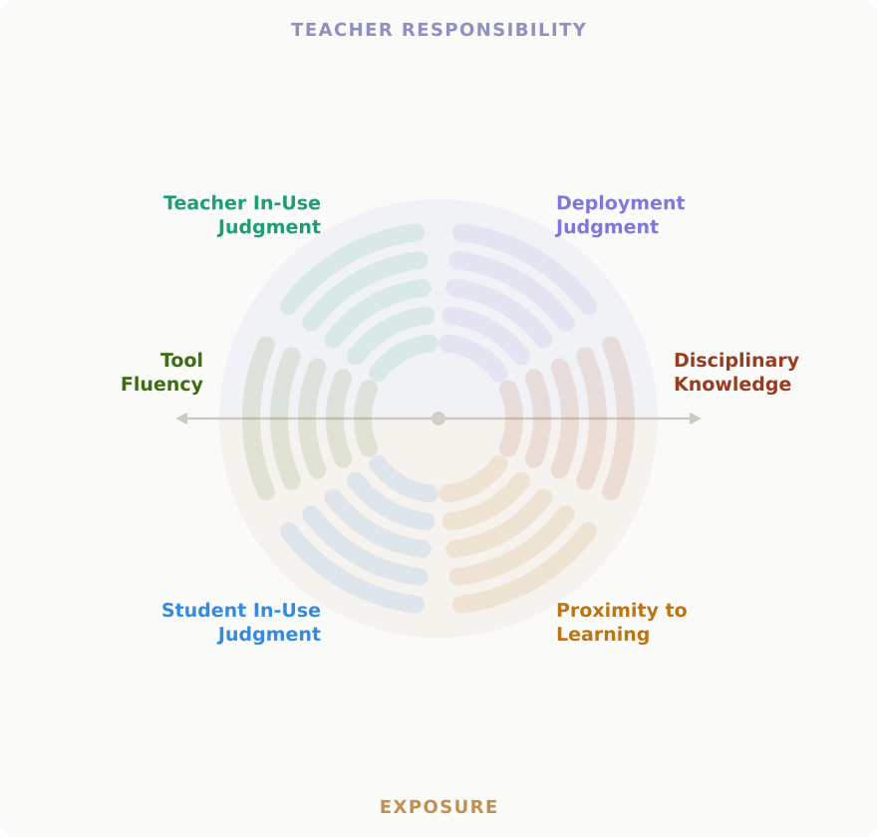 | Dimension Score  Deployment Judgment /5  Teacher In-Use Judgment /5  Tool Fluency /5  Proximity to Learning /5  Student In-Use Judgment /5  Disciplinary Knowledge /5

Reading the Profile
The equator is the key insight  A healthy profile fills the upper half — high teacher demand means professional judgment is doing its work. An unbalanced profile that bulges downward signals that AI is reaching into learning while oversight is low. | Lopsided can be right  Not all asymmetric profiles are warnings. Task streamlining is safely lopsided — high teacher in-use judgment, low student reach. The question is whether the asymmetry is intentional and appropriate to context. | Two warning shapes to watch for  High proximity + low deployment judgment: AI deep in learning, professional judgment absent at the threshold. Low disciplinary knowledge + low tool fluency: both student capacity poles are depleted — the longer the tool runs, the more ground students lose in both directions.

Middlesex School · Concord, Massachusetts · March 2026 · © 2026 Mike Harrington · CC BY-NC-SA 4.0

