Clear Seeing
You Already Know the Answer
▼
Before APP
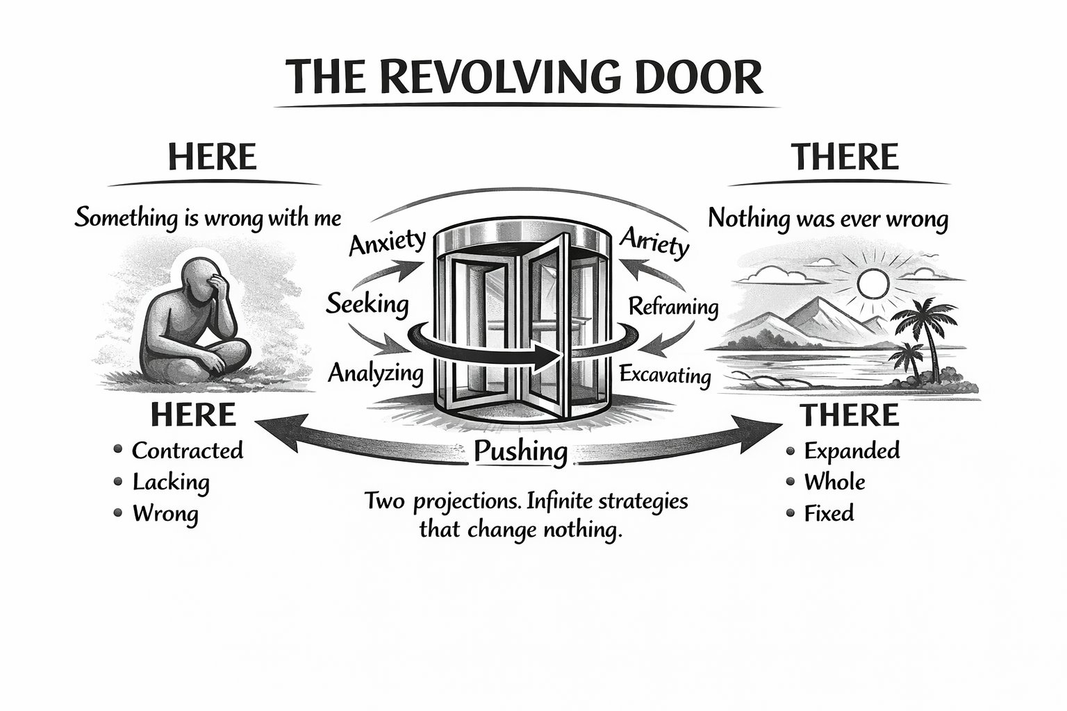
▼
After APP
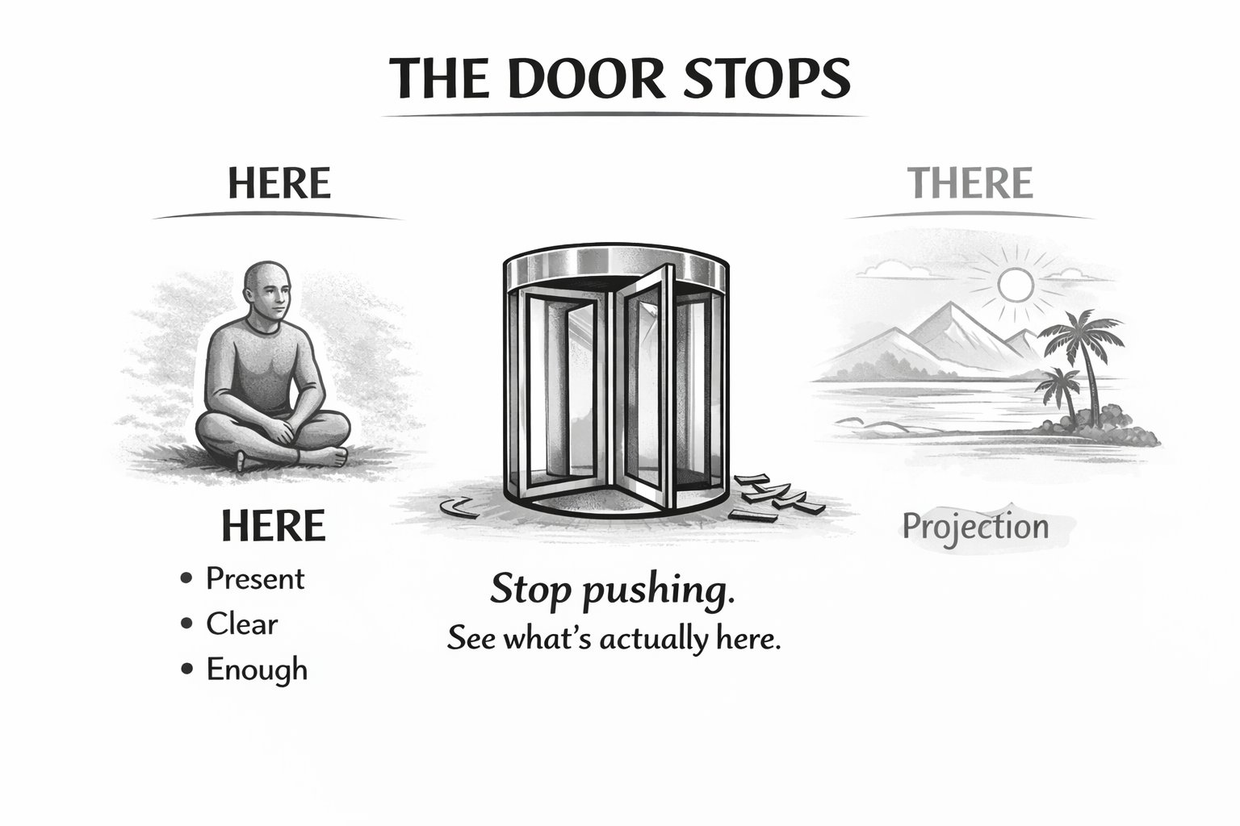

You've Been Pushing on a Revolving Door

Something in your life isn't working. You know it. You've thought about it, talked about it, tried to fix it. You've pushed. Nothing has moved.
What you probably haven't noticed is that the door keeps spinning. You push toward the solution — the better relationship, the resolved situation, the version of yourself that doesn't have this problem — and for a moment it seems like you're getting there. Then you're back at the start. Same door. Same push. Same result.
This isn't because you're not trying hard enough. It's because the door you're pushing on has no exit.

On the left: HERE. Contracted. Lacking. Wrong. Something is wrong with me, with them, with this situation. The here is uncomfortable. Intolerable, some days.
On the right: THERE. Expanded. Whole. Fixed. Where things will be better. Where the problem is solved. Where the version of you that doesn't carry this weight finally gets to exist.
In the middle: the door. Spinning. Anxiety, seeking, analysing, reframing, excavating — every strategy you've tried is just another hand on the same door. Pushing from here toward there.

HERE is a story. A heavily curated, selectively edited account of what's present — filtered through a model of how things should be. Not reality. A story about reality.
THERE is a fantasy. A projection of what the model wants. Not a real place. A moving target that recedes the closer you get.
You're pushing between two projections. The door keeps spinning because there's nowhere to arrive. When you finally get to THERE, it becomes the new HERE. Not good enough. Wrong. Lacking. And a new THERE appears on the horizon.

It never ends.

Until you stop pushing.

You hide in the cave because the battlefield feels unsurvivable. But the cave has its own cost — you watch others moving while you rot. So you armor up and go out. Full gas. Except the brake never came off. You never believed it was survivable. That's the door spinning.

"There's no way out of this that doesn't destroy something."
"I've been carrying this so long I don't remember what before felt like."
"I know what I should do. I just can't make myself do it."

Those aren't descriptions of unsolvable problems. They're descriptions of someone exhausted by a machine that was never going to deliver what they needed from it.

Get off the machine. See what's actually here.

It's almost always fine.

The Mechanism

Why the Door Keeps Spinning

The machine runs on a gap.
Your nervous system builds a constant prediction of how things should be — how people should behave, how situations should resolve, what you should be feeling. When reality matches the prediction, there's no signal. When reality doesn't match, a gap opens between the model and what's actually here.
That gap produces a charge. The charge is not a problem — it's information. It's saying: your model and reality are out of alignment. Something needs updating.
But the charge is uncomfortable. And the moment it appears, the distortion goggles go on.
With the goggles on, everything coming in gets filtered through the model. The gap looks like a problem to be solved — not a signal to be felt. So you push. Toward the better there. Away from the unbearable here. Infinite strategies. Nothing changes. Because the strategies are all feeding the model. And the model is what created the gap.
The charge doesn't live in the story. It lives in the gap itself. And no amount of thinking, talking, analysing, or reframing can reach the gap. They can only describe it.

What closes the gap is simple. Not easy — simple.

The gap lives in the abstract. That's why thinking can't close it — thinking stays in the abstract, which is where the gap was manufactured in the first place. More thinking just builds more scaffolding around the same fiction.
The app moves you from abstract to concrete. Not by explaining the gap or reframing it — by asking what's actually here, in the body, right now, in specific physical terms. Location. Sensation. Weight. And the concrete is where the gap can't survive. Because the gap is a comparison between two abstractions — HERE as story, THERE as fantasy. Neither exists in the concrete. When you contact what's actually here, the gap has nothing to stand on.

That's the bluff call. Not an argument. Not a reframe. Just: show me what's actually here. And the gap, which felt absolutely solid and real, reveals itself as mental architecture with no foundation underneath it.

Stop pushing. Feel what you don't want to feel. Not the story about it — the actual physical sensation of this charge, in this moment, in your body. Contact it directly. Hold it without immediately trying to resolve it.

When both forces are held simultaneously — what you want to be true and what is actually here — the charge dissolves. Not because you resolved it. Because you stopped running from it. The contracted view opens. Same situation, wider field. The next move, which was invisible a moment ago, becomes obvious.

When the charge dissolves, the brake releases. Not through effort. Through contact.

Peace is not the reward at the end of solving the last problem. It's what's already there when the machine stops.

The Eight Escapes

Every Move That Feels Like Progress

When the gap opens and the charge builds, there are eight things the mind does. Every one of them is an attempt to close the gap without contacting it. None of them work — not because you're doing them wrong, but because they're structurally incapable of reaching the gap.
You'll recognise yourself in at least three.

- 1. Analyzing — treating it like a problem to solve instead of a feeling to contact. The analysis feeds the model. The gap doesn't move.
- 2. Seeking reassurance — looking for someone to confirm it will be okay. The charge stays underneath the reassurance.
- 3. Reframing — building a better story about what's happening. The reframe sits on top of the charge. Doesn't contact it.
- 4. Catastrophizing — running every consequence forward, stacking worst cases. Feels like preparing. It's avoidance with momentum.
- 5. Excavating the past — tracing it back to where it started. The origin doesn't close the gap. Contact does.
- 6. Comparing progress — measuring how far you've come or how far you still have to go. Keeps the revolving door spinning.
- 7. Seeking certainty — needing to know how it will turn out before you can move. Certainty isn't available. The charge stays live.
- 8. Meta-observing — watching yourself experience it, analysing the pattern, understanding the mechanism. Still not contact. Still distance.

Each one feels like progress. Each one maintains the distance.
The charge returns — in this situation, in the next one, at 3am when there's nothing left to distract you.

Why This Works When Nothing Else Did

Most inquiry — including therapy, meditation, and direct pointing practices — happens when nothing is particularly at stake. You're looking for a self that isn't currently defending anything. The signal is weak. Nothing real is being tested.
The search comes up empty. But the nervous system doesn't update, because there was no real test. No threat, no activation, nothing on the line.

When the existential alarm is ringing — job gone, relationship over, identity on the line — the signal is loud and direct. The nervous system is fully committed to protecting something specific. That's when the test is real.

Follow the charge inward. Find what's about to be hit. Look directly at it.

There's nothing there to receive the impact.

Run that under real activation enough times and something changes — not as an idea, but in the system that was predicting danger. The nervous system stops treating the threat as real. Not through insight. Through repeated contact with the absence of a target.

That's why the app works when years of other approaches didn't. It waits until something is actually charged, removes the escape routes, and walks the attention back to what's being protected.

Same discovery. Stronger signal. Repeated until the ground holds.

Why Other Approaches Don't Work
- Talking about it — feeds the story. The charge stays underneath.
- Analysing it — refines the model. The gap doesn't move.
- Positive reframing — sits on top of the charge. Doesn't contact it.
- Advice — answers the story. The real question is underneath the story.
- Time — numbs the signal. Doesn't resolve it.
- Talk therapy — works at the level of the mind. The mind generated the charge. You can't think your way out of a feeling.
These are legitimate approaches. They're just not designed to contact the gap.

The App

Come In With Catastrophe. Leave With a Clear Path.

The Clear Seeing Guide was built for this exact moment. Not for ongoing work. Not for processing the past. For the charged situation that's live right now — the one that has that revolving door quality, the one that's been following you, the one that looks like it has no exit.

The app does something none of the approaches above do.

It doesn't feed your story.

Every conversation you've had about this situation has fed the story. Friends, partners, therapists, the voice in your head at 3am — all feeding the model, all adding detail to the HERE or the THERE. The app refuses to. That's the first and most important thing it does differently.

It meets you exactly where you are. Then it does this:

- 01 Mirrors back what's actually here. Not the story. The charge itself — where it lives, what it actually feels like, stripped of the narrative that's been carrying it.
- 02 Names the escape route you're running. Not as criticism. As recognition. Here's the move you're making. Here's what it looks like from outside the contraction.
- 03 Asks you to stop pushing. Not forever. For this conversation. Stop and turn toward what you've been moving away from.
- 04 Holds you in the gap. Both forces present simultaneously — what you want to be true, and what is actually here. Not resolved. Not argued away. Held. This is the part every other approach skips. This is the part that produces the shift.
- 05 Waits for Gibraltar.¹

Gibraltar is the moment the contracted view can no longer hold — the point where the pushing stops not because you decided to stop but because there is nothing left to push against. Not always dramatic. Sometimes it's quiet: something that was pressing stops pressing. A small recognition. The situation looks slightly different than it did ten minutes ago.

Everyone has a Gibraltar moment. The app is built to get you there in twenty minutes.

The HERE reveals itself as a story. The THERE reveals itself as a fantasy. Both dissolve. And what remains is what's actually here.

Which is almost always fine. Manageable. Workable. Real.

And the next move — the one that's been invisible since the door started spinning — is suddenly obvious.

Not because the app gave you the answer.

Because you already had it. The charge was what made it invisible.

¹ Gibraltar — and the mechanism underneath it — explored in full in CLEAR SEEING: When Pushing Fails — No One to Defend, by Michael Harris.

Twenty minutes. Walk in with catastrophe. Walk out knowing what you already knew.

This is not therapy. No ongoing relationship, no diagnosis, no treatment plan. If you're in active crisis, therapy is what you need and this is not a substitute for it.
This is a tool for a specific moment. The situation that's live, charged, and needs to be seen clearly — not processed indefinitely. Seen. Once. Clearly.

Stop Pushing. See What's Actually Here.

The machine has been running for a while. You know that. The door has been spinning and every strategy to get through it has produced the same result — back at the start, same door, same weight, slightly more exhausted.
That's not a personal failing. That's the correct output of a machine that was never going to deliver what you needed from it.

The HERE you've been trying to escape is a story. The THERE you've been pushing toward is a fantasy. Underneath both of them — right now, available, not requiring any strategy to reach — is what's actually here.
It's almost always fine.
There is almost always a path forward.
And you already know what it is.
The charge is what's been making it invisible. Twenty minutes. Come in with the weight of it. Leave with a clear path forward.
The door stops when you stop pushing.

Michael Harris
app.clearseeing.ca

