Enterprise Data Warehouse with Interactive Dashboards & Reports

Software Project Management Plan



Prepared By

Harsh Mehta (13CE051)

Project ID: PRJ2017CE068

Instructors:

Meghna Luthra

Sagar Patel

of

Software Project Major (CE408)

Faculties of Software Group Project

Table of Contents

Chapter 1 Introduction 1

1.1 Objective 1

1.2 Major Functions 1

1.3 Management and Technical Constraints 1

1.3.1 Management Constraint…………………….………………………………1

1.3.2 Technical Constraint………………………..………………………………2

Chapter 2 Project Estimation 3

2.1 Estimation Technique Used 3

Chapter 3 Risk Management Plan …………………………………………5

3.1 Risk Estimation 5

3.2 Risk Abatement Procedure 5

3.3 Risk Management Plan……………………………………………………….….6

3.4 Risk Estimation and Risk Abatement Procedure …...............................................6

Chapter 4 Scheduling 10

4.1 Work Breakdown Structure (WBS) 10

4.2 Task Network Representation 11

4.3 PERT Chart 12

4.4 Network Chart 13

Chapter 5 Staff Organization 16

6.1 Team Structure 16

6.2 Management Reporter 16

Chapter 6 Project Tracking and Control Plan 17

**Chapter 1: Introduction**

**1.1 Objective:**

Data will be sourced from various systems and required transformation will be performed and loaded in data warehouse for historical and performance analysis, which shall help various organizations to access analyzed data and use it to future business decision-making. Also to identify the trends and improve the system or the steps to carry out business processes.

This project has following objectives:

* To help various organizations to access analysed data and use it to future business decision-making.
* Also to identify the trends and improve the system or the steps to carry out business processes.

**1.2 Major Functions:**

* System should contain merged data from all the different data sources.
* System should have interactive reports.
* System should not take time to run the packages.
* System should contain Dashboards which can generate important information like sales per year, Employee information etc.
* Data should be loaded automatically when new data is inserted on any of the source.
* System should make proper analysis of the organization.
* Data should be available all the time.

**1.3 Management and Technical Constraints**

**1.3.1 Management constraint:**

* Regularity policies: Our system is dependent on the environment of different sources. There are many different types of data sources are there which contains different environment. Our goal is to merge the data from all the sources and to create a single data warehouse which contains the data from every single one of them.
* Hardware limitations: In our system data needs to be extracted on a regular basis and extracted data needs to transformed. Thereafter the transformed data needs to loaded in data warehouse. Slower hardware can increase the time of the whole process. Server needs to be faster and also the volume of data needs to much larger because a staging database is required to perform all the transformations.
* Interfaces to Other Applications: There is only a single interface with client application i.e. all the packages can be executed through a client framework.
* Parallel Operations: The only parallel operations which are required in our system is parallel execution of the created packages which can slow down the system.
* Safety/Security Considerations: Our system contains credentials which are given to the client by admin. These credentials are required to view any data including reports, dashboards. So without credentials data cannot be accessed which is considered as a security measure in our system.

**1.3.2 Technical constraint:**

These constraints deal with the actual construction processes that are tasked to complete an activity or assembly.  Technical constraints are the most common type of constraint and in many instances, are based on practicality of building methods and standards.

Microsoft SQL Server is a [relational database management system](https://en.wikipedia.org/wiki/Relational_database_management_system) developed by [Microsoft](https://en.wikipedia.org/wiki/Microsoft). As a [database server](https://en.wikipedia.org/wiki/Database_server), it is a [software product](https://en.wikipedia.org/wiki/Software_product) with the primary function of storing and retrieving data as requested by other [software applications](https://en.wikipedia.org/wiki/Software_application)—which may run either on the same computer or on another computer across a network (including the Internet). SQL Server Integration Services (SSIS) is a component of the [Microsoft SQL Server](https://en.wikipedia.org/wiki/Microsoft_SQL_Server) database software that can be used to perform a broad range of [data migration](https://en.wikipedia.org/wiki/Data_migration) tasks. SSIS is a platform for [data integration](https://en.wikipedia.org/wiki/Data_integration) and [workflow applications](https://en.wikipedia.org/wiki/Workflow_application). It features a fast and flexible [data warehousing](https://en.wikipedia.org/wiki/Data_warehouse) tool used for data [extraction, transformation, and loading (ETL)](https://en.wikipedia.org/wiki/Extract,_transform,_load). The tool may also be used to automate maintenance of SQL Server databases and updates to multidimensional [cube data](https://en.wikipedia.org/wiki/OLAP_cube). Microsoft SQL Server Analysis Services, SSAS,[[1]](https://en.wikipedia.org/wiki/Microsoft_Analysis_Services#cite_note-1) is an online analytical processing ([OLAP](https://en.wikipedia.org/wiki/Online_analytical_processing)) and [data mining](https://en.wikipedia.org/wiki/Data_mining) tool in [Microsoft SQL Server](https://en.wikipedia.org/wiki/Microsoft_SQL_Server). SSAS is used as a tool by organizations to analyze and make sense of information possibly spread out across multiple databases, or in disparate tables or files. [Microsoft](https://en.wikipedia.org/wiki/Microsoft) has included a number of services in SQL Server related to [business intelligence](https://en.wikipedia.org/wiki/Business_intelligence) and [data warehousing](https://en.wikipedia.org/wiki/Data_warehousing). These services include Integration Services, Reporting Services and Analysis Services. Analysis Services includes a group of OLAP and [data mining](https://en.wikipedia.org/wiki/Data_mining) capabilities and comes in two flavors - Multidimensional and Tabular. SQL Server Reporting Services (SSRS) is a server-based report generating software system from [Microsoft](https://en.wikipedia.org/wiki/Microsoft). It is part of suite of [Microsoft SQL Server](https://en.wikipedia.org/wiki/Microsoft_SQL_Server) services, including SSAS ([SQL Server Analysis Services](https://en.wikipedia.org/wiki/SQL_Server_Analysis_Services)) and SSIS ([SQL Server Integration Services](https://en.wikipedia.org/wiki/SQL_Server_Integration_Services)). While SSAS enables users to construct special databases for fast analysis of very large amounts of data, and while SSIS enables users to integrate data from many sources outside [Microsoft SQL Server](https://en.wikipedia.org/wiki/Microsoft_SQL_Server), SSRS enables users to quickly and easily generate reports from [Microsoft SQL Server](https://en.wikipedia.org/wiki/Microsoft_SQL_Server) databases. The SSRS service provides a unique interface into [Microsoft Visual Studio](https://en.wikipedia.org/wiki/Microsoft_Visual_Studio) so that developers as well as SQL administrators can connect to SQL databases and use SSRS tools to format SQL reports in many complex ways. SSRS also provides a 'Report Builder' tool for less technical IT workers to format SQL reports of lesser complexity. **Power BI is a suite of business analytics tools to analyze data and share insights.** Power BI dashboards provide a 360-degree view for business users with their most important metrics in one place, updated in real time, and available on all of their devices. With one click, users can explore the data behind their dashboard using intuitive tools that make finding answers easy. Creating a dashboard is simple thanks to [over 50 connections](https://powerbi.microsoft.com/en-us/#connect-wrapper) to popular business applications, complete with pre-built dashboards crafted by experts that help you get up and running quickly. And you can **access your data and reports from anywhere with the**[Power BI Mobile](https://powerbi.microsoft.com/en-us/mobile/)**apps, which update automatically with any changes to your data.**

**Chapter 2: Project Estimation**

**2.1 Estimation Technique used**

The project size is a measure of the problem complexity in terms of the effort and time required to develop the product. Currently, two metrics are popularly being used to estimate size: Line of Code (LOC) and Function Point (FP).



**Table 2.1 FP count**

**FP Count:**

FP = count total*[0.65+0.01 *(Fi)]

FP = 151* [0.65+0.01*77]

FP = 214.42

**Function Point is: 214.42**

Line of code (LOC) = FP*30 = 214.42*30 = 6432.6

* **Software Project Type: Semi-detached**

|  |  |  |  |  |
| --- | --- | --- | --- | --- |
| **Type** | **ab** | **bb** | **cb** | **db** |
| Organic | 2.4 | 1.05 | 2.5 | 0.38 |
| **Semi-detached** | **3.0** | **1.12** | **2.5** | **0.35** |
| Embedded | 3.6 | 1.20 | 2.5 | 0.32 |

**Table 2.2 Software Project Type**

**Effort = ab*(KLOC) ^bb**

= 3.0*(6.4326) ^1.12

= 24.12 Person Month (PM)

**Tdev = cb * (Effort) ^db**

= 2.5*(24.12) ^0.35

= 7.6 Months

**Chapter 3: Risk management plan**

**3.1 Risk Estimation**

**Complexity Weight Factor:**

|  |  |  |
| --- | --- | --- |
| **Sr. No.** | **Factors** | **Weights** |
| 1. | Does the system require reliable backup and recovery? | **5** |
| 2. | Is one module data can be used in other function? | **2** |
| 3. | Are there distributed processing functions? | **1** |
| 4. | Is performance critical? | **3** |
| 5. | Will the system run in an existing, heavily utilized operational environment? | **3** |
| 6. | Does the system require online data entry? | **5** |
| 7. | Are the inputs, outputs, files, or inquiries complex? | **2** |
| 8. | Is the internal processing complex? | **2** |
| 9. | Is the code designed to be reusable? | **4** |
|  |  | **Total=27** |

|  |  |
| --- | --- |
| **Weight** | **Degree of Influence** |
| 0 | No Influence |
| 1 | Incidental |
| 2 | Moderate |
| 3 | Average |
| 4 | Significant |
| 5 | Essential |

**3.2 Risk abatement procedure**

The following are the monitoring and controlling mechanisms for the risks identified in the project.

1. Continuous review of project momentum by all levels.
2. Regularly track and report project progress.
3. Redistribute tasks in case of delay in completion prioritizing as per requirement.
4. Pre-plan tasks in case the task's complexity had been under estimated before.
5. Have clearly identified and usable deliverable.
6. Communication of any changes to the requirement being document and communicated to the team.

**3.3 Risk Management Plan**

|  |  |  |  |
| --- | --- | --- | --- |
| RISK | CATEGORY | PROBABILITY | IMPACT RANK |
| Wrong time estimation | Schedule risk | Low | 1 |
| Lack of communication in team | Schedule risk | Low | 1 |
| System may be down. | Technical risk | high | 4 |
| Failure to identify complexity of different functionality | Schedule risk | medium | 3 |
| Failure to assign responsibility | Schedule risk | medium | 2 |
| Different project module integration | Technical risk | high | 4 |
| Project is complex to implement | Project risk | high | 1 |
| No Proper domain knowledge | Business risk | high | 4 |
| Project failure on testing | Project risk | medium | 4 |
| Requirement Change | Project risk | high | 1 |

**3.4 Risk Estimation, risk abatement procedure**

The activities of the risk planning are as follows:

**Risk 1: Wrong time estimation**

Risk Definition: It is a bit difficult to continue with the development of the project if time of the project is estimated wrongly.

Risk Assessment: We have to keep track of project regularly and should do work regularly.

Risk Monitoring: We can get rid of this problem if good communication mechanism is provided among the team members. Also, definite working hours for the team-members should be determined.

Risk Management: Extra working hours for the absent team-member can be arranged to catch up with the schedule-plan.

**Risk 2: Lack of communication in team**

Risk Definition: We have not worked with a team for any project before. So, we may not have any experiences.

Risk Assessment: There may be lack of communication between team members. So, there may be a case where the customer is not satisfied with the work done due to misunderstanding of concepts in between team members.

Risk Monitoring: The quality and the frequency of communications with the team members.

Risk Management: We should put on extra effort to communicate with the customer and try to understand his/her expectations.

**Risk 3: System may be down**

Risk Definition: The risk of loss of data always persists if there is an overload of work on the computer or due to some other unavoidable Reason.

Risk Assessment: Loss of data may cause a lot of problem and the development of the project may come to a standstill.

Risk Monitoring: We must check whether there are any slippages that occur due to system slow down.

Risk Management: We should take back up regularly.

**Risk 4: Failure to identify complexity of different functionality**

Risk Definition: The risk of failure to identify complexity of different functionality that we don’t understand function correctly.

Risk Assessment: There may be failure to identify complexity of function. So, there may be a case where the customer is not satisfied with the work done due to misunderstanding of concepts in between team members about functionality of project.

Risk Monitoring: We must check correct concept behind all functions.

Risk Management: We should take extra efforts to understand functionality.

**Risk 5: Failure to assign responsibility**

Risk Definition: The risk of failure to assign responsibility is causes when lack of communication between team members and project manager.

Risk Assessment: There may be lack of communication between team members and project manager. So, there may be a case where the customer is not satisfied with the work done due to misunderstanding of concepts in between team members and project manager.

Risk Monitoring: The quality and the frequency of communications with the team members and project manager.

Risk Management: We should put on extra effort to communicate with the team members and project manager.

**Risk 6: Different project module integration**

Risk Definition: Difficult to integrate modules of project.

Risk Assessment: Difficult to integrate module of project so understand all module with priorities and then integrate them.

Risk Monitoring: We must check correct concept behind all functions and integrate all modules.

Risk Management: We should put on extra effort to understand all modules briefly.

**Risk 7: Project is complex to implement**

Risk Definition: We can’t implement project easily. Hard to implement.

Risk Assessment: May be our project will not done.

Risk Monitoring: We must study all concepts and implement them in easy way.

Risk Management: Need to have detailed knowledge regarding every subject. also put extra efforts.

**Risk 8: No proper domain knowledge**

Risk Definition: Team members do not have proper domain knowledge.

Risk Assessment: May be our project will not be done.

Risk Monitoring: We must hire the expert for the project and then start work.

Risk Management: Need to have detailed knowledge regarding every subject. Also put extra efforts.

**Risk 9: Project failure on testing**

Risk Definition: Failure occurs during the testing phase.

Risk Assessment: May be we are not implementing all requirements.

Risk Monitoring: We must aware the requirement of our project.

Risk Management: First of all we have the detail knowledge of the requirement that we can implement or not.

**` Risk 10: Requirement Change**

Risk Definition: Customer can change the requirement after the project has been started.

Risk Assessment: May be we cannot change the requirement after the project has been started.

Risk Monitoring: We must check the requirement is needed or not.

Risk Management: We should put the extra effort to implement those requirement on the time.

**Chapter 4: Schedule**

**4.1 Work break down structure**

Data ware

House

Requirement

Gathering

Coding

Study of current system

Requirement

Analysis

Module – 2

Module – 1

Integration Testing

Unit Testing

Debugging

Database

Designing

Designingggggg

Testing

Performance Testing

**4.2 Task network representation**

Coding

Design

Requirement

Gathering

Testing

Requirement

Analysis

Current System study

Database

Module-1

Module-2

Module-3

Unit Testing

Integration Testing

System Testing

Data ware

House

Graphical

User interface

**4.3 PERT Chart**

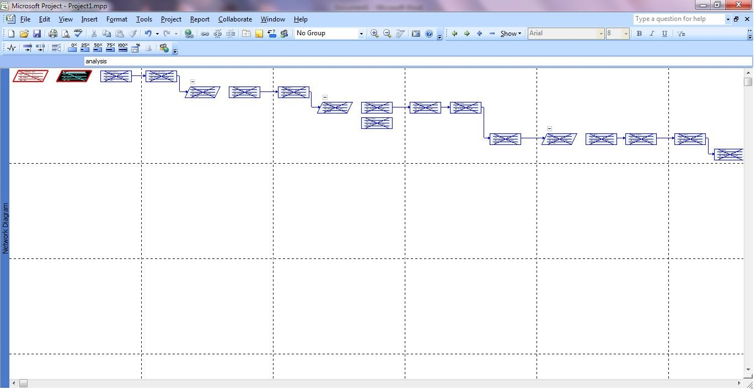

**4.4 Network Chart**

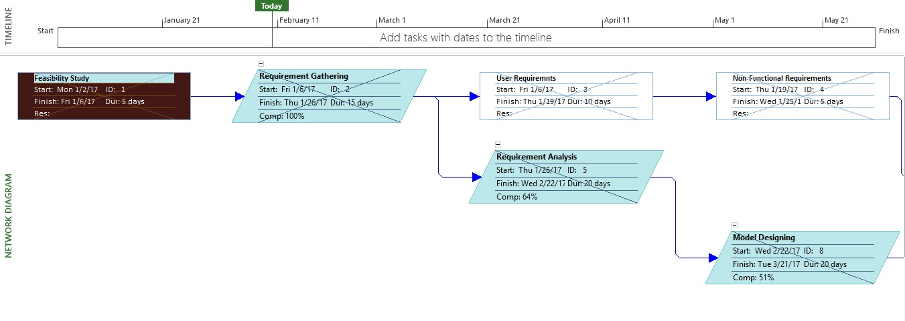

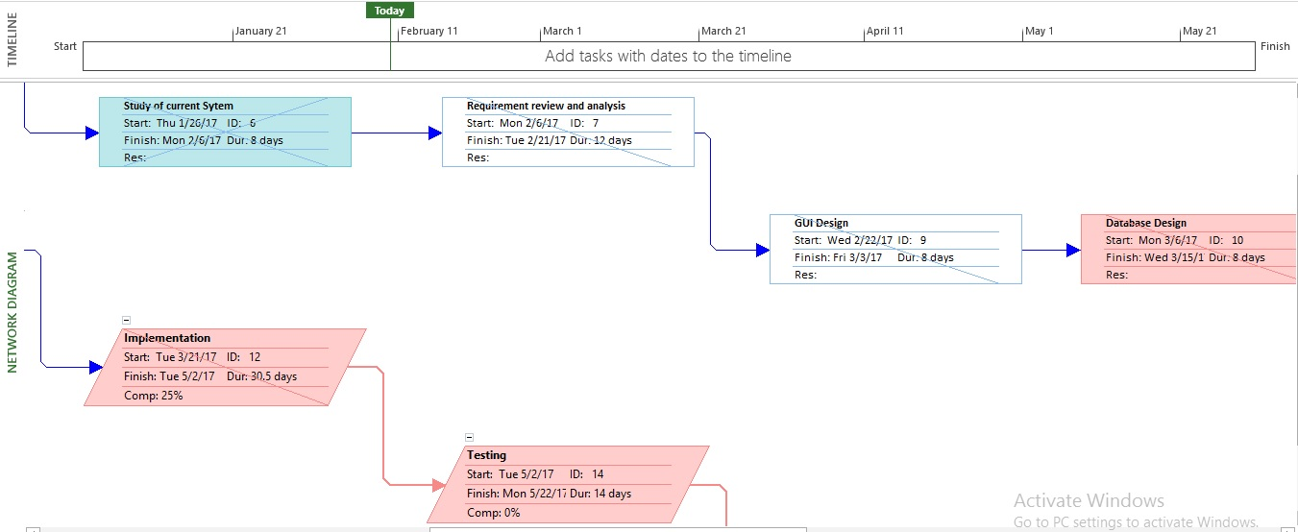

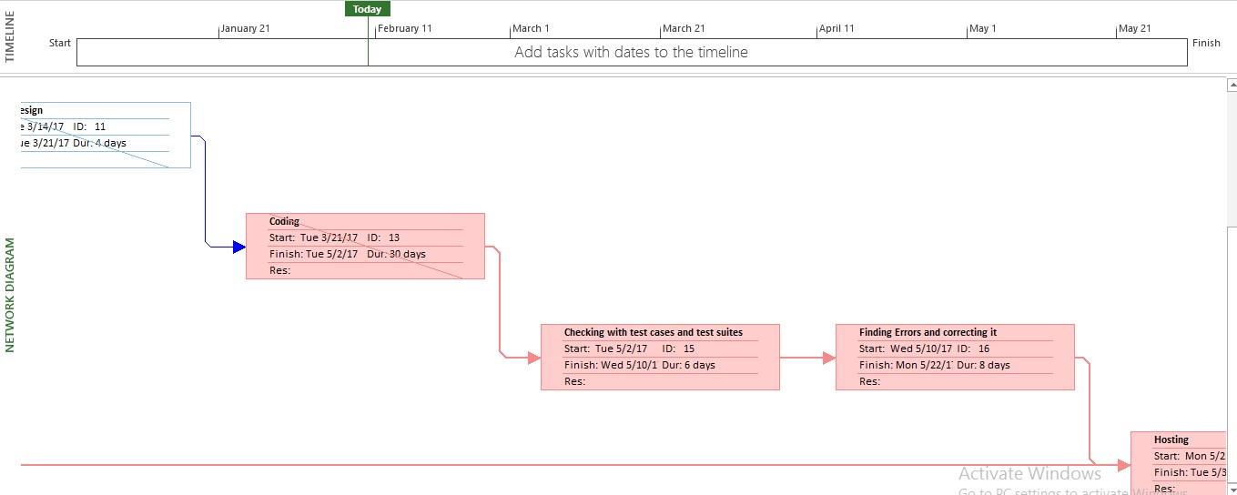

**Chapter 5: Staff Organization**

**5.1 Team Structure**

In this application, team structure is chosen to be **democratic decentralized**. The reason for choosing this structure is every task is performed individually and then the report is given to the management reporter or internal guide.

|  |  |
| --- | --- |
| **Name** | **Roles/Responsibilities** |
| Harsh | Feasibility Study |
| Harsh | Requirement gathering and Analysis |
| Harsh | Designing |
| Harsh | Implementation |
| Harsh | Testing |
| Harsh | Deployment |
| Harsh | Documentation (SRS, SPMP etc.) |

**5.2 Management Reporter**

A weekly report is sent directly to the internal guides:

* 1. Meghna Luthra
  2. Sagar Patel

**Chapter 6: Project Tracking and Control Plan**

