Kickstarter Data Analysis

# Conclusions

1. Theater was the most popular category of campaign (1,393) with plays making up the largest portion (76.5%) of that category.
2. The category with the highest percentage of successful campaigns is Music (77%).
3. No campaigns with a goal **more** than $400,000 have been fully funded

# Data Limitations

1. Data for 2017 appears to be incomplete as months April through October are missing.
2. Some additional information would have been useful to further analyze cause for successful versus failed outcomes. While category, goal, and timing seem to contribute to the outcome, other factors may have been an influence as well such as:
   1. Completeness of profile – Did the project owner provide a detailed explanation of the project along with pictures, FAQs, and bio?
   2. Social stats – how many times shared on various social networks
   3. Number of project updates posted by the project owner
   4. Number of questions asked by the community versus number answered by the project owner
3. The outcome is limited to whether or not the campaign was fully funded. This does not indicate that the project itself was actually launched.

# Additional Tables & Graphs

1. To create more a more accurate value for Goal, we could have created a formula to to convert the amount of the Goal to a single currency. Or, filtered the data for the chart to a specific country. This would provide a more accurate view of the outcome based on the amount of the goal.
2. We could also look at how campaigns performed based on the length of the project:

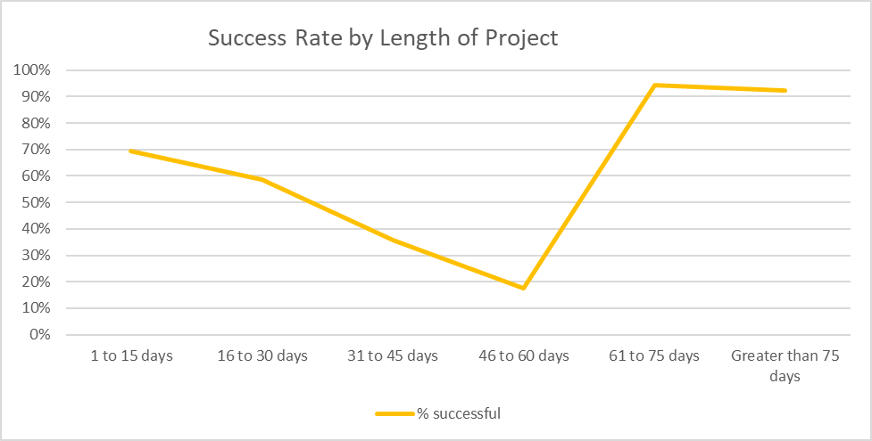

1. Success Rate by Country:

