M. Hasan
E1-A

CS Practical File

Index

S.# | Objective | Page #. | Date
1 | Write a Python program to take input from the user and print the values using all data types.
2 | Write a program that input two numbers from the user and use all the arithmetic operators on them.
3 | Write a Python program that imports the datetime module and uses the following arguments:  a. %A, b. %B, c. %C, d. %D, e. %H, f. %I, g. %S, h. %Y.
4 | Write a program that inputs marks of five subjects and calculate sum, percentage and grade
5 | Write a program that inputs a year from the user and find whether the year is leap or not.
6 | Write a program that inputs three unequal numbers and find the largest and smallest number.
7 | Write a program that inputs a value and decide whether it is Alphabet, Digit or neither.
8 | Write a program that inputs a number from the user and decide whether it is four digit number or not.
9 | Write a program that inputs the name of Logic Gate (AND, OR and NOT) and two Boolean values and then calculate the output accordingly.
10 | Write a program that inputs starting and ending range and print ONLY even numbers in reverse order using for loop.
11 | Write a program that inputs a number from the user and calculate factorial of that number.
12 | Write a program that inputs the ending range (N) and generate the following series without using library function.  11 + 22 + 33 …. NN
13 | Write a program that inputs a character and generates a pattern using nested for loop.
14 | Write a program that inputs an integer and decide whether it is palindrome number or not using while loop.
15 | Write a program to generate Fibonacci series till the inputted range.

Practical #1
Code  strinput = input("Enter a string: ")  intinput = int(input("Enter an integer: "))  boolinput = input("Enter a boolean (True/False): ").strip().lower() == 'true'  floatinput = float(input("Enter a float: "))  print(f"Your value for the string is: {strinput} and its type is {type(strinput)}")  print(f"Your value for the integer is: {intinput} and its type is {type(intinput)}")  print(f"Your value for the boolean is: {boolinput} and its type is {type(boolinput)}")  print(f"Your value for the float is: {floatinput} and its type is {type(floatinput)}") | Output  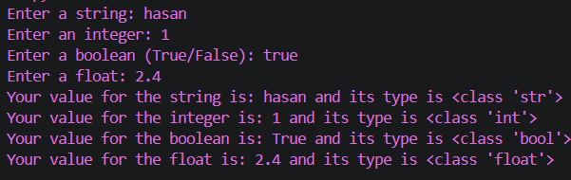
Algorithm  Step 1: Start  Step 2: Input strinput , intinput , boolinput , floatinput  Step 3: Display type(strinput)  Step 4: Display type(intinput)  Step 5: Display type(boolinput)  Step 6: Display type(floatinput)  Step 7: Stop | Flowchart  Start  Stop  Display type(strinput)  Display type(intinput) Display type(boolinput)  Display type(floatinput)  Input strinput, intinput, boolinput, floatinput
Practical #2
Code  num1 = int(input("Enter the first number: "))  num2 = int(input("Enter the second number: "))  sum_result = num1 + num2  sub_result = num1 - num2  division_result = num1 / num2  multiplication_result = num1 * num2  print(f"The sum of {num1} and {num2} is: {sum_result}")  print(f"The difference of {num1} and {num2} is: {sub_result}")  print(f"The division of {num1} by {num2} is: {division_result}")  print(f"The multiplication of {num1} and {num2} is: {multiplication_result}") | Output  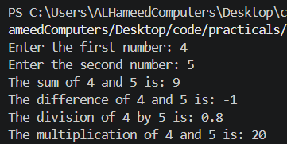
Algorithm  Step 1: Start  Step 2: input num1  Step 3: input num2  Step 4: set sum_result = num1 +num2  Step 5: set sub_result = num1-num2  Step 6: set divide_result = num1/num2  Step 7: set product = num1*num2  Step 8: Display sum_result, sub result, divide_result, product  Step 7: Stop | Flowchart  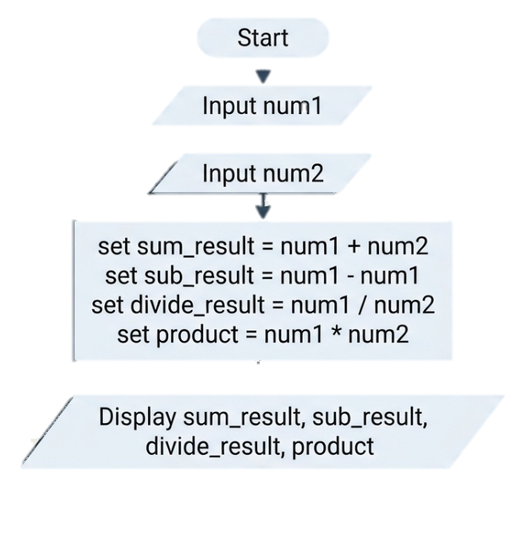

Practical #3
Code  import datetime  now = datetime.datetime.now()  print("Full Weekday Name:", now.strftime("%A"))  print("Full Month Name:", now.strftime("%B"))  print("Century:", now.strftime("%C"))  print("Short Date Format (MM/DD/YY):", now.strftime("%D"))  print("Hour (24-hour clock):", now.strftime("%H"))  print("Hour (12-hour clock):", now.strftime("%I"))  print("Seconds:", now.strftime("%S"))  print("Full Year:", now.strftime("%Y")) | Output  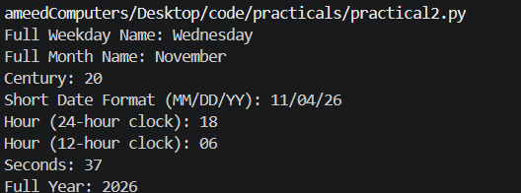
Algorithm  Step 1: Start  Step 2: Import datetime and store the current date and time in a variable called now.  Step 3: Format now using the required arguments and store them in separate variables:  - a = now.strftime("%A")  - b = now.strftime("%B")  - c = now.strftime("%C")  - d = now.strftime("%D")  - e = now.strftime("%H")  - f = now.strftime("%I")  - g = now.strftime("%S")  - h = now.strftime("%Y")  Step 4: Display variables a, b, c, d, e, f, g, h.  Step 5: Stop | Flowchart  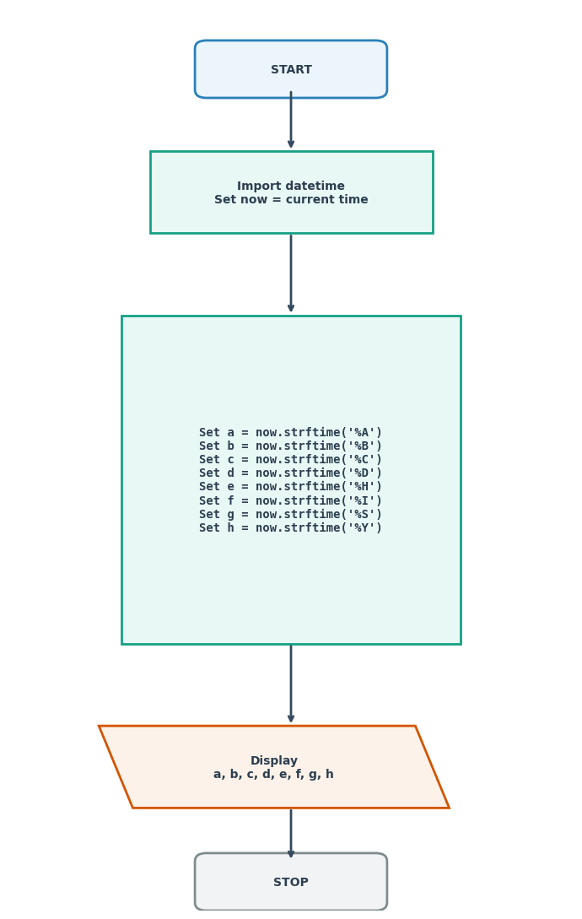

Practical #4
Code  sub1 = int(input("Enter the marks out of 100: "))  sub2 = int(input("Enter the marks out of 100: "))  sub3 = int(input("Enter the marks out of 100: "))  sub4 = int(input("Enter the marks out of 100: "))  sub5 = int(input("Enter the marks out of 100: "))  sum = sub1 + sub2 + sub3 + sub4 + sub5  percentage = (sum / 500) * 100  if percentage >= 90:  print("Grade: A")  elif percentage >= 80:  print("Grade: B")  elif percentage >= 70:  print("Grade: C")  elif percentage >= 60:  print("Grade: D")  else:  print("Grade: F")  print(f"The total marks obtained is: {sum}")  print(f"The percentage is: {percentage}%") | Output  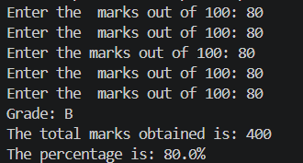
Algorithm  Step 1: Start  Step 2: Input five subject marks: sub1, sub2, sub3, sub4, sub5  Step 3: Calculate sum = sub1 + sub2 + sub3 + sub4 + sub5  Step 4: Calculate percentage = (sum / 500) * 100  Step 5: Determine grade based on percentage:  - If percentage >= 90: Grade = "A"  - Else if percentage >= 80: Grade = "B"  - Else if percentage >= 70: Grade = "C"  - Else if percentage >= 60: Grade = "D"  - Else: Grade = "F"  Step 6: Display Grade, sum, and percentage  Step 7: Stop | Flowchart  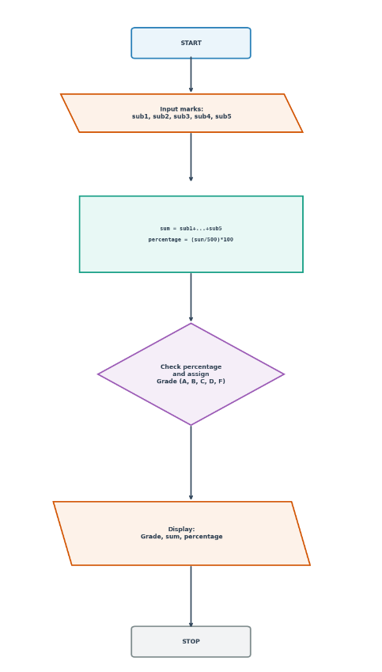

Practical #5
Code  year = int(input("Enter a year: "))  if year % 4 == 0 and year % 100 != 0:  print(f"{year} is a leap year.")  else:  print(f"{year} is not a leap year.") | Output  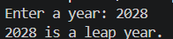
Algorithm  Step 1: start  Step 2: input year  Step 3: if year %4 == 0:  Display “Leap”  else Display “Not Leap” | Flowchart  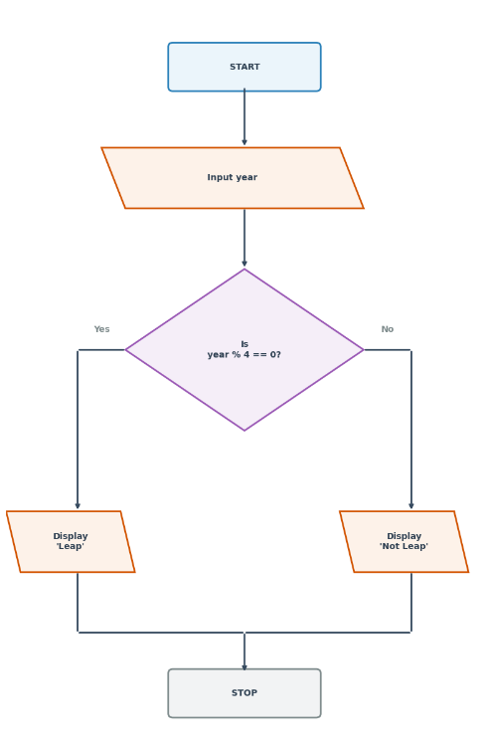
Practical #6
Code  num1 = int(input("Enter the first integer: "))  num2 = int(input("Enter the second integer: "))  num3 = int(input("Enter the third integer: "))  if num1 >= num2 and num1 >= num3:  largest = num1  if num2 >= num1 and num2 >= num3:  largest = num2  if num3 >= num1 and num3 >= num2:  largest = num3  print(f"The largest number is {largest}.") | Output  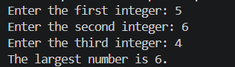
Algorithm  Step 1: Start  Step 2: Input three integers: num1, num2, num3  Step 3: Evaluate conditions to find the largest:  If num1 >= num2 and num1 >= num3: largest = num1  If num2 >= num1 and num2 >= num3: largest = num2  If num3 >= num1 and num3 >= num2: largest = num3  Step 4: Display largest  Step 5: Stop | Flowchart  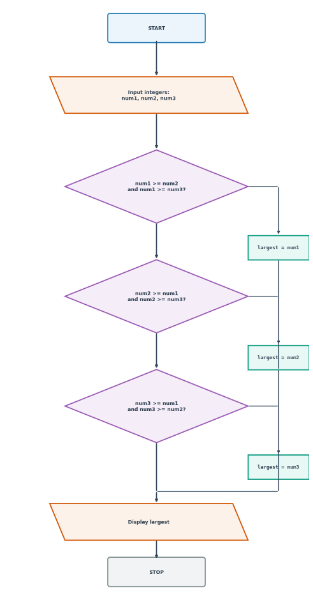

Practical #7
Code  value = input("Enter any value:")  if value.isdigit():  print(f"{value} is an integer.")  elif value.isalpha():  print(f"{value} is An Alphabet")  else:  print(f"{value} is neither!.") | Output  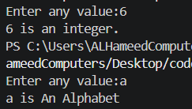
Algorithm  Step 1: Start  Step 2: Input a string string: value  Step 3: Evaluate conditions:  If value.isdigit() is True: Display "value is an integer."  Else if value.isalpha() is True: Display "value is An Alphabet"  Else: Display "value is neither!."  Step 4: Stop | Flowchart  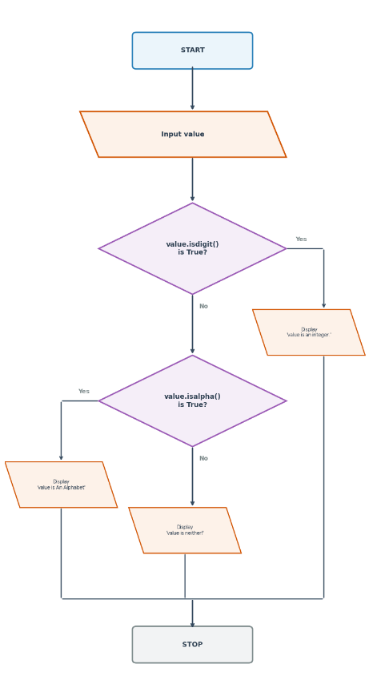
Practical #8
Code  num = int(input("Enter a number: "))  if len(str(num)) == 4:  print(f"{num} is a four-digit number.")  else:  print(f"{num} is not a four-digit number.") | Output  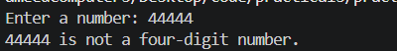
Algorithm  Step 1: Start  Step 2: Input num1  Step 3: If num1.lenght() == 4:  Display "A four digit number"  Else:  Display "Not 4 digit"  Step 4: Stop | Flowchart  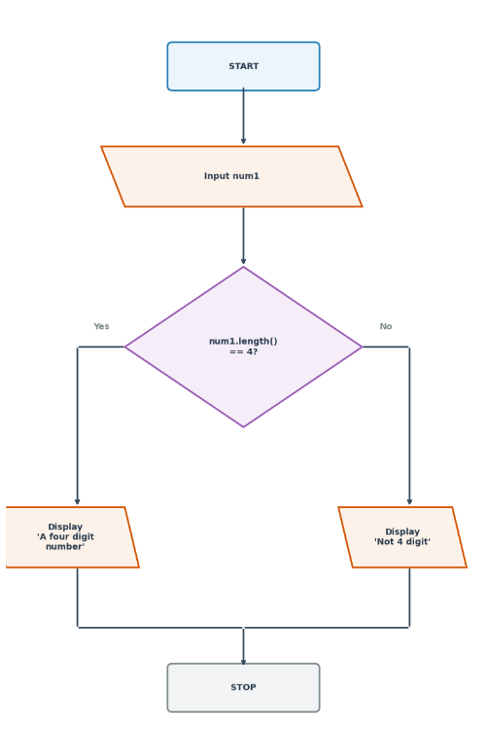

Practical #9
Code  val1 = bool(int(input("Enter 0 or 1: ")))  val2 = bool(int(input("Enter 0 or 1: ")))  gate = input("Enter the logic gate (AND, OR, NOT): ").strip().upper()  if gate == "AND":  result = val1 and val2  print(f"Result of {val1} AND {val2} is {result}.")  elif gate == "OR":  result = val1 or val2  print(f"Result of {val1} OR {val2} is {result}.")  elif gate == "NOT":  result = not val1  print(f"Result of NOT {val1} is {result}.") | Output  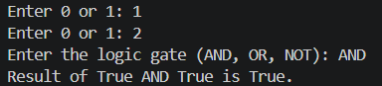
Algorithm  Step 1: Start  Step 2: Input val1 and convert to true/false boolean  Step 3: Input val2 and convert to true/false boolean  Step 4: Input selection for gate (AND, OR, NOT)  Step 5: Evaluate gate choice:  If gate is "AND": Set result = val1 and val2  Else if gate is "OR": Set result = val1 or val2  Else if gate is "NOT": Set result = not val1  Step 6: Display the calculation result  Step 7: Stop | Flowchart  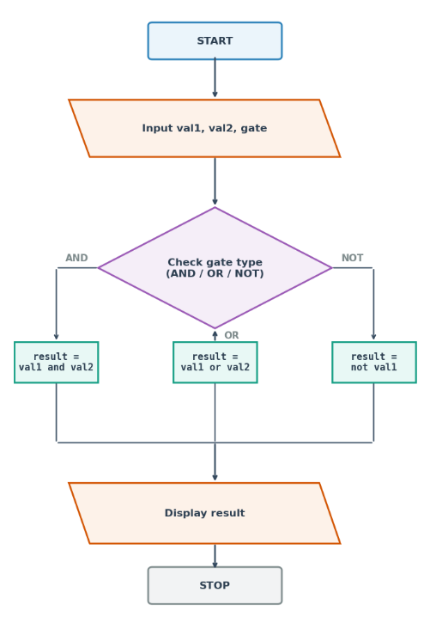

Practical #10
Code  start = int(input("Enter starting range: "))  end = int(input("Enter ending range: "))  for i in range(end, start - 1, -1):  if i % 2 == 0:  print(i) | Output  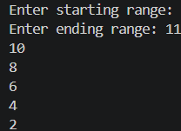
Algorithm  Step 1: Start  Step 2: input start_range  Step 3: end_range  Step 3: for end_range in range:  If end_range %2 == 0:  Display end_range  end_range = end_range =1  if end_range == start range:  break  Step 7: Stop | Flowchart  

