**Github**

1. Create account in GitHub

<https://github.com>

2. Create repository by click new:

2.1 set repository name

2.2 make it public

2.3 add readme file

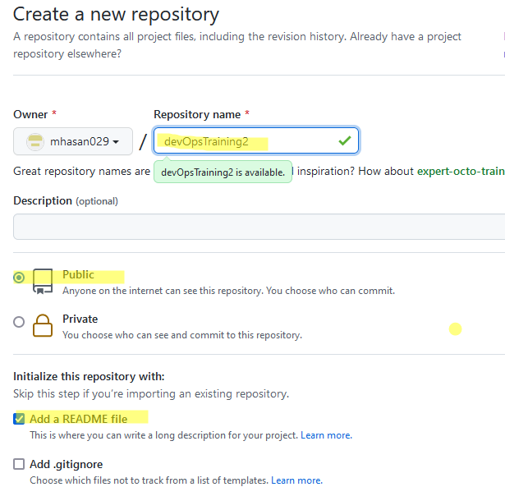

3. install gitbash from this link :

[https://git-scm.com/download/win](https://git-scm.com/download/win 4)

[4](https://git-scm.com/download/win 4). In windows maching go to the folder where you clone github folder

D:\DevOps\GithubTest

Copy github repository location which need to clone

Click on code and copy the link:

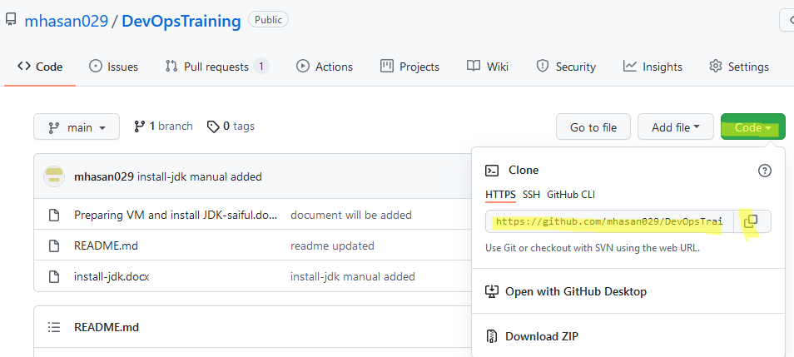

5. go to the directory in windows machine and open git bash here by right click

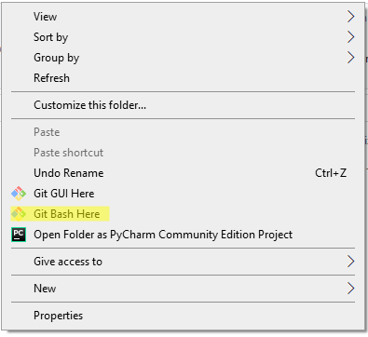

5.1 clone repository from github

git clone <https://github.com/mhasan029/DevOpsTraining.git>

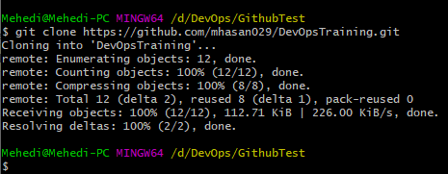

5.2 in windows machine, we will get the repository now

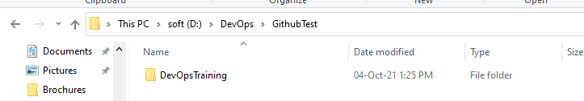

5.3 enter the folder

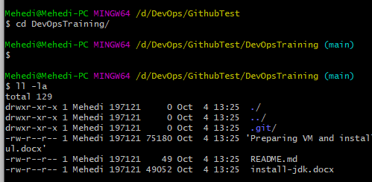

5.4 copy new files in this folder

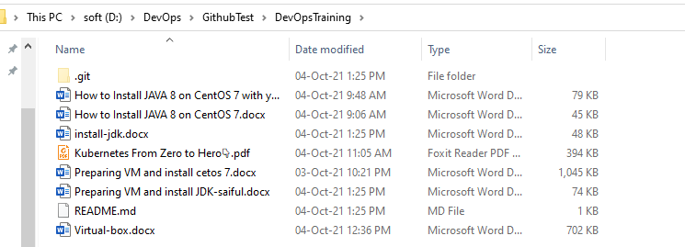

5.5 add them

git add .

5.6 now connect with github account

git config --global user.email "mhasan.sust@gmail.com"

5.7 comments added with commit command

git commit -m "document will be added"

5.8 now push those resource to github repository under main branch

git push origin main

