<https://www.virtualbox.org/wiki/Downloads>

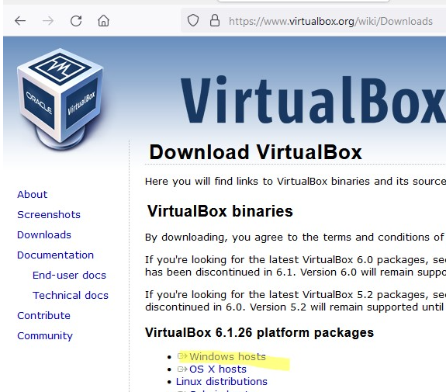

**Centos 7 Installation steps:**

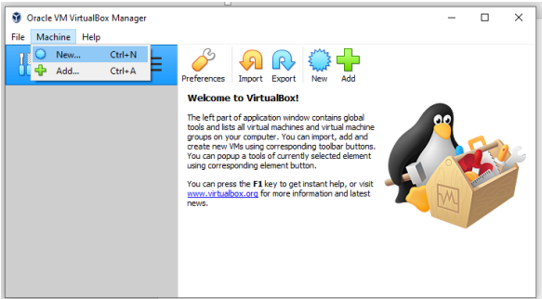

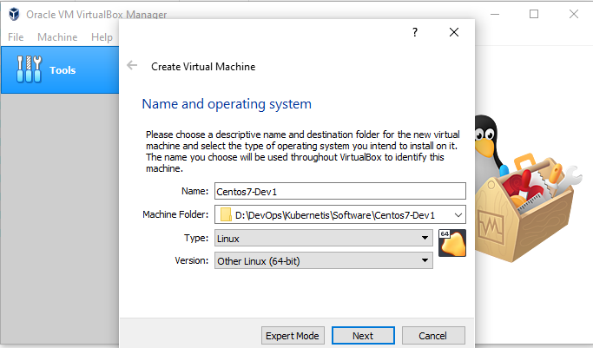

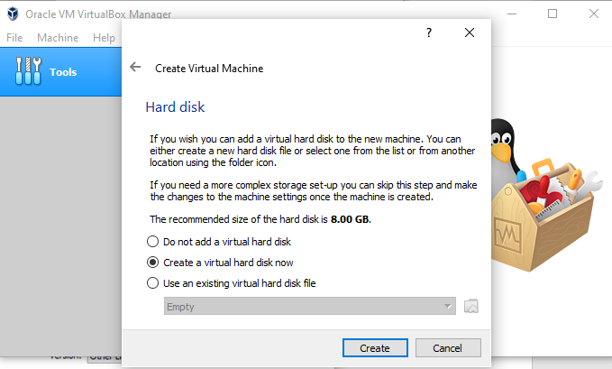

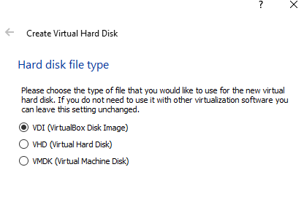

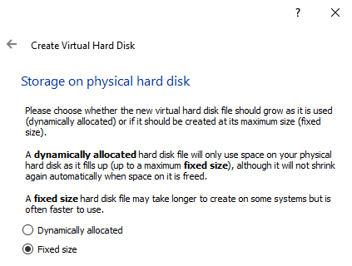

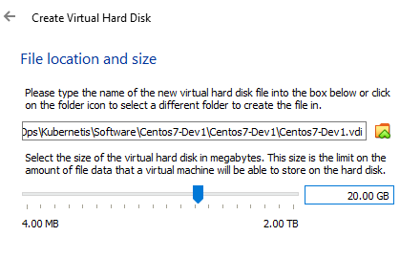

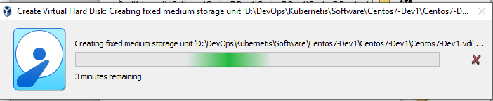

Now from settings, need to select iso file and also set network settings.

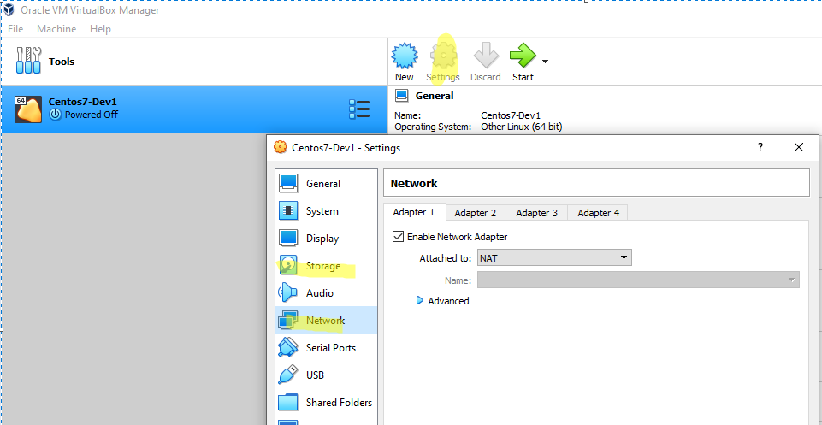

* Setup the VirtualBox to use 2 adapters:  
  • The first adapter is set to NAT (that will give you the internet  
  connection).  
  • The second adapter is set to host only. (for access from host device)

|  |  |
| --- | --- |
|  |  |

Select iso:

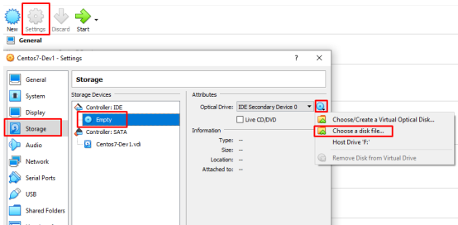

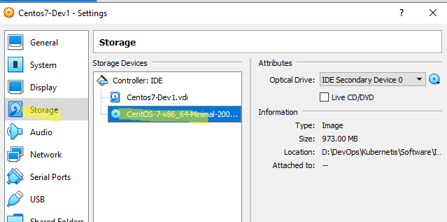

Now press start, to install os:

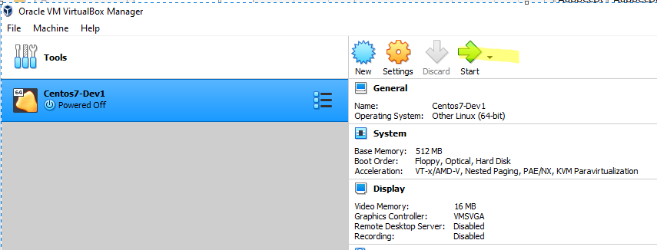

After install OS, check machine got the ip or not.

If ip not assigned then run this command to get IP.

**dhclient**