***JDK Installation:***

***Step 1:***

To download the latest Java SE Development Kit 8 release use following commands to download from the shell.

**# cd /opt/**

wget <https://supportresources.revesoft.com:4430/media/Tools/Java/jdk1.8.0_161.zip>

# **unzip jdk1.8.0_161.zip**

***Step 2 – Install Java 8 with Alternatives***

**# cd jdk1.8.0_161**

**# alternatives --install /usr/bin/java java /opt/**jdk1.8.0_161**/bin/java 2**

**# alternatives –config java**

The newly installed Java version listed at number 1, So input 1 and press enter.

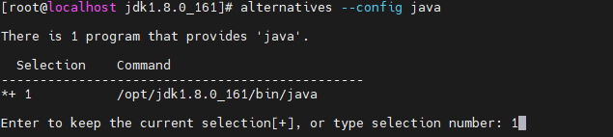

At this point, JAVA 8 has been successfully installed on your system. Recommend to setup javac and jar commands path using alternatives

**#alternatives --install /usr/bin/jar jar /opt/jdk1.8.0_161/bin/jar 2**

**# alternatives --install /usr/bin/javac javac /opt/jdk1.8.0_161/bin/javac 2**

**# alternatives --set jar /opt/jdk1.8.0_161/bin/jar**

**# alternatives --set javac /opt/jdk1.8.0_161/bin/javac**

**Step 3 – Check Installed Java Version**

**# java -version**



**Step 4 – Setup Java Environment Variables**

Most of Java based application’s uses environment variables to work. Set the Java environment variables using following commands.

Set the JAVA_HOME, JRE_HOME and PATH environment variables.

**# vi ~/.bash_profile**

set JAVA_HOME

**JAVA_HOME=/opt/jdk1.8.0_161**

**export PATH=$PATH:$JAVA_HOME/bin;**

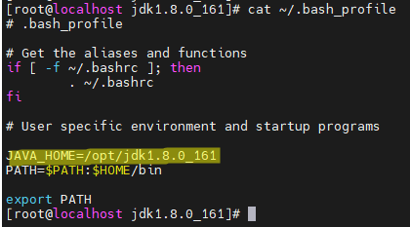

Now execute below command to effect the change in /.bash_profile

**# source ~/.bash_profile**

Check **JAVA_HOME** by executing below command

# echo $**JAVA_HOME**