**Project Report**

In this project, we simulated publishing and packaging of the books with a multi-thread program using **Pthread** library. All parameters must be given by user input. For example number of publishers, packagers, books, threads etc.

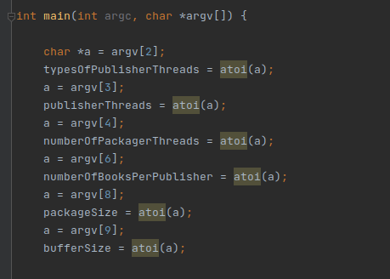

All input arguments are first stored in **argv[]** array and then they are converted to integer with **atoi()** function and stored in their corresponding variables.

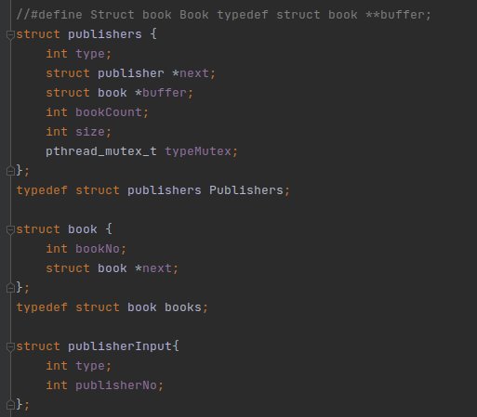

To store data of buffers, publishers, books we used **structs**.

We got 3 structs in our project. **publishers**, **book** and **publisherInput**.

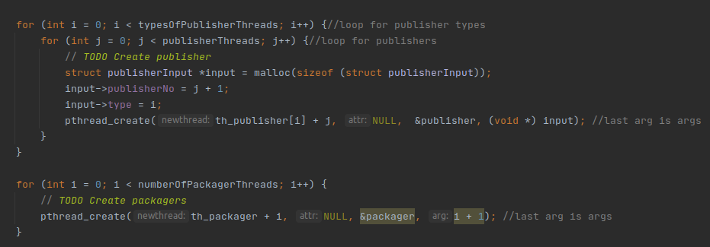Inside **main()** function, threads for publishers and packagers are being creating with **pthread_create()** in **for** loops in order to input values.

**publisher()** and **packager()** functions are functions that are mainly undertake the processes.



**publisher()** function can create different types of publishers and books. After creating publishers, books can be published from these publishers.



**packager()** function puts books in to packages until the package is full. When a package is full, packager starts to fill a new package. If all books are packaged, packager will exit the system.





We used **pthread_mutex_lock()** and **pthread_mutex_unlock()** functions to prevent threads from interrupting each other.