**Task 4**

For the HTTP based website access, answer the following after analyzing collected traces of HTTP:

1. **What is the name of website?**

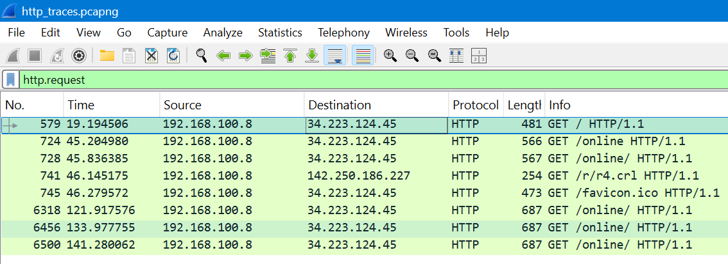

In the Packet Details pane expand **Hypertext Transfer Protocol** → look for the **Host:** header (or look at the Request URI).

* **Host:** contains the website name

Find the packet that contains the **first GET request** for the website you have accessed.

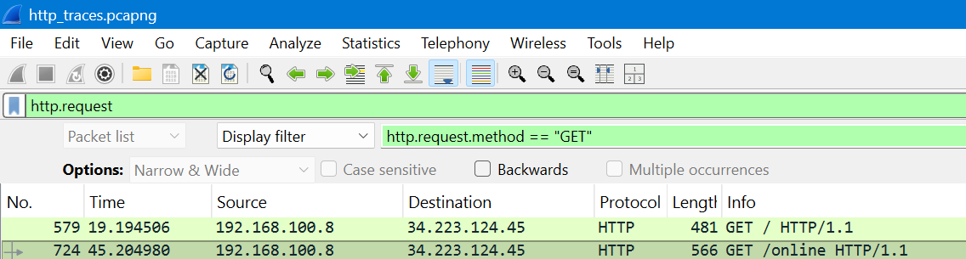

**Describe all headers and their values in this GET request message**

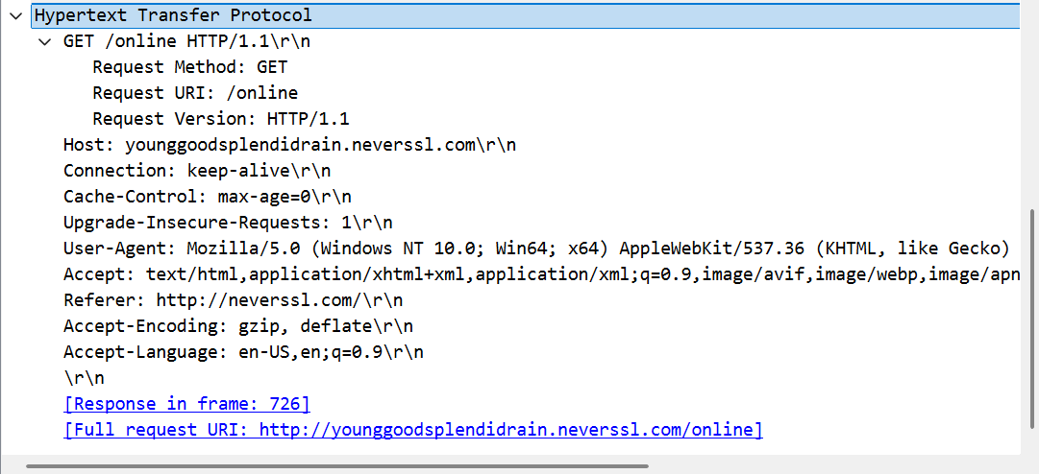

Identify the status code in the first server response

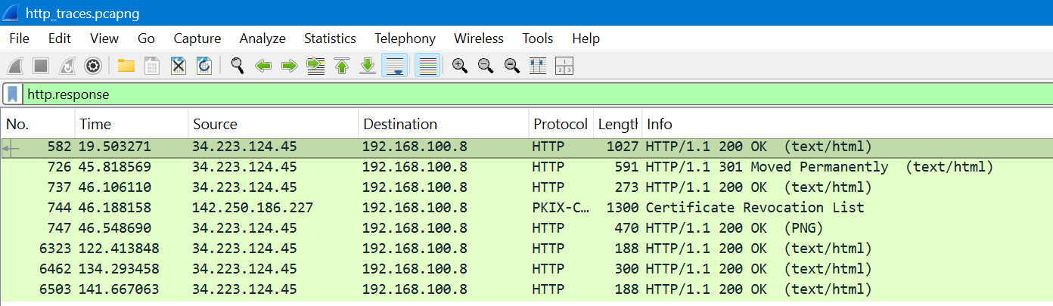

**200 OK**

**301 Moved Permanently**

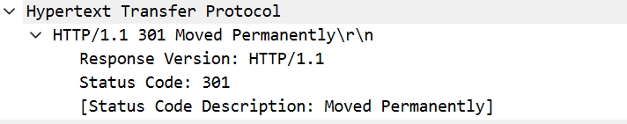

**How many HTTP response messages are exchanged in total?**

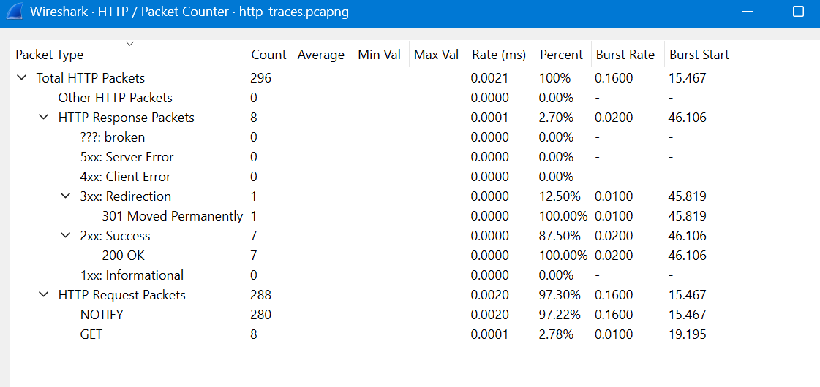

**Determine whether the connection is persistent or not. Justify with evidence**

* **Persistent (keep-alive)** evidence: multiple HTTP requests/responses occur over the **same TCP connection** (same tcp.stream) with **no Connection: close** header and without an immediate TCP FIN/RST. HTTP/1.1 is persistent by default unless Connection: close.
* **Non-persistent** evidence: Connection: close header present, or each request/response pair is followed by TCP FIN/RST closing the connection, or HTTP/1.0 without Connection: keep-alive.

Connection: keep-alive  
**persistent**

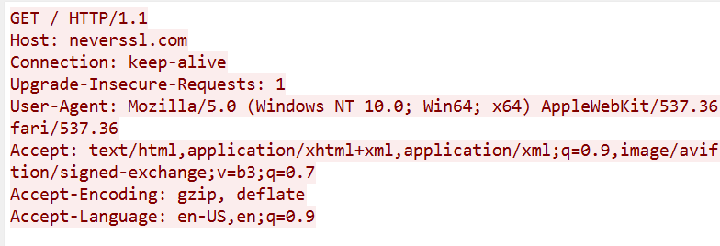

***THE END***