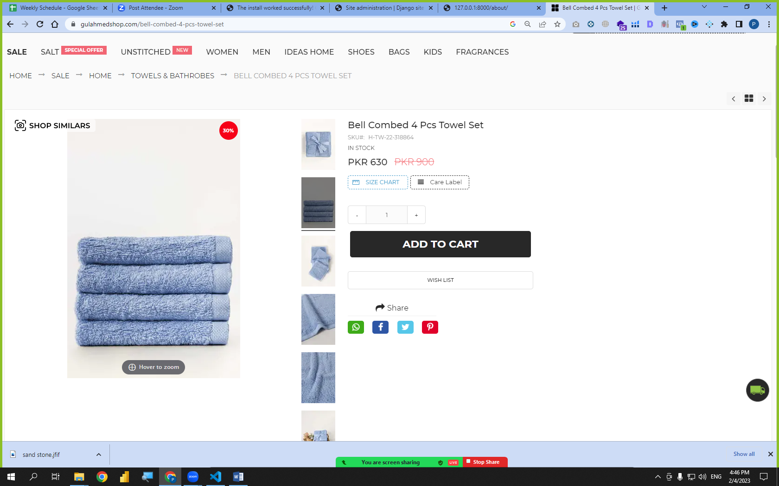

Products = [

{

Id: 1

Name: “a”,

Price: 5000

},

{

Id: 2

Name: “b”,

Price: 4800

},

{

Id: 11

Name: “a”,

Price: 5500

},

Select name from products

WHERE ID = 11

]



Products = [

{

Id: 1

Name: “a”,

Price: 5000

},

{

Id: 2

Name: “b”,

Price: 4800

},

{

Id: 11

Name: “a”,

Price: 5500

},

Select name from products

WHERE ID = 11

]