

NASTP Institute of Information Technology
BS Cyber Security — Semester IV

Simulation of Deadlock Avoidance, Detection, and Recovery
in Operating Systems using C++

Operating System Lab — Course Project Report

Submitted by:
Muhammad Haseeb Sajid (F2024CY018)
Session: Fall 2024 – 2028
Date of Submission: June 07, 2026

1. Project Overview / Abstract
This project focuses on simulating core deadlock handling mechanisms found in real operating systems, implemented using C++ and a Qt-based graphical user interface. The central goal is to model how multiple concurrent processes compete for a finite set of shared resources, and to demonstrate how deadlocks can be proactively avoided, detected after they occur, and resolved through recovery strategies.
The system implements three distinct modules: Banker's Algorithm for deadlock avoidance, a Resource Allocation Graph (RAG) based detection algorithm, and two process-termination recovery strategies. All three modules are accessible through a tabbed GUI that allows users to configure system state through interactive data tables, run algorithms, and observe step-by-step results in a color-coded output log. A live Resource Allocation Graph is rendered directly in the application, visually highlighting deadlocked processes and edges in real time.
This project provides hands-on practical understanding of operating system resource management, process synchronization, and the classical deadlock problem — concepts that are fundamental to both system design and security-aware software development.

2. Objectives
- To understand and implement deadlock avoidance using Banker's Algorithm with safe sequence detection.
- To simulate a deadlock detection algorithm that identifies processes stuck in circular wait.
- To analyze safe and unsafe system states through the need matrix and work vector evolution.
- To implement and demonstrate two deadlock recovery strategies: terminating all deadlocked processes and terminating one process at a time.
- To build a fully functional GUI application with tabbed navigation, interactive data tables, and real-time algorithm output.
- To visualize the Resource Allocation Graph (RAG) with color-coded deadlock highlighting.
- To enhance understanding of OS resource management through practical simulation and experimentation.

3. Problem Statement
In operating systems, multiple processes frequently compete for a limited pool of shared resources such as memory, I/O devices, and CPU time. When resource allocation is handled without careful control, circular wait conditions can arise in which each process in a set holds a resource needed by the next process in the set. This circular dependency causes all involved processes to block indefinitely — a condition known as deadlock.
Deadlock is one of the most critical problems in concurrent systems. A deadlocked system wastes resources, fails to make progress, and in production environments can lead to complete system failure or denial of service. Three fundamental strategies exist to address it: avoidance (never enter an unsafe state), detection (identify when deadlock has already occurred), and recovery (break the deadlock once detected).
This project addresses the need to simulate all three strategies in a controlled, visual, and interactive environment. By building a working simulator, the aim is to make these abstract OS concepts tangible and testable, and to demonstrate how each strategy behaves across different resource allocation scenarios.

4. Scope of the Project

4.1 Included
- Simulation of up to 10 processes and 8 resource types with configurable instances.
- Full implementation of Banker's Algorithm — need matrix computation, safety check, and resource request with rollback.
- Deadlock Detection Algorithm based on the resource-request graph reduction technique.
- Safe sequence calculation and step-by-step work vector trace in the output log.
- Two deadlock recovery strategies: terminate all deadlocked processes, and terminate one process at a time.
- Qt-based GUI with three tabs, interactive tables, and a live RAG visualization panel.
- Input validation — catches negative values, non-integer inputs, and allocation exceeding maximum demand.
- Pre-loaded example scenarios for both Banker's Algorithm and Deadlock Detection.

4.2 Not Included
- Real-time operating system integration or kernel-level resource management.
- Advanced scheduling algorithms or CPU burst simulation.
- Hardware-level resource handling or physical memory management.
- Resource preemption as a recovery strategy (only process termination is implemented).

5. Methodology / Approach
The project was implemented using C++17 with the Qt 5/6 framework for the graphical user interface. A modular architecture was followed where each component is developed as an independent class with its own header and implementation file, then integrated through the main window controller.

5.1 Architecture
The application is structured into five classes:
- Banker — implements Banker's Algorithm: need computation, safety check, and resource request with rollback.
- Detection — implements the deadlock detection algorithm using the resource-request reduction technique.
- Recovery — implements two recovery strategies: terminate all and terminate one.
- RAGWidget — a custom Qt widget that paints the Resource Allocation Graph using QPainter.
- MainWindow — the top-level controller that connects all components through a three-tab interface.

5.2 Algorithm Design
Banker's Algorithm maintains four data structures: Available (free resource instances), Maximum (each process's declared resource ceiling), Allocation (currently allocated amounts), and Need (remaining demand = Maximum minus Allocation). The safety check uses a work vector initialized to Available and a finish array; it iterates over processes, granting resources to any process whose need does not exceed work, simulating process completion and resource release. If all processes finish, the system is safe and the order of completion forms the safe sequence.
The detection algorithm uses a similar reduction approach but without the maximum matrix. Processes with zero allocation are immediately marked as finished. The remaining processes are checked against current work; any process whose request does not exceed work is allowed to finish and release resources. Processes that cannot finish under any order are flagged as deadlocked.

5.3 Tools and Technologies
- Language: C++17
- GUI Framework: Qt 5/6 (QMainWindow, QTableWidget, QTextEdit, QPainter, QSplitter)
- Build System: qmake / CMake
- IDE: Qt Creator
- Structure: Modular .h/.cpp file structure with separate compilation

6. Implementation and Results
The simulator was successfully built and tested across all three functional modules. The following sections present each module with corresponding screenshots captured from actual execution.

6.1 Banker's Algorithm — Deadlock Avoidance
The Banker's Algorithm tab allows the user to configure the number of processes (1-10) and resource types (1-8). After entering the Available, Maximum, and Allocation matrices, clicking Check Safe State runs the safety algorithm. The Need matrix is auto-computed and displayed. The step-by-step trace shows which processes can proceed and how the Work vector evolves at each step.
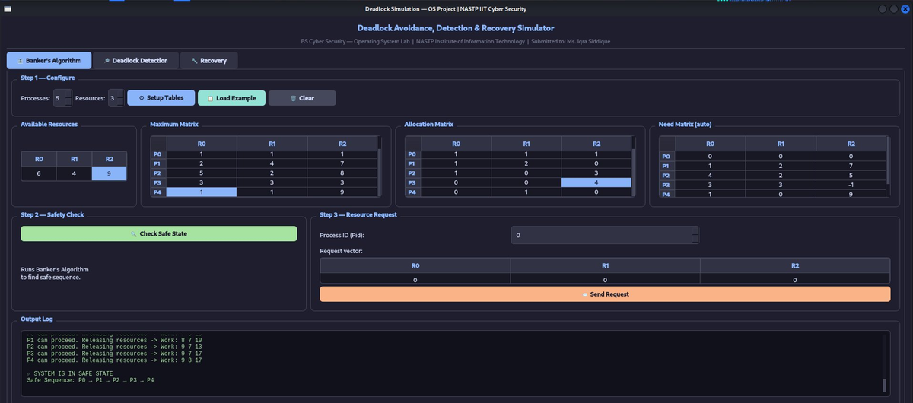
Figure 1: Full Banker's Algorithm tab with all matrices visible and output log showing safe state result.
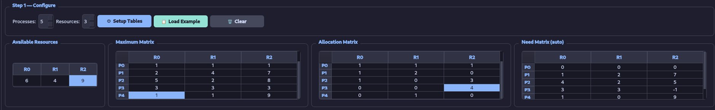
Figure 2: Input matrices for 5 processes and 3 resources. Need matrix is auto-computed from Maximum minus Allocation.
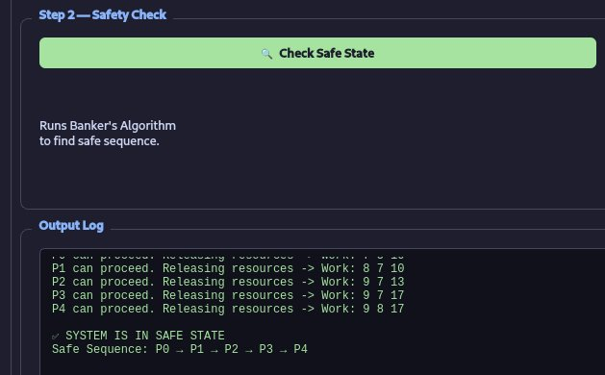
Figure 3: Algorithm output showing each process that can proceed, Work vector updates, and the final safe sequence P0 -> P1 -> P2 -> P3 -> P4.
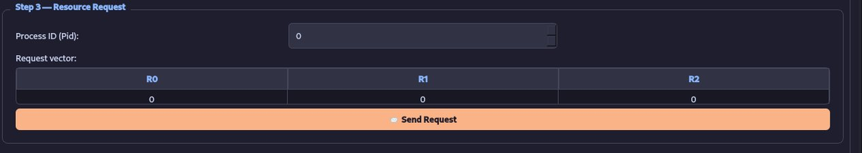
Figure 4: Step 3 resource request panel. A process ID is selected and a request vector is entered. The algorithm grants the request only if the resulting state remains safe; otherwise it rolls back.

6.2 Deadlock Detection Algorithm
The Deadlock Detection tab uses the resource-request reduction algorithm. The user provides Available resources, an Allocation matrix, and a Request matrix. The algorithm marks processes with zero allocation as immediately finished, then iteratively attempts to reduce the graph. Any process that cannot finish is identified as deadlocked. Results are shown in the output log and visualized in the RAG panel.
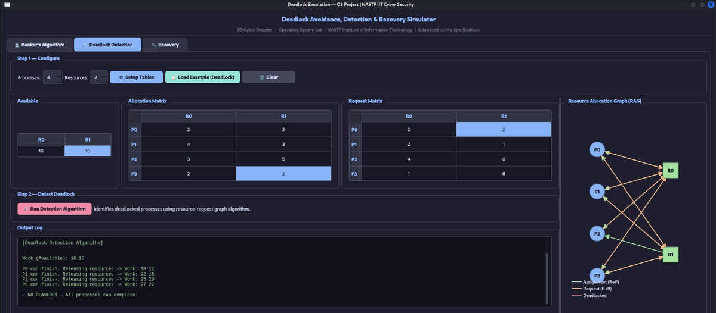
Figure 5: Detection tab showing a scenario with 4 processes and 2 resources where no deadlock exists.
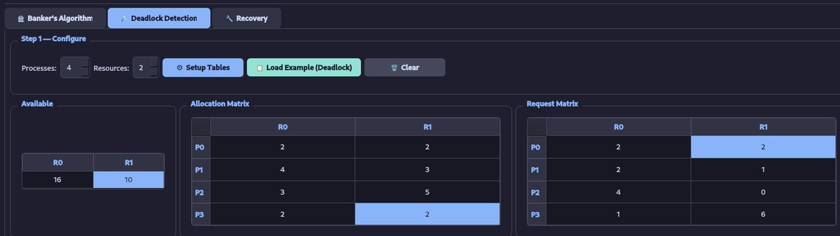
Figure 6: Available, Allocation, and Request matrices for the no-deadlock test case.
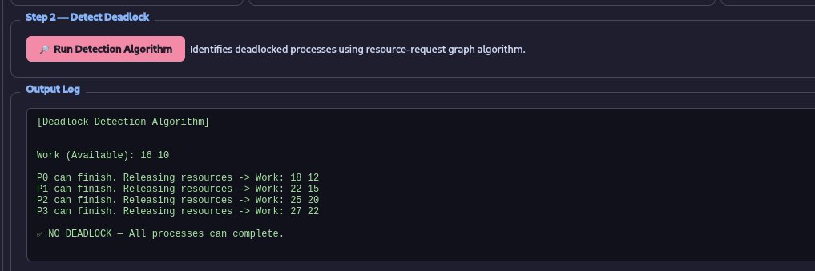
Figure 7: Output log confirming NO DEADLOCK — all processes P0 through P3 can complete in order.
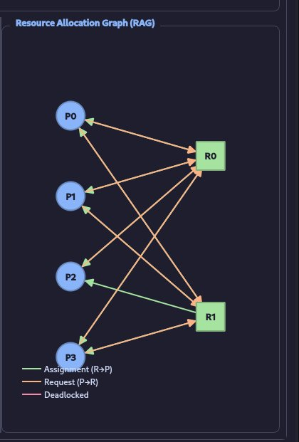
Figure 8: RAG visualization with no deadlock. Green = assignment (R to P). Orange = request (P to R). Blue nodes = safe processes, green squares = resources.
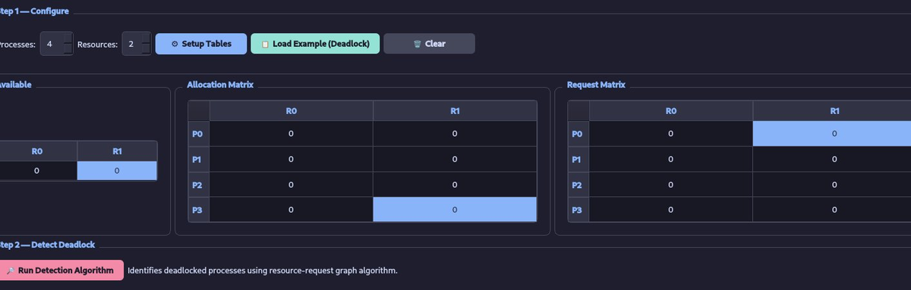
Figure 9: Detailed detection log showing Work vector evolution as each process finishes and releases resources.
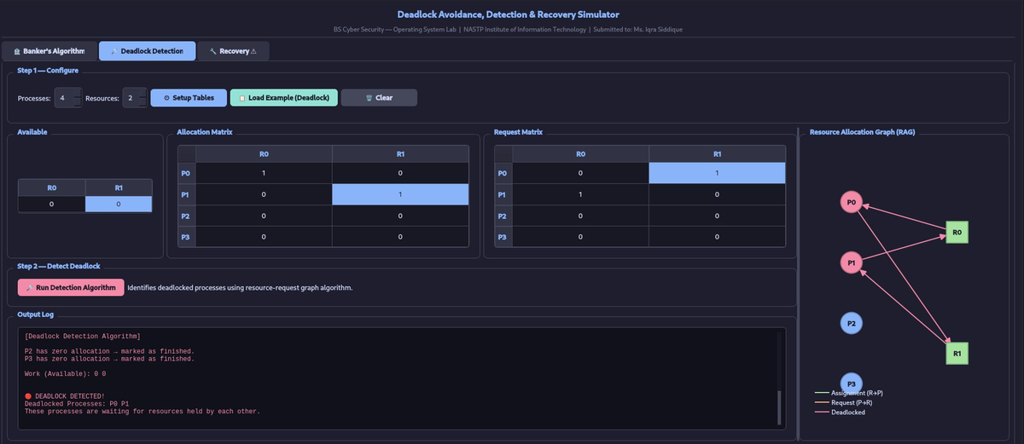
Figure 10: Detection tab with deadlock scenario. P0 holds R0 and wants R1; P1 holds R1 and wants R0. RAG shows circular wait in red.
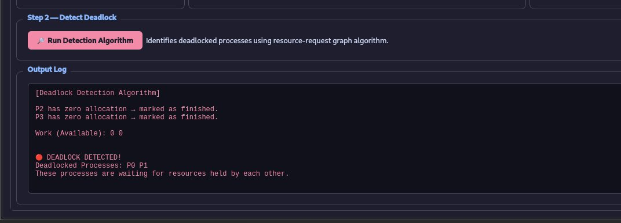
Figure 11: Output log confirming DEADLOCK DETECTED. Processes P0 and P1 identified as waiting for resources held by each other.
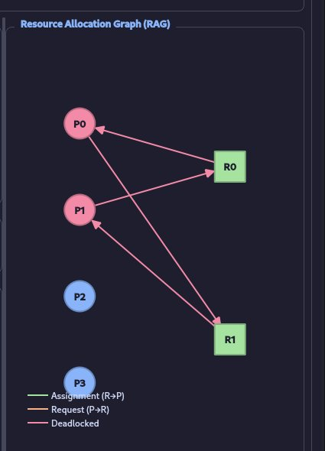
Figure 12: RAG with deadlock. Deadlocked nodes P0 and P1 highlighted in red. P2 and P3 are safe blue nodes with no connections.

6.3 Deadlock Recovery
Once a deadlock is detected, the system automatically passes the deadlock state to the Recovery tab. Two recovery strategies are available:
- Terminate ALL Deadlocked Processes — immediately terminates every deadlocked process and releases all their held resources in one step.
- Terminate ONE Process — terminates only the lowest-PID deadlocked process, releases its resources, and prompts the user to re-run detection to check if deadlock is fully resolved.
Both strategies update the system state and refresh the Resource Allocation Graph to reflect the recovered state.
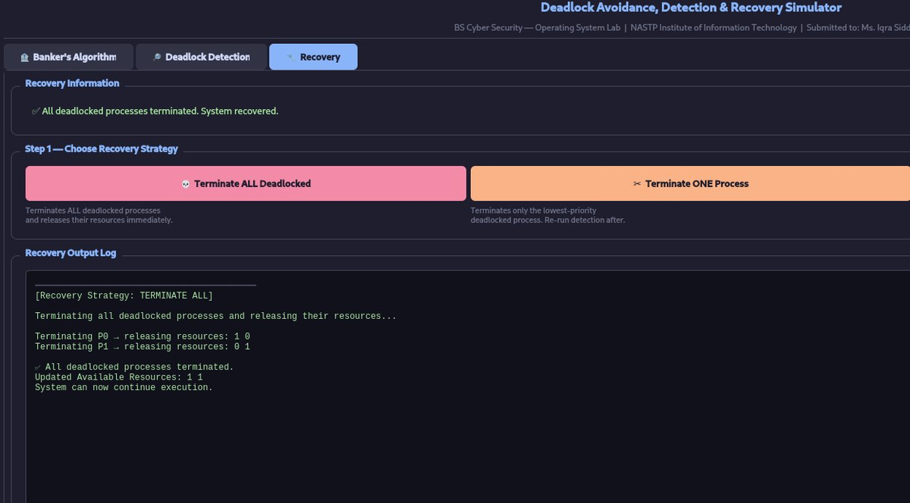
Figure 13: Recovery tab — Terminate ALL result. P0 released [1 0] and P1 released [0 1]. Updated Available becomes [1 1]. System recovered.
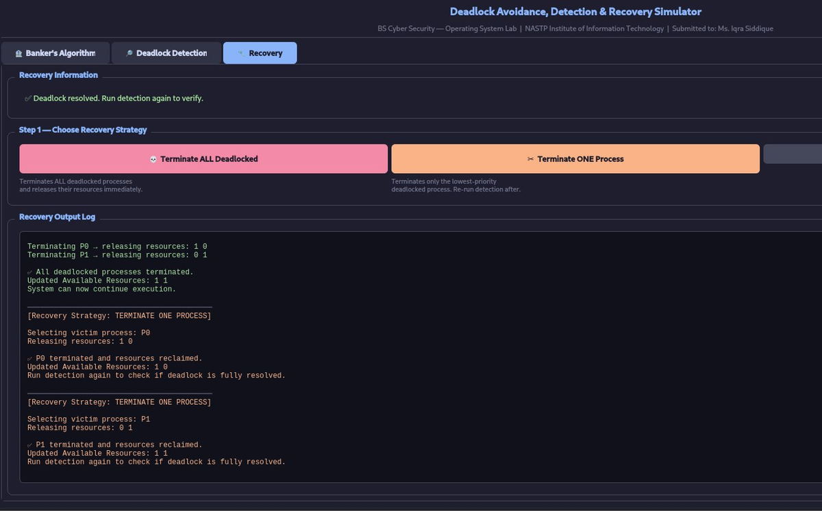
Figure 14: Terminate ONE strategy. P0 terminated first (Available -> [1 0]), then P1 terminated (Available -> [1 1]). Deadlock fully resolved.

7. Results Summary
The table below summarizes all test scenarios executed during project demonstration:

Test Scenario | Module | Result | Key Observation
5P / 3R — safe state | Banker's Algorithm | SAFE | Safe sequence: P0->P1->P2->P3->P4
Resource request P0 | Banker's Algorithm | GRANTED | Request within need; system stays safe
4P / 2R — no deadlock | Detection | NO DEADLOCK | All processes reduce; Work grows to [27 22]
4P / 2R — P0 and P1 wait | Detection | DEADLOCK | P0 holds R0 wants R1; P1 holds R1 wants R0
Terminate ALL recovery | Recovery | RECOVERED | P0+P1 terminated; Available -> [1 1]
Terminate ONE recovery | Recovery | PARTIAL->FULL | P0 terminated first; P1 second; resolved

8. Expected Outcome
The final deliverable is a fully functional C++ desktop application that simulates all three phases of deadlock management in operating systems. The application meets every requirement defined in the project proposal and exceeds the optional GUI requirement by delivering a polished, interactive interface.
Users can configure arbitrary process and resource counts, enter real allocation scenarios, run Banker's Algorithm to verify safety before granting requests, detect deadlocks with a visual RAG that highlights the circular wait in real time, and apply recovery strategies with immediate state feedback. The application handles invalid input gracefully through validation dialogs and provides detailed step-by-step algorithm traces in the output log.
A detailed project report accompanies the software, explaining the algorithms, implementation architecture, test results, and analysis. The project strengthens practical understanding of OS resource management, concurrency control, and the real-world consequences of improper resource allocation.

9. Conclusion
This project successfully demonstrated the three fundamental approaches to the deadlock problem in operating systems: avoidance through Banker's Algorithm, detection through graph reduction, and recovery through process termination. All modules were implemented from scratch in C++ with clean class separation, verified against standard textbook examples, and integrated into a cohesive Qt GUI application.
The Resource Allocation Graph widget provided real-time visual confirmation of algorithm results — safe processes in blue, deadlocked processes in red, and color-coded edges distinguishing assignments from requests. The recovery module correctly updated system state and refreshed the RAG after each recovery action, closing the full avoidance to detection to recovery workflow.
Key lessons learned include the importance of the safety check before any resource grant, the role of circular wait as the necessary condition for deadlock, and the trade-off between recovery strategies terminating all processes is immediate but costly, while terminating one at a time is conservative but may require multiple iterations. These insights align directly with how real operating systems, from Linux to Windows, handle resource contention in multi-process environments.

