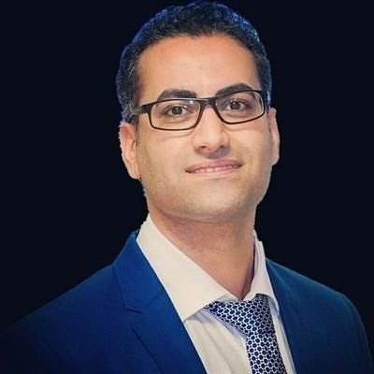
Profile
English, French, Persian
Viktor JIRSA (viktor.jirsa@univ-amu.fr)
Axel HUTT (axel.hutt@inria.fr)
A. VALIZADEH (valizade@iasbs.ac.ir)

References

Meysam.hashemi@gmail.com



Meysam HASHEMI
LANGUAGES
Welcome to my home page

Senior Research Flow
French, Iranian
27 blvd. Jean Moulin
13005, Marseille, France
Meysam.hashemi@univ-amu.fr

I develop and adapt biologically and physics-informed AI/ML for flexible and efficient inference using Frequentist and Bayesian approaches to decision-making process.
I have over 12 years of experience working with computational models, particularly, spiking neurons, neural populational mean-fields, and whole-brain models, both analytically and numerically, to improve diagnostics, intervention strategies, and therapies for brain-related medicine, digital health, and drug research (including Anaesthesia, Epilepsy, Alzheimer, Aging, Parkinson, AUD, and other brain diseases).
- MCMC/HMC, Variational inference, Simulation-based Inference, Optimization.
- Probabilistic AI/ML, HMM, MVAR, GP, Kalman filter, Time series forecasting.
- PD/PK modeling, Oscillations, Signal processing, Neuroimaging, Clinical trials.
- Dynamical system identification, Stochastic and Delay Differential equations.
- Python, Pytorch, Tensorflow, Matlab, C++, Git, high-performance computing.
- PPLs (Stan, PyMC3, NumPyro), VAEs/ NFs, scikit-learn, The Virtual Brain.



SKILLS
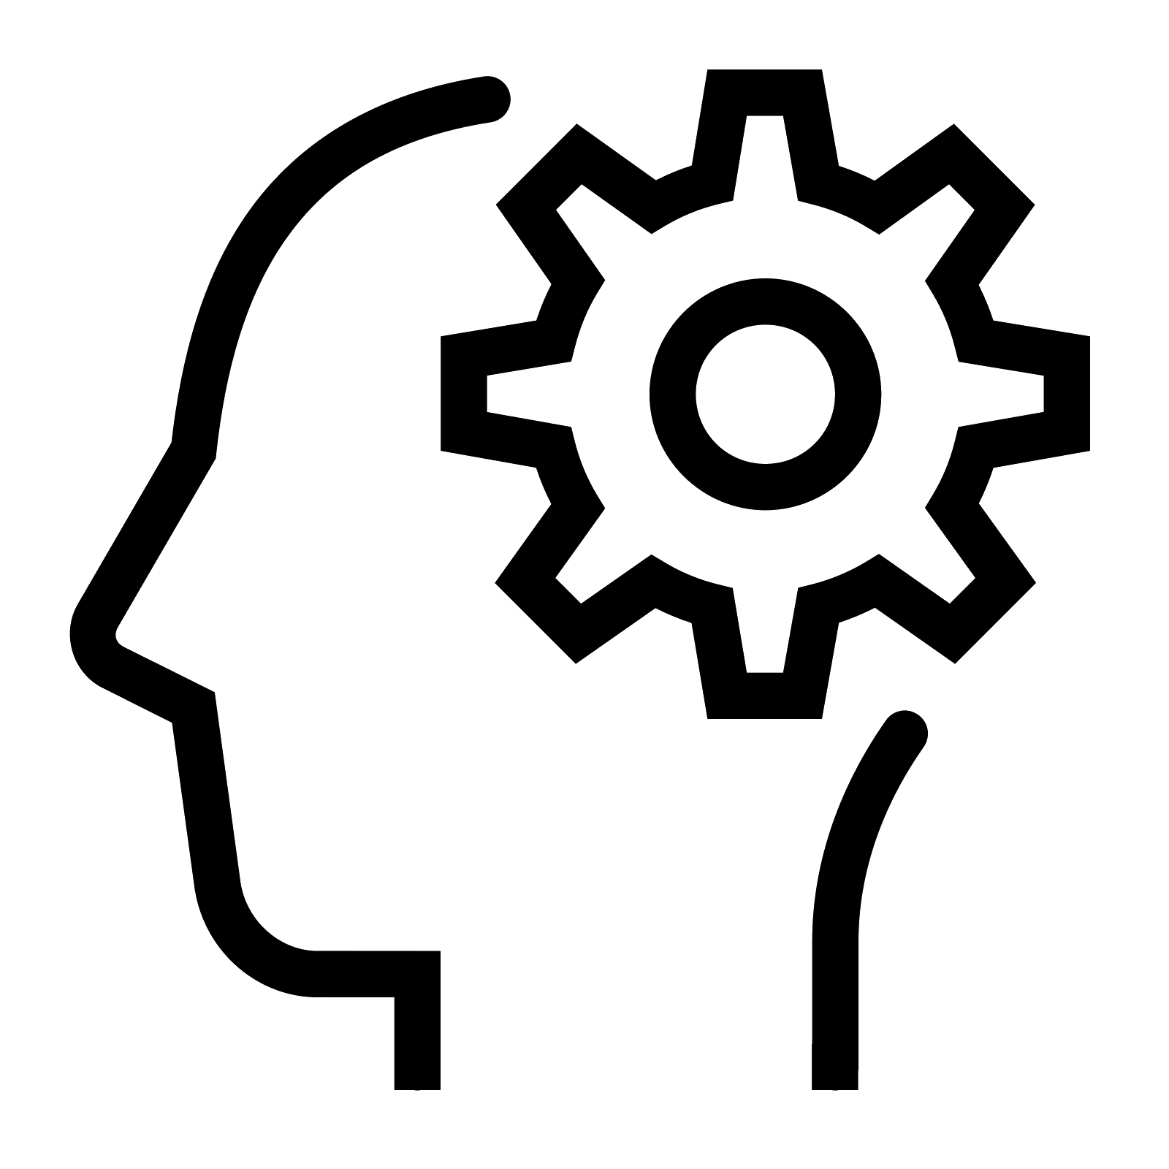

ACTIVITIES

WORK EXPERIENCE
- PhD. researcher: INRIA Grand-Est, Nancy, France | 2012-2016

- RHU researcher: INS, EPINOV, Marseille, France | 2016-2023

- Engineer researcher: SATT Sud-Est, Marseille, France | 2017-2018

- Data scientist: EBRAINS, Human Brain Project (HBP) | 2022-2023
- >35 Publications including Lancet Neurology, Science Medicine, Science Advances, Neural Networks, NeuroImage, Neuroinform, PLOS CB, Commun Biol, MLST, PRE.
- Multiple patents with current use in national clinical trials, and best tech Innov. HBP).
- (co-)Supervising master and PhD students, teaching, grant-writing, and workshops.


EDUCATION
- Bachelor of Science: Physics, solid state | 2004-2008
KHU, Tehran, Iran.

- Master of Science: Physics, soft condensed matter | 2008-2012
IASBS, Zanjan, Iran.
Thesis: Effect of duration of synaptic activity on spike rate of a Hodgkin-Huxley
neuron with delayed feedback.

- PhD.: Computer science | 2012-2016
Université de Lorraine, Nancy, France
Thesis: Analytical and numerical studies of thalamo-cortical neural population
models during general anesthesia.

- Research fellow: AI/ML for digital brain twins | 2016-2023
Aix-Marseille université, Marseille, France
Project: State-of-the-art Bayesian inference on the virtual brain models for
brain diseases; Deep neural density estimators for simulated-based inference
and adaptive Monte Carlo for principled and automatic statistical estimation.
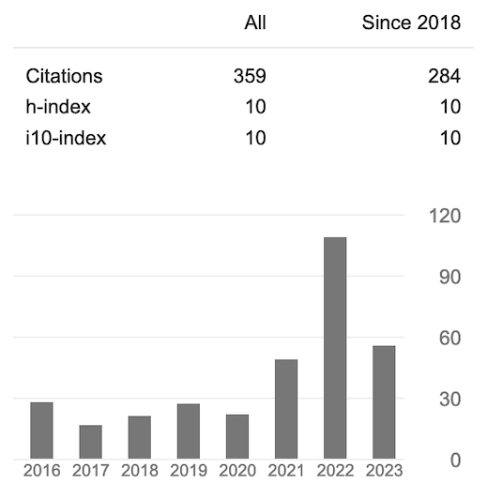
Google Scholar


