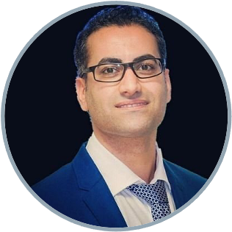
27 blvd. Jean Moulin
13005, Marseille, France
+33 (0)4 91 32 42 51

Meysam.hashemi@univ-amu.fr

Meysam HASHEMI
LANGUAGES
Profile
Meysam.hashemi@gmail.com

Senior Research Flow
English, French, Persian


French, Iranian

Welcome to my home page
Viktor JIRSA (viktor.jirsa@univ-amu.fr)
Axel HUTT (axel.hutt@inria.fr)
A. VALIZADEH (valizade@iasbs.ac.ir)

References

EDUCATION
WORK EXPERIENCE
Google Scholar
I develop and adapt biologically- and physics-informed AI/ML tools for flexible and efficient parameter estimation using Frequentist and Bayesian approaches.
I have extensive experience (>12 years) in working with different computational models, particularly, to quantify the uncertainty for decision-making process by interventions in complex systems (e.g., mean-fields and whole-brain models), both analytically and numerically, to improve diagnostics and therapies for brain disorders, digital health and drug research.
- Bachelor of Science: Physics, solid state | 2004-2008
KHU, Tehran, Iran.

- Master of Science: Physics, soft condensed matter | 2008-2012
IASBS, Zanjan, Iran.
Thesis: Effect of duration of synaptic activity on spike rate of a Hodgkin-Huxley
neuron with delayed feedback.

- PhD: Computer science | 2012-2016
Université de Lorraine, Nancy, France
Thesis: Analytical and numerical studies of thalamo-cortical neural population
models during general anesthesia.

- Postdoctoral: Probabilistic AI/ML for digital brain twins | 2016-2023
Aix-Marseille université, Marseille, France
Project: State-of-the-art Bayesian inference over the virtual brain models of
brain diseases; Deep neural density estimators for simulated-based inference
and adaptive Monte Carlo for principled and automatic statistical estimation.
SKILLS
- Bayesian inference, MCMC, Variational/Simulation-based inference, Optimization.
- Probabilistic AI/ML, Clinical trials, Time-series forecasting, GMLSS, HMM, VAR.
- Dynamical system, Stochastic and Delay Differential equations (SDEs/DDEs).
- Oscillations, Spiking and Mean-Field models, Pharmacometrics, Neuroimaging data.
- Python, Pytorch, Tensorflow, Matlab, C++, Git, Slurm, high-performance computing.
- PPLs: Stan, PyMC3, NumPyro, Edvard, Turing, scikit-learn, and The Virtual Brain.

self






- PhD Researcher: INRIA Grand-Est, Nancy, France | 2012-2016

- RHU Researcher: INS, EPINOV, Marseille, France | 2016-2023

- Engineer Researcher: SATT Sud-Est, Marseille, France | 2017-2018

- Data Scientist: EBRAINS, Human Brain Project (HBP) | 2018-2023
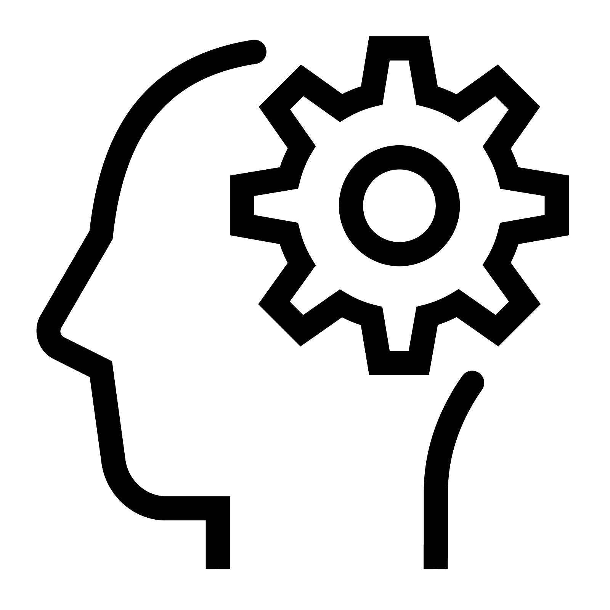

ACTIVITIES
- >40 Publications including Lancet Neurology, Science Medicine, Science Advances, Nature Computational Biology, Neural Networks, NeuroImage, PLOS CB, MLST, …
- Multiple patents with current use in national clinical trials and best tech Innov. HBP).
- (co-)Supervising master and PhD students, teaching, grant-writing, and workshops.
