

**Profile**

English, French, Persian

[**Viktor JIRSA**](https://scholar.google.com/citations?user=0ZVdLpMAAAAJ&hl=en)([viktor.jirsa@univ-amu.fr](mailto:viktor.jirsa@univ-amu.fr))

[**Axel HUTT**](https://scholar.google.com/citations?hl=en&user=PDupwHQAAAAJ) ([axel.hutt@inria.fr](mailto:axel.hutt@inria.fr))

[**A. VALIZADEH**](https://scholar.google.com/citations?hl=en&user=mt6sIDkAAAAJ) ([valizade@iasbs.ac.ir](mailto:valizade@iasbs.ac.ir))

**References**



Meysam.hashemi@gmail.com



 

**Meysam HASHEMI**

**LANGUAGES**

[Welcome to my home page](https://mhashemi0873.github.io/personalwebpage/)



**Senior Research Flow**

French, Iranian

27 blvd. Jean Moulin

13005, Marseille, France

Meysam.hashemi@univ-amu.fr

I develop and adapt biologically and physics-informed AI/ML for flexible and efficient inference using Frequentist and Bayesian approaches to decision-making process.   
I have over 12 years of experience working with computational models, particularly, spiking neurons, neural populational mean-fields, and whole-brain models, both analytically and numerically, to improve diagnostics, intervention strategies, and therapies for brain-related medicine, digital health, and drug research (including Anaesthesia, Epilepsy, Alzheimer, Aging, Parkinson, AUD, and other brain diseases).

* MCMC/HMC, Variational inference, Simulation-based Inference, Optimization.
* Probabilistic AI/ML, HMM, MVAR, GP, Kalman filter, Time series forecasting.
* PD/PK modeling, Oscillations, Signal processing, Neuroimaging, Clinical trials.
* Dynamical system identification, Stochastic and Delay Differential equations.
* Python, Pytorch, Tensorflow, Matlab, C++, Git, high-performance computing.
* PPLs (Stan, PyMC3, NumPyro), VAEs/ NFs, scikit-learn, The Virtual Brain.

[](https://github.com/mhashemi0873)

[](https://www.researchgate.net/profile/Meysam-Hashemi-2)

**SKILLS**

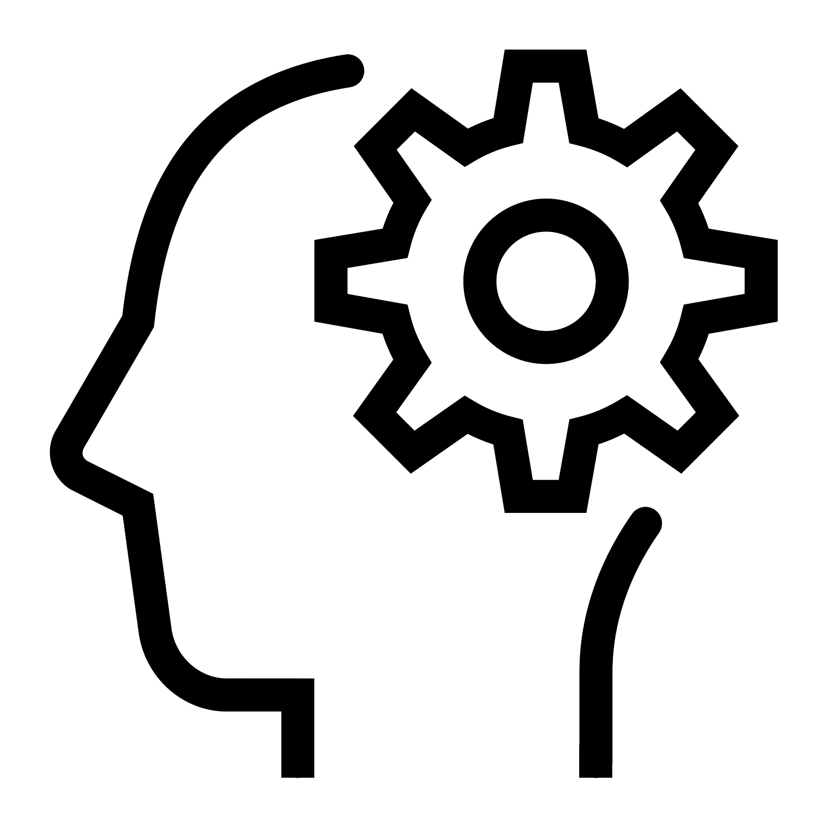



**ACTIVITIES**



**WORK EXPERIENCE**

* **PhD. researcher:** [INRIA Grand-Est](https://www.inria.fr/fr/centre-inria-nancy-grand-est), Nancy, France **| 2012-2016**
* **RHU researcher:** [INS](https://ins-amu.fr/), [EPINOV](https://clinicaltrials.gov/ct2/show/NCT03643016), Marseille, France **| 2016-2023**
* **Engineer researcher:** [SATT Sud-Est](https://www.sattse.com/), Marseille, France **| 2017-2018**
* **Data scientist:** [EBRAINS](https://ebrains.eu/), Human Brain Project ([HBP](https://www.humanbrainproject.eu/en/)) **| 2022-2023**
* >35 Publications including [Lancet Neurology](https://www.thelancet.com/journals/laneur/article/PIIS1474-4422(23)00008-X/fulltext), [Science Medicine](https://www.science.org/stoken/author-tokens/ST-984/full), [Science Advances](https://www.science.org/doi/10.1126/sciadv.abq7547), [Neural Networks](https://www.sciencedirect.com/science/article/pii/S0893608023001752), [NeuroImage](https://www.sciencedirect.com/science/article/pii/S1053811920303268), [Neuroinform](https://link.springer.com/article/10.1007/s12021-018-9369-x), [PLOS CB](https://journals.plos.org/ploscompbiol/article?id=10.1371/journal.pcbi.1009129), [Commun Biol](https://www.nature.com/articles/s42003-021-02751-5#citeas), [MLST](https://iopscience.iop.org/article/10.1088/2632-2153/ac9037), [PRE](https://journals.aps.org/pre/abstract/10.1103/PhysRevE.85.021917).
* Multiple patents with current use in [national clinical trials](https://www.nature.com/articles/d41586-023-00990-6), and [best tech Innov. HBP](https://www.thevirtualbrain.org/tvb/zwei/newswire-blog?filter-tag=epilepsy)).
* (co-)Supervising master and PhD students, teaching, grant-writing, and workshops.



**EDUCATION**

* **Bachelor of Science: Physics, solid state | 2004-2008**

[KHU](https://khu.ac.ir/), Tehran, Iran.

* **Master of Science: Physics, soft condensed matter | 2008-2012**

[IASBS](https://iasbs.ac.ir/), Zanjan, Iran.

Thesis: *Effect of duration of synaptic activity on spike rate of a Hodgkin-Huxley*

*neuron with delayed feedback.*

* **PhD.: Computer science | 2012-2016**

[Université de Lorraine](https://www.univ-lorraine.fr/), Nancy, France

Thesis: *Analytical and numerical studies of thalamo-cortical neural population*

*models during general anesthesia.*

* **Research fellow: AI/ML for digital brain twins | 2016-2023**

[Aix-Marseille université](https://www.univ-amu.fr/), Marseille, France

Project: *State-of-the-art Bayesian inference on the virtual brain models for*

*brain diseases; Deep neural density estimators for simulated-based inference*

*and adaptive Monte Carlo for principled and automatic statistical estimation.*

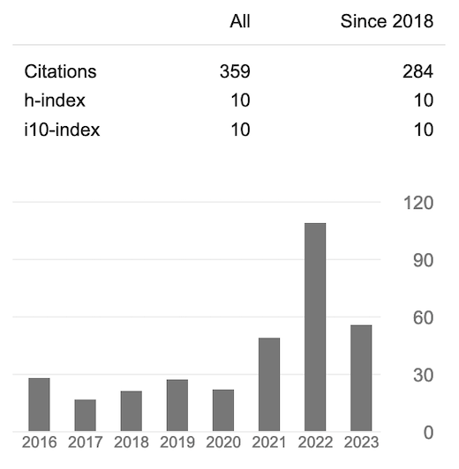

**Google Scholar**

**[](https://scholar.google.co.uk/citations?user=Hma4XDMAAAAJ/&user=Hma4XDMAAAAJ)**