Power, Pressure & Choice — Game Design Document

Power, Pressure & Choice — Game Design Document
Tagline: Same roots, different trees. Concept: A short, reflective, branching web experience where a player grows a tree that mirrors how pressure becomes behaviour — and discovers that beliefs, responses, and leadership decide whether it withers or flourishes. Genre / format: Narrative reflection game · single procedural canvas scene · ~3–6 minutes Platform: Web (desktop + mobile), built in Next.js. Every leaf, root, hill and cloud is drawn live on a <canvas> — no image assets. Status: Playable build. This document shows the team the current look & feel; screenshots below are real frames from the running game.
▶ Try it now: open Power-Pressure-Choice-POC.html — a single self-contained file that plays the whole game in any browser (no install, works offline, runs on a phone). Hand-off notes are in POC_README.md.
Companion docs: the player flow is in USER_JOURNEY.md; the branch map is journey-diagram.mmd / journey-diagram.png.

1. Vision
A man under real pressure is never reduced to a villain or a victim. The tree is a calm, beautiful metaphor the player can act on: choices visibly grow it, harm it, or heal it. The feeling we are designing for is reflective, warm, and hopeful — the player should feel they are tending something alive, and leave with one real commitment rather than shame.

Design pillars
- The tree feels alive. A sunlit, breathing landscape — drifting clouds, birds, wildflowers, a soft breeze — so growth and wither land emotionally, not just informationally.
- Choices are felt, not scored. Consequences show on the tree (colour, falling leaves, light), never as a number or a “wrong” label.
- Hope is always reachable. Every harm has a door back; the support line is always on screen; nothing dead-ends in blame.
- Calm, premium, restrained. Golden-hour palette, serif reflection text, generous space. It should feel considered, not gamey.

2. Look & feel — art direction
The whole scene is procedural and golden-hour warm. The hero state is the fully grown, flourishing tree:
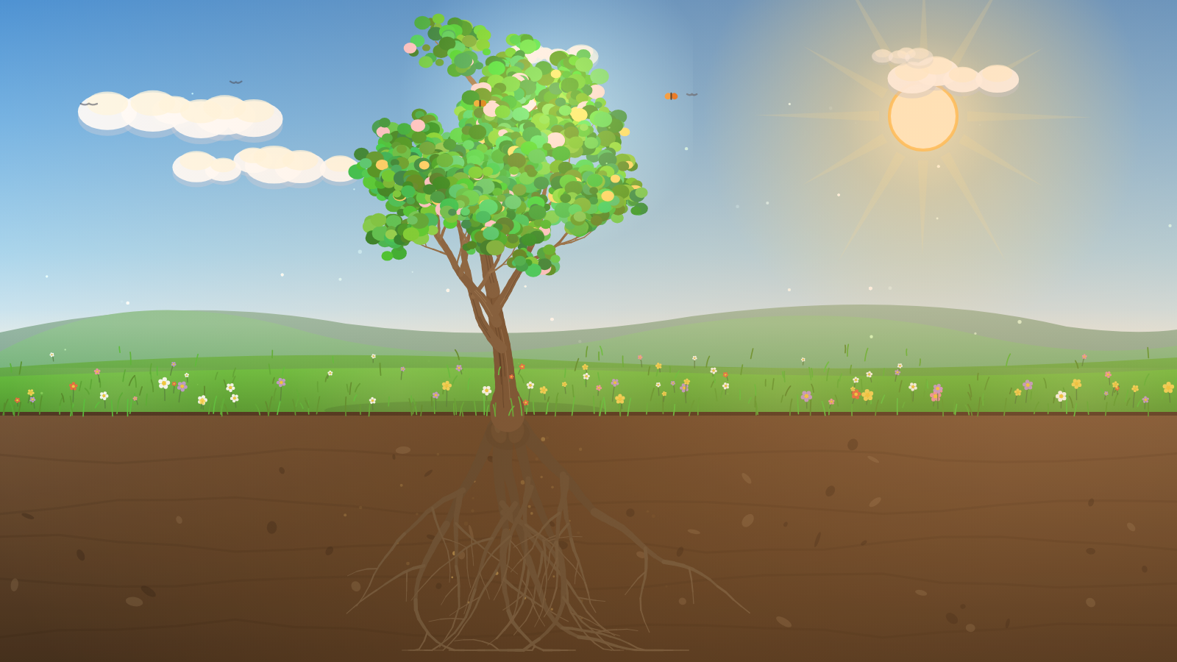
Flourishing tree — full colour, golden light, wildflower meadow

The living scene
Layered for depth (back to front): graded sky → hazy distant mountains → soft hills → rolling field band → foreground meadow with grass and wildflowers. Atmosphere and life on top: sun with glow and slow rays, three-tone clouds, birds and a distant flock, butterflies, floating sunlit pollen motes, and a gentle ambient breeze that sways the whole scene. Below ground: a soil cross-section with strata, pebbles, and the tree’s roots.

Colour & light
A healthy scene is golden-hour warm. As a tree declines its leaves change colour (green → yellow → brown) and then fall, the canopy thins to a bare crown, the branches droop and the bark dies — while the wider landscape stays alive, so the loss reads as this tree, not the world ending.
Role | Reference
Sky gradient | #4a92d6 → #74b4e6 → #a8d6ef → #edf3e6 (zenith → horizon)
Healthy foliage | living greens (HSL hue ~92→142), bright at golden hour
Dying canopy | leaves recolour green → yellow ~54° → brown ~24°, then fall to bare
Bark / wood | warm browns #6b4c31 … #937753, darkening to dead grey-brown #473f36, then peeling to pale sapwood #bcb19c and weathering to silvery snag #7c746a
UI gold accent | #f0c66a
Panel / ink | translucent dark bar rgba(26,19,11,0.85) · text #f5efe2

Typography & UI
- Reflective voice (titles, questions, insights): Georgia serif italic — feels human and considered.
- Interface (labels, buttons, legend): Helvetica/Arial sans — clean and quiet.
- Accent: a single warm gold for the primary action and highlights.
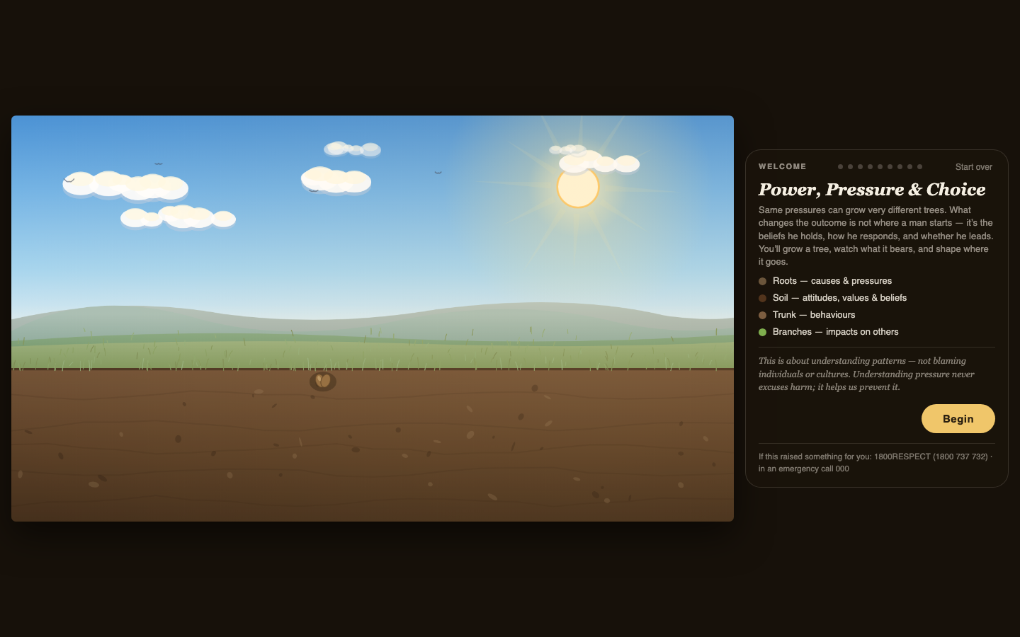
Game UI — scene with the reflection panel, legend, and support line
The UI is one floating panel (a right-hand column on desktop, a bottom sheet on mobile) over the full-bleed scene. Choices are rounded pills; the selected one fills gold. A nine-step progress indicator, a phase tag, the question, a hint, and — after choosing — a reflective insight line. The 1800RESPECT / 000 support line sits in the panel footer on every screen.

Motion & feel
- Growth eases in over ~1–2s as the player advances (the tree literally grows on each choice). The roots spread gradually alongside the trunk, young leaves appear while the sapling is still rising, and the crown scales up from seedling to mature — auto-fitted so the full-grown tree always sits inside the frame.
- Watering accompanies growth: on each growth step a pair of small ground sprinklers rise by the base and throw arcs of water in toward the trunk, with splashes and the soil darkening where it lands — so growth reads as tended, not magical.
- Decline is a gradual, natural die-back tied to a hidden health value (100→0): leaves change colour (yellow then brown), the canopy thins and sheds, branches droop and sag, bark darkens, cracks and peels (pale dead wood showing through), and outer branches snap off, with the sway slowing to complete stillness when dead — sober and lifelike, never flashy. Shed leaves and broken branches collect on the ground beneath the tree. As a clear escalating cue, the first wrong choice recolours the leaves and the second makes them start to fall.
- Healing rewards: green returns, a brief gold heal shimmer rises through the canopy, butterflies and flowers come back — and the flourish builds one leadership step at a time (warmth and first flowers → golden colour and butterflies → full golden light).
- Breeze is a subtle, self-driving ambient sway across leaves, grass, flowers, clouds and motes — and it fades out as the tree loses vitality.

3. The tree as a system
The metaphor is the mechanic. Each layer of the tree maps to a layer of the model:
Tree | Meaning
Roots | Causes & pressures (migration stress, money, racism, isolation)
Soil | Attitudes, values & beliefs
Trunk | Behaviours
Branches | Impacts on others (partner, children, community)
Vitality (health 100→0) | The tree’s living condition — restored by leadership, drained by harm. Drives the staged die-back in §4.

Growth progression (a healthy run)
The beginning | Taking shape | Flourishing
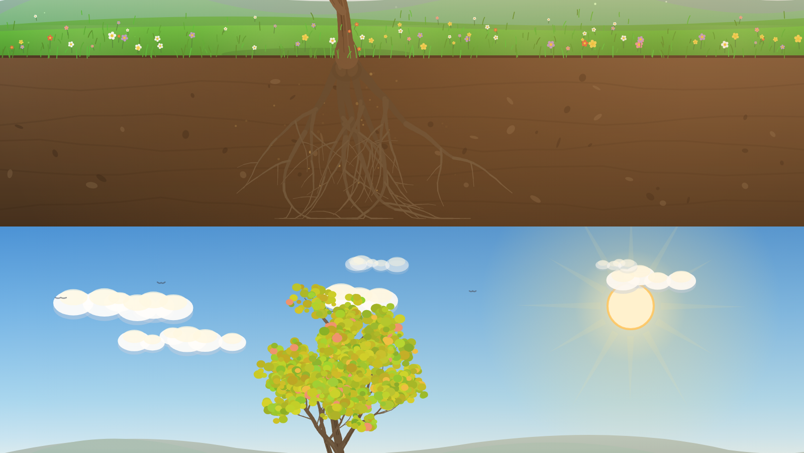 | 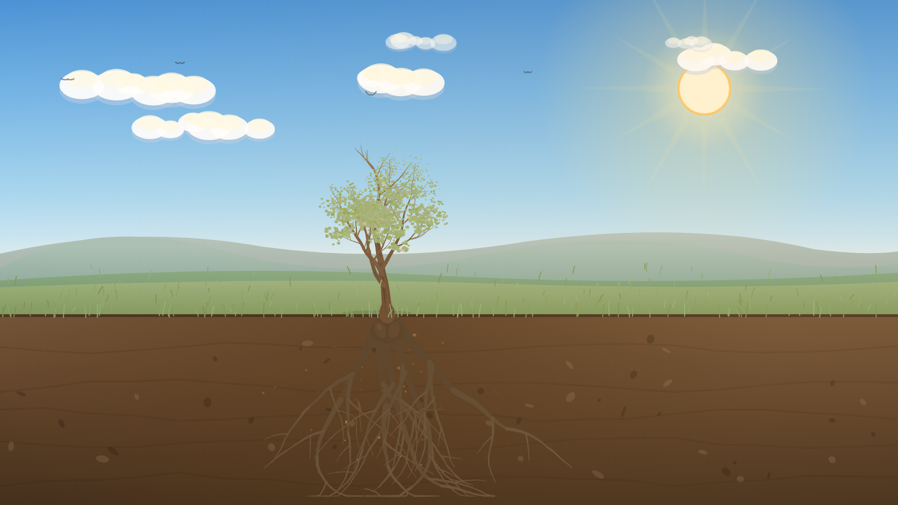
Seed in a living landscape | A young sapling — already leafing out as it rises | Full-grown, golden hour

4. The natural die-back (the heart of it)
Harm no longer just “pales” the tree — it drives a continuous, lifelike death process keyed to the hidden health value. As the player makes harmful choices the tree moves down these six stages in real time (and healthy choices move it back up). This is the single most important thing to show the team.
Health | Stage | The tree
100–80% · Healthy | 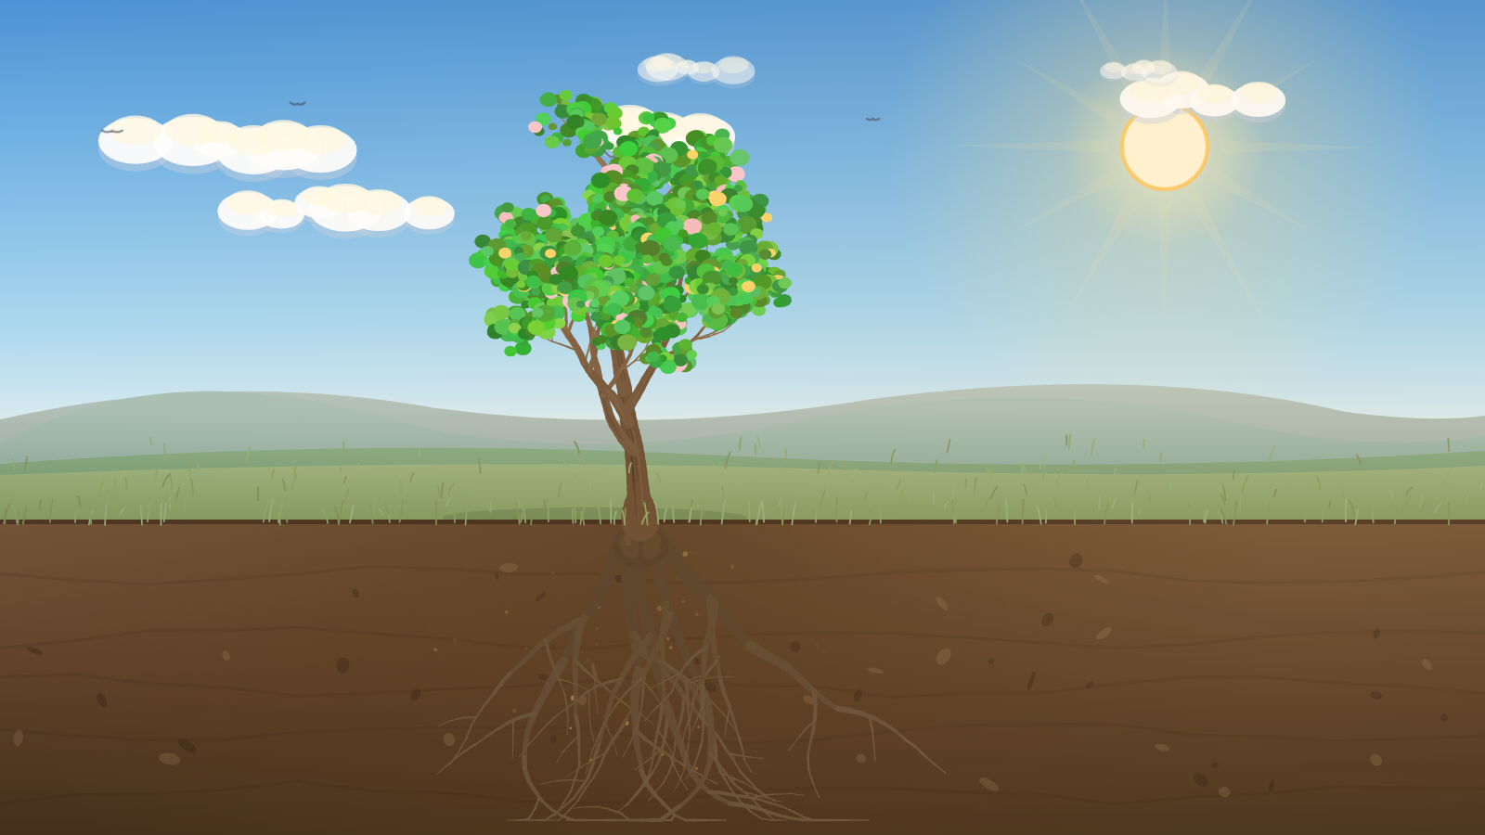 | Full green canopy, vibrant, upright
79–60% · Early stress | 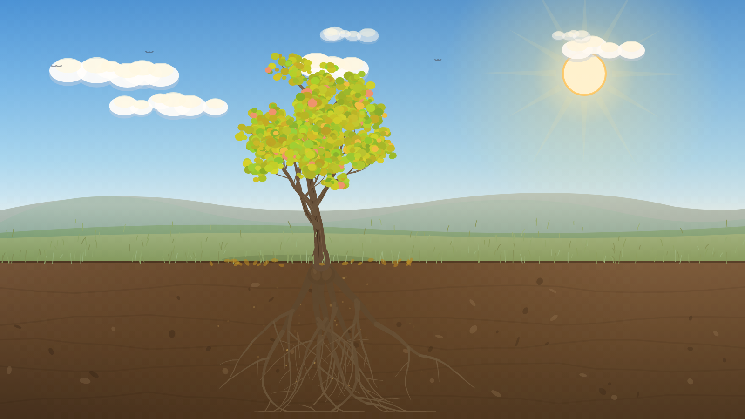 | Leaves yellowing, canopy starting to thin, sway softens
59–40% · Decline | 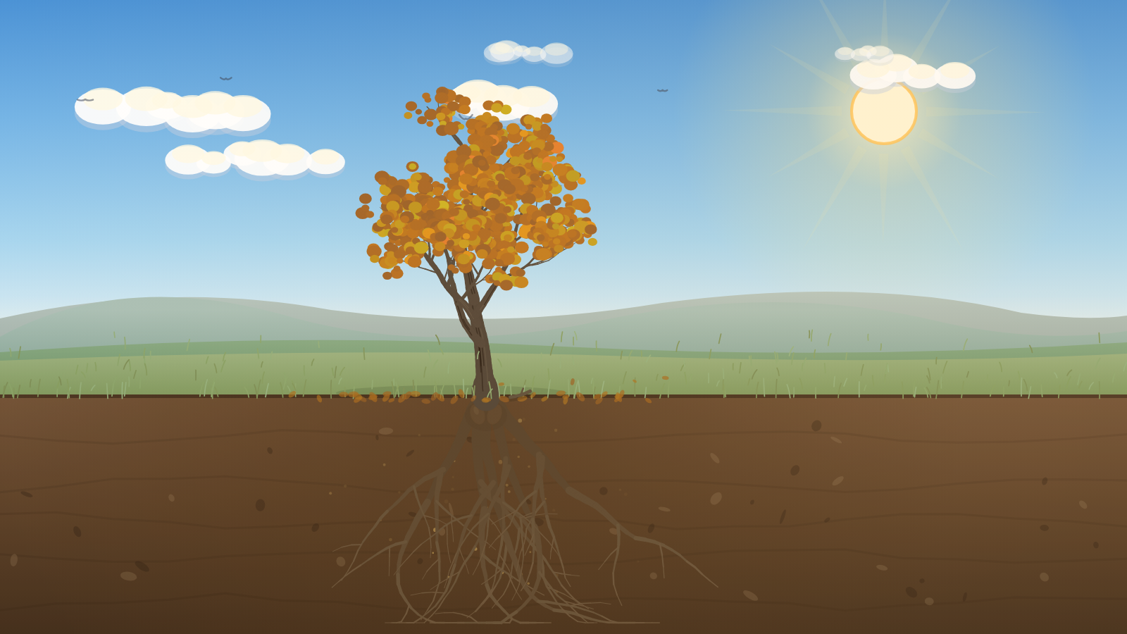 | Yellow/amber leaves, leaves falling and gathering on the ground, thinning canopy, branches begin to droop
39–15% · Severe damage | 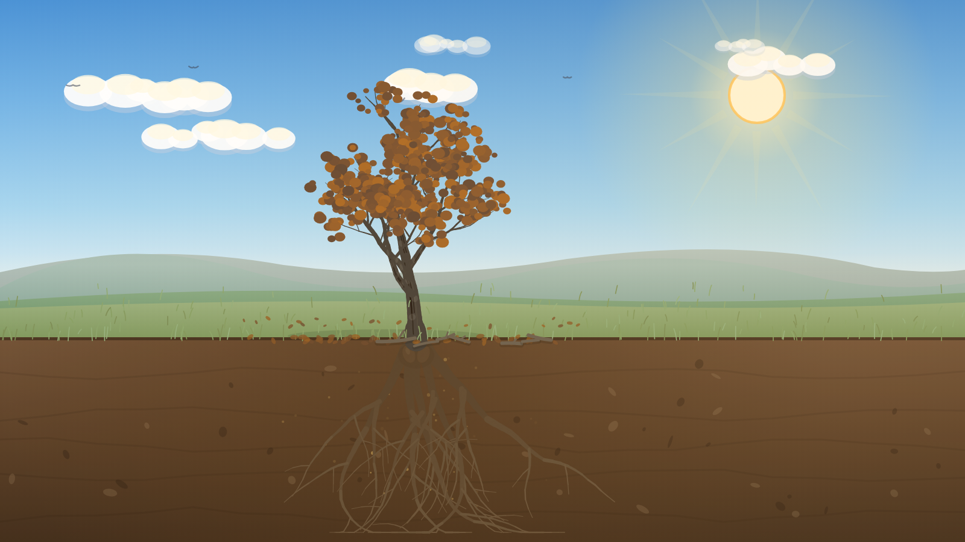 | Brown, sparse leaves, many fallen, branches sag, bark darkening, cracking and starting to peel
14–1% · Near death | 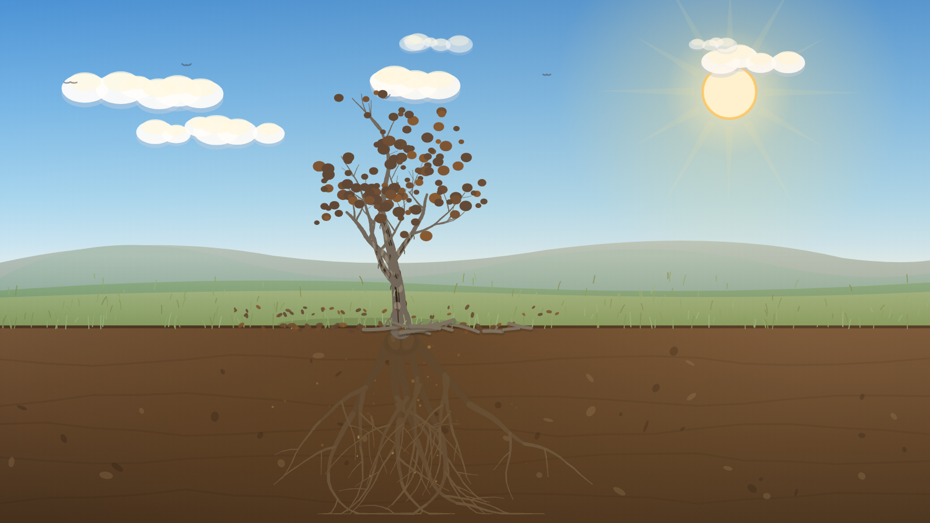 | Almost bare, a few last brown leaves, branches sag heavily and some snap off, trunk dark with peeling bark, broken branches and leaves littering the base
0% · Dead | 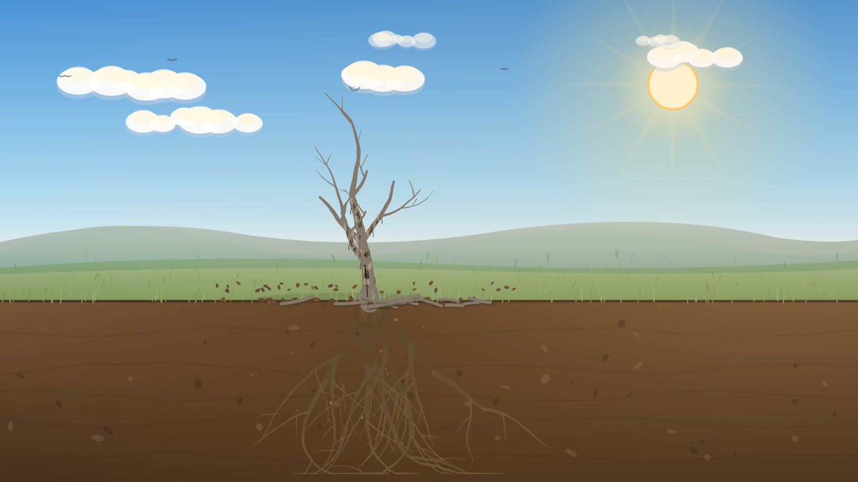 | Bare grey-brown snag — bark peeled, outer branches broken off, fallen leaves and branches littering the ground, no animation or life
The meadow’s flowers, butterflies and motes recede as the tree dies, while the hills and sky stay alive — the loss is focused on the tree. The decline is deliberately quiet, not punishing: a warning, not a “game over”, and at the turning point it is always reversible.

5. Gameplay, in brief
The player grows the tree through four understanding steps (roots → soil → trunk → impact), reaches a turning point, then either leads it back to health (self → family → community) or walks a harm arc that always offers an accountability door. A run ends in one of three states. Full detail and the branch map are in the user journey doc.
flowchart LR
A[Understand] --> B{Turning point}
B -->|owns it| C[Lead]
B -->|defends / shuts down| D[Harm arc · withers]
D -->|door back| C
D -->|doubles down| E([Withered]):::bad
C --> F([Flourishing / Recovering]):::good
classDef good fill:#dff0c6,stroke:#6f9c2f,color:#243a07;
classDef bad fill:#d9dde0,stroke:#8a949a,color:#2c3338;

The three endings
Ending | Look | Tone
Flourishing | Full colour, golden light, butterflies (health 100) | Earned, warm: “Not by chance — by choice.”
Recovering | Partly recovered green, some brown/bare twigs remain (health ~60) | The most admirable: change after harm is strength
Withered | A full-grown but dead tree — bare grey-brown, drooping, still (health 0) | Sober warning, always reversible; support line foregrounded
Each ending recaps the player’s actual path and the commitment they wrote, so replaying with different choices genuinely tells a different story.

6. Audio (implemented)
Synthesised live in the browser — no audio files, matching the asset-free approach of the visuals. A low ambient bed (gentle wind + occasional distant birds + a soft warm pad) fades in when the player begins, with soft, non-gamified cues layered on top: a warm chord swell on healing / leadership choices, and a hush + a single low note on harm. Endings get a fuller resolve (flourishing / recovering) or a low, somber note (withered). A sound toggle in the panel mutes/unmutes and the choice is remembered. No stings, no “fail” buzzer. Audio starts on the first interaction (browser autoplay policy) and honours the mute preference.

7. Technical snapshot
- Stack: Next.js (React) + a single framework-free canvas engine (lib/tree-engine.js).
- All visuals are generated — procedural tree, scenery, particles. No image/sprite assets to manage, fully resolution-independent, tiny footprint.
- Audio is generated too — lib/audio-engine.js synthesises the ambient bed and cues via the Web Audio API; no audio files, with a remembered mute toggle.
- Content as data: the whole branching script lives in lib/game-content.js as an editable node graph — writers can change copy and branches without touching rendering.
- Persistence: progress, path, and commitment auto-save to localStorage.
- Health-driven rendering: a single setHealth(0–100) value drives the whole die-back (leaf colour, canopy thinning, branch droop, bark darkening/cracking/peeling, branches breaking off, leaf-and-branch litter on the ground, animation), so designers can tune the death curve in one place.
- Auto-fit crown: the mature tree is measured per shape and scaled so the full crown always fits the canvas — no clipping off the top, even when a new random tree is generated.
- Accessibility: decline is conveyed by colour and canopy thinning and droop and text (not colour alone); the leaf-fall and branch-fall bursts soften under prefers-reduced-motion.

8. Tone & guardrails (non-negotiable)
This is a violence-prevention tool. The look & feel serves it: consequences attach to the depicted choice, never the player’s worth. Pressures are never a “wrong answer”, naming a victim is never a failure, help-seeking always heals, and support is always one glance away. (Full list in lib/game-content.js and the user journey doc.)

9. Visual reference index
File | What it shows
images/ui-intro.png | The game UI: scene + reflection panel + legend + support line
images/scene-seed.png | Opening state — the living landscape before growth
images/scene-growing.png | Mid-growth — trunk and canopy forming
images/scene-flourishing.png | Hero — full colour, golden hour, wildflowers
images/health-100.png … health-0.png | The six-stage die-back (healthy → dead), §4
All frames are real output from the current build (1600×900 canvas).

