How the Tree Grows and Dies — the Answer Flows

How the Tree Grows and Dies — the Answer Flows
A simple walk-through for the team: how the tree grows when the player makes healthy, leadership choices — and how it dies when the choices are harmful.
The game is built on one idea: the same pressure can grow very different trees — what changes the outcome is the man’s beliefs, his response, and whether he leads. This document follows both paths so you can see the contrast: Part 1 is the healthy path that grows the tree to full bloom; Part 2 is the harmful path that makes it decline and die.
A note on “correct”: the first steps (Roots and Branches) are about understanding, not scoring — there’s no wrong pressure to be under, and naming who is affected is never a failure. The tree’s growth or decline comes from the choices the man makes (belief → response → turning point → Self / Family / Community).
Grounded in a real tree’s life cycle. The growth and decline are modelled on the natural life cycle of a tree: healthy choices carry it through Seed → Germination → Sapling → Mature tree, and harmful choices push a mature tree through the natural dying process — ageing → decline (dieback) → a decaying, dead “snag” (deadwood).
 | Life-cycle stages it moves through
Growth (correct answers) | Seed → Germination (seedling) → Sapling → Mature tree (fruit & flowers)
Decline (incorrect answers) | Mature tree → Ageing → Decline (dieback) → Decaying tree / snag (dead)

The tree is the model
Part of the tree | What it represents
Roots | Causes & pressures (migration stress, money, racism, isolation)
Soil | Attitudes, values & beliefs
Trunk | Behaviours
Branches | Impacts on others (partner, children, community)
Colour & leaves | Vitality — the tree greens and blooms, or yellows, sheds and dies

Part 1 — The growth path (healthy choices)
Each healthy choice grows the tree one step further. Together, the steps carry it through a real tree’s life cycle — seed → germination → sapling → mature tree.
As it grows, three things keep the growth feeling alive and tended: the roots spread gradually alongside the trunk (they keep reaching deeper as the tree gets taller, instead of appearing all at once); young leaves appear while the sapling is still rising, so it is never a bare stick; and on every growth step a pair of small ground sprinklers water the tree — arcs of water play over the base and the soil darkens where it lands.
Step | The question the player faces | The healthy choice | The tree grows…
1. Roots | Choose a pressure this man is carrying | Name any pressure (all valid — understanding, not blame) | Roots spread underground — the tree takes hold (and keep reaching deeper as it grows)
2. Soil | What belief is feeding the soil? | “I can share the load — honesty protects my family more than image” | The soil enriches and a first sprout appears
3. Trunk | The pressure is rising — how does he respond? | “Notice the pressure rising — and pause before acting” | The trunk rises and its first young leaves show as it grows taller
4. Branches | Behaviours bear fruit — who feels it? | Name an impact honestly (the first act of leadership) | Branches fill out and the canopy leafs out full green
5. Turning point | The impact is visible — what does he do with that? | “Own it — this is on me to change” | Colour begins to return to the canopy (the bloom then builds over the next steps)
6. Self | What does he do for himself? | “Acknowledge the stress and seek support” | The canopy warms and the first wildflowers open, with a soft heal-glow
7. Family & peers | What does he do at home and with his mates? | “Share decision-making and money openly at home” | The canopy turns golden and butterflies return to a meadow full of flowers
8. Community | What does he lead beyond his own home? | “Normalise help-seeking among the men around him” | Golden light floods the scene and the tree reaches full bloom
9. Commitment | Write one action you will take as a leader | The player writes their own real commitment | The tree stands in full bloom
The result is the Flourishing ending — a full-colour, golden-hour tree.
The flourish is earned one step at a time. The leadership steps each land as their own visible change rather than all at once: Self warms the canopy and brings the first flowers, Family turns it golden with butterflies returning, and Community brings the golden light and full bloom. (Because owning it grows the tree from a green young tree up to maturity, each leadership choice adds a distinct layer of colour, flowers and light.)

The growth ladder, in pictures
Mapped to a real tree’s life cycle (the game step is shown in brackets).
Life-cycle stage | The tree | What’s happening
Seed | 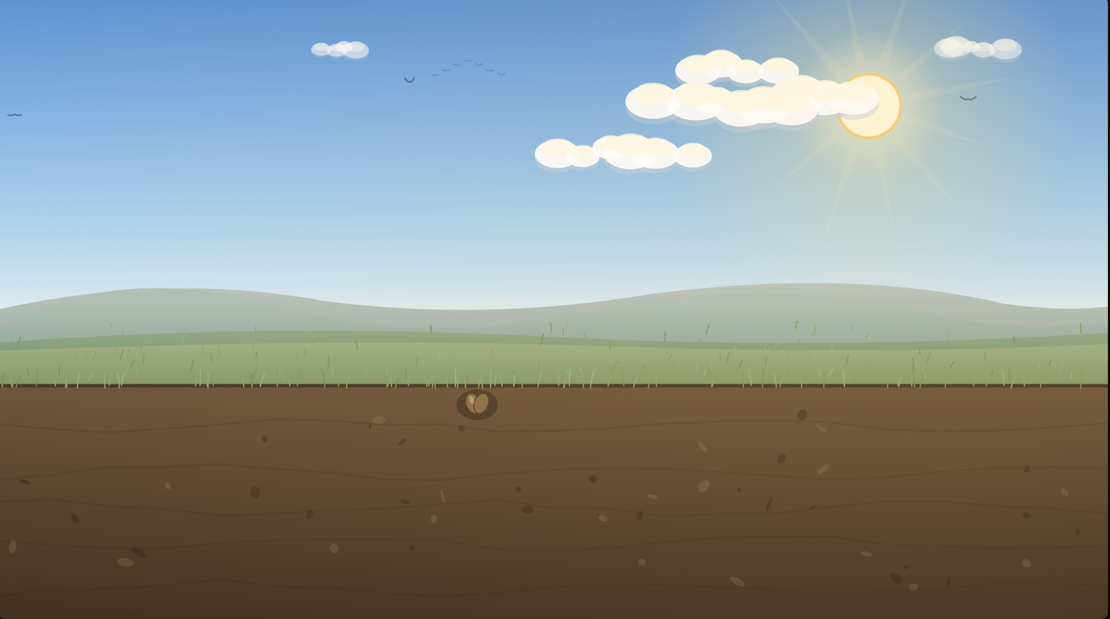 | A seed in the soil — the starting point (start)
Germination | 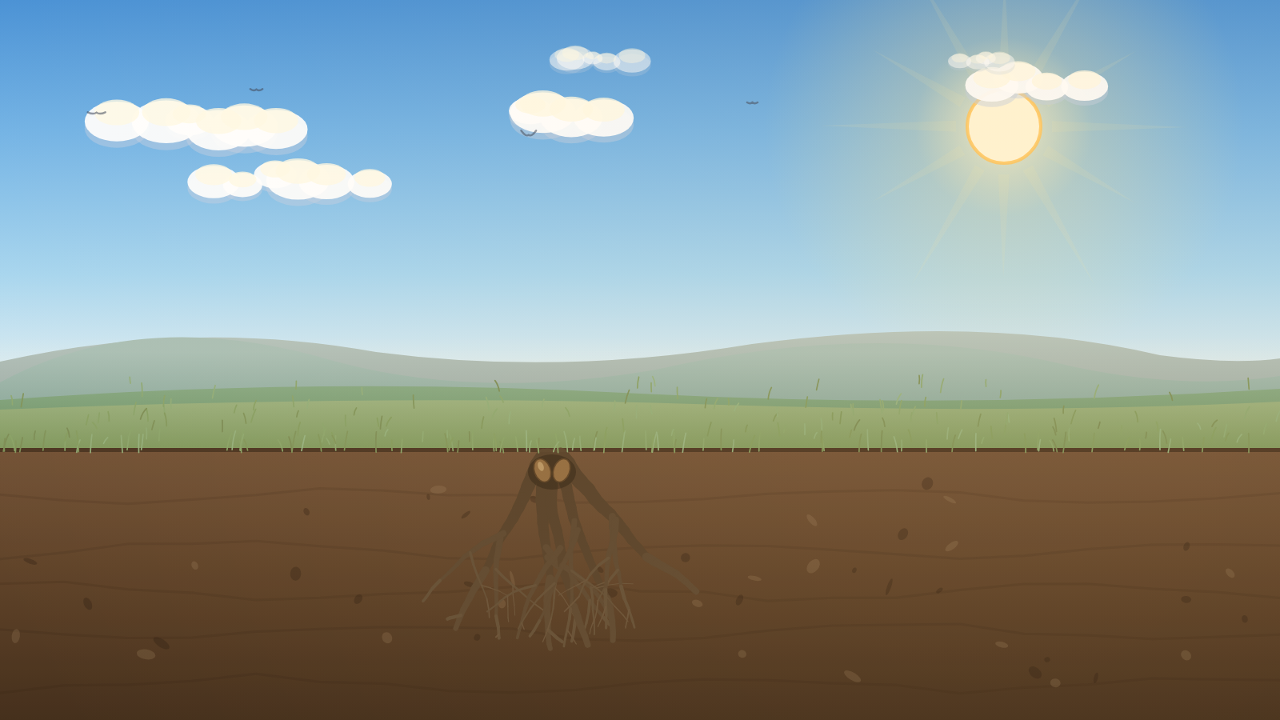 | Roots and a first shoot emerge (Roots — causes & pressures)
Seedling | 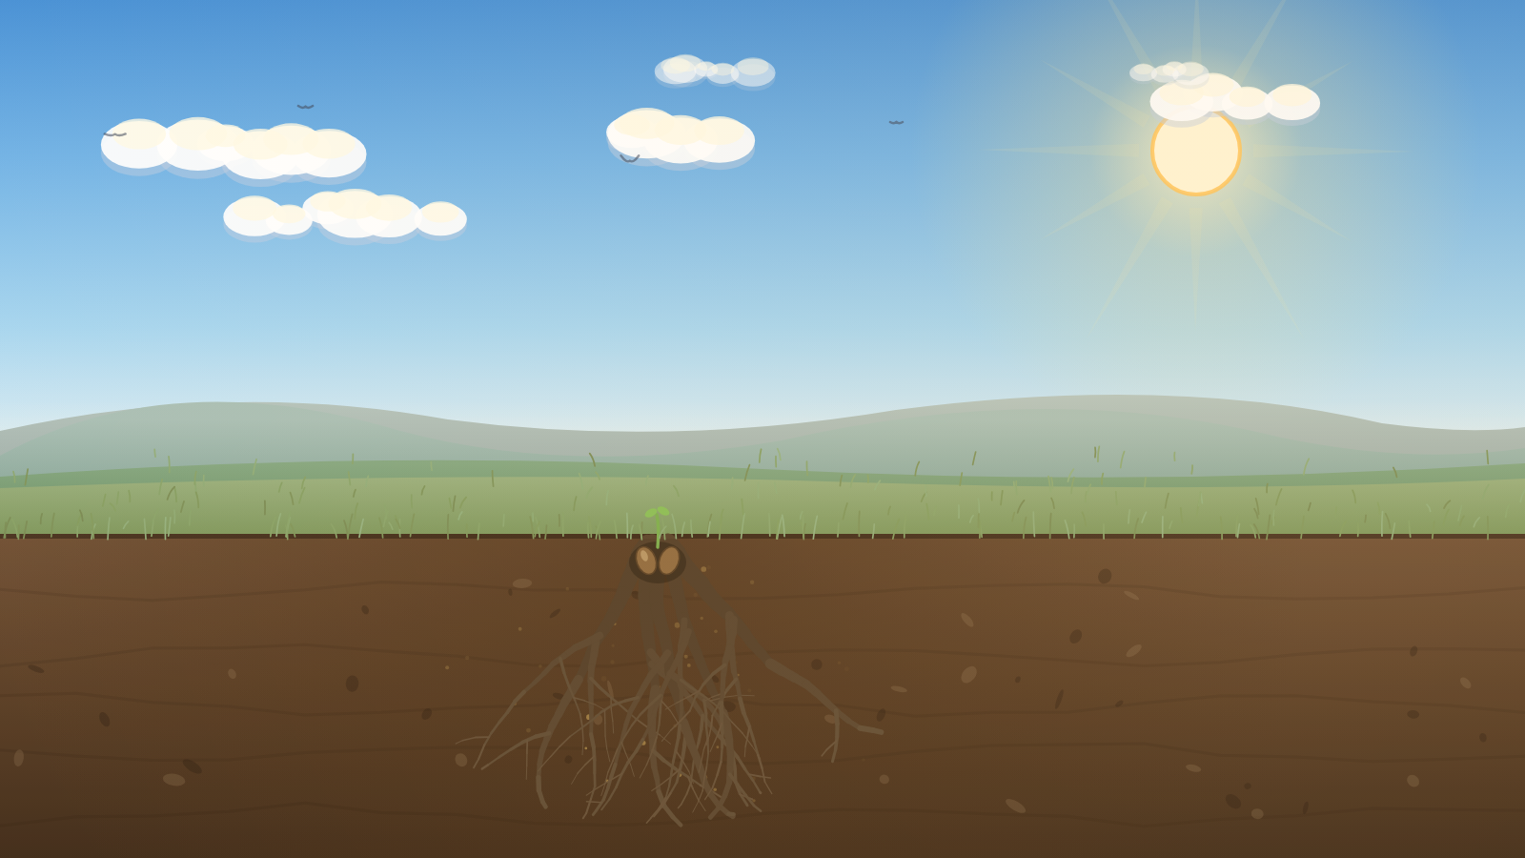 | The sprout establishes, the soil enriches, the roots keep spreading (Soil — beliefs)
Sapling | 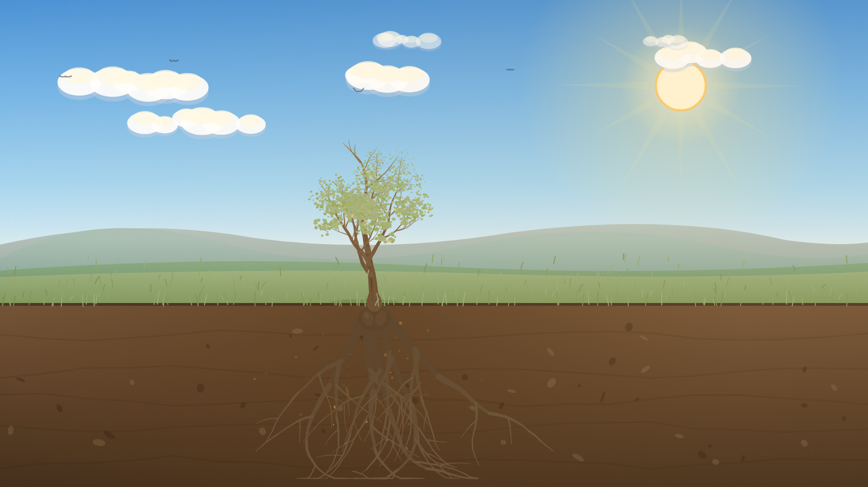 | A young sapling — the trunk rises already carrying its first young leaves (Trunk — behaviour)
Young tree | 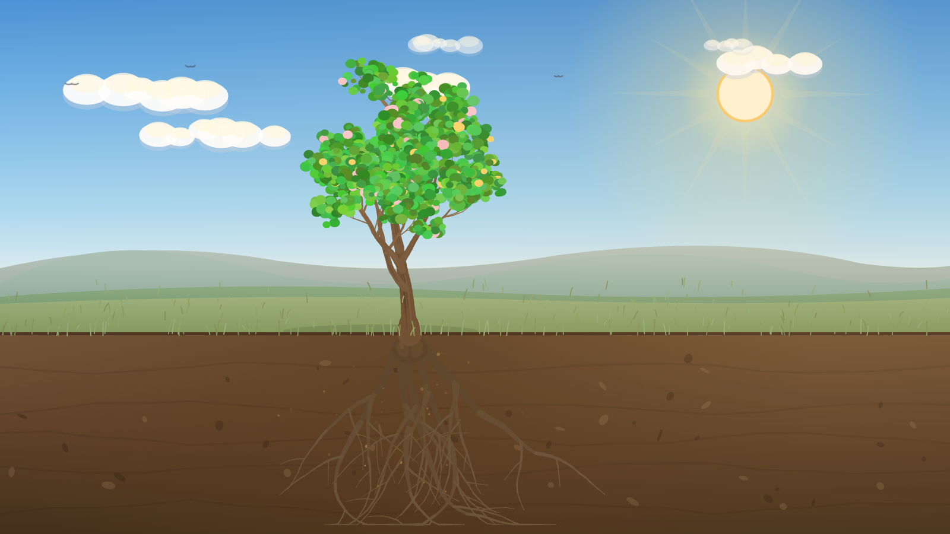 | The canopy fills out full green (Branches — impacts)
Mature tree | 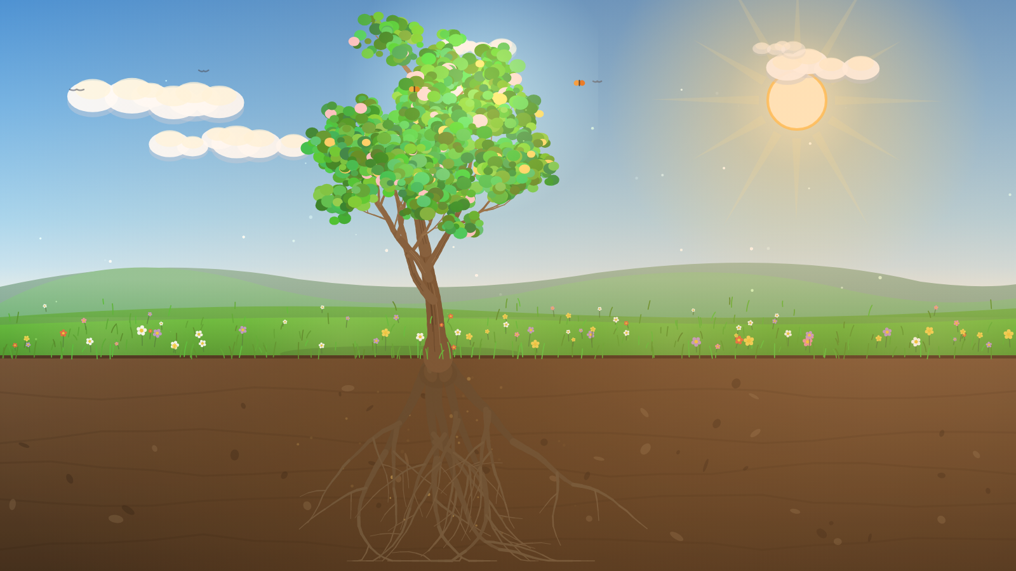 | Full height, bearing fruit & flowers in golden light (Leadership)
In one line: Pressure → a healthier belief → a paused response → owning the impact → leading at every level → a tree in full bloom.

Part 2 — The decline path (harmful choices)
Harmful choices do the reverse: each one drains the tree’s hidden health, and the tree visibly declines — following the natural way a tree dies: the tree it had grown into ages, its canopy goes into decline (dieback), and it ends as a decaying, standing dead “snag” (deadwood). The leaf feedback is deliberately staged so the player feels the consequence build:
- First wrong answer → the leaves change colour (they start to yellow).
- Second wrong answer → the leaves begin to fall — and shed leaves start to collect on the ground beneath the canopy.
- Keep going → the canopy thins to bare, branches droop, the bark darkens, cracks and peels (pale dead wood showing through), outer branches snap off and broken branches fall to the ground, the movement stills, and the tree dies — ending as a bare snag with a litter of fallen leaves and branches at its base.
The tree declines in place — it never grows on a wrong answer. Past the turning point, harmful choices only age and drain the tree; they never make it bigger. It sheds, droops and decays at the same size it had reached, finishing as a bare snag of that exact height. Only leadership ever grows the tree — so the dead snag is visibly the young, unfinished tree the harm cut down, never a taller one. (The build steps — Roots → Branches — are the only place the tree gains size, because the structure has to exist before there is anything to harm.)

The decline, step by step
Step | The harmful choice | The tree…
Soil | “I must stay in control” | Health drops — the leaves change colour (first yellowing)
Trunk | “Tighten control over the money” | Health drops again — the leaves begin to fall
Branches | (naming who is harmed — no penalty) | The canopy keeps thinning; branches start to droop
Turning point | “Defend it” or “Shut down” | The tree is failing — colour drains, more leaves fall, branches droop, bark darkens (declining, not yet bare)
The door is still open | “Keep insisting he’s the one being wronged” | Only now does it reach bare and dead — the Withered ending, at the size it had reached
At the Turning point and the door, the opposite choice — owning it and being accountable — reverses the decline and the tree begins to recover. The withered ending is always reversible: it offers “go back and choose again”, and the support line (1800RESPECT / 000) is on every screen.
(The Self / Family / Community leadership steps work the same way — a harmful option there (“push through alone”, “quietly control the money”, “keep it private”) leaves that part of the canopy pale and sheds a few more leaves.)

The dying stages, in pictures
How the tree ages and dies as its health falls from 100% to 0% — mapped to the natural dying process (the article calls the dead end-state a “decaying tree” or snag).
Health | Life-cycle stage (dying) | The tree
100–80% · Mature & healthy |  | Full green canopy, vibrant, upright
79–60% · Ageing / early stress | 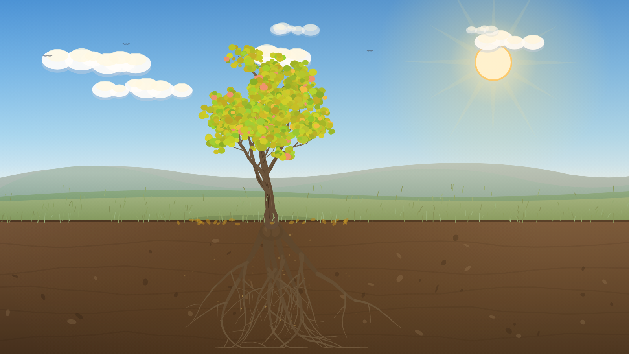 | Leaves yellowing, canopy starting to thin
59–40% · Decline (dieback begins) | 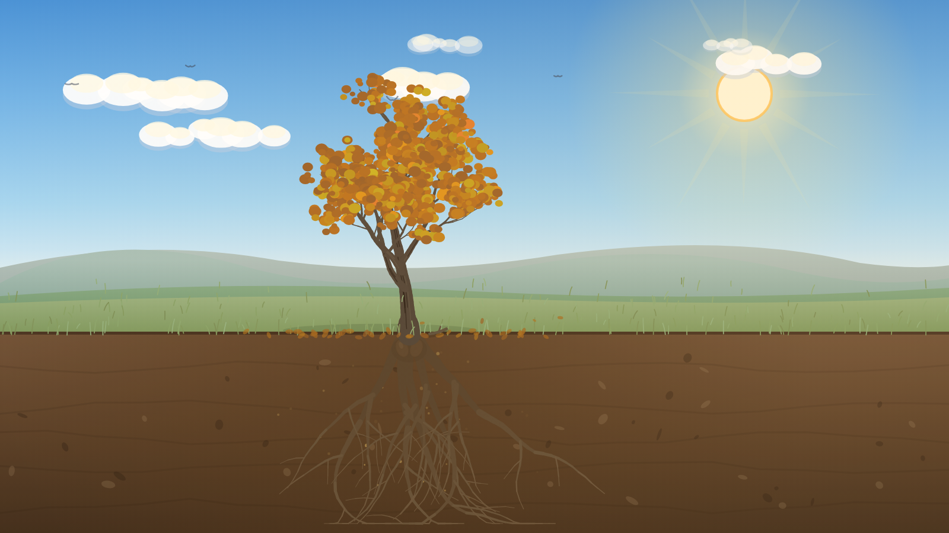 | Yellow/amber leaves, leaves falling and gathering on the ground, branches begin to droop
39–15% · Severe dieback | 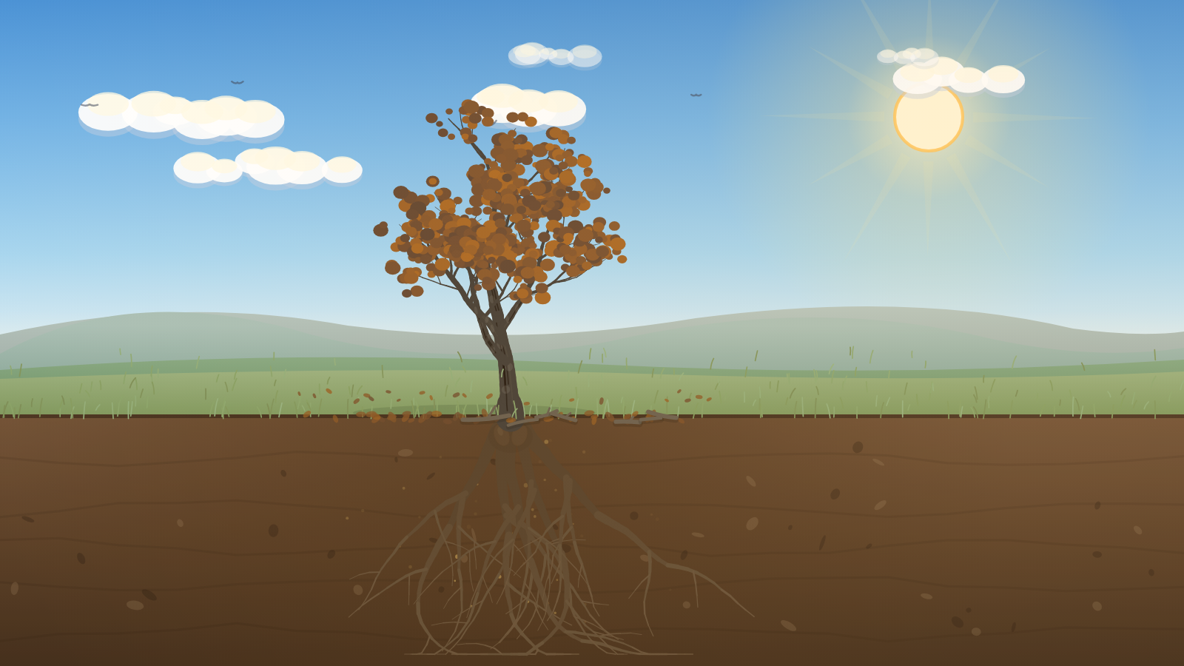 | Brown, sparse leaves, many fallen, bark darkening, cracking and starting to peel
14–1% · Near death | 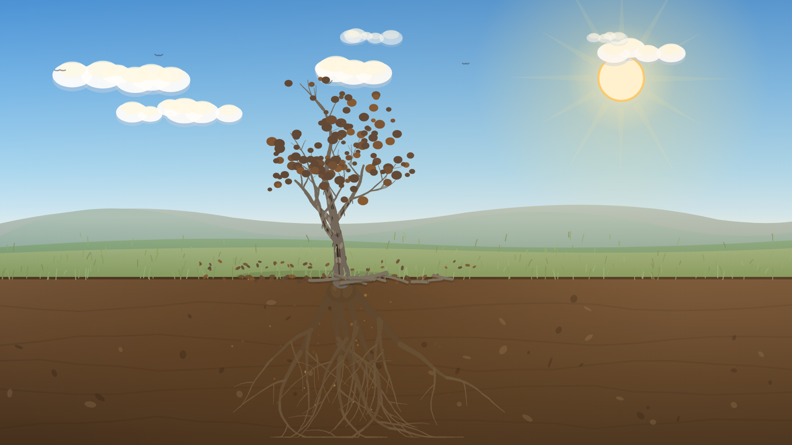 | Almost bare, branches sag and some snap off, bark peeling, broken branches and leaves litter the base
0% · Decaying snag (dead) | 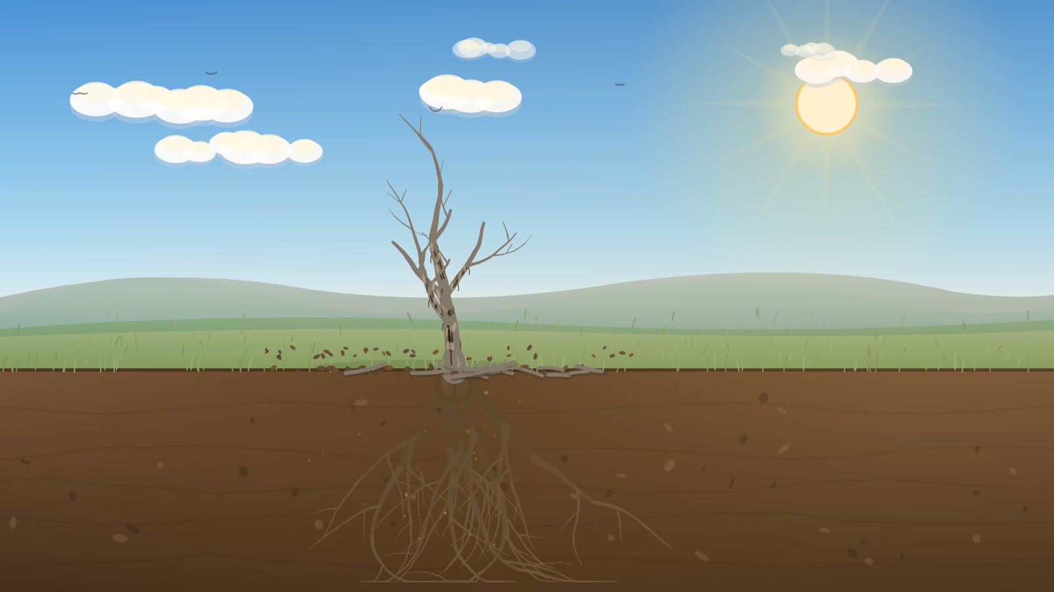 | Bare grey-brown deadwood — peeled bark, branches broken off, fallen leaves and branches littering the ground
In one line: A hardening belief → controlling behaviour → defending it → refusing to own it → a bare, dead tree — but at every step a different, accountable choice brings the tree back. Understanding the pressure never excuses the harm; it helps prevent it.

The full branching map and all endings are in the Game Design Document and the User Journey.
Life-cycle stages are based on EcoTree, “The life cycle of a tree” (Seed → Germination → Sapling → Mature tree; and the decaying tree / “snag”).

