Apigee API Proxy Generation based on templates
Apigee API Proxy Generation based on templates 1
To install 1
Prerequisite & Versions 2
Paths 3
Input files 3
Proxytobuild.json 3
Template Files 3
specs folder 6
To run in WSL 6
In the general case, API Proxies code deployed on the API Platform support the non-functional requirements of APIs. These include security , routing, logging,auditing etc . The API proxy code is repetitive and pattern-based, making it ideal for templating.
This tool generates proxy code using the following inputs:
(1) an OpenAPI specification,
(2) a proxy template, and
(3) an input JSON message containing values for template variable substitution and other metadata such as the proxy name.
ApigeeProxyGeneration.md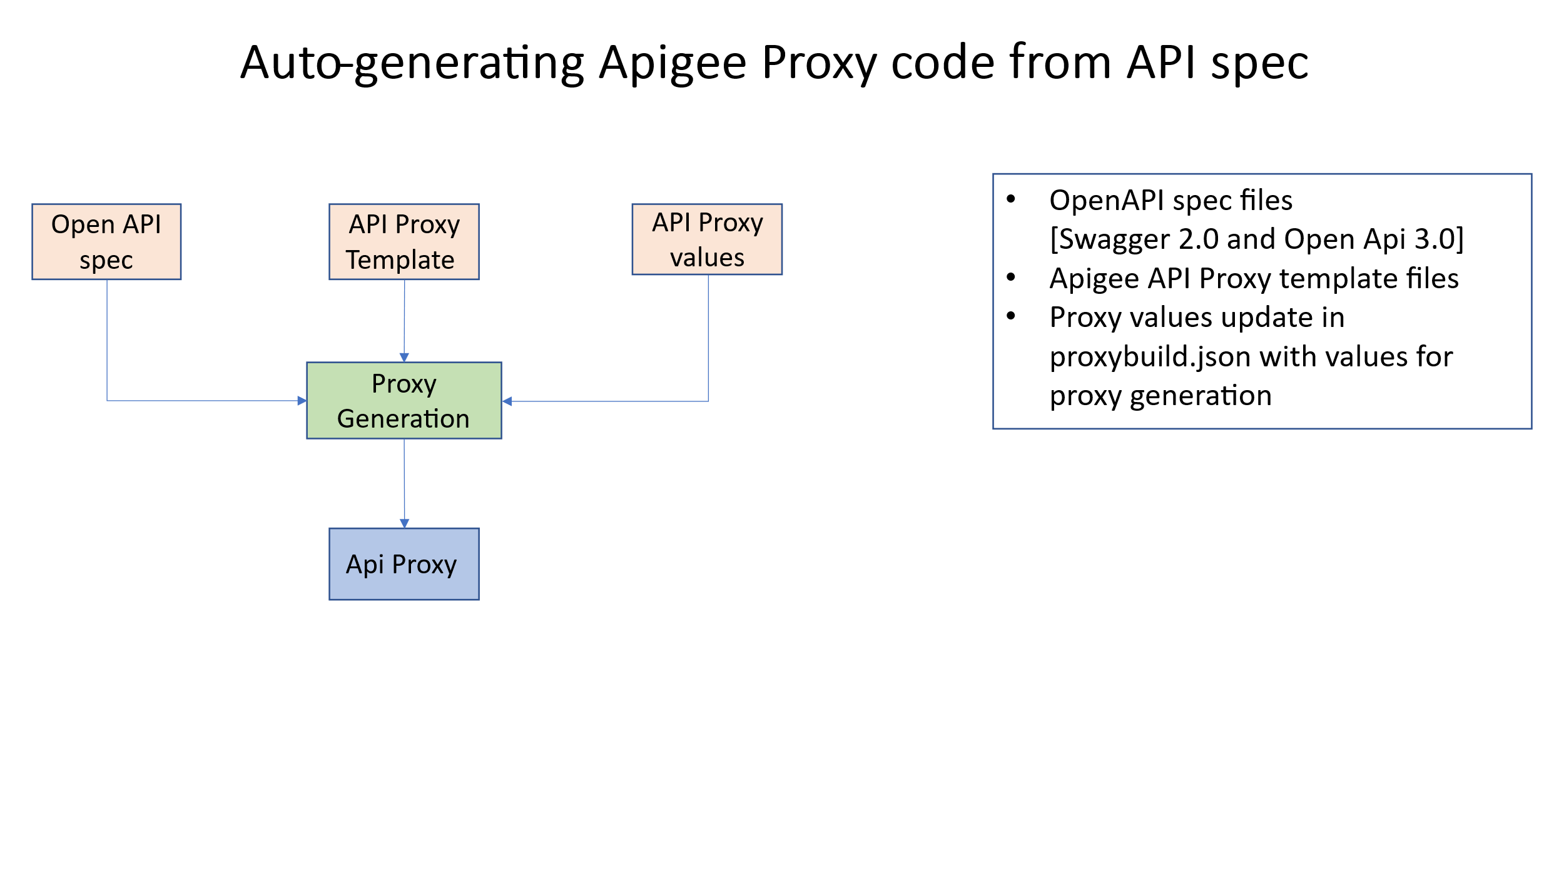

To install
Clone repo to your desktop
https://github.com/mhashir69/oas-apiproxy-gen/tree/main
You will always run commands from the \oas-apiproxy-gen\src\specToProxy folder.
- ./proxytobuild.sh
- node main.js
- Input files , openApi spec, templates in template folder and value to use to build proxy (more detailed explanation further down in the document)
  - oas-apiproxy-gen\src\specs\petstore.yaml
  - oas-apiproxy-gen\src\specToProxy\templates\Template-V3-fh-sec-rt-eh-lg
  - oas-apiproxy-gen\src\specToProxy\resources\proxytobuild.json

Prerequisite & Versions
This code is tested on a Windows Subsystem for Linux.
$ lsb_release -a
No LSB modules are available.
Distributor ID: Ubuntu
Description: Ubuntu 22.04.5 LTS
Release: 22.04
Codename: jammy
$ node –version
v20.20.2
npm list @apidevtools/swagger-parser handlebars lodash --depth=0
oas-apiproxy-gen@1.0.0
├── @apidevtools/swagger-parser@12.1.0
├── handlebars@4.7.9
└── lodash@4.18.1
Use npm install or upgrade to install the lhese version or the latest ones
$ jq --version
jq-1.6
Note: install jq on WSL
sudo apt install jq

Paths
src
├── gateway contains generated proxy code
├── sharedflows
├── specs contains openAPI specs
├── specToProxy
│ ├── hbs
│ ├── node_modules
│ ├── resources contains file proxytobuild.json
│ ├── templates contains proxy templates
│ └── utils

Input files

Proxytobuild.json
Json messages, each json message is formatted and stored as a single line. For each proxy to build there will be a single line in the file.
See explainer
{
"proxyname": "Gen-httpbin", Name of proxy to build and is written to the Gateway folder show in the structure above
"templatename": "Template-V3-fh-sec-rt-eh-lg", Template to use and is read from the templates folder
"basepath": "gen-httpbin",
"urltarget": "https://httpbin.org", variable urltarget in the template files will be replaced with this value and the generated proxy is stored in the gateway folder
"openapispecfile": "httpbin.yaml" openApi spec file is read from the specs folder
}

Template Files
The folder structure the proxy template files are stored in
── templates
│ │ └── Template-V3-fh-sec-rt-eh-lg
│ │ └── apiproxy
│ │ ├── manifests
│ │ ├── policies
│ │ ├── proxies
│ │ └── targets
Looking into the files ,
\specToProxy\templates\Template-V3-fh-sec-rt-eh\pom.xml
<project xmlns="http://maven.apache.org/POM/4.0.0" xmlns:xsi="http://www.w3.org/2001/XMLSchema-instance" xsi:schemaLocation="http://maven.apache.org/POM/4.0.0 http://maven.apache.org/xsd/maven-4.0.0.xsd">
<parent><artifactId>parent-pom</artifactId>
<groupId>apigee</groupId>
<version>1.0</version>
<relativePath>../shared-pom.xml</relativePath>
</parent>
<modelVersion>4.0.0</modelVersion>
<groupId>apigee</groupId>
<artifactId>{{proxyname}}</artifactId> variable, also called handlebar variable which will be replaced with values from Proxytobuild.json file
<version>1.0</version>
<name>{{proxyname}}</name>
<packaging>pom</packaging>
</project>

Another file
\apiproxy\proxies\default.xml
OK , here we see some more of this handlebar templating code – its minimal
There is the basic variable substitution , and then there is an if condition check , and a “for loop” to handle multiple paths(routes) . Yes, you have to learn a few handlebar commands to build your template.
https://handlebarsjs.com/
<ProxyEndpoint name="default">
<DefaultFaultRule name="default-fault">
<Step>
<Name>FC_ErrorHandling</Name>
</Step>
<Step>
<Name>FC_Logging</Name>
</Step>
<AlwaysEnforce>true</AlwaysEnforce>
</DefaultFaultRule>
<PreFlow name="PreFlow">
<Request/>
<Response/>
</PreFlow>
<Flows>
{{#if paths}} {{#each paths}} // for each uri path
<Flow name="{{keyHttpverb}} {{keyPath}}">
<Description>{{description}}</Description>
<Request/>
<Response/>
<Condition>(proxy.pathsuffix MatchesPath "{{keyPath}}") and (request.verb = "{{loud keyHttpverb}}" )</Condition>
</Flow>
{{/each}} {{/if}} // for each uri path
</Flows>
<PostFlow name="PostFlow">
<Request/>
<Response/>
</PostFlow>
<HTTPProxyConnection>
<BasePath>/{{basepath}}</BasePath>
<VirtualHost>secure</VirtualHost>
</HTTPProxyConnection>
<RouteRule name="default">
<TargetEndpoint>default</TargetEndpoint>
</RouteRule>
</ProxyEndpoint>

specs folder
Is just that, Openapi files either swagger 2.0 or swagger 3.x

To run in WSL
Change to directory specToProxy
src/specToProxy$ ./proxybuild.sh
Start: /mnt/c/Users/mhash/Documents/apigeeWS/apigeeWS/src/specToProxy
ProxyName: petStore | TemplateName: Template-V3-fh-sec-rt-eh
ProxyName: Gen-httpbin | TemplateName: Template-V3-fh-sec-rt-eh
src/specToProxy$ node main.js
Using Swagger Parser Version: Latest/ESM
Starting Proxy Build Process...
Building proxy: petStore
Template Name: Template-V3-fh-sec-rt-eh
Processing directory: ../../src/gateway/petStore
API name: Swagger Petstore - OpenAPI 3.1, Version: 1.0.12
Successfully updated 5 files.
Finished proxy: petStore

