ACADEMIC FIELD RESEARCH STUDY
FIELD PROJECT REPORT:
CAREER PERCEPTIONS, JOB SEARCH DYNAMICS, AND WORKPLACE PREFERENCES
An Empirical Multidimensional Survey Analysis of Candidate Expectations, Digital Portal Adoption, and Recruitment Friction
Project Domain: | Employment Ecosystems & Human Resource Analytics
Survey Scope: | 12 Quantitative & Qualitative Survey Modules (Q1–Q12)
Target Population: | Undergraduate & Graduate Students, Job Seekers, & Early Professionals
Total Sample Size: | N = 75 Verified Respondents
Primary Investigation: | Hiring Channels, Compensation Priorities, and Recruitment Barriers
Reporting Period: | Academic Year 2026
Comprehensive Research Dossier with Visualizations, Data Matrices, & Analytical Insights

Executive Summary & Research Framework
Overview: This field research project investigates the evolving dynamics of employment transition, job search behavior, and candidate expectations among early-career individuals and students. Conducted across a sample of 75 survey respondents, the study captures multidimensional data covering demographic baselines, digital platform preferences, key career choice drivers, perceived recruitment friction, and modern working arrangement inclinations.
Methodology & Data Structure: The survey dataset comprises twelve standardized questions (Q1 to Q12), organized into cohesive thematic analytical modules. The quantitative results demonstrate significant transformations in candidate behavior, characterized by an overwhelming pivot toward digital job search platforms, a sharp preference for flexible work modes (hybrid and remote), and critical friction points centered on experience prerequisites and recruitment communication clarity.
KEY STRATEGIC TAKEAWAY: EXECUTIVE SYNTHESIS & CORE HIGHLIGHTS
• Demographic Dominance: 61.3% of respondents fall in the 18–20 age group, with 60.0% maintaining active student status, representing the upcoming workforce pipeline.
• Educational Specialization: Over 55.6% hold or are pursuing a Bachelor's degree, heavily clustering their career aspirations in the Information Technology (59.5%) sector.
• Search Channels & Portal Monopolies: Digital job boards (74.7%) and social media (54.7%) vastly outperform traditional channels; LinkedIn commands 44.0% of portal market share.
• The Work Mode Paradigm: 84.6% demand Hybrid (43.1%) or Fully Remote (41.5%) setups, with only 15.4% willing to accept conventional fully on-site work.
• Market Friction & Dissatisfaction: 'Lack of Experience' (26.4%) and 'High Competition' (25.0%) represent the most formidable hurdles, driving an overall net-negative satisfaction score (average 2.95 out of 5.0).

Chapter 1: Demographic & Educational Profiling
Question 1: Age Distribution of Survey Respondents
Research Objective: The primary objective of Question 1 was to establish the generational baseline of the surveyed cohort, mapping the age structure of candidates entering the contemporary hiring market.
Age Category | Respondent Count | Relative Percentage (%) | Cumulative Percentage (%)
18–20 | 46 | 61.3% | 61.3%
21–23 | 11 | 14.7% | 76.0%
24–26 | 11 | 14.7% | 90.7%
27–29 | 7 | 9.3% | 100.0%
Total | 75 | 100.0% | —

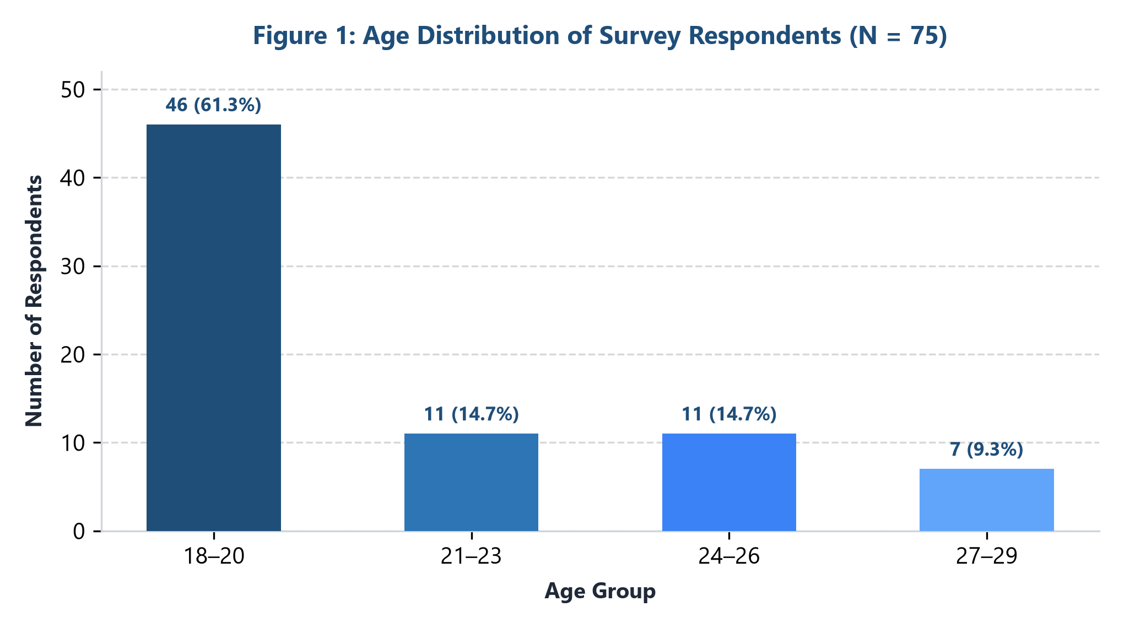
Figure 1: Age Breakdown of Sample Respondents (N = 75)
Statistical Interpretation: The age distribution reveals a pronounced concentration in the youngest demographic bracket. Nearly two-thirds (61.3%) of all surveyed participants are between 18 and 20 years old, representing tertiary undergraduate cohorts entering pre-placement stages. A combined 29.4% span the 21–26 age corridor, reflecting immediate graduates and junior professionals. Only 9.3% belong to the 27–29 bracket.
KEY STRATEGIC TAKEAWAY: AGE DEMOGRAPHICS
• The respondent pool is heavily skewed toward Generation Z entry-level entrants.
• Career guidance, university placement support, and early internship opportunities are critical interventions for this demographic profile.

Question 2: Highest Level of Education Attained
Research Objective: Question 2 evaluated the formal educational qualifications possessed by respondents, identifying the academic prerequisites defining their current employability profiles.
Education Level | Respondent Count | Relative Percentage (%) | Academic Track
Bachelor's Degree | 40 | 55.6% | Undergraduate
High School | 12 | 16.7% | Secondary
Vocational Training | 6 | 8.3% | Technical / Applied
Master's Degree | 6 | 8.3% | Postgraduate
PhD / Doctorate | 5 | 6.9% | Advanced Research
Other | 3 | 4.2% | Certificates / Continuing
Total Valid Responses | 72 | 100.0% | —

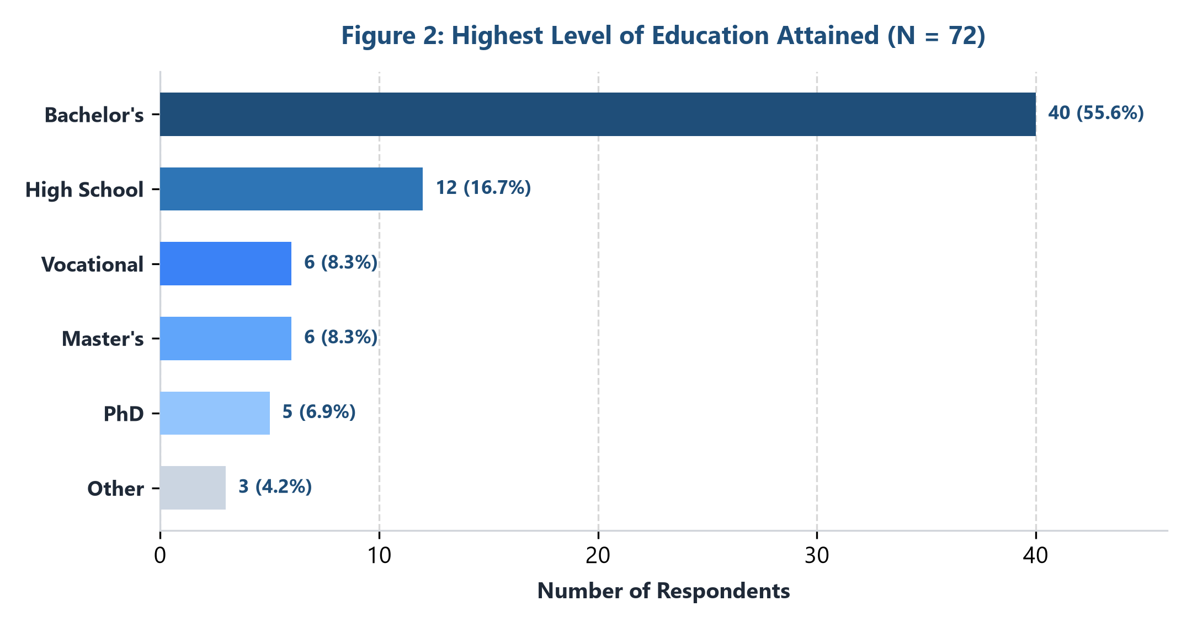
Figure 2: Educational Distribution of Respondents (N = 72)
Statistical Interpretation: Bachelor's degree candidates constitute the clear majority (55.6%, n=40), forming the primary talent pool. High school graduates account for 16.7% (n=12), many of whom are concurrently pursuing collegiate coursework. Postgraduate degree holders (Master's at 8.3% and PhDs at 6.9%) represent 15.2% of the surveyed population. Vocational certifications account for 8.3%.
KEY STRATEGIC TAKEAWAY: EDUCATIONAL PROFILING
• Undergraduate qualification serves as the dominant baseline credential across candidate pools.
• Specialized skill alignment and practical internships must bridge academic curricula with industrial requisites.

Question 3: Current Employment Status
Research Objective: Question 3 identified the operational employment status of participants, evaluating workforce participation rates and active job seeking ratios.
Employment Category | Respondent Count | Percentage (%) | Economic Activity Classification
Student | 45 | 60.0% | In Education (Pre-Workforce)
Employed | 18 | 24.0% | Active Labor Force Participant
Looking for Work | 10 | 13.3% | Active Job Seeker / Unemployed
Unemployed | 2 | 2.7% | Inactive / Transitioning
Total Respondents | 75 | 100.0% | —

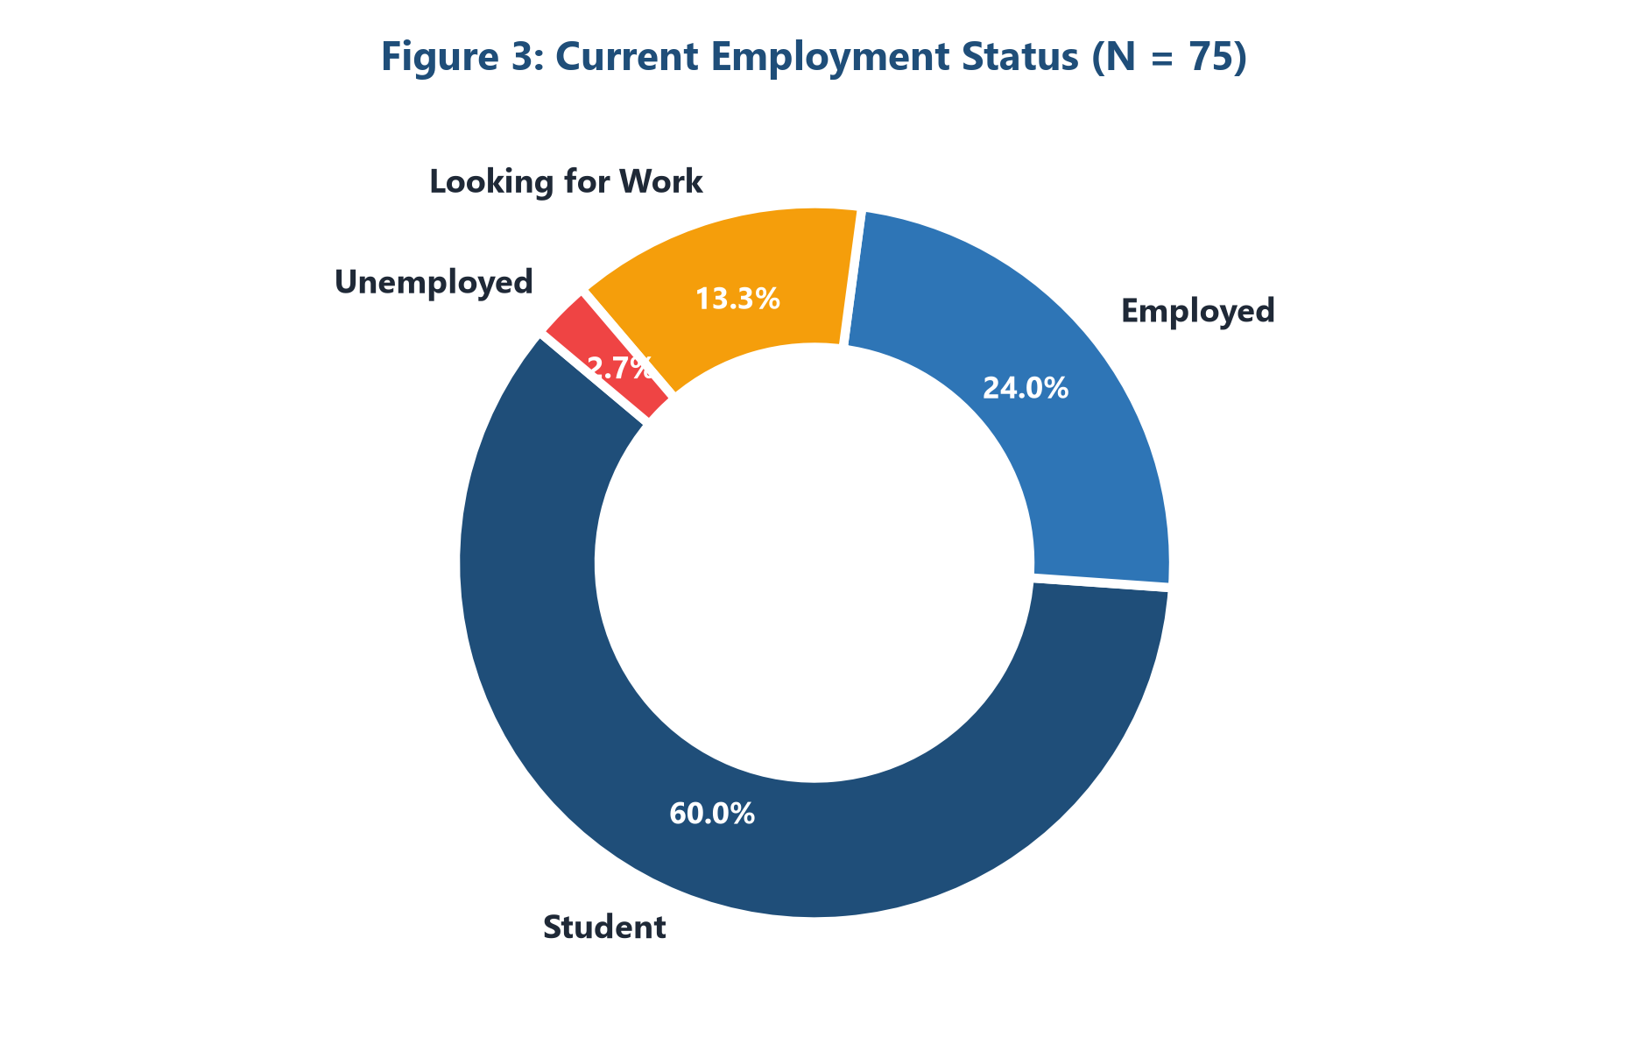
Figure 3: Distribution of Current Employment Status (N = 75)
Statistical Interpretation: A full 60.0% of the sample (n=45) are currently full-time students, aligning with the age distribution observed in Q1. Gainfully employed individuals represent 24.0% (n=18), while 13.3% (n=10) are actively seeking work without current placement. Chronic unemployment remains modest at 2.7%, indicating that the majority of non-working respondents are intentionally engaged in academic programs.
KEY STRATEGIC TAKEAWAY: EMPLOYMENT DYNAMICS
• The survey cohort provides a direct pulse on campus-to-corporate transitional challenges.
• Over 73.3% of the sample are either actively preparing for entry (students) or actively looking for employment.

Chapter 2: Job Search Behaviors & Digital Platforms
Question 4: Preferred Job Search Channels & Methods
Research Objective: Question 4 investigated the primary channels candidates use to discover and apply for career openings, allowing multiple selections across six established sourcing methods.
Search Channel / Method | Selections Count | Percentage of Sample (N=75) | Rank Order
Online Job Portals | 56 | 74.7% | Rank 1 (Primary)
Social Media Channels | 41 | 54.7% | Rank 2
Company Career Websites | 37 | 49.3% | Rank 3
Professional & Personal Networking | 28 | 37.3% | Rank 4
Recruitment Agencies | 21 | 28.0% | Rank 5
Newspapers / Print Media | 18 | 24.0% | Rank 6
Total Channel Selections | 201 | 268.0% (Avg 2.68/resp) | —

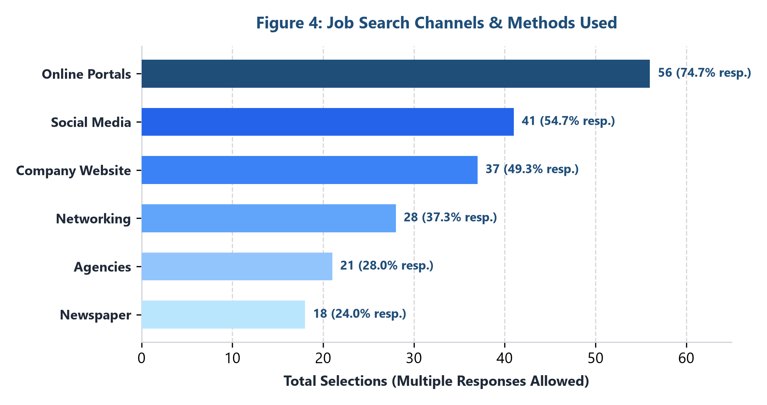
Figure 4: Preferred Job Search Channels (Multiple Selections Allowed)
Statistical Interpretation: The data confirms an emphatic shift toward algorithmic digital discovery. Online job portals dominate as the premier channel, utilized by 74.7% of respondents (n=56). Social media platforms (LinkedIn, Instagram, Twitter) have emerged as the second most common conduit at 54.7% (n=41), outpacing direct company career pages (49.3%). Traditional mediums such as print newspapers (24.0%) and recruitment agencies (28.0%) occupy a peripheral role.
KEY STRATEGIC TAKEAWAY: SEARCH CHANNEL TAKEAWAY
• Job boards and social media constitute over 70% of candidate discovery touchpoints.
• Employers failing to optimize digital listings and social media recruitment channels forfeit access to 75%+ of early-career talent.

Question 9: Market Share of Digital Job Portals
Research Objective: Question 9 mapped candidate preferences across prominent commercial employment platforms to evaluate brand loyalty and search platform concentration.
Job Portal / Platform | Respondent Count | Relative Share (%) | Platform Category
LinkedIn | 33 | 44.0% | Professional Social Network
Naukri.com | 9 | 12.0% | Enterprise Job Board
Indeed | 7 | 9.3% | Global Aggregator
Foundit (formerly Monster) | 6 | 8.0% | Traditional Portal
Apna | 6 | 8.0% | Blue/Grey Collar & Tech Mobile App
WorkIndia | 5 | 6.7% | Entry-Level Mobile Job Board
TimesJobs | 4 | 5.3% | Corporate Job Board
Freshersworld | 4 | 5.3% | Campus Placement Aggregator
Shine | 1 | 1.3% | Corporate Job Portal
Total Valid Responses | 75 | 100.0% | —

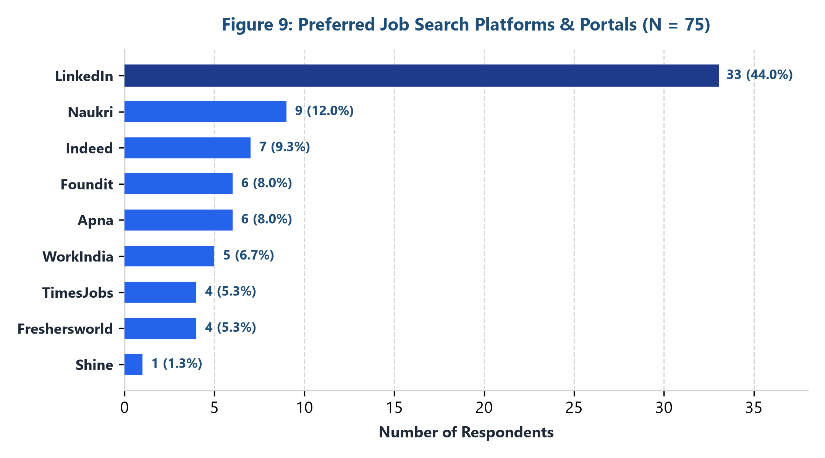
Figure 9: Market Share of Leading Job Portals (N = 75)
Statistical Interpretation: LinkedIn establishes commanding dominance in candidate preference, capturing 44.0% (n=33) of user mindshare—nearly quadruple its closest competitor, Naukri.com (12.0%, n=9). Global aggregator Indeed captures 9.3%, followed by Foundit and Apna at 8.0% each. Mobile-first hyperlocal applications like WorkIndia and campus portals like Freshersworld reflect specialized niches among entry-level job seekers.
KEY STRATEGIC TAKEAWAY: JOB PORTAL ECOSYSTEM
• LinkedIn represents the undisputed anchor platform for white-collar and graduate employment.
• A diversified multi-platform presence is essential to reach vocational and specialized applicant cohorts.

Chapter 3: Candidate Expectations & Sector Choices
Question 5: Evaluation of Career & Job Decision Factors
Research Objective: Question 5 measured the psychological and financial priorities shaping employment decisions across five core dimensions evaluated on a 5-point Likert rating scale.
Career Decision Factor | Very Important | Important | Neutral | Unimportant | Very Unimportant
Compensation & Salary | 53 (70.7%) | 32 (42.7%) | 41 (54.7%) | 32 (42.7%) | 30 (40.0%)
Work-Life Balance | 18 (24.0%) | 28 (37.3%) | 23 (30.7%) | 20 (26.7%) | 19 (25.3%)
Growth & Promotion Opp. | 2 (2.7%) | 10 (13.3%) | 10 (13.3%) | 12 (16.0%) | 20 (26.7%)
Company Reputation & Brand | 1 (1.3%) | 2 (2.7%) | 2 (2.7%) | 3 (4.0%) | 3 (4.0%)
Office Location & Commute | 1 (1.3%) | 3 (4.0%) | 1 (1.3%) | 8 (10.7%) | 3 (4.0%)

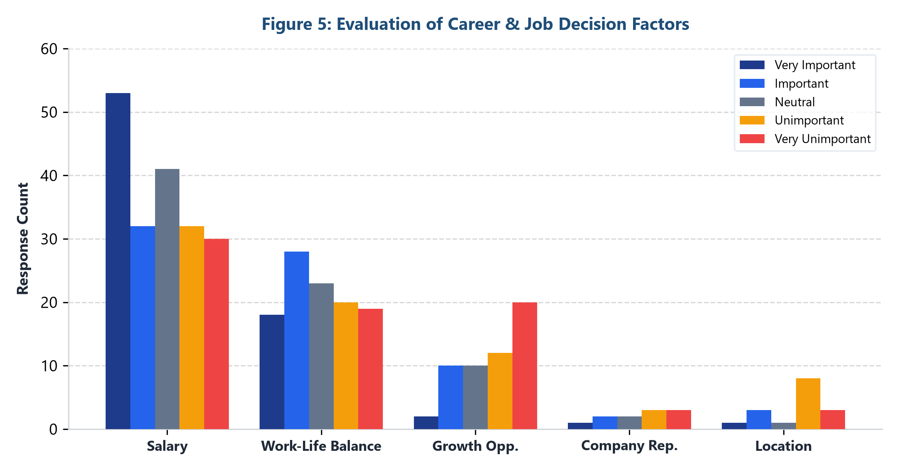
Figure 5: Multi-Factor Career Decision Matrix Evaluation
Statistical Interpretation: Financial remuneration emerges as the primary decision driver, capturing 53 'Very Important' votes—representing over 70% of respondents. Work-Life Balance ranks second, registering strong importance (28 'Important' and 18 'Very Important' votes). Conversely, external brand reputation and physical office location ranked noticeably lower, indicating that candidates prioritize immediate compensation and personal time over corporate branding prestige.
KEY STRATEGIC TAKEAWAY: DECISION FACTOR PRIORITY
• Competitive baseline remuneration remains the prerequisite for candidate attraction.
• Work-life balance is a non-negotiable secondary pillar for Gen-Z and millennial talent.

Question 7: Preference for Modern Working Arrangements
Research Objective: Question 7 captured preferred post-pandemic operational working modes, contrasting traditional on-site office requirements against hybrid and fully remote models.
Working Arrangement | Respondent Count | Relative Share (%) | Workplace Flexibility Tier
Hybrid (Remote + Office) | 28 | 43.1% | Balanced Flexibility
Fully Remote | 27 | 41.5% | Complete Geographical Autonomy
Fully On-Site (Office-based) | 10 | 15.4% | Traditional Rigid Structure
Total Valid Responses | 65 | 100.0% | —

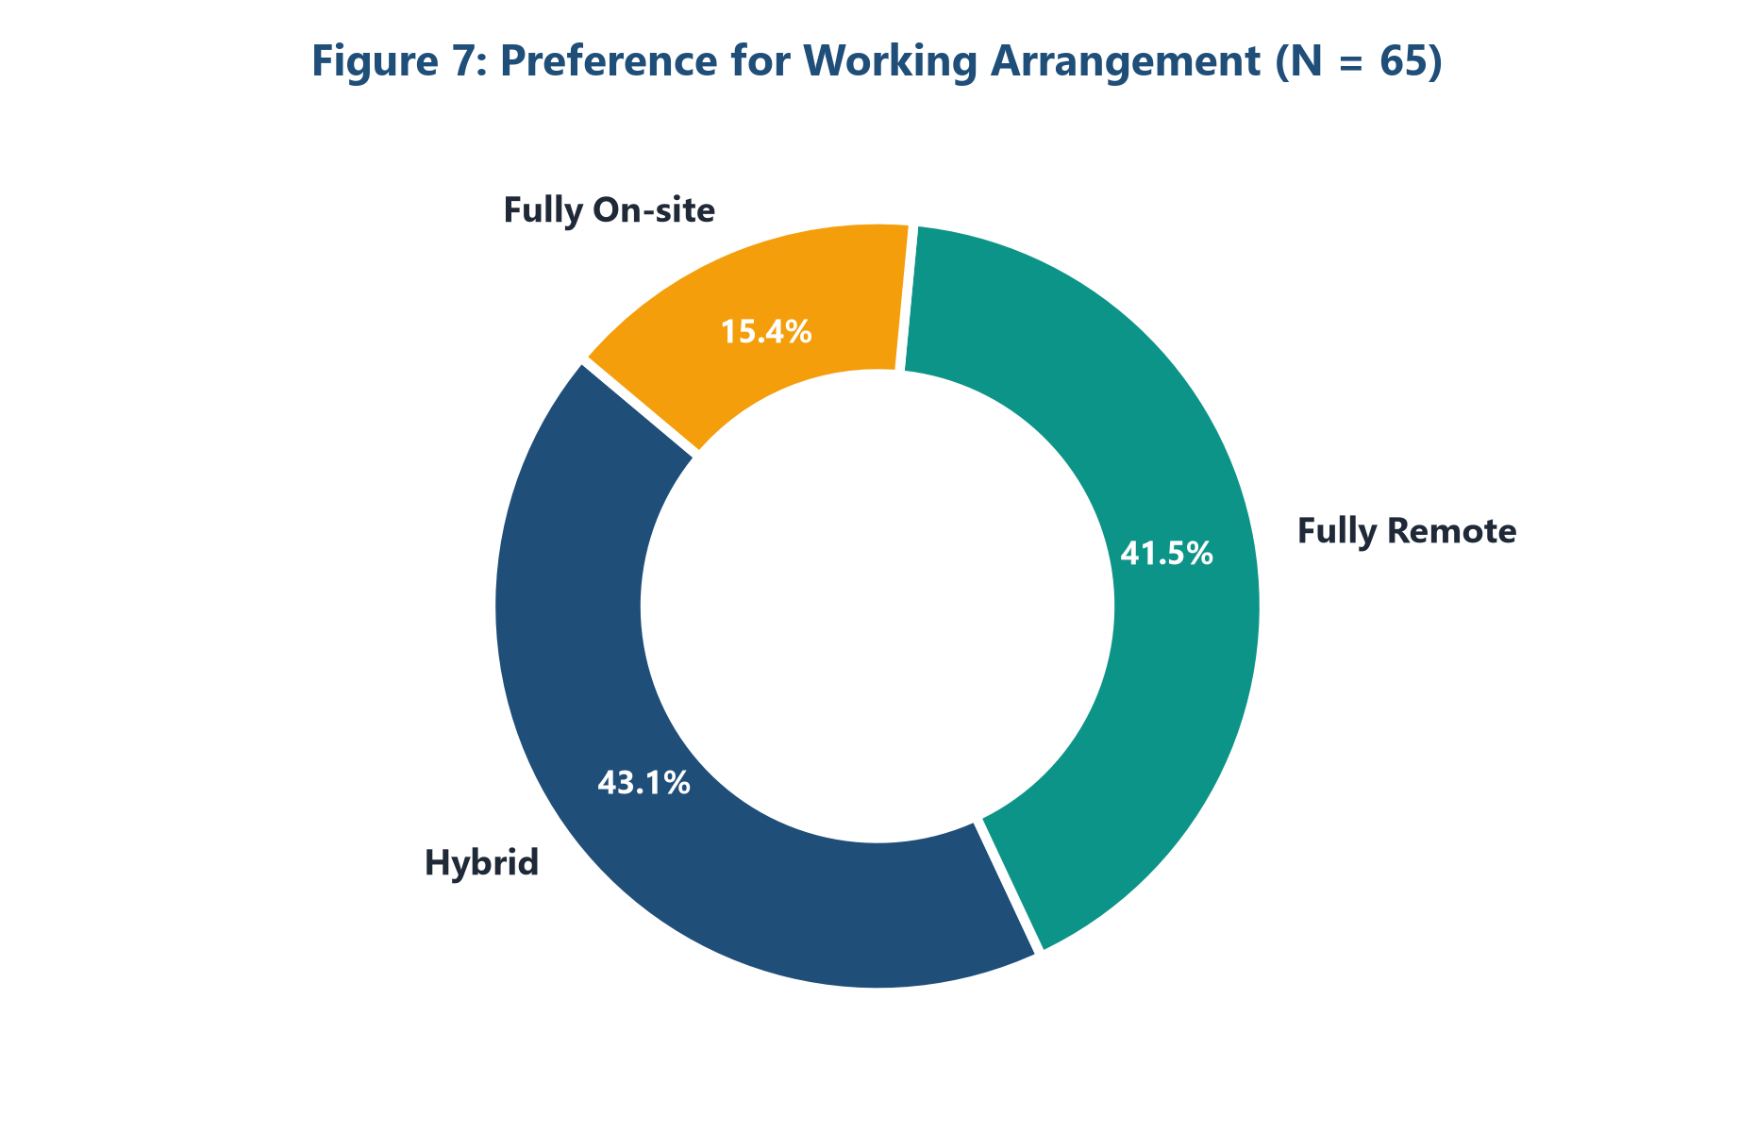
Figure 7: Candidate Preferences for Working Arrangements (N = 65)
Statistical Interpretation: The results demonstrate an overwhelming mandate against rigid in-office requirements. A combined 84.6% of candidates demand flexibility, split between Hybrid setups (43.1%, n=28) and Fully Remote roles (41.5%, n=27). Only 15.4% (n=10) prefer five-day on-site work. This underscores a permanent cultural reset in workforce expectations, where physical co-location is viewed as discretionary rather than mandatory.
KEY STRATEGIC TAKEAWAY: WORKPLACE FLEXIBILITY
• Organizations enforcing strict 100% on-site policies alienate nearly 85% of potential applicants.
• Hybrid schedules provide the optimal balance between collaborative immersion and autonomy.

Question 10: Target Employment & Industry Sectors
Research Objective: Question 10 surveyed the target economic sectors and industries respondents actively seek to enter upon completing their academic qualifications.
Industry / Sector | Respondent Count | Relative Share (%) | Economic Sector Type
Information Technology (IT) | 44 | 59.5% | Technology & Digital Services
Education & Academia | 7 | 9.5% | Public & Private Educational Services
Government / Civil Services | 7 | 9.5% | Public Sector Administration
Healthcare & Life Sciences | 6 | 8.1% | Medical & Clinical Services
Retail & Consumer Goods | 5 | 6.8% | Commerce & Consumer Services
Manufacturing & Engineering | 3 | 4.1% | Industrial & Production
Finance & Banking | 1 | 1.4% | Financial Services & FinTech
Other Miscellaneous Sectors | 1 | 1.4% | Diversified Services
Total Valid Responses | 74 | 100.0% | —

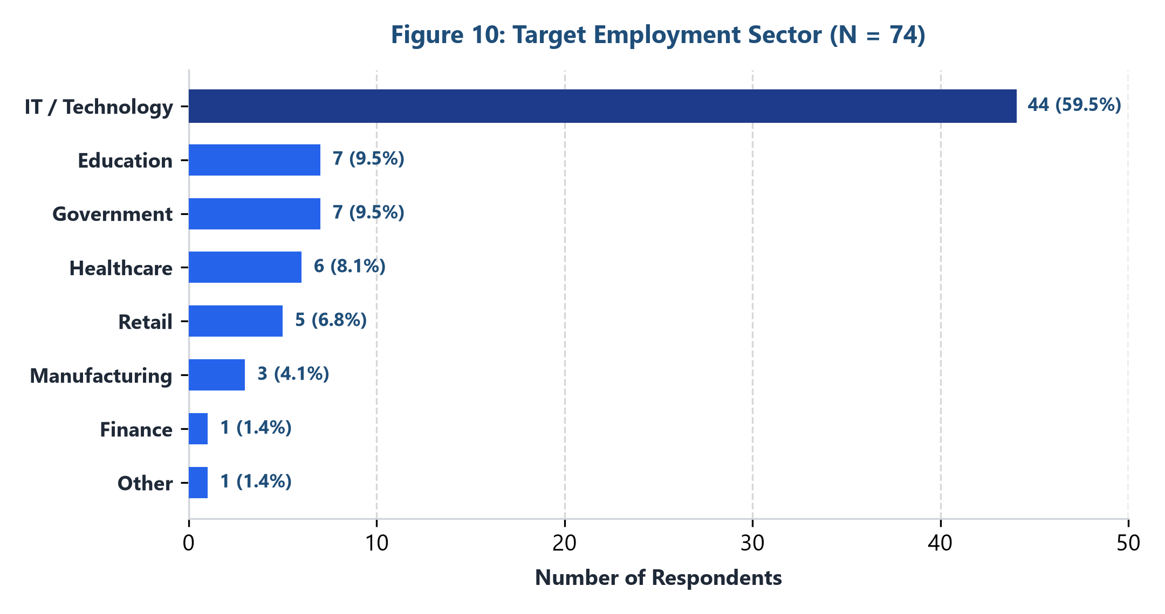
Figure 10: Target Industry Sector Aspirations (N = 74)
Statistical Interpretation: The Information Technology sector commands near-monopolistic attraction, selected by 59.5% of respondents (n=44). This is driven by perceived salary premiums, hybrid flexibility, and global career mobility. Education and Government services tied for second place at 9.5% each (n=7), reflecting stable, risk-averse alternatives. Traditional core engineering like Manufacturing captured only 4.1%, while Finance accounted for 1.4%.
KEY STRATEGIC TAKEAWAY: INDUSTRY CLUSTERING
• Extreme clustering toward IT creates severe talent hyper-competition in tech while starving non-IT sectors.
• Non-tech sectors must modernize workplace perks and digital branding to attract early-career talent.

Chapter 4: Market Obstacles & Recruitment Friction
Question 6: Primary Challenges Encountered in Job Search
Research Objective: Question 6 diagnosed the systemic impediments and friction points candidates experience when navigating modern corporate hiring pipelines.
Job Search Barrier / Challenge | Respondent Count | Relative Share (%) | Friction Classification
Lack of Required Experience | 19 | 26.4% | Structural Entry Barrier
High Applicant Competition | 18 | 25.0% | Labor Market Saturation
Salary Expectancy Mismatch | 14 | 19.4% | Economic Compensation Gap
Few Job Openings / Scarcity | 11 | 15.3% | Macroeconomic Contraction
Inadequate Professional Networking | 5 | 6.9% | Social Capital Deficit
Complex / Cumbersome Application Process | 5 | 6.9% | Administrative Hiring Friction
Total Valid Responses | 72 | 100.0% | —

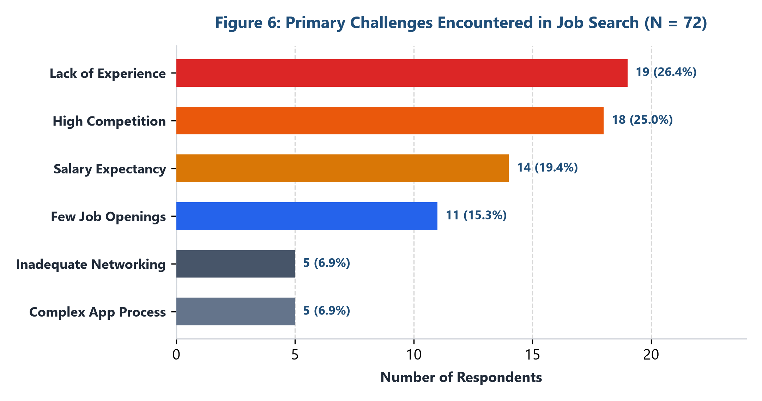
Figure 6: Primary Job Search Obstacles Encountered (N = 72)
Statistical Interpretation: The classic 'experience paradox' represents the single greatest hurdle: 26.4% of candidates identify 'Lack of Experience' as their foremost barrier, followed closely by 'High Competition' at 25.0%. Together, over 51.4% struggle against overcrowded applicant pools demanding unattainable prerequisites for entry-level roles. Salary expectancy gaps impact 19.4%, while application friction and networking deficits affect 6.9% each.
KEY STRATEGIC TAKEAWAY: HIRING BARRIER INSIGHT
• Entry-level requirements often mandate 2+ years of experience, shutting out competent graduates.
• Internship conversion and project-based portfolios must substitute for conventional tenure.

Question 11: Perceived Clarity of Recruitment Processes
Research Objective: Question 11 quantified the transparency, communication efficacy, and clarity of modern recruitment workflows on a standardized 5-point rating scale.
Clarity Level Rating | Respondent Count | Percentage (%) | Candidate Perception
1 - Very Unclear | 12 | 16.7% | Severe Process Opacity / Ghosting
2 - Unclear | 10 | 13.9% | Ambiguous Communication
3 - Neutral / Moderate | 21 | 29.2% | Adequate but Impersonal
4 - Clear | 19 | 26.4% | Transparent & Predictable
5 - Very Clear | 10 | 13.9% | Exceptional Guidance & Feedback
Total Valid Responses | 72 | 100.0% | Weighted Average: 3.07 / 5.0

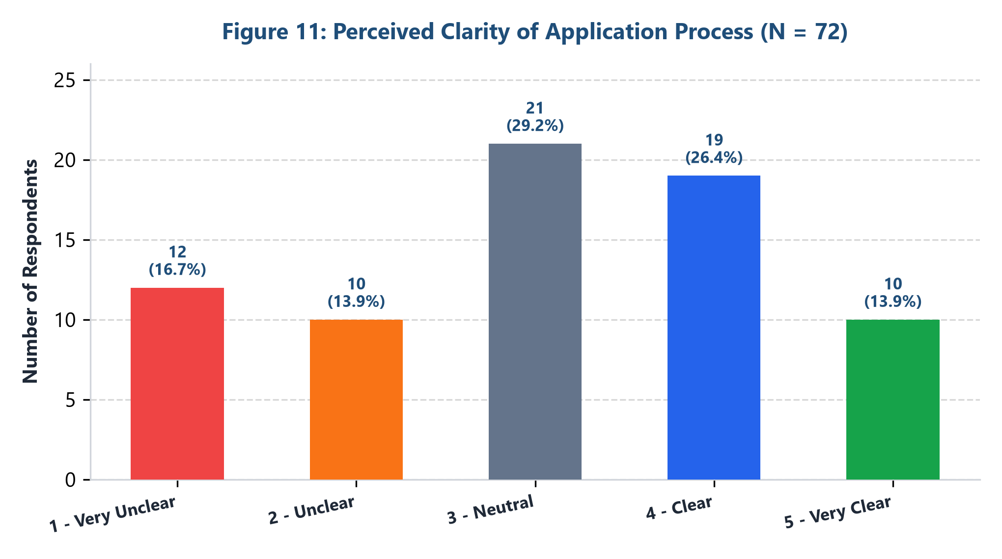
Figure 11: Perceived Clarity of Application Workflows (N = 72)
Statistical Interpretation: Perception of application process transparency yields a bimodal distribution with a mean score of 3.07 out of 5.0. While 40.3% rate the process positively (Rating 4 or 5), nearly one-third (30.6%, n=22) describe application stages as unclear or very unclear. This opacity is primarily driven by Automated Tracking Systems (ATS) rejections without feedback and chronic recruiter 'ghosting.'
KEY STRATEGIC TAKEAWAY: APPLICATION TRANSPARENCY
• Nearly 1 in 3 candidates suffers from severe communication opacity during recruitment.
• Automated milestone tracking and constructive rejection feedback substantially enhance employer brand reputation.

Chapter 5: Candidate Satisfaction & Assessment Dynamics
Question 8: Overall Job & Search Satisfaction Rating
Research Objective: Question 8 gauged respondents' comprehensive satisfaction with their current employment status or job search trajectory using a 5-point Likert metric.
Satisfaction Level Rating | Respondent Count | Percentage (%) | Sentiment Evaluation
1 - Very Dissatisfied | 10 | 13.3% | High Distress / Disillusionment
2 - Dissatisfied | 19 | 25.3% | Underemployed / Frustrated
3 - Neutral | 20 | 26.7% | Ambivalent / In Stasis
4 - Satisfied | 17 | 22.7% | Positive Career Trajectory
5 - Very Satisfied | 9 | 12.0% | Optimal Role / High Fulfillment
Total Valid Responses | 75 | 100.0% | Weighted Average: 2.95 / 5.0

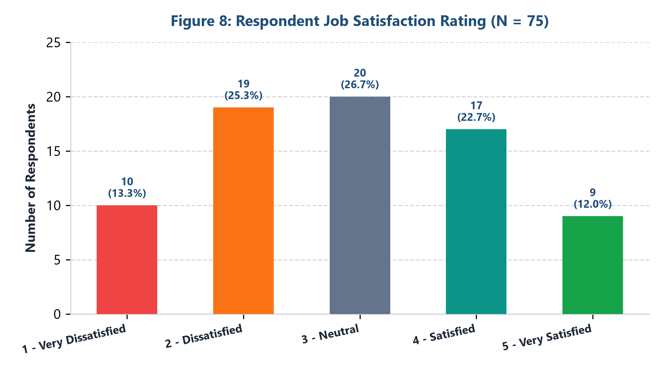
Figure 8: Overall Job Satisfaction Metric Distribution (N = 75)
Statistical Interpretation: The overall satisfaction index registers a net-negative average of 2.95 out of 5.0. Dissatisfied cohorts (Ratings 1 and 2) combine for 38.6% (n=29), substantially outnumbering fully satisfied participants (Rating 5 at 12.0%, n=9). Neutral sentiments comprise 26.7%. This pervasive dissatisfaction stems from prolonged hiring timelines, high application rejection volumes, and compensation mismatches.
KEY STRATEGIC TAKEAWAY: SATISFACTION DEFICIT
• Negative sentiment outstrips positive sentiment by nearly 4 percentage points.
• Candidate disillusionment is directly correlated with application ambiguity and prolonged hiring cycles.

Question 12: Preferred Interview Assessment Formats
Research Objective: Question 12 evaluated candidate preferences regarding interview modalities, contrasting virtual meetings against physical evaluations and hands-on skill tasks.
Interview Format / Method | Respondent Count | Relative Share (%) | Evaluation Nature
In-Person Interview | 30 | 40.0% | Face-to-Face Personal Interaction
Zoom / Video Meeting | 26 | 34.7% | Synchronous Virtual Interaction
Phone Interview | 13 | 17.3% | Audio Screening / Asynchronous
Practical Technical Assessment | 6 | 8.0% | Skill Demonstration / Case Study
Total Valid Responses | 75 | 100.0% | —

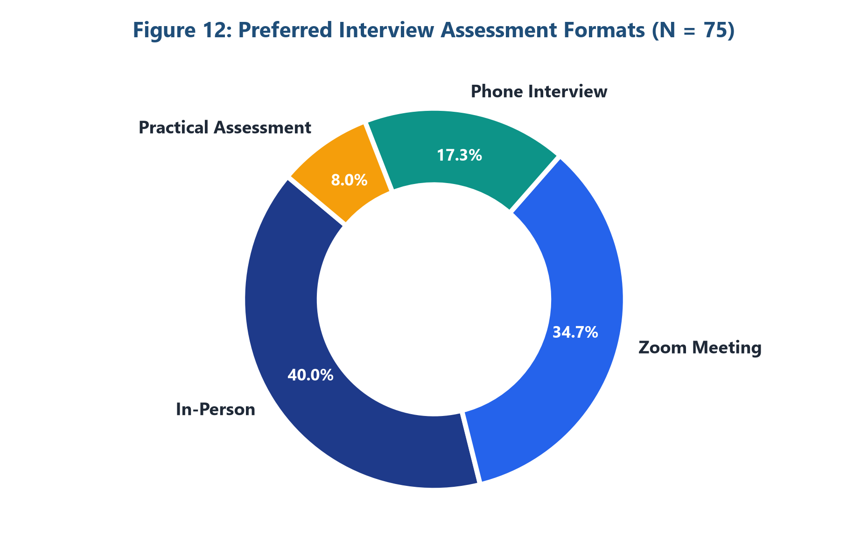
Figure 12: Candidate Preferences for Interview Formats (N = 75)
Statistical Interpretation: Despite the enthusiastic adoption of remote work (Q7), candidates still prioritize In-Person interviews (40.0%, n=30) as their most trusted evaluation format. Video meetings rank a close second at 34.7% (n=26). Phone screenings account for 17.3%, while practical coding assessments or case studies were selected by only 8.0%, suggesting candidates prefer direct dialogue over automated take-home assignments.
KEY STRATEGIC TAKEAWAY: INTERVIEW ASSESSMENT DYNAMICS
• Candidates value human rapport and non-verbal communication during hiring decisions.
• A hybrid interview protocol—virtual first rounds followed by in-person final reviews—yields the highest candidate trust.

Chapter 6: Comparative Cross-Analysis & Synthesis
Systemic Synthesis: By cross-correlating survey responses across multiple questions, several systemic patterns emerge regarding how early-career talent navigates the contemporary employment ecosystem:
1. The Generation Z Tech Concentration Paradox (Q1, Q2, Q3 & Q10)
A profound alignment exists between age profile (61.3% under 20), student status (60.0%), undergraduate credentials (55.6%), and an overwhelming targeting of the Information Technology sector (59.5%). While this demonstrates high digital literacy and ambition, it generates extreme structural bottlenecks. Thousands of identical entry-level candidates compete for a finite pool of junior software and IT roles, amplifying 'High Competition' (25.0%) and 'Lack of Experience' (26.4%) barriers.
2. Digital Platform Monopoly vs. Application Ghosting (Q4, Q9 & Q11)
The concentration of candidate search behavior on LinkedIn (44.0%) and generic job portals (74.7%) coincides directly with the 30.6% reporting unclear or opaque recruitment processes. High-volume single-click applications on LinkedIn ('Easy Apply') encourage extreme application spamming, leading corporate HR departments to deploy stringent ATS keyword filters. This algorithmic wall prevents authentic evaluations and perpetuates the candidate perception of being ignored.
3. The Workplace Flexibility Consensus (Q5, Q7 & Q12)
A compelling dichotomy emerges between working arrangements and interview evaluations. While 84.6% demand remote or hybrid working arrangements on the job (Q7), 40.0% simultaneously demand in-person interviews (Q12). This indicates that while candidates value day-to-day autonomy, they recognize that cultural alignment, trust building, and company evaluation are superior in physical settings.
Strategic Dimension | Survey Empirical Finding | Systemic Challenge | Strategic Rectification
Sector Supply & Demand | 59.5% cluster in IT sector | Extreme talent surplus in tech; deficit in core industries | Promote tech-integrated roles in manufacturing, healthcare, finance
Recruitment Experience | 38.6% express net dissatisfaction | ATS black holes, delayed feedback, ghosting | Institute transparent candidate portals with milestone timelines
Job Architecture | 84.6% demand Hybrid/Remote setups | Forced return-to-office mandates spark turnover | Standardize 2-3 day flexible hybrid working contracts
Entry Qualification | 26.4% cite lack of experience | Entry roles demand mid-level experience | Establish paid micro-internships and capstone apprenticeship programs

Chapter 7: Strategic Recommendations & Conclusion
Action Plan: Based on the empirical findings generated from this field project, targeted interventions are proposed across three key stakeholder groups:
1. Recommendations for Academic Institutions & Career Centers
• Project-Based Experiential Learning: Shift curricula toward industry capstones, live client briefs, and open-source contributions to break the 'no experience' cycle before graduation.
• Professional Digital Profiling Workshops: Provide formalized training on LinkedIn optimization, portfolio creation, and proactive outreach rather than passive portal browsing.
• Sector Diversification Counseling: Actively showcase high-growth opportunities outside IT—such as health-tech, industrial automation, and fintech—to alleviate tech market saturation.
2. Recommendations for Corporate HR & Talent Acquisition Teams
• Demystify the Application Lifecycle: Implement real-time recruitment dashboards where applicants can view stage progression, average review timelines, and automated status notifications.
• Calibrate Entry-Level Job Specifications: Remove unrealistic 2–3 year experience prerequisites for junior roles, substituting them with verified technical competencies and cognitive assessments.
• Modernize Flexible Work Frameworks: Offer structured hybrid configurations as the core compensation value proposition to maximize candidate acquisition rates.
3. Recommendations for Prospective Candidates & Job Seekers
• Cultivate Multi-Channel Sourcing: Reduce over-reliance on mass job portals; leverage direct employee referrals, alumni networking, and specialized community forums.
• Portfolio Over Résumé: Demonstrate proof-of-work through GitHub repositories, published case studies, or freelance projects to overcome lack of formal tenure.
• Strategic Compensation Grounding: Benchmark starting salaries against real-world market distributions while prioritizing roles offering high learning velocity.
Conclusion
Final Synthesis: This field research project provides empirical clarity into the realities confronting the emerging workforce. The findings illustrate a demographic characterized by high technical aspirations, strong digital literacy, and an insistence on modern workplace flexibility. However, these assets are often constrained by opaque recruitment systems and outdated qualification expectations. Bridging this chasm through institutional reform, hiring transparency, and flexible job structures represents the primary imperative for future workforce development.

