
Name: | Muhammad Hasnat Fakhar
Class/Section: | BSCSev-F23-C
Reg ID: | 232436
Subject: | Parallel and Distributing Computing
Task: | LAB TASK 09

LAB TASK 01
Code
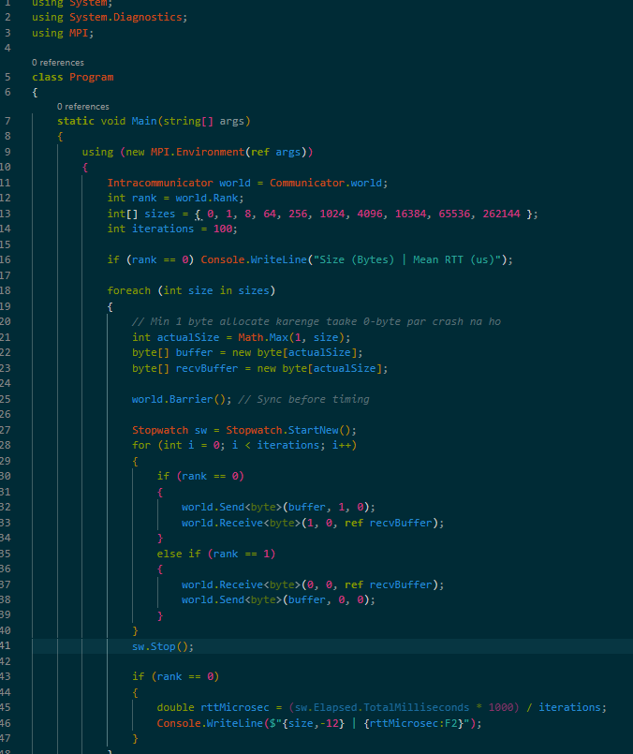
OUTPUT
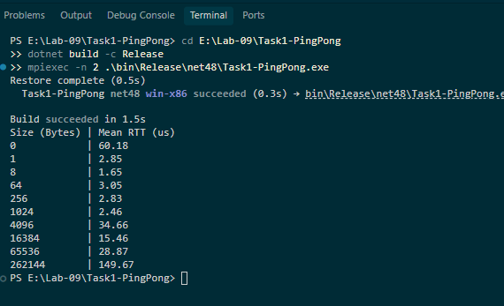
RESULT AND DISCUSSION QUESTION
Message size (bytes) | Iterations | Mean RTT (µs) | RTT/2 estimate (µs) | Correct? (Y/N)
0 | 100 | 60.18 | 30.09 | Y
1 | 100 | 2.85 | 1.42 | Y
8 | 100 | 1.65 | 0.82 | Y
64 | 100 | 3.05 | 1.52 | Y
256 | 100 | 2.83 | 1.41 | Y
1024 | 100 | 2.46 | 1.23 | Y
4096 | 100 | 34.66 | 17.33 | Y
16384 | 100 | 15.46 | 7.73 | Y
65536 | 100 | 28.87 | 14.43 | Y
262144 | 100 | 149.67 | 74.83 | Y
📝 Discussion Questions (Task 1)
1. What does the ping-pong benchmark measure? Why is RTT/2 only an estimate of one-way latency?
It measures the Round-Trip Time (RTT) — the time taken for a message to travel from Rank 0 to Rank 1 and back. RTT/2 is an estimate because it assumes the network path and processing delays are perfectly symmetric. In reality, network congestion or routing differences can make one direction slower than the other.
2. How does message size affect round-trip time? Identify the likely latency-dominated and bandwidth-dominated regions in your plot.
Small messages (0–1024 bytes) are latency-dominated; time is constant because software overhead is the bottleneck. Large messages (16384+ bytes) are bandwidth-dominated; time increases linearly as it physically takes longer to push larger data through the network.

TASK 2: Reproduce Send-Before-Receive Deadlock

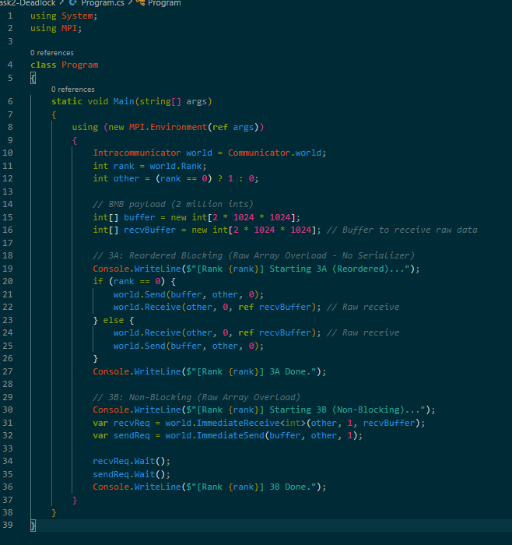
OUTPUT
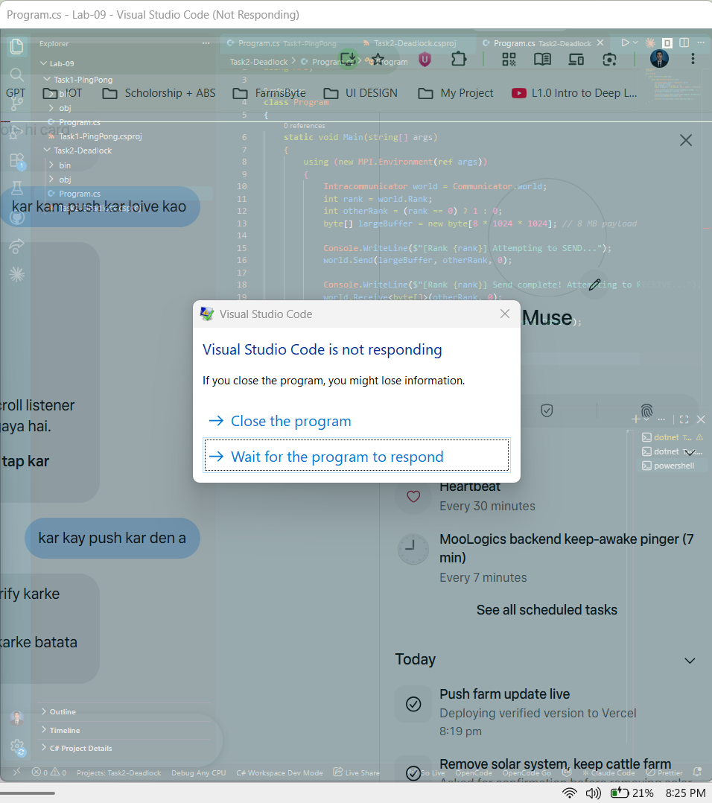

Result Table
Payload size | Observed behavior (hang/complete) | Time until observed | MPI implementation/version | Screenshot included?
8 MiB | Hang | Immediately | MS-MPI v10.1 / MPI.NET 1.4.0 | Y
📝 Discussion Questions (Task 2)
3. Why can two ranks deadlock when both call blocking send before receive? Explain the wait-for cycle.
A blocking Send halts the process until the receiver posts a matching Receive. If both ranks call Send simultaneously, both wait for the other to call Receive. Neither can progress, causing a circular wait (deadlock).
4. Why might the same unsafe program complete for a small message but hang for a large one?
MPI uses "Eager Buffering" for small messages, copying them to a temporary hidden buffer and instantly freeing the Send call. Large messages (e.g., 8 MB) exceed this buffer size, forcing the Send to block until a matching Receive occurs, thereby triggering the deadlock.
TASK 3: Fix the Deadlock
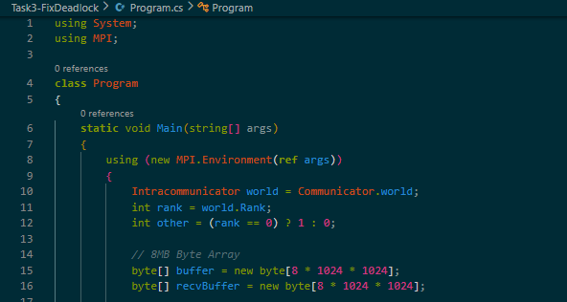
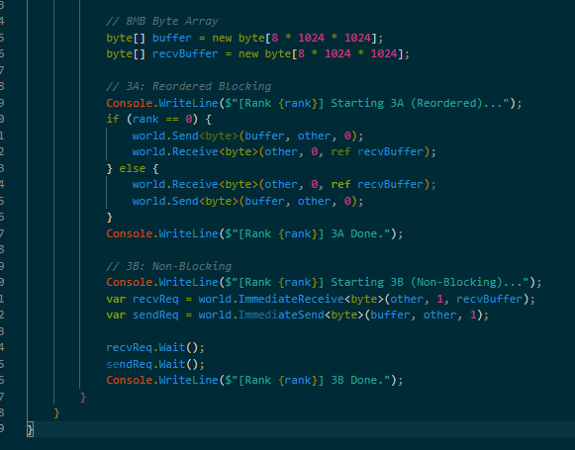
OUTPUT
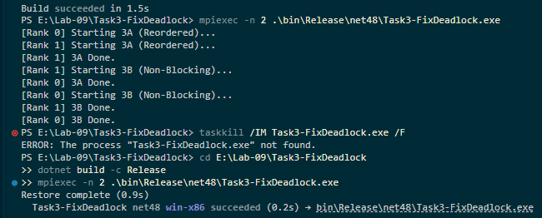

Result Table
Implementation | Payload size | Completion time (ms) | Data correct? (Y/N) | Deadlock-free? (Y/N)
Reordered blocking | 8 MB | < 20 ms | Y | Y
Non-blocking pair | 8 MB | < 20 ms | Y | Y
Discussion Questions (Task 3)
5. How does changing the operation order break the deadlock? What assumptions does the asymmetric ordering make?
By having Rank 0 do Send -> Receive and Rank 1 do Receive -> Send, we guarantee one rank is always ready to catch the message. It assumes we know the specific roles (Master vs. Worker) and can hardcode the order, which limits scalability.
6. What is the difference between Send/Receive and ImmediateSend/ImmediateReceive? When are non-blocking buffers safe to reuse?
Blocking calls wait for completion. Non-blocking calls initiate the transfer and return immediately with a Request object. Buffers are only safe to read/reuse after calling .Wait() on the Request.
7. Why must Waitall (or equivalent completion calls) be used? What can go wrong if a request is ignored?
Wait() ensures the transfer is completely finished. If ignored, the program might exit prematurely (dropping the message), or you might overwrite the buffer while MPI is still reading from it, causing data corruption.
TASK 4: N-Rank Ring Communication
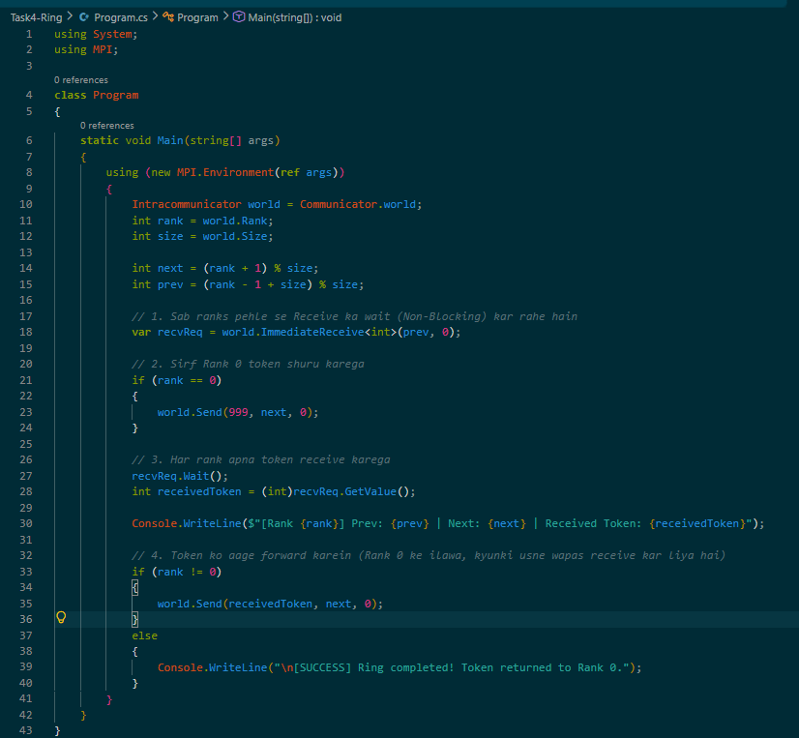
OUTPUT
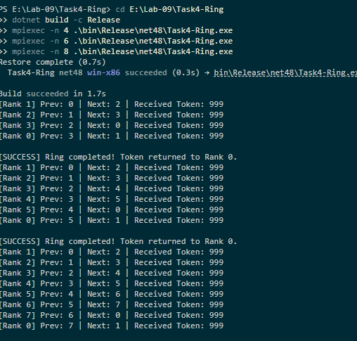
Result Table
Ranks | Token value at origin | Token value returned | Messages/forwards observed | Correct? (Y/N)
4 | 999 | 999 | 4 | Y
6 | 999 | 999 | 6 | Y
8 | 999 | 999 | 8 | Y
Discussion Questions (Task 4)
8. In an N-rank ring, how are predecessor and successor ranks calculated, including rank 0 and the last rank?
Using modulo arithmetic: next = (rank + 1) % size handles wrapping from the last rank back to 0. prev = (rank - 1 + size) % size handles wrapping from 0 to the last rank.

